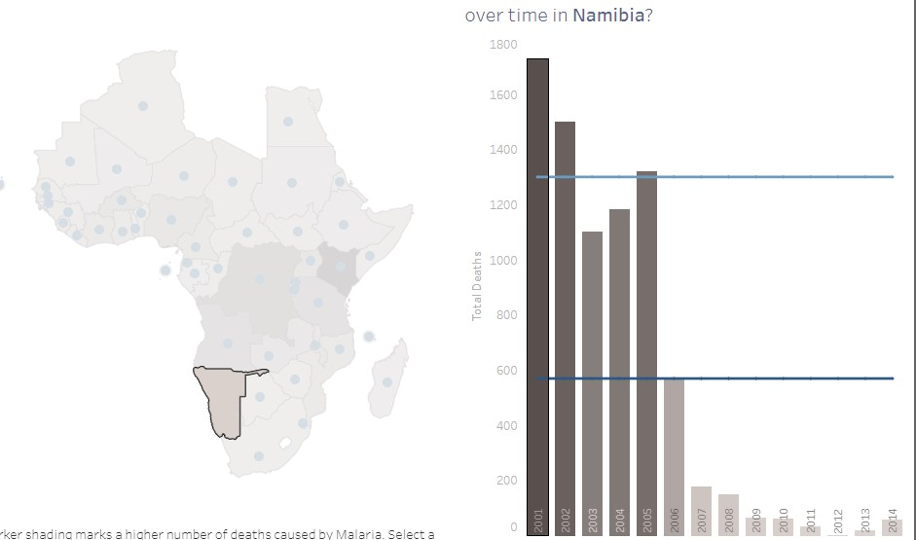

The chart shows that the year2001 had high death rate compared to the year2006,it decreased by half. the least year in which deaths occurred was 2012.

The deaths per a years 2006-2014 lower than the average in the country due to the data dashboard.

I was able to collect this data by pressing on the dashboard. Also ,the colors of the dark columns indicated the presence of a large number of death, the light ones indicated the opposite.it also helped me in the analysis .when pressing on the dashboard, I was able to see the average of Africa, and the length of the columns also helped me to explain. For example, the year 2001 is the longer and the darker

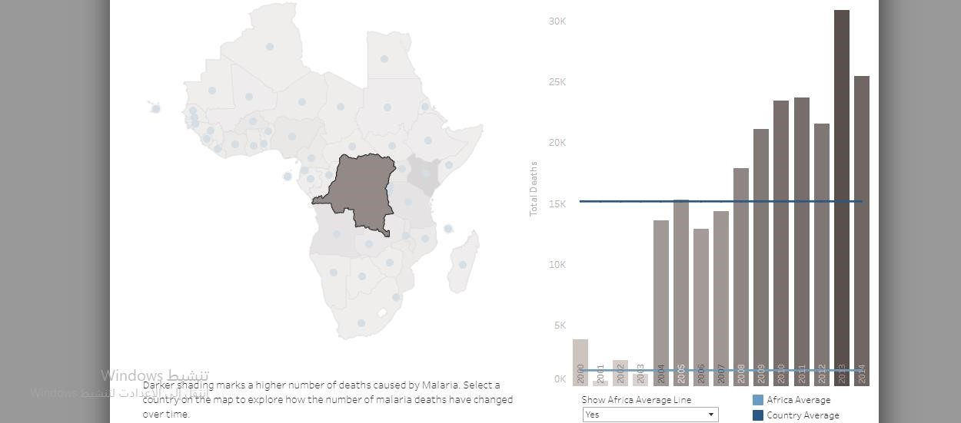

From 2000 to 2003 there is decrease in the number of deaths in the democratic republic of the congo , from 2004 to 2014 there has been an increase in the number of deaths .the highest year in the death rate is 2013.from 2000 to 2007 , the death rate was less than the country’s average

The length of the columns from 2000 to 2003 showed me that was a decrease in the number of deaths, and also the light color showed me the decrease, and also the dashboard showed me that columns had increased in length, which means that the percentage of deaths increased from 2004to2014 light and dark blue are the African average and the country average helps to understand the map

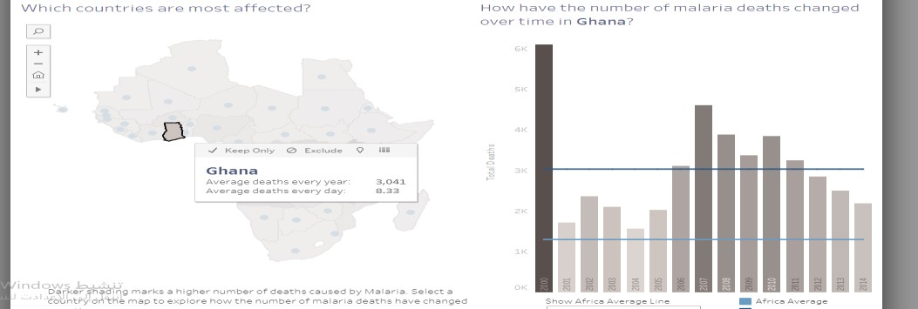

Ghana had a death rate 6k in the year 2000, and that years was highest in deaths.

Deaths from 2000 to 2014 were higher than the Africa averaged

The color of the dark column and its length showed me that the year 2007 was the year in which the highest death rate occurred .the light blue line that represents Africa had the columns longer that it ,which means that the years from 2000to 2014 are higher than the average of Africa