Analyze survey data

(**the data is from Survey Respondents and not from the entire Udacity Student population)**

# Level of education

It showed us that the master's degree is the highest (316) in the level of education, while the associate degree is the smallest (12).

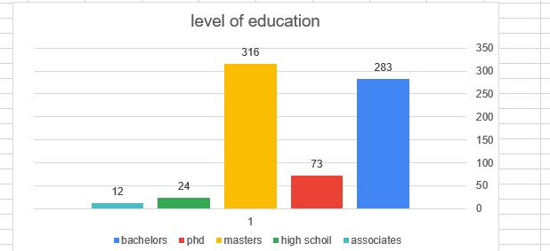

Number of student

Education program

Average commute time Canada and Japan

When comparing Canada with Japan, it seems that there is no significant difference between them except that the extreme value is the Japanese 32.25 and the Canada

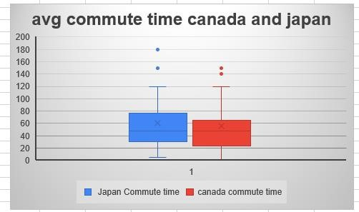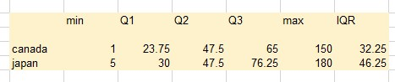

46.25

Bachelors study hours per weak VS Non-bachelors hours per

# weak

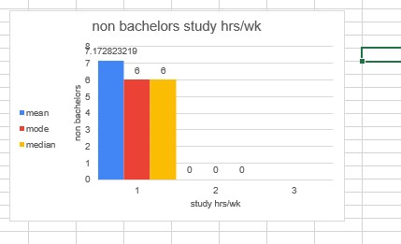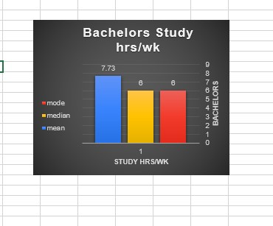

The data show us that mean of bachelors study hours per week ( 7.738) and nonbachelors study hours per week (7.17) .

that's show there are a little difference on bachelors and non- bachelors participant on spend study hours per week

The median for bachelors study hrs/wk(6) and the median for non-bachelors study hrs/wk(6) there are no difference on study hours per week.

the mode show that bachelor and nonbachelors both spend 6 hrs/wk on study

## Commute times for PhD and Non-PhD

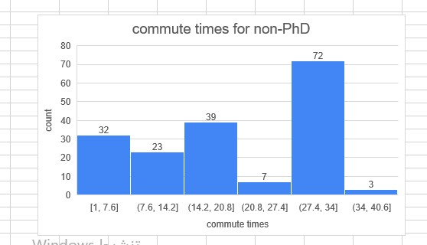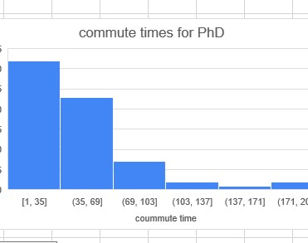

The data showed us standard deviation for PhD is(53.13473) while standard deviation for non-PhD is(60.48057) that’s mean commute times for non-PhD is larger.

The minimum value of commute times for PhD is 1 and the maximum value is 239 which gives a range value 238 .

The minimum value of commute times for Non-PhD is 1 and the maximum value is 600 which gives a range value 599 .

The range has highlighted some outliers which could be effecting the value