What is the highest month in sales of ABC TREASURE BOOK BOX in 2011?

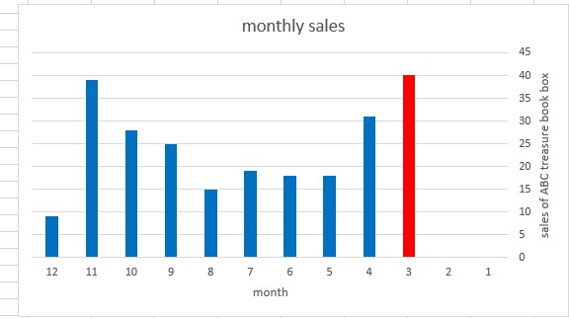

As the chart showed us march is the highest month in sales, where sales were 40 times during the month.

What is the lowest month in sales of ABC TREASURE BOOK BOX in 2011?

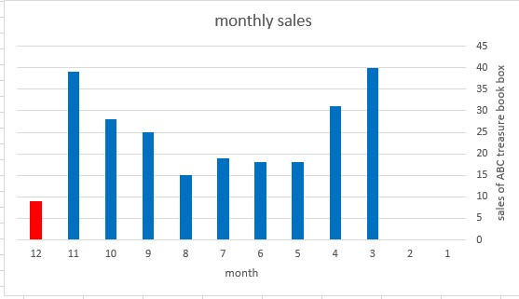

According to the data showed in the chart December was the lowest month in sales, where sales were 9 times during the month.

What the rate of sales of ABC TREASURE BOOK BOX over year 2011?

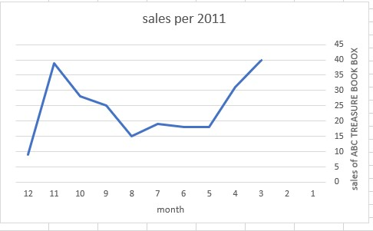

The chart shows us there was fluctuate in sales over 2011.

There was increase in bought ABC TREASURE

book box in March and September while there was decrease in bought ABC TREASURE book ox in May, August and December.

In the time between April and November there was fluctuate in sales up and down.