# The cancellation map for USA

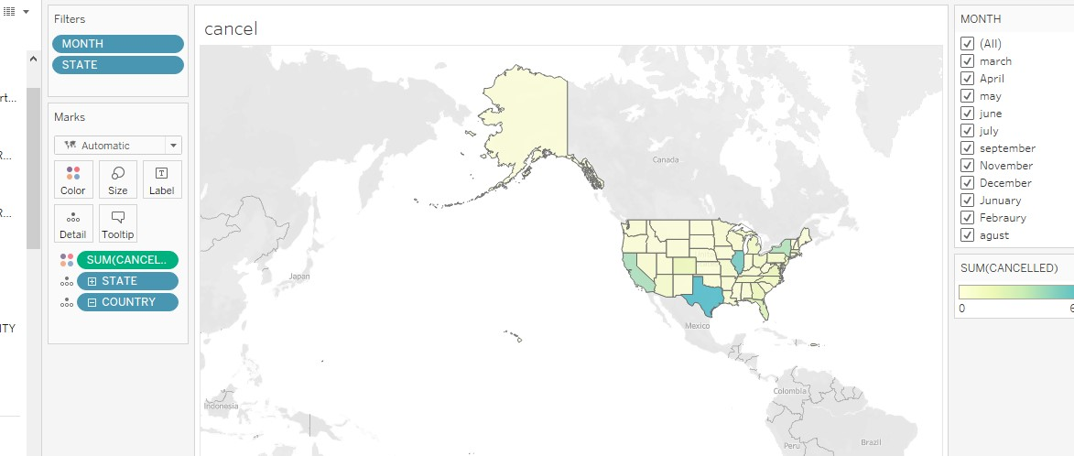

[https://public.tableau.com/app/profile/rawan.alharbi4547/viz/mapsheetofcountryandstate/ cancel?publish=yes](https://public.tableau.com/app/profile/rawan.alharbi4547/viz/mapsheetofcountryandstate/cancel?publish=yes)

The data show us the highest state in canceled flights in USA is the state of TX , and the number of canceled flights is 668 and the loswest state in canceleed in USA is WV and MT the number of canceled flights is 3.

We chose this map because it clear ,simple,and more effective.it shows canceled flights clearly by distinguish light and dark colors ,the light coloer means decreased cancled flights and the dark coloer means increased cancled flight

- We have put in a filter for months

-The blue color shows the state that have the most cancellation and the lighter the color shows the less cancelled the state.

# The cancellation rate for USA

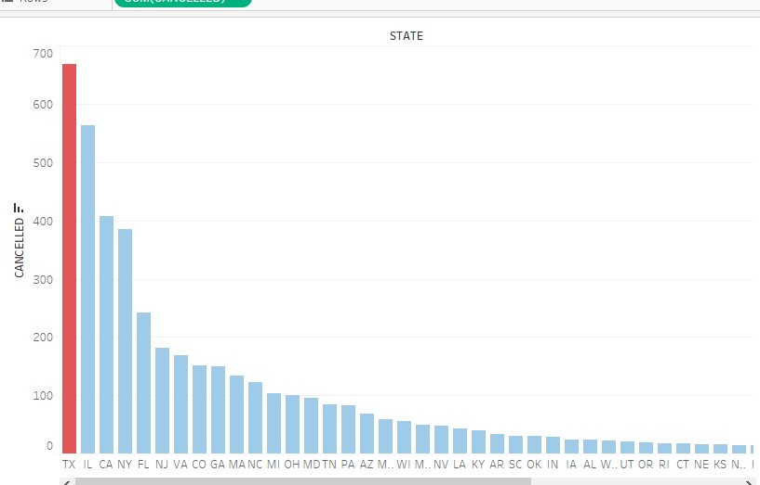

-I chose the red color for the state with the highest cancellation.and the blue color for the states with the lowest cancellation.in order to distinguish

- We have put in a filter for months

[https://public.tableau.com/app/profile/rawan.alharbi4547/viz/sheetofthenumberofcancellat ionsperstate/cancel2?publish=yes](https://public.tableau.com/app/profile/rawan.alharbi4547/viz/sheetofthenumberofcancellationsperstate/cancel2?publish=yes)

# Dashboard of The cancellation for USA

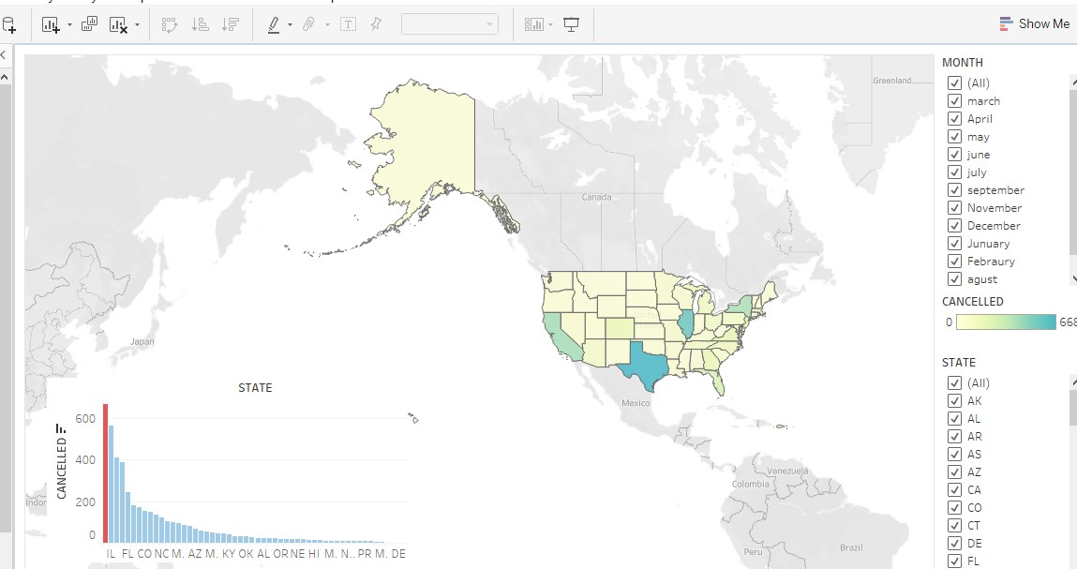

we applied the filter to the bar chart and the map, then we created the dashboard and made sure to choose the appropriate colors.

[https://public.tableau.com/app/profile/rawan.alharbi4547/viz/canceldashbord2/canceldash bord?publish=yes](https://public.tableau.com/app/profile/rawan.alharbi4547/viz/canceldashbord2/canceldashbord?publish=yes)

# The reasons of cancellation

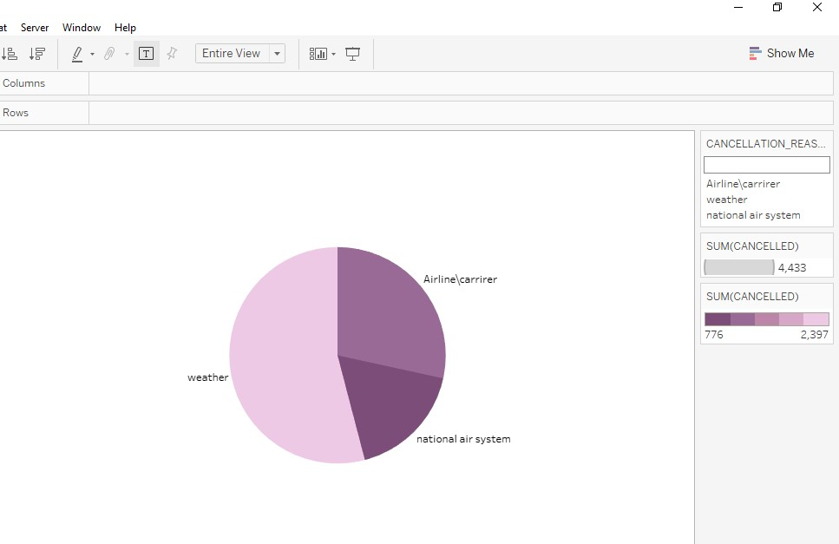

|  |
| --- |
| Here I chose the pie chart, the data showed very clearly Airline/Carrier cancelled |
| 1.260 National Air System cancelled 776 Weather cancelled 2.397  The most reason for cancellation is the weather, so we put the light purple color is the highest reason for cancellation, and the dark purple color is the lowest reason for cancellation |

[https://public.tableau.com/app/profile/rawan.alharbi4547/viz/she etpiechartcancellationresone/Sheet3?publish=yes](https://public.tableau.com/app/profile/rawan.alharbi4547/viz/sheetpiechartcancellationresone/Sheet3?publish=yes)

# Airline Delay

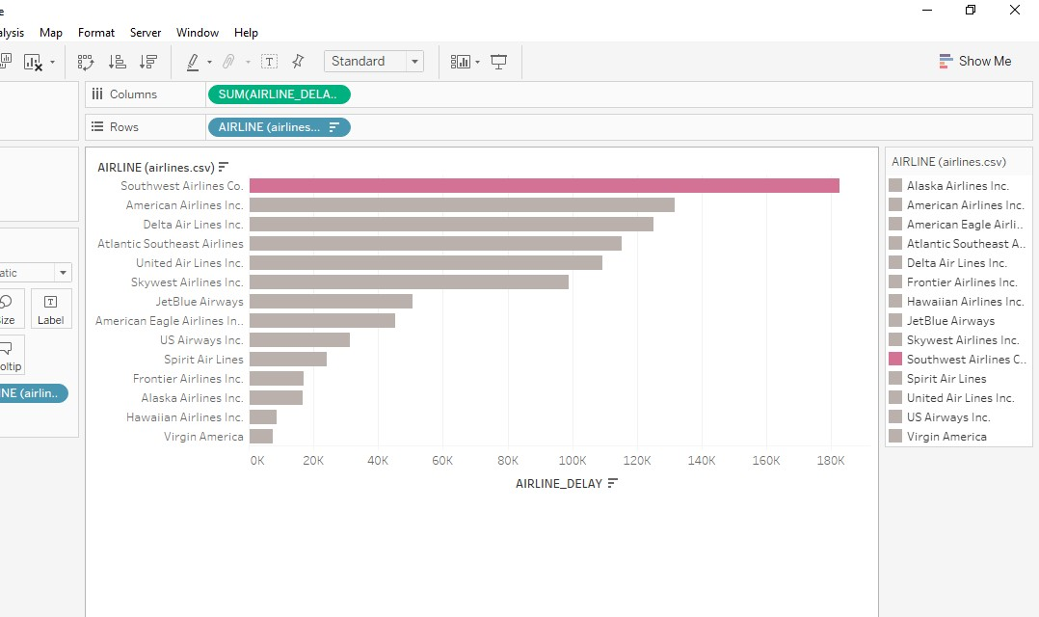

I used bar chart and the figure showed that the most delayed flight is southwest airlines and the least delayed flight is virgin America.

-I chose the dark pink color for the top delayed flights and put it another color so that the viewer can distinguish and know at first sight what are the most delayed flights.

[https://public.tableau.com/app/profile/rawan.alharbi4547/viz/sheetarilinedelay/She](https://public.tableau.com/app/profile/rawan.alharbi4547/viz/sheetarilinedelay/Sheet4?publish=yes)

[et4?publish=yes](https://public.tableau.com/app/profile/rawan.alharbi4547/viz/sheetarilinedelay/Sheet4?publish=yes)