Objective:

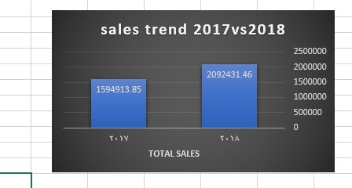

|  |  |
| --- | --- |
| **Increase** | the total sales was rise by 30% on Black Friday 2018 vs. |
| Black Friday 2017. The sales increase 31.19% (sales volume in2018-sales volume in2017)/ sales volume in2017))*100 This objective achieved | |

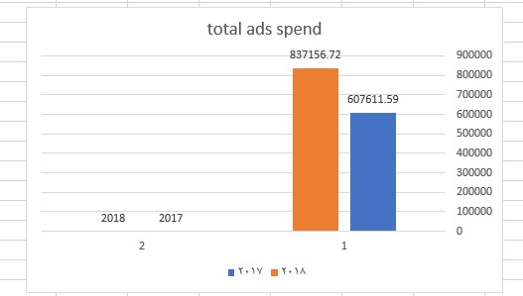

|  |  |
| --- | --- |
| **Decrease** | the total ad spend by 30% from Black Friday 2017 to |
| Black Friday 2018. Ad spend increased 229545.13 in 2018 this means increase 37.7% the objective was not achieved. | |

Evaluate the audience:

1)

•

Which City generated the most sales

2017

?

•

The Houston I s the most

sales 2970

•

Which City generated the least sales

? The

San

Diego

is the

least sales 38

•

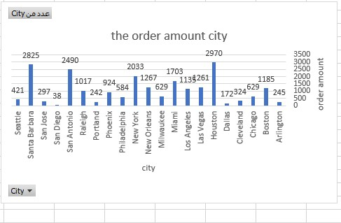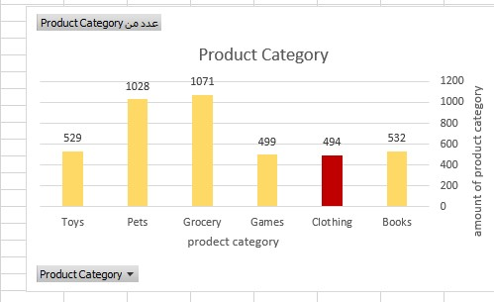

• Which product category was least popular to 18-25 year olds? The figure shows that the clothing category is the least popular among the 18-25 age group and the grocery

category is the most popular among 18-25 age group

•

Who spent more, men or women?

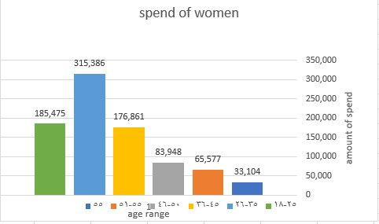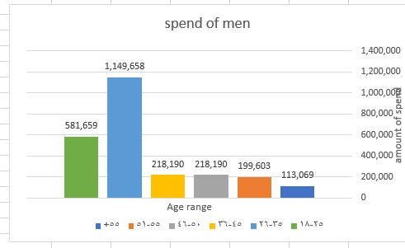

The men spend more than women

Most age in terms of spending 26-35

# Evaluate the marketing

|  |
| --- |
| Required: Was the ROI on our Paid Channel positive or negative? |
| What was it? Which age-range had the best CPA? |

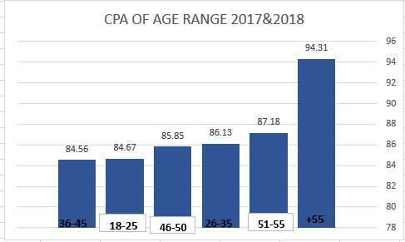

Total sale =1.549.620

Means the ROI=(1,549.620-1,444,765)/1,444,765*100=7.26%

The ROI is positive at about 7.26%

The range 36-45 the best CPA

The high CPA+55 the less CPA 36-45

|  |  |
| --- | --- |
| • | Which channel was the biggest driver in sales for 2017? For 2018? |

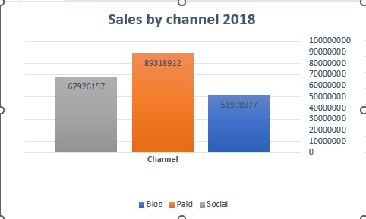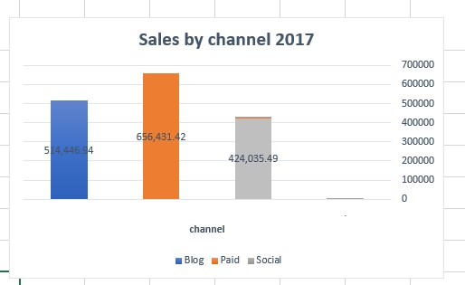

The paid channel achieved the highest sales equal to 89318912 in the 2018 and 65643142 in the 2017

- Evaluate the Sales

How much revenue did we generate in 2017? In 2018?

Revenue in the 2017= 159,4913 and the Revenue in the 2018= 209,2431

The growth increased by the 31 means (sales volume 2018-sales volume 2017)*100



|  |  |
| --- | --- |
| • | What was our average order amount in 2017 vs 2018? |

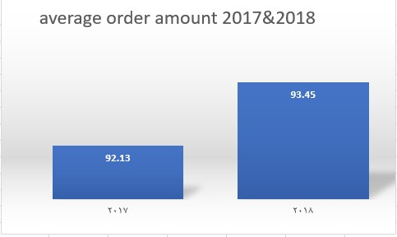

The average order in the 2017 was 92.13 and the average order in the 2018 was 93.45

# - Evaluate the Product Categories

Which product category was most popular in 2017 & 2018?

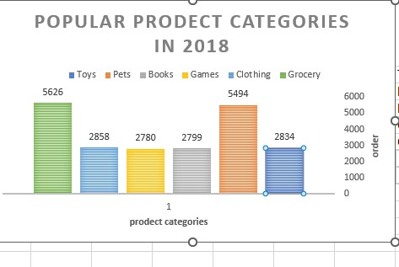

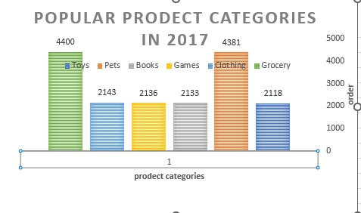

Which product category was most popular in 2017 & 2018?

In 2017 and 2018 the grocery was the most popular.

In 2017 there was( 4400) order and in the 2018 there was (5626) order.

# - Evaluate the Product Categories

|  |  |
| --- | --- |
| • | Demonstrate sales by product category? |

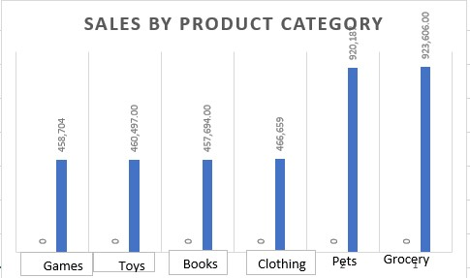

Groceries were the most sold, with an amount equal to 923,60600, while books were the least sold , with an amount of 457,69400