To whom it may concern,

I am writing to highly recommend my friend Charbel Azar for any position that requires hard work, intelligence, and an ability to excel under pressure. I have had the pleasure of working with Charbel for several years now, and I can confidently say that he is one of the most dedicated and competent individuals I have ever met.

Charbel is an amazing person to work with, and he consistently goes above and beyond what is expected of him. His work ethic is unparalleled, and he never procrastinates when it comes to getting things done. Charbel has always been a reliable team member and his ability to consistently meet deadlines and exceed expectations is truly impressive.

Charbel’s skills are diverse and far-reaching. His most notable work has been on the database course project where he helped me build a hospital website from scratch. He also excelled in courses like business data analytics using Tableau and SPSS, which showcased his proficiency in data analysis and problem-solving. His project management skills are also highly impressive, and his innovative ideas in solving consulting cases and coding problems have proven to be invaluable in our collaborative efforts.

Working with Charbel on our startup project of a tutoring app is a positive experience. His contributions to the app's development are integral in making it a success in the future. He consistently displays the same level of dedication and determination that has made him such a valuable asset in every project we have worked on together.

Charbel is not only hardworking, but he is also easy to work with. His communication skills are exceptional, and he always makes himself available to provide assistance and quick solutions to problems. He's able to work with a wide range of individuals, and he's always willing to go above and beyond to ensure that everyone on the team is comfortable and performing at their best.

Overall, I cannot recommend Charbel enough. He is an amazing individual, and I'm confident that his skills and work ethic will make him an asset to any organization. He's a future software developer in the making, and his ability to deliver amazing results is second to none. If you have any further questions, please don't hesitate to reach out to me.

Sincerely,

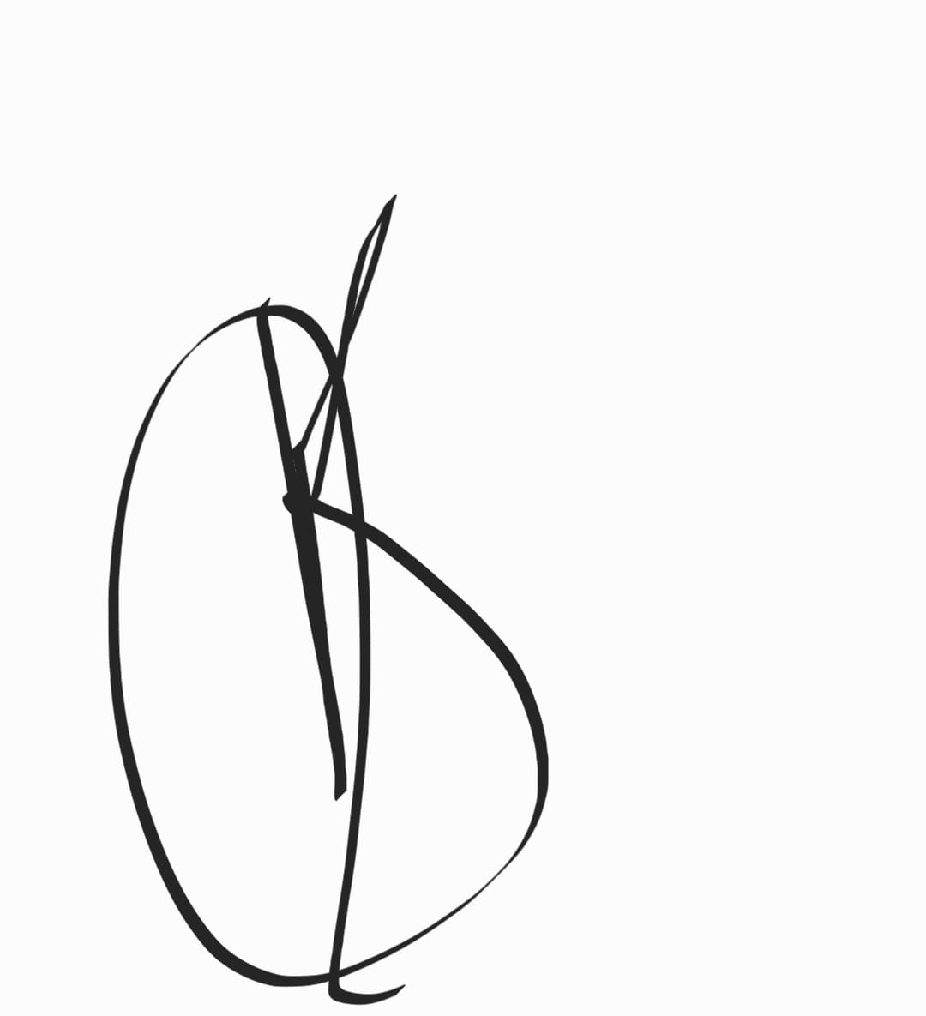Karim Hamawi