MVP

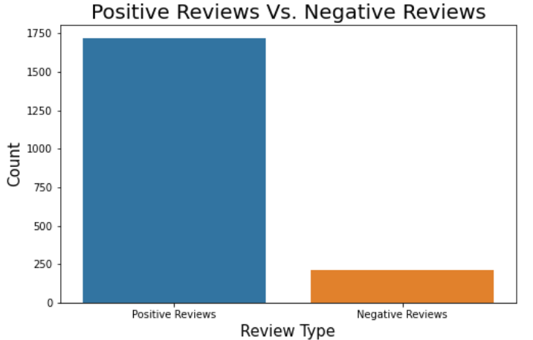

This figure show the Positive Reviews VS Negative Reviews

The Positive Reviews higher than Negative Reviews