 

CAR AGANS

Under Supervision of: Eng. Mohamed Ibrahim.

Chapter 1

* **Abstract**
* This program helps the user in storing the needs of the customer.
* **Implementation of a project that presents the user with all the information about cars of all kinds and helps him to choose a type of car suitable for his desires or needs and also at an appropriate price.**

# **Introduction to AGANS Program**

* Helps customers choose the finest car extraction.

Chapter 2

* **The parts of the project**

* * GUI
* * Home frame
* * Browse frame
* Contact Us frame
* Admin frame to login
* * Search for cars frame that user need it
* * details of cars frame
* * Database
* * connection
* * The mapping
* * The diagram

ERD:

CARS

For sale

Employee

works

Car Agency

*Chapter 3*

*THE GUI:*

**Home:**

**-**When user input type of car he needs the range of money the program looking for the car that he need in our AGANS and choose the car.

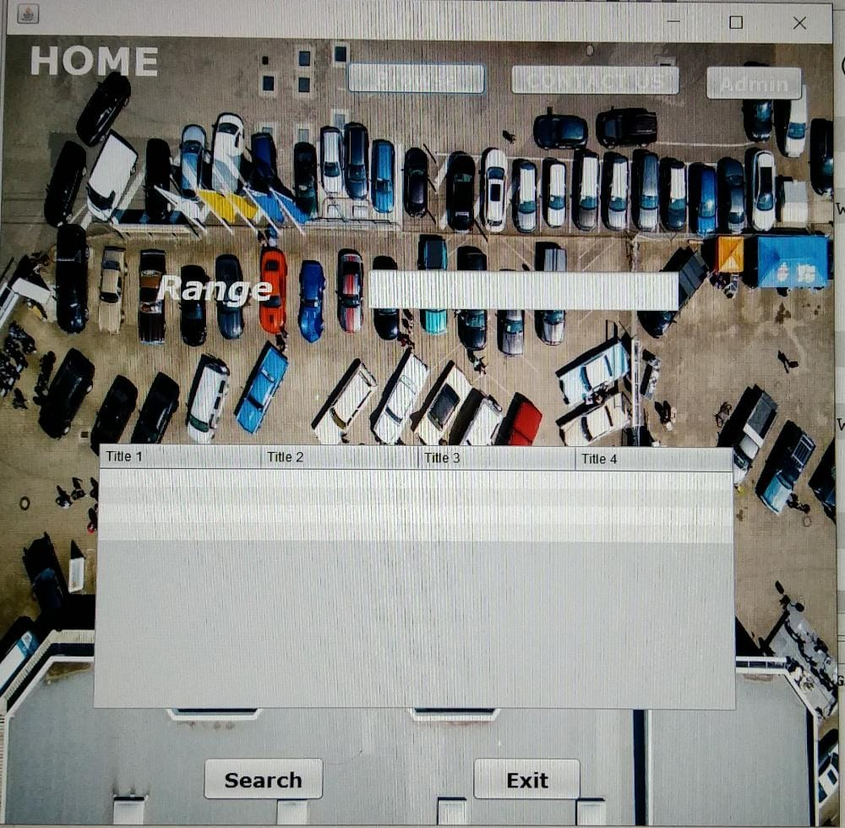

**Browse**

-If customer click on button “Browse” move to the next frame to choose the brand of car he needs.

-The brands of cars is

1. BMW

2. Jeep

3. FIAT

4. KIA

5. GMC

6. Mercedes

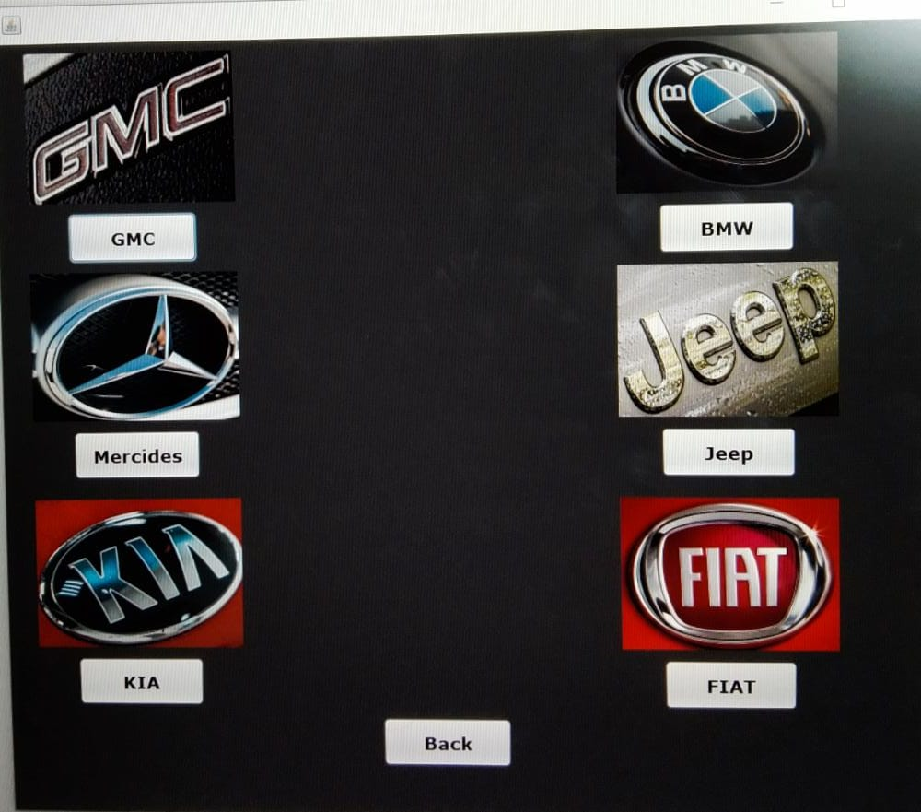

**Contact Us:**

-This page help customer to communicate with us and send his feedback to report any errors

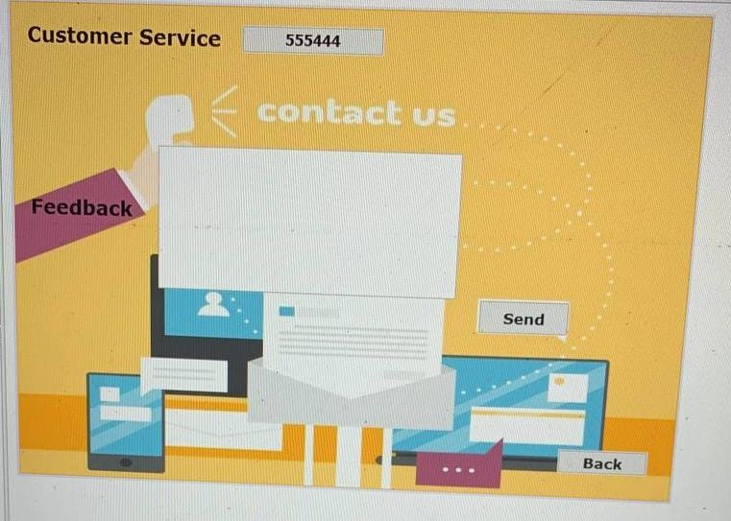

**Admin:**

**-**When user input “username” and “password” and press on Button program check if this user in program database or not if he in it start program if not it show him ‘incorrect user name or password please try again’.

-User can save or remove or update any data.

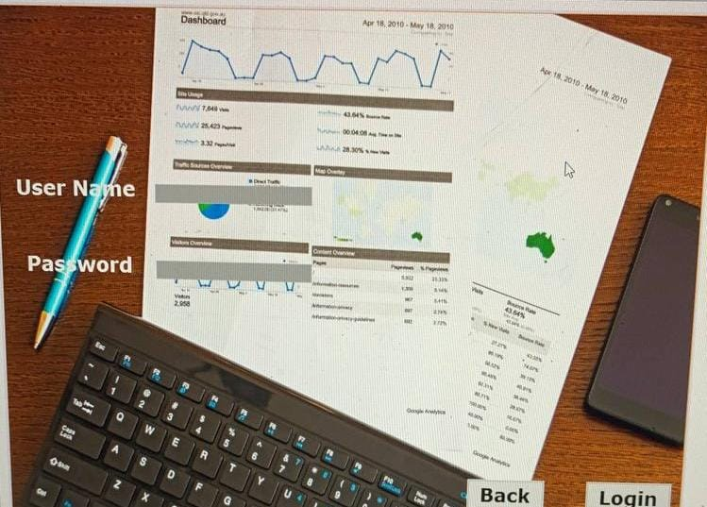

**Search**

-This menu shows data of car that customer wants to search for it and he can find it.

-this page shows table contains data for car and this data connect with database

*Put the cost and the system will show the relational data.

**\*\*Insert:**

* **Program open database and make connection with it**

**After make connection start to make insert in database**

* **This apply this order but don’t get value of this data get data by**

**Pst.setstring(1,textfield.gettext);**

* **After this make excute to finish this order.**

**\*\*update**

* **Program open database and make connection with it**
* **After make connection start to make update to data in database**

**(update tabelname set col1 = ‘”+jtextfield.gettext()+”’ where col2 = ‘”+jtextfield.gettext()+”’**

* **Excute .**
* **(Insert into (coul1, coul2, coul3,..) values (?,?,?,..)**

**\*\*delete:**

* **Program open database and make connection with it**
* **After make connection start to make delete from data in database**

**Delete from tablenam where col1 = ?**

* **Pst.setstring(1,Jtextfield.gettext());**

**OUR DATABASE CODE:**

#create table car (carr_id int primary key auto_increment,price varchar(100),car_id int references cartype(car_id));

# insert into employe (emp_name,salary,age,adresse,phone,position,cartyp) values("Rawan",9000,19,"benha",01020811480,"manager"),("Roaa",5000,19,"cairo","01288633116","vice"),("ahmed",10000,20,"benha",01279827842,"mentor"),

#("Taha",6000,20,"Alex",01061127596,"manager"),("Omar",4000,19,"benha",01152187232,"Marketing"),("Ziad",6000,19,"Benha",01020811480,"HR"),

#("Riham",5000,19,"benha",01020811480,"Media");

#select * from employe;

insert into cartyp (car_name,carcolor,carmodel,carCost) values

("KIA Pride","Gtray","2000",51000),

("KIA Pride","RED","2001",54000),

("KIA Pride","Gray","2002",58000),

("KIA Pecanto","RED","2022",180000),

("KIAPagas","Blue","2022",414900),

("KIA Carens","Wihte",2021,500000),

("KIA Grand Carnaval","Black","2022",300000),

("KIA Cee'd"," white","2022",350000),

("KIA Soul","white","2022",400000),

("KIA Soul","Gray","2022",400000),

("KIA Serato","Blue","2022",299900),

("KIA Serato LX","Black","2021",309900),

("KIA Sportage","RED","2022",529900),

("KIA Sportage","white","2021",500000),

("Jeep Cheroke","White","1999",108000),

("Jeep Cheroke","White","2000",118000),

("Jeep Liperty","White","2002",154000),

("Jeep Liprety","White","2003",150000),

("Jeep Liperty","White","2004",164000),

("Jeep Liperty","White","2005",168000),

("Jeep Liperty","White","2006",174000),

("Jeep Liperty","White","2007",184000),

("Jeep Chiroke","White","2008",241000),

("Jeep Ciroke","White","2009",258000),

("Jeep Cheroke","White","2010",264000),

("Jeep Cheroke","White","2011",291000),

("Jeep Cheroke","White","2012",309000),

("Jeep Cheroke","White","2013",351000),

("Jeep Wrangler","White","2014",416000),

("Jeep Wrangler","White","2015",477000),

("Jeep Wrangler","White","2016",522000),

("Jeep Cheroke","White","2017",737000),

("Jeep Cheroke","White","2018",847000),

("Jeep Cheroke","White","2019",995000),

("Jeep Cheroke","White","2020",1135000),

("Jeep Cheroke","White","2021",1150000),

("Mercedes C180","Selver","1999",155000),

("Mercedes C180","Gold","1999",155000),

("Mercedes C180","Black","1999",155000),

("Mercedes C180","Selver","2000",173000),

("Mercedes C180","Gold","2000",173000),

("Mercedes C180","Black","2000",173000),

("Mercedes C180","Selver","2001",190000),

("Mercedes C180","Gold","2001",190000),

("Mercedes C180","Black","2001",190000),

("Mercedes C180","Selver","2002",193000),

("Mercedes C180","Gold","2003",205000),

("Mercedes C180","Black","2003",205000),

("Mercedes C180","Selver","2003",205000),

("Mercedes C180","Gold","2004",210000),

("Mercedes C180","Black","2004",210000),

("Mercedes C180","Selver","2004",210000),

("Mercedes C180","Gold","2005",215000),

("Mercedes C180","Black","2005",215000),

("Mercedes C180","Selver","2005",215000),

("Mercedes C180","Gold","2006",238000),

("Mercedes C180","Black","2007",238000),

("Mercedes C280","Selver","2008",307000),

("Mercedes C280","Gold","2008",307000),

("Mercedes C280","Black","2009",322000),

("Mercedes C250","Selver","2010",397000),

("Mercedes C180","Gold","2011",343000),

("Mercedes C180","Black","2012",397000),

("Mercedes C180","Selver","2013",429000),

("Mercedes C180","Gold","2014",422000),

("Mercedes C180","Black","2014",422000),

("Mercedes C180","Selver","2015",607000),

("Mercedes C180","Gold","2016",661000),

("Mercedes C180","Black","2017",735000),

("Mercedes C180","Selver","2018",773000),

("Mercedes C180","Gold","2019",881000),

("Mercedes C180","Black","2020",881000),

("Mercedes E200","Selver","2021",1360000),

("Mercedes E200","Gold","2021",1360000),

("Mercedes E200","Black","2021",1360000),

("GMC Manual ","Selver","2020",197000),

("GMC Manual","White","2020",197000),

("GMC Manual","Black","2020",197000),

("GMC Manual ","Selver","2021",215000),

("GMC Manual ","White","2021",215000),

("GMC Manual","Black","2021",215000),

("GMC Manual Baseline ","Selver","2022",220000),

("GMC Manual Baseline ","White","2022",220000),

("GMC Manual Baseline ","Black","2022",220000),

("GMC Manual Highline ","White","2020",230000),

("GMC Manual Highline ","Dark Blue","2020",230000),

("GMC Manual Highline ","Selver","2020",230000),

("GMC Manual Highline ","Black","2020",230000),

("FIAT 128","light Green","1999",26000),

("FIAT 128","white","2000",35000),

("FIAT Shahin","Black","2002",45000),

("FIAT Shahin","light Green","2003",50000),

("FIAT Shahin","White","2004",51000),

("FIAT Shahin","Gray","2005",56000),

("FIAT Shahin","Red","2005",56000),

(" FIAT Shahin","White","2005",53000 ),

("FIAT Shahin","light Blue","2006",57000),

("FIAT Shahin","Black","2007",47000),

("FIAT Sina","Black","2008",58000),

("FIAT Sina","White","2008",58000),

("FIAT Punto","White","2009",80000),

(" FIAT Punto","Red","2009",80000),

("FIAT Punto","Black","2010",109000 ),

("FIAT Punto","White","2010",109000),

("FIAT Punto","White","2011",80000),

("FIAT Punto","White","2012",91000),

("FIAT Punto","Red","2010",91000),

("FIAT Punto","White","2015",144000),

("FIAT Punto","Black","2015",144000),

("FIAT Punto","White","2016",143000),

("FIAT Tipo","White","2017",227000),

("FIAT Tipo","White","2018",229000),

("FIAT Tipo","White","2019",243000),

("FIAT Tipo","White","2020",250000),

("FIAT Tipo","black","2020",250000),

("FIAT Tipo","Blue","2020",250000),

("FIAT Tipo","Red","2020",250000),

("FIAT Tipo","Gray","2020",250000),

("FIAT Tipo","White","2021",266000),

("FIAT Tipo","White","2022",280000),

(" BMW 318","Selver","1999",139000),

("BMW 318","White","2000",139000),

("BMW 318","Black","2001",146000),

("BMW 318","Selver","2002",157000),

("BMW 318","White","2005",174000),

("BMW 320","Black","2006",186000),

(" BMW 320 ","Selver","2007",202000),

("BMW 320","White","2008",224000),

("BMW 320","Black","2009",248000),

("BMW X3","Selver","2010",266000),

("BMW 320 ","White","2011",269000),

("BMW X3","Black","2012",383000),

(" BMW 320","Selver","2013",362000),

("BMW X3","White","2014",490000),

("BMW X3","Black","2015",506000),

("BMW 320","Selver","2016",497000),

("BMW 320","White","2017",536000),

("BMW 320","Black","2018",601000),

(" BMW 320 ","Selver","2019",692000),

("BMW 320 ","White","2019",692000),

("BMW 320","Black","2020",796000),

("BMW 320","Selver","2020",796000),

("BMW 320 ","White","2020",796000),

("BMW Z4","White","2021",1095000),

("BMW Z4","Black","2021",1095000),

("BMW Z4","Red","2021",1095000);

#select * from cartyp;

**THANKS**