Overview:
API is build to predict price of a commodity after 10 seconds. When url containing timestamp is requested, current time is used as a filter to get last 100 records from database. Further these records are preprocessed and only last 5 records are used for prediction. These 5 records are fed into model to get the predicted price and result shown in the API.

Input :
model_name:str (currently not using for prediction)
datetime : str

Output:
dictionary containing
current_date: time at which the url was hit
model: model_name
prediction: predicted price value after 10 second

Working of API:

A. preprocessing of data
- Using the date and time , last 100 records from that time is fetched from database.
- Converted into pandas dataframe
- resample data for 10 seconds
- missing values were filled using ffill().bfill()
- taken last 5 records since we have kept windows_size=5
- selected price and bid columns
- scaled using scalar objects from price_forecasting_bid

B. Prediction
- given these 5 values as a input to model for prediction
- inverse scale to get denormalised values of predicted value

API endpoint:
http://196.10.215.53:8000/url/?model_name=model&datetime=2022-02-08 18:46:15

Input example :
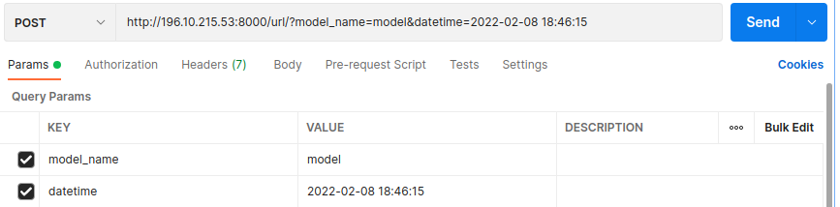

Output example :
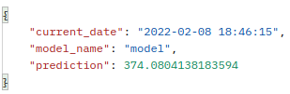

Exception case: when last 5 records contains nan value we will get Internal server error

