MARITIME SENTINEL
AI Maritime Early-Warning Platform

Technical Report
Hackathon 2026 | Working Prototype (Proof of Concept)
November 2026
AI detects, the human decides.

Contents
Abstract
1. Introduction
2. Proposed Solution
3. Target Users
4. System Architecture
5. Data: Real and Simulated
6. Radar and AIS Fusion
7. Risk Assessment Engine
8. Computer Vision (Drone Verification)
9. Dashboard
10. Demonstration Workflow
11. Limitations
12. Future Work
13. Conclusion
Appendix A: Project Files
Appendix B: Technologies
References

Abstract
Maritime Sentinel is an AI early-warning platform that protects ships from threats at sea. It fuses radar data with the Automatic Identification System (AIS) to detect "dark" boats that do not broadcast their identity, then assesses the risk of each target with a score from 0 to 100, a level (LOW, MEDIUM, HIGH) and reasons written in Arabic, by combining maritime rules with a machine learning model (Isolation Forest) trained on real ship traffic. When a threat appears, the operator can launch a drone for visual verification using a deep learning model (YOLOv8), and all outputs are shown on a dashboard with a 3D map.
The system is a working prototype across all of its stages. In evaluation, the risk engine detected 100% of threats in 160 simulated scenarios 5 to 7 minutes before they arrived, with 97.6% precision and a 3.3% false alarm rate, and raised no alert on 35 real ships. Radar and AIS fusion identified 100% of real ships with no ship wrongly classified as a dark target.
The interactive demo is available online at: https://rawanwattpada-debug.github.io/maritime-sentinel/
Methodological note: the recorded ships are real data, while the radar and the attack targets are simulated because real attack data is not available. Each result states whether it was measured on real or simulated data.

1. Introduction

1.1 Problem
Around 80% of the volume of international trade in goods is carried by sea [1], and disruptions to maritime security can delay shipments and raise transport costs. Reports show rising threats:
- 137 incidents of piracy and armed robbery against ships were recorded worldwide in 2025, the highest annual figure since 2020 [2].
- Firearms were used in 42 incidents in 2025, compared with 26 incidents in 2024 [2].
- More than 100 attacks have targeted merchant ships in the Red Sea since November 2023, and 4 ships were sunk by July 2025 [3].
- By early May 2025, the tonnage of ships transiting the Suez Canal remained about 70% below the 2023 average [4].
Current tracking systems provide ship positions, but small boats often do not use AIS, a course deviation alone is not enough to determine intent, and continuous human monitoring exhausts operators. A system is needed that interprets target behavior and warns early with clear reasons.

1.2 Objectives
- Detect targets that do not broadcast their identity (dark targets) by fusing radar with AIS.
- Assess the risk of each target with a score, a level and reasons the operator can understand.
- Warn early enough to respond, with as few false alarms as possible.
- Verify the target visually with a drone, by human decision.
- Measure the performance of each part with reproducible evaluations on real and simulated data.

2. Proposed Solution
An integrated intelligent system with three capabilities:
Capability | What it does | Technology
Multi-source maritime perception | Fuses radar and AIS data into a unified maritime picture and detects dark targets | Matching algorithm (Hungarian) with distance, speed and course gates
Machine learning and behavioral recognition | Detects unusual patterns and explains the reason for every alert | Isolation Forest + maritime rules
Smart prediction and decision support | Anticipates the point and time of approach, and verifies visually with a drone | CPA/TCPA + YOLOv8 deep learning model

3. Target Users
The platform is designed for the region (the Red Sea and its approaches) and serves two groups:
Group | Users | How they benefit
Businesses and organizations | Shipping companies, ship operators and bridge crews, ports, marine insurers | Early warning on board, fewer false alarms for the watch officer, and a record of every alert and decision
Government entities | Coast guards, border guards, navies, maritime transport authorities | A unified picture of registered and dark targets in their waters, and explained alerts that support a fast response

4. System Architecture
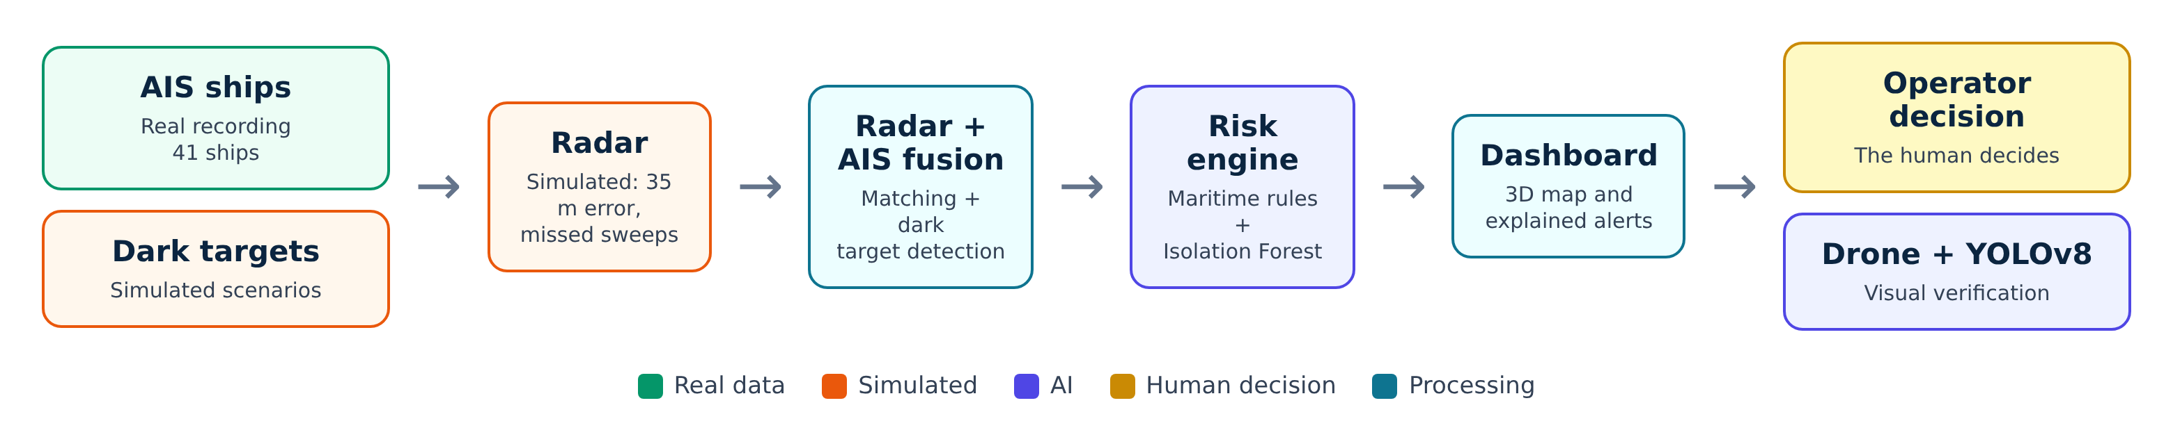
Figure 1: Data flow through the system
Stage | Input | Output | File
Data | Real AIS recording + simulated scenarios | Ship and target tracks | record_ais.py, convert_ais.py, simulator.py
Radar (simulated) | Positions of all targets | Anonymous radar plots with measurement error | fusion.py (RadarSim)
Fusion | Radar plots + AIS messages | Matched to a ship / dark / being identified | fusion.py (Fuser)
Risk engine | Fused targets | Score + level + reasons in Arabic | risk_engine.py
Dashboard | Outputs of the previous stages | 3D map and alerts | site/
Visual verification | Drone video | Detected and tracked boats | YOLOv8 (Ultralytics)

5. Data: Real and Simulated
Data | Type | Details
Recorded ships (AIS) | Real | 41 ships and 729 points over 5 hours, recorded from aisstream.io on 8 November 2026
Anomaly model training data | Real | NOAA AIS 2024 (Los Angeles coast): 463 ships and 177,214 points [5]
Dark targets | Simulated | 5 scenarios for the demo + 280 random scenarios for evaluation
Radar | Simulated | Position error of about 35 m, detection probability 92% for ships and 80% for small boats, 12 nautical mile range
Weather in the interface | Real | Open-Meteo at the ship's position (weather type, day/night, wave height)
Drone video | Real | Real aerial footage of a boat, processed with YOLOv8

5.1 Relocating the shipping lane
aisstream.io does not cover the Red Sea because it has no ground receiving stations there (the area was tested for 3 hours with no ships), so real traffic was recorded in the Dover Strait and the lane was then relocated to Bab el-Mandeb (convert_ais.py):
- The lane was rotated to match the direction of the Bab el-Mandeb lane (146°).
- Speeds, along-lane distances and times were kept unchanged; the sideways distance between lanes was compressed (×0.45) because the strait is narrower, and speed and course were transformed with the same rule.
- Ferries crossing the lane sideways were removed because they would have ended up on land.
NOAA data was not relocated, because the anomaly model learns movement patterns (speed and turning) that do not depend on location.

6. Radar and AIS Fusion
The simulated radar gives anonymous plots and estimates each target's speed and course from its plots over about a minute, as ARPA systems do. Fusion then matches each radar target to at most one AIS ship:
- Matching gate: distance ≤ 300 m, speed difference ≤ 6 knots, and course difference ≤ 35° for moving targets.
- Optimal assignment: the Hungarian algorithm chooses the best overall matching so that no ship is matched to two targets.
- Confirmation: a target is confirmed as a registered ship after 3 matches in the last 5 sweeps, and classified as dark if it matches no ship for 3 consecutive sweeps.
- Dark target persistence: after staying dark for 6 sweeps (about one minute) the target is locked as dark and no longer takes part in matching, so it cannot take the identity of a ship it approaches; an alert is raised if it comes within 300 m of a registered ship.

6.1 Results
Test | Data | Result
Identifying registered ships | 19 real ships, 3,737 decisions (simulated radar) | 100% correct, 0% wrongly classified as dark, 0% matched to the wrong ship
Detecting dark targets | 11 simulated targets × 20 runs | 100% detected, median 21.5 seconds
Boat hiding next to a ship | 25 runs: closes from 3 km to 120 m and follows a real ship | 100% stayed dark, 100% alerted, and the real ship stayed identified 100% (before the improvement: hidden as a ship 19% of the time)
Worse radar (120 m error) | The same real ships | 99.8% correctly identified

7. Risk Assessment Engine
The engine assesses each target at every new reading, adding points from maritime rules and a machine learning model:
Factor | Points | Condition
No AIS | 15 | The target does not broadcast its identity
Heading toward the ship | 25 | Closing, heading within 30° of the bearing to the ship, speed ≥ 6 knots, and predicted closest approach ≤ 1 nautical mile
High speed | up to 15 | While approaching: > 20 knots (full) or > 15 knots (half)
Closest point of approach (CPA/TCPA) | up to 20 | < 0.5 nm within 10 minutes (full) or < 1 nm within 20 minutes (half)
Turn toward the ship | 15 | A turn of ≥ 30° within two minutes toward the ship
Coordination between targets | 15 | At least one other dark target approaching from a different direction (≥ 45°)
Unusual movement (Isolation Forest) | up to 15 | Anomaly score of the movement compared with normal traffic

Levels: LOW below 40, MEDIUM from 40, HIGH from 70. Rule points are halved for ships that broadcast AIS.

7.1 Machine learning model
An Isolation Forest model from scikit-learn with 200 trees, trained without supervision on 177,214 real NOAA points, on three features: speed, rate of speed change, and rate of course change per minute. It learns what normal movement looks like and gives every movement an anomaly score from 0 to 1.

7.2 False alarm reduction
- Persistence: a target only reaches HIGH after 60 seconds of continuous approach.
- Averaged motion: speed and course come from the average of the last 30 seconds instead of a single reading, because an error of a few degrees in one radar reading shifts the predicted approach point by hundreds of meters.
- Measurement tolerance: position jitter of up to 90 m does not break a "continuous approach".
- Ignoring drift: a course change of a near-stationary boat is not counted as a turn.
- Alert stability: the level rises immediately and only falls after staying lower for 30 seconds.

7.3 Evaluation method
The original evaluation file was not usable because its attack boats moved in random directions, so a new evaluation was built (evaluate_risk.py) with random scenarios in which the label matches the actual movement, seen with realistic radar error (35 m position, 8% missed readings, speed error 1.2 knots and course error 6°), with our ship sailing at 10 knots. 40 runs were made for each type, then the engine was run on all real ships in the recording.

7.4 Results
Scenario (threat) | Boats | Reached HIGH | Before 1 km | First HIGH at | Warning time
Single boat chasing the ship | 40 | 100% | 100% | 4.7 km | 6 min 5 s
Coordinated attack (2-4 boats) | 123 | 100% | 100% | 4.6 km | 5 min 25 s
Skiff launched from a mother ship | 40 | 100% | 100% | 5.1 km | 6 min 40 s
Passes by, then turns suddenly | 40 | 100% | 100% | 4.3 km | 5 min 5 s

Scenario (normal) | Boats | False HIGH | MEDIUM | LOW
Drifting fishing cluster | 188 | 0% | 1.1% | 98.9%
Slow boat without AIS on its way | 40 | 0% | 0% | 100%
Fast boat crossing 2-4 km away | 40 | 10% | 10% | 80%

Metric | Before improvement | After improvement
Threat detection (Recall) | 100% | 100%
Precision | 86.0% | 97.6%
False alarms in normal scenarios | 21.7% | 3.3%
Real ships (35 ships, 9,230 readings) | No alert | No alert

The "improvement" is computing motion from a 30-second average and narrowing the "heading toward the ship" condition from 2 to 1 nautical mile. Its only cost was a later first alert, from about 5.1 km to 4.7 km, with the warning time staying at 5 minutes or more.

8. Computer Vision (Drone Verification)
The YOLOv8n model (Ultralytics) is used with ready-made weights pre-trained on the COCO dataset, filtered to the "boat" class, with tracking of targets across frames. Real aerial footage was processed frame by frame, and the annotated frames were written to an output video converted to H.264 to play in the browser.
Metric | Result
Model | YOLOv8n (pre-trained COCO weights)
Frames processed | 1,453
Boat detections across frames | 1,322
Frames with a boat | 1,266
Unique tracked boats | 3
Average confidence | 78.1%

Interpreting the numbers: 1,322 is the total number of detections across frames, not the number of boats. Confidence is not a real-world accuracy measure, and the model was not trained specifically on maritime imagery.

9. Dashboard
A web application (React) presents the system in two main parts:
- Interactive introduction: a 3D ocean (Three.js) that changes with the real weather at the ship's position, a globe with shipping lanes, then a descent to the strait.
- Operations room: an overview with indicators and alerts, 3D monitoring (MapLibre and deck.gl), alert investigation with reasons and timeline, drone verification after operator approval, and a vessel profile.

9.1 Syncing with real weather
When the page opens, the interface reads the current weather at the ship's position from Open-Meteo and shows it in the 3D scene:
- Day: clear with visible sunlight, cloudy, or fog.
- Night: a sky full of stars, or cloudy, rain, or fog.
- Wave size follows the real wave height in the area.
- The current weather is shown as text: temperature, day or night, and wave height.
- The presenter can change the weather manually during the demo.
- Without an internet connection, the scene shows a clear day.
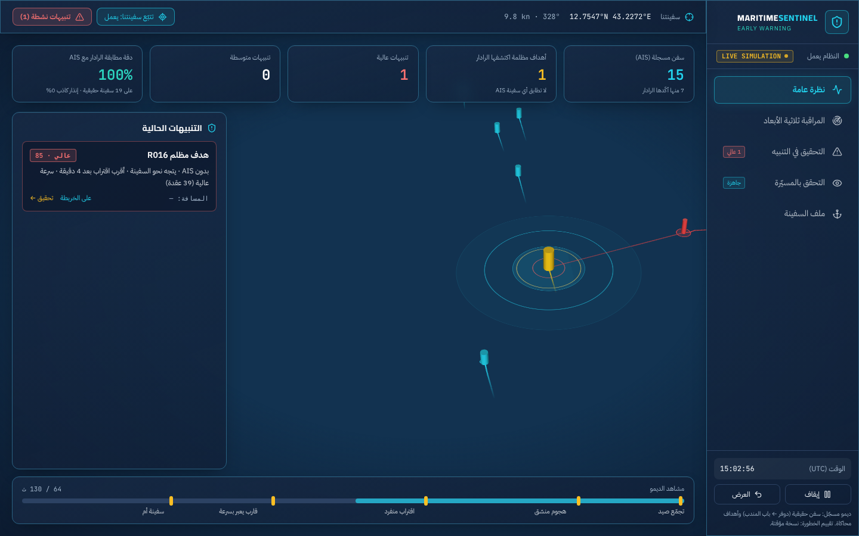
Figure 2: Operations room during an attack: a dark target with a HIGH alert
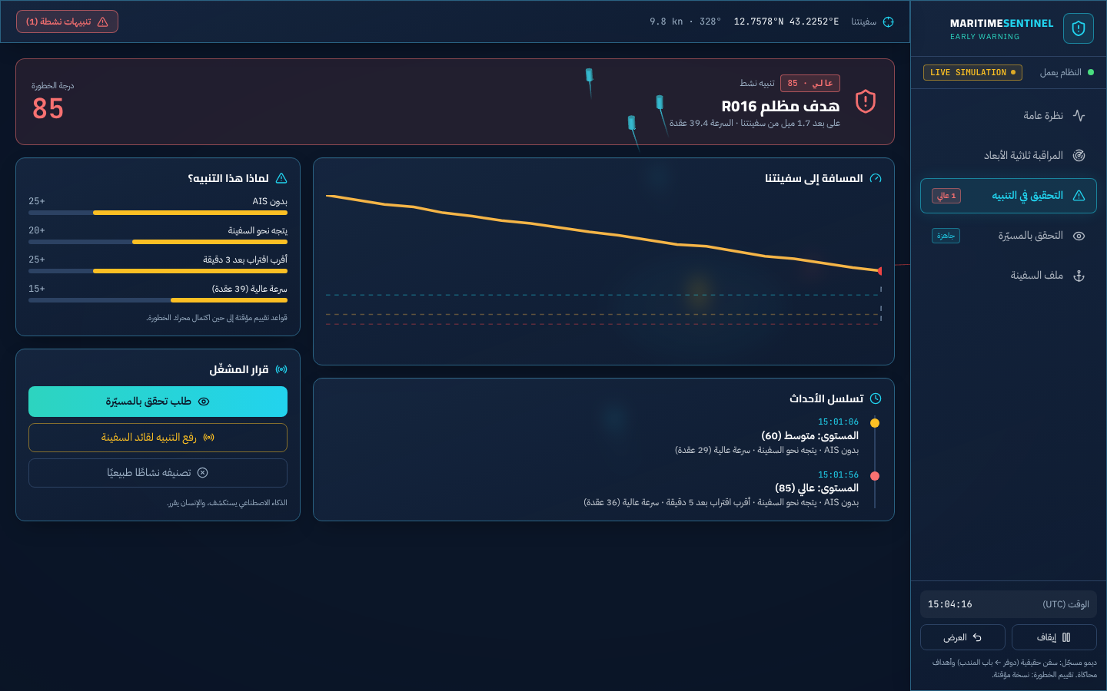
Figure 3: Alert investigation: score reasons, event timeline and operator decision
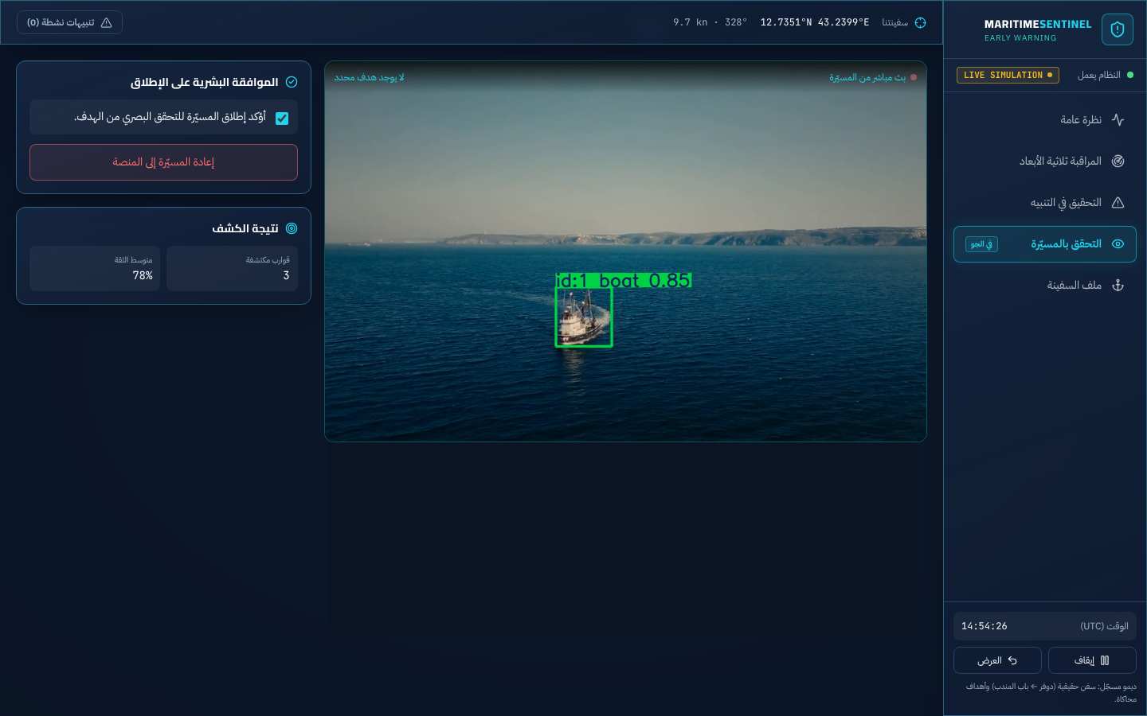
Figure 4: Drone verification after operator approval, with YOLO results

10. Demonstration Workflow
- Introduction: the 3D ocean with real weather, then the problem figures, then the globe and the descent to the strait.
- Operations room: real ships on the lane, and fishing boats that stay at low risk.
- Coordinated attack: the radar reveals dark targets, rising from MEDIUM to HIGH with their reasons.
- Alert investigation, then the operator decides to launch the drone, and the video shows the YOLO detection.
- Presentation of the evaluation results.
The demo replays results computed by the full system (export_demo.py), which is why the dashboard carries a "LIVE SIMULATION" badge.

10.1 How to open the demo
- Website: https://rawanwattpada-debug.github.io/maritime-sentinel/ (Chrome on a desktop computer is recommended).
- Scroll down through the introduction, then click "غرفة العمليات" (Operations Room) to enter the dashboard.
- In the introduction: the sound and weather buttons are at the bottom left; keys W and N change the weather and switch between day and night.
- Source code: https://github.com/rawanwattpada-debug/maritime-sentinel

11. Limitations
- The radar and attack targets are simulated, so the threat detection figures are measured on simulated scenarios, not real attacks.
- The real ships are relocated from the Dover Strait: their movement is real and their location is relocated.
- Rule weights and thresholds are based on expertise, not learned from attack data.
- The YOLO model uses general weights not trained on maritime imagery, and the video is recorded rather than a live drone feed.
- The system is a prototype for demonstration and research and has not been tested for operational security decisions.

12. Future Work
Where possible, and as suitable data becomes available, the next steps are:
- Connecting to a real radar (ARPA/NMEA protocols) and to AIS sources that cover the Red Sea, if access to them becomes available.
- Training the vision model on maritime data (such as SeaDronesSee) and evaluating it with accuracy metrics, when suitable data is available.
- Learning rule weights from documented incident data if such data becomes available, and field evaluation with operators where possible.
- Live drone streaming, edge deployment on board the ship, and data protection, where feasible.

13. Conclusion
Maritime Sentinel presents a prototype that works across all of its stages: from real AIS data and a simulated radar, to fusion that reveals dark targets, a risk engine that combines maritime rules with machine learning and explains every alert, through to deep learning visual verification and a dashboard that leaves the decision to the human. The evaluation showed all simulated threats detected at least five minutes before arrival with 97.6% precision, with no alert on real ships.

Appendix A: Project Files
File | Purpose | Output
record_ais.py, clean_noaa.py, convert_ais.py | AIS recording, NOAA cleaning, lane relocation | data/ais_live.parquet, data/ais_noaa_clean.parquet
simulator.py | Dark target scenarios | data/sim/
fusion.py, fusion_config.json | Radar simulation and fusion | -
risk_engine.py, train_iforest.py | Risk engine and anomaly model | models/iforest.joblib
evaluate_fusion.py, shadow_test.py | Fusion evaluation | fusion_eval.json, shadow_eval.json
evaluate_risk.py, test_risk_engine.py | Risk engine evaluation and tests | risk_eval.json
export_demo.py | Demo preparation | site/public/data/demo.json
site/ | Website and dashboard | -

Appendix B: Technologies
Area | Technologies
Language and data | Python, pandas, NumPy, PyArrow
Machine learning | scikit-learn (Isolation Forest), SciPy (Hungarian assignment)
Deep learning | Ultralytics YOLOv8, OpenCV
Streaming and server | FastAPI, WebSockets
Interface | React, Vite, Tailwind CSS, Three.js, MapLibre GL, deck.gl, GSAP
Data sources | aisstream.io, NOAA AIS 2024, Open-Meteo, Esri World Imagery

References
[1] UNCTAD, Review of Maritime Transport 2023. Geneva, Switzerland: United Nations, 2023, doi: 10.18356/9789213584569.
[2] ICC International Maritime Bureau, "Global maritime piracy and armed robbery increased in 2025," ICC, Jan. 15, 2026. [Online]. Available: https://iccwbo.org/news-publications/report/global-maritime-piracy-and-armed-robbery-increased-in-2025/
[3] "Maritime industry condemns deadly Red Sea attacks," gCaptain, Jul. 2025. [Online]. Available: https://gcaptain.com/maritime-industry-condemns-deadly-red-sea-attacks/
[4] UNCTAD, Review of Maritime Transport 2025. Geneva, Switzerland: United Nations, 2025. [Online]. Available: https://unctad.org/system/files/official-document/rmt2025ch2_en.pdf
[5] NOAA Office for Coastal Management, "AIS vessel traffic data 2024," Marine Cadastre. [Online]. Available: https://noaaocm.blob.core.windows.net/ais/csv2/csv2024/index.html

