At first time (almost default options), Cassandra flush 64MB SSTable

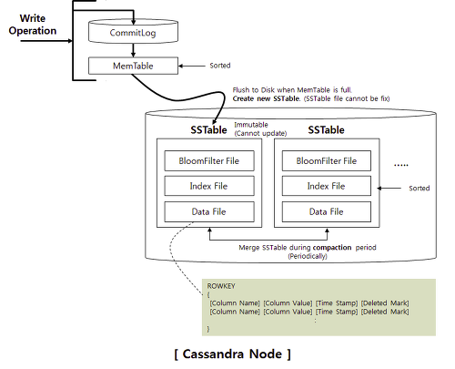

An overview of Cassandra's structure.
Cassandra is designed to handle big data workloads across multiple nodes with no single point of failure. Its architecture is based on the understanding that system and hardware failures can and do occur. Cassandra addresses the problem of failures by employing a peer-to-peer distributed system where all nodes are the same and data is distributed among all nodes in the cluster. Each node exchanges information across the cluster every second. A commit log on each node captures write activity to ensure data durability. Data is also written to an in-memory structure, called a memtable, and then written to a data file called an SSTable on disk once the memory structure is full. All writes are automatically partitioned and replicated throughout the cluster. Using a process called compaction Cassandra periodically consolidates SSTables, discards tombstones (an indicator that a column was deleted), and regenerates the index in the SSTable.
Cassandra is a row-oriented database. Cassandra's architecture allows any authorized user to connect to any node in any data center and access data using the CQL language. For ease of use, CQL uses a similar syntax to SQL. From the CQL perspective the database consists of tables. Typically, a cluster has one keyspace per application. Developers can access CQL through cqlsh as well as via drivers for application languages.

Client read or write requests can go to any node in the cluster. When a client connects to a node with a request, that node serves as the coordinator for that particular client operation. The coordinator acts as a proxy between the client application and the nodes that own the data being requested. The coordinator determines which nodes in the ring should get the request based on how the cluster is configured.

Key components for configuring Cassandra¶
- Gossip: A peer-to-peer communication protocol to discover and share location and state information about the other nodes in a Cassandra cluster.
Gossip information is also persisted locally by each node to use immediately when a node restarts. You may want to purge gossip history on node restart for various reasons, such as when the node's IP addresses has changed.
- Partitioner: A partitioner determines how to distribute the data across the nodes in the cluster. Choosing a partitioner determines which node to place the first copy of data on.
You must set the partitioner type and assign the node a num_tokens value for each node. If not using virtual nodes (vnodes), use the initial_token setting instead.
- Replica placement strategy: Cassandra stores copies (replicas) of data on multiple nodes to ensure reliability and fault tolerance. A replication strategy determines which nodes to place replicas on. The first replica of data is simply the first copy; it is not unique in any sense.
When you create a keyspace, you must define the replica placement strategy and the number of replicas you want.
- Snitch: A snitch defines the topology information that the replication strategy uses to place replicas and route requests efficiently.
You need to configure a snitch when you create a cluster. The snitch is responsible for knowing the location of nodes within your network topology and distributing replicas by grouping machines into data centers and racks.
- The cassandra.yaml file is the main configuration file for Cassandra. In this file, you set the initialization properties for a cluster, caching parameters for tables, properties for tuning and resource utilization, timeout settings, client connections, backups, and security.
- Cassandra stores table properties in the system keyspace. You set storage configuration attributes on a per-keyspace or per-table basis programmatically or using a client application, such as CQL.
By default, a node is configured to store the data it manages in the /var/lib/cassandra directory. In a production cluster deployment, you change the commitlog-directory to a different disk drive from the data_file_directories.

Client requests
Client read or write requests can go to any node in the cluster because all nodes in Cassandra are peers.
When a client connects to a node and issues a read or write request, that node serves as the coordinator for that particular client operation.
The job of the coordinator is to act as a proxy between the client application and the nodes (or replicas) that own the data being requested. The coordinator determines which nodes in the ring should get the request based on the cluster configured partitioner and replica placement strategy.

Backing up and restoring data
Cassandra backs up data by taking a snapshot of all on-disk data files (SSTable files) stored in the data directory.
You can take a snapshot of all keyspaces, a single keyspace, or a single table while the system is online.
Using a parallel ssh tool (such as pssh), you can snapshot an entire cluster.

Taking a snapshot
Snapshots are taken per node using the nodetool snapshot command. To take a global snapshot, run the nodetool snapshot command using a parallel ssh utility, such as pssh.
A snapshot first flushes all in-memory writes to disk, then makes a hard link of the SSTable files for each keyspace. By default the snapshot files are stored in the /var/lib/cassandra/data/keyspace_name/table_name/snapshots directory.
You must have enough free disk space on the node to accommodate making snapshots of your data files. A single snapshot requires little disk space. However, snapshots can cause your disk usage to grow more quickly over time because a snapshot prevents old obsolete data files from being deleted. After the snapshot is complete, you can move the backup files to another location if needed, or you can leave them in place.
Note: Cassandra can only restore data from a snapshot when the table schema exists. It is recommended that you also backup the schema.

Procedure
Run the nodetool snapshot command, specifying the hostname, JMX port, and keyspace. For example:
$ nodetool -h localhost -p 7199 snapshot demdb

Deleting snapshot files
When taking a snapshot, previous snapshot files are not automatically deleted. You should remove old snapshots that are no longer needed.
The nodetool clearsnapshot command removes all existing snapshot files from the snapshot directory of each keyspace. You should make it part of your back-up process to clear old snapshots before taking a new one.

Procedure
To delete all snapshots for a node, run the nodetool clearsnapshot command. For example:
$ nodetool -h localhost -p 7199 clearsnapshot

