# **Icinga To Monitor Your Servers and Services**

**Run following command to install Icinga PPA.**

root@2dafe8e6402d:~# **add-apt-repository ppa:formorer/icinga**

root@2dafe8e6402d:~# **apt update**

Now install Icinga and MySQL with apt:

root@2dafe8e6402d:~# **apt install icinga icinga-doc icinga-idoutils mysql-server libdbd-mysql mysql-client**

**Please Fill all required detail below**

* MySQL Configuration: Enter a new MySQL root user password
* PostFix Configuration: Select "Internet Site"
* PostFix Configuration: Enter your Fully Qualified Domain Name (example.com, for example)
* Configuring icinga-cgi: Enter "icingaadmin" user's password (login to access Icinga).
* Configuring icinga-common: Enter "No" to enabling external commands
* Configuring icinga-idoutils: Enter "Yes" to configuring database for icinga-idoutils with dbconfig-common
* Configuring icinga-idoutils: Select "mysql" as the database type
* Configuring icinga-idoutils: Enter MySQL root password (that you just assigned above)
* Configuring icinga-idoutils: Enter a new icinga-idoutils database user password

Add Apache user (www-data) to nagios group:

root@2dafe8e6402d:~# **sudo usermod -a -G nagios www-data**

Enable the ido2db daemon to start on boot up, which stores Icinga events and configurations in the database. Edit Icinga default configuration:

root@2dafe8e6402d:~# **sudo vi /etc/default/icinga**

Change the value of IDO2DB to *yes*, so it looks like the following:

I**DO2DB=yes**

root@2dafe8e6402d:~# **service ido2db start**

root@2dafe8e6402d:~# **cp /usr/share/doc/icinga-idoutils/examples/idoutils.cfg-sample /etc/icinga/modules/idoutils.cfg**

root@2dafe8e6402d:~# **service icinga restart**

## **Accessing the Icinga User Interface**

<http://13.59.96.117/icinga/>

## **Ways To Monitor apache2 With Icinga**

root@2dafe8e6402d:~# **vi /etc/icinga/objects/myhost.cfg**

**define host {  
 use generic-host  
 host_name apache2  
 alias A Web Server  
 address** [**13.59.96.117**](http://13.59.96.117/icinga/)

**}  
  
define service {  
 use generic-service  
 host_name apache2  
 service_description HTTP  
 check_command check_http  
}**

root@2dafe8e6402d:~# **service icinga reload**

## **Ways To Monitor Mysql With Icinga**

root@2dafe8e6402d:~# **mysql -u root -p**

**Create user with password in mysql**

**GRANT USAGE ON *.* TO nagios@localhost IDENTIFIED BY ‘nagios@123’;**

**GRANT USAGE ON *.* TO nagios@localhost.localdomain IDENTIFIED BY ‘nagios@123’;**

**FLUSH PRIVILEGES;**

**exit;**

root@2dafe8e6402d:~# **vi /etc/icinga/objects/localhost_icinga.cfg**

**------ Please add below line in end -------**

**define service{**

**use generic-service**

**host_name localhost**

**service_description MySQL**

**check_command check_mysql_cmdlinecred!nagios!nagios@123**

}

root@2dafe8e6402d:~# **service icinga reload**

root@2dafe8e6402d:~# **service ido2db restart**

**IN BELOW SCREENSHOT YOU CAN SEE apache2 and MYSQL Status**

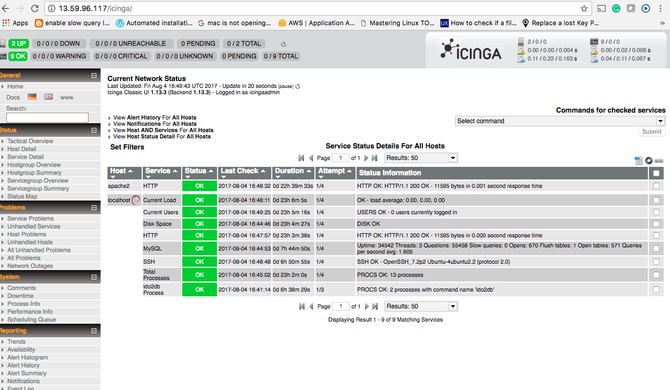

IF SSH Service is down so please first install ssh using below command

root@2dafe8e6402d:~# **apt-get install ssh**