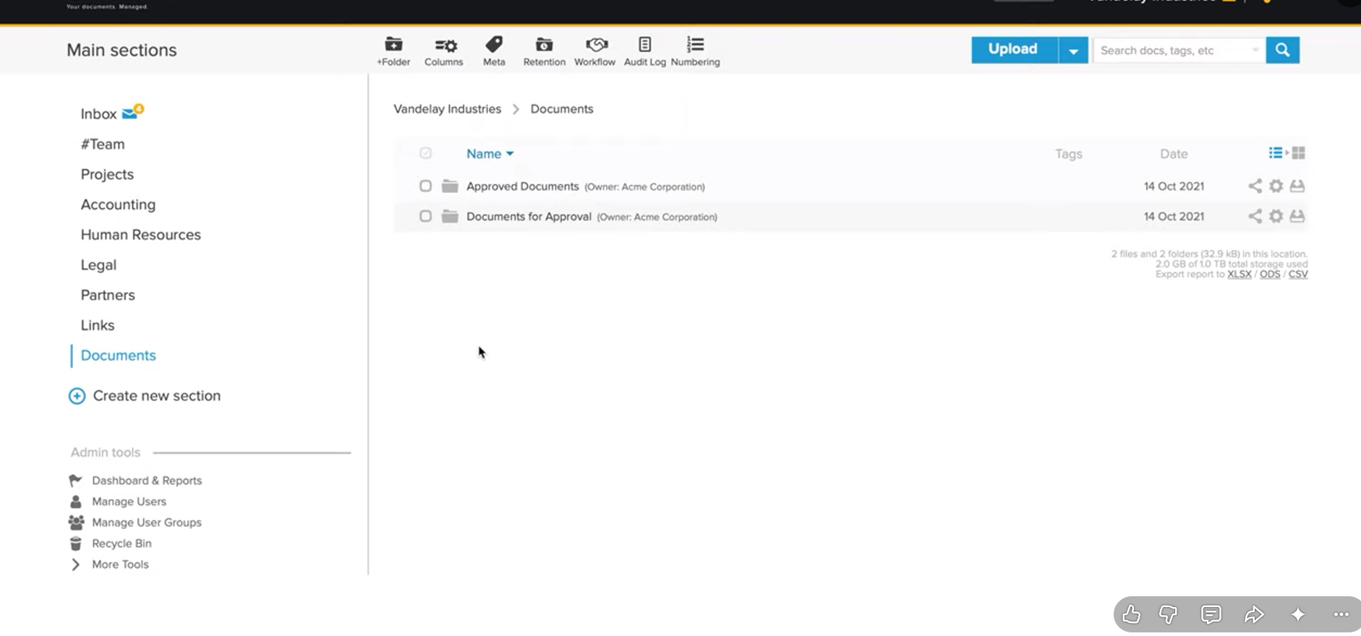
Two section document approved and document for approval

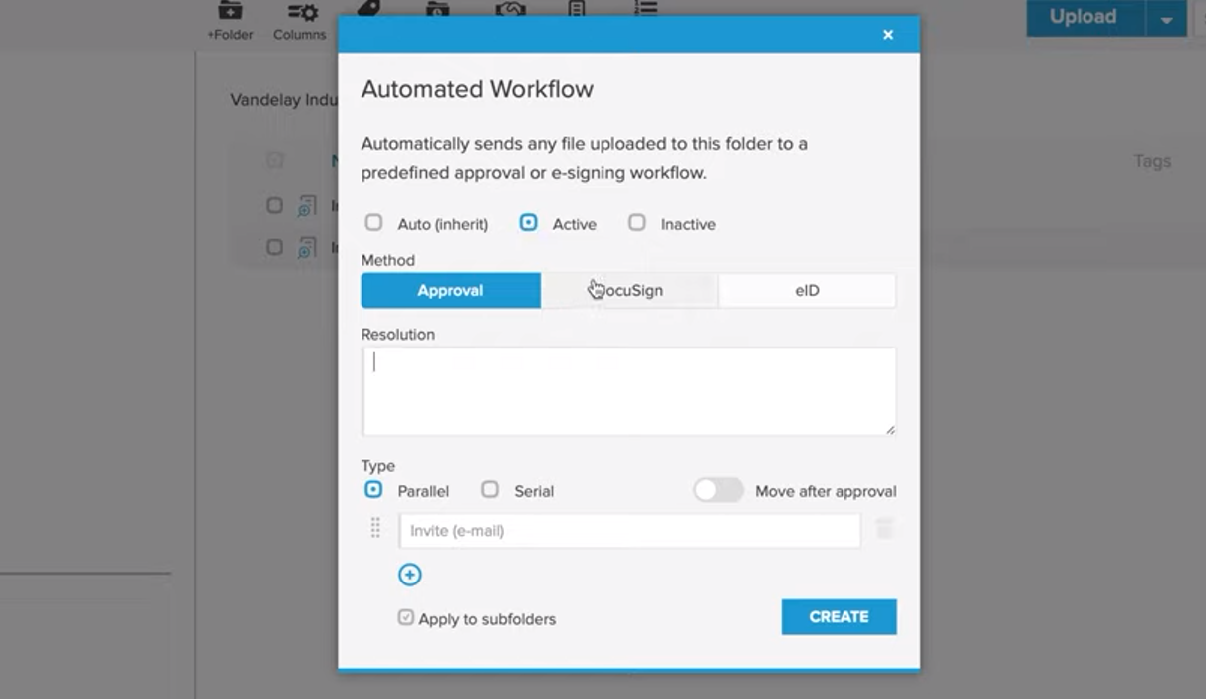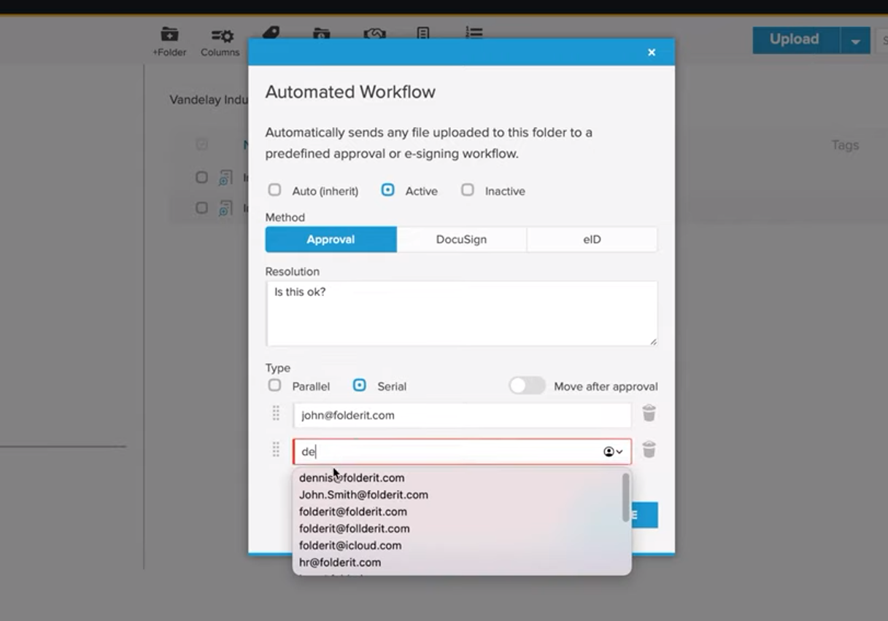
ask for document permission – parallel and serial

Also add or create folder where user can get the document after approval

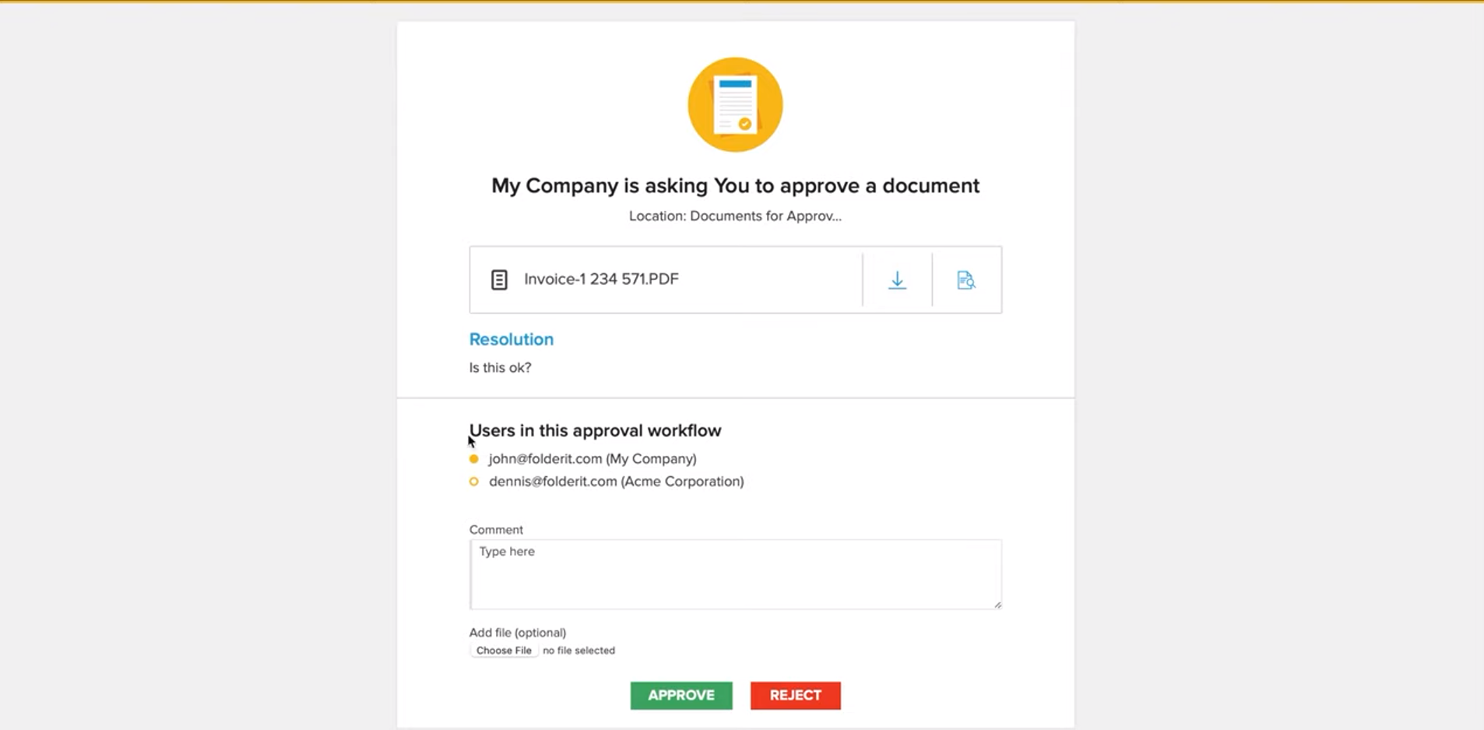
If someone send you the document then if you need to accept or reject or any suggestions you want to give regarding document

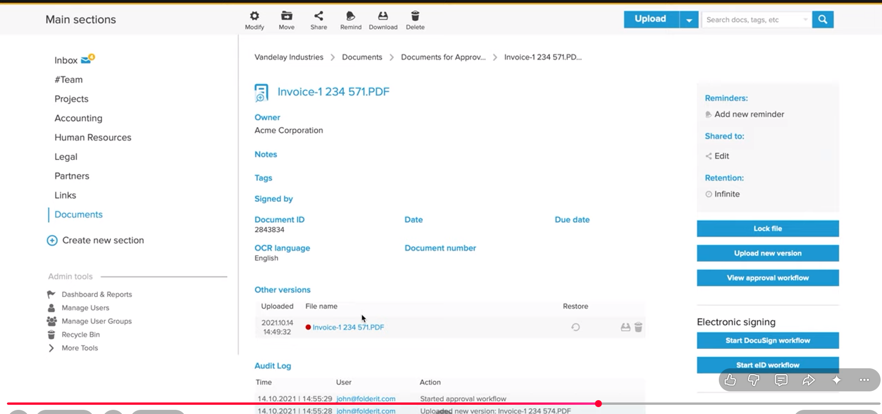
if reject we can add new version of the document and also all the workflow would be saved like at what time requested and when rejcted and reason and when new doc uploaded
and new version automatically send to same person which we send previouslt only by uploading
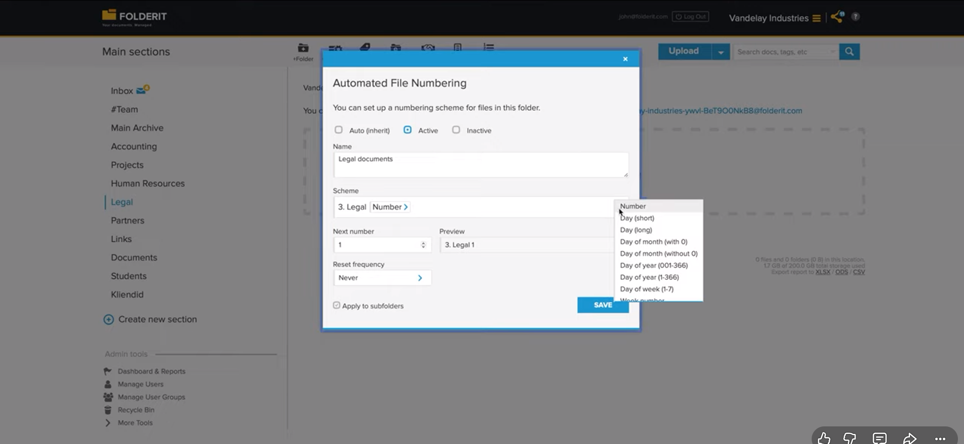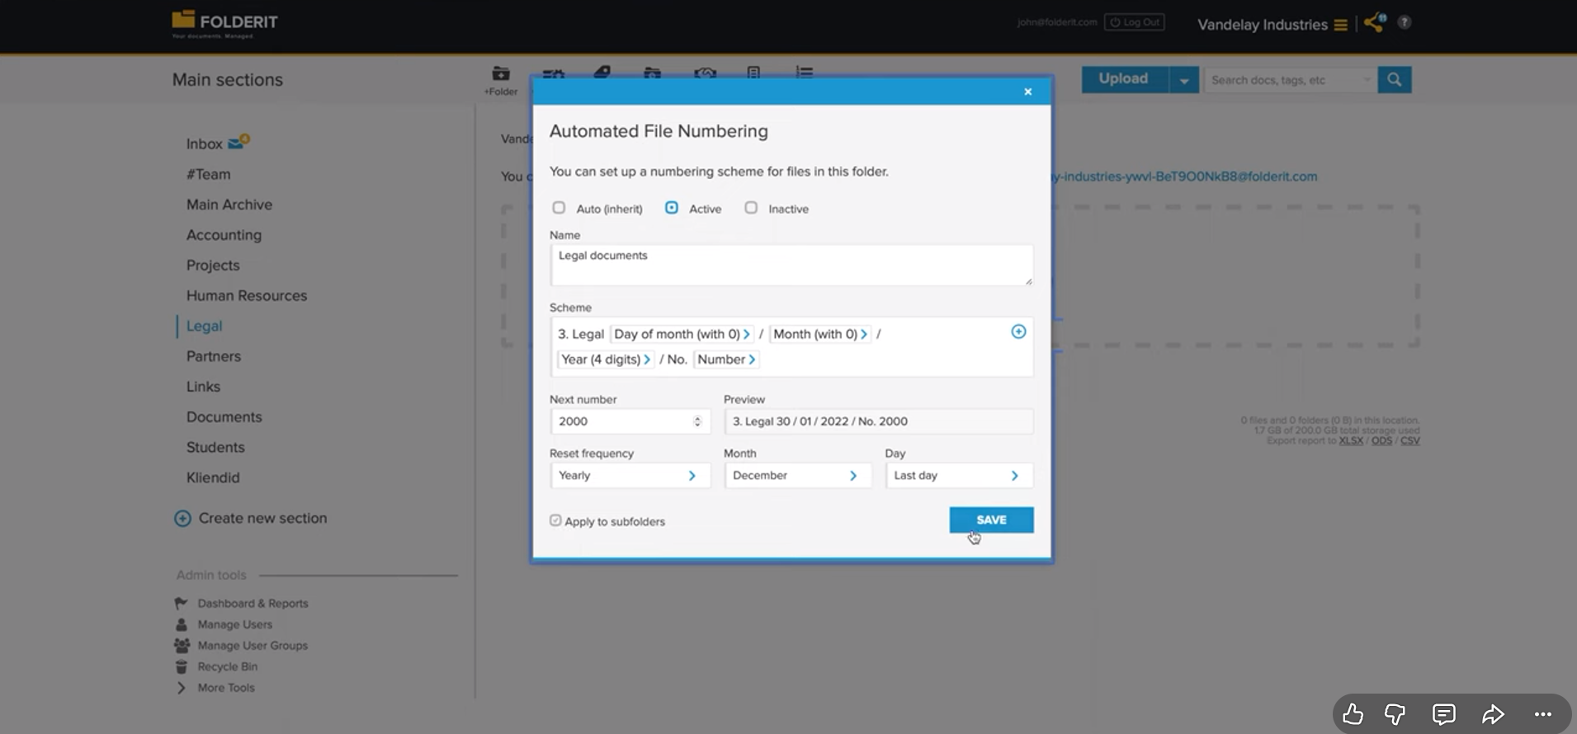
When we want to arrange our data like we can have options like how to manage the data
we can order them in time date or any number format that we want that data to be in

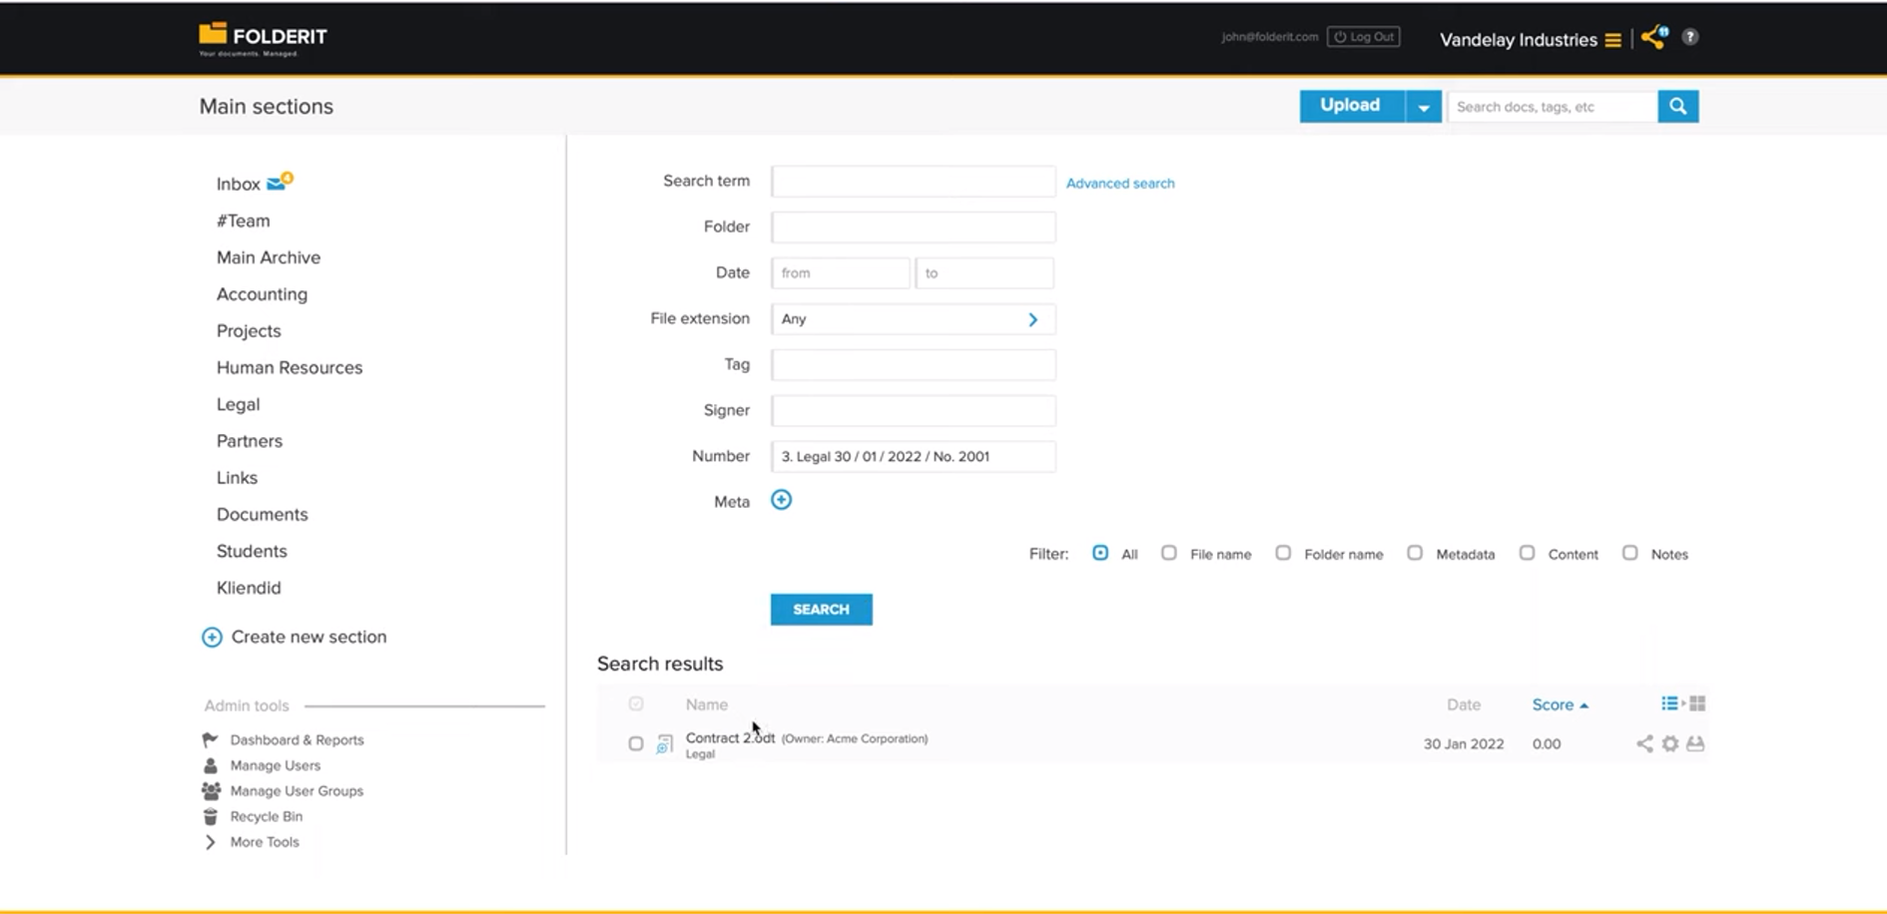
and that number or data will be help to search on the database files and there will be admin user who can find its own documents and all

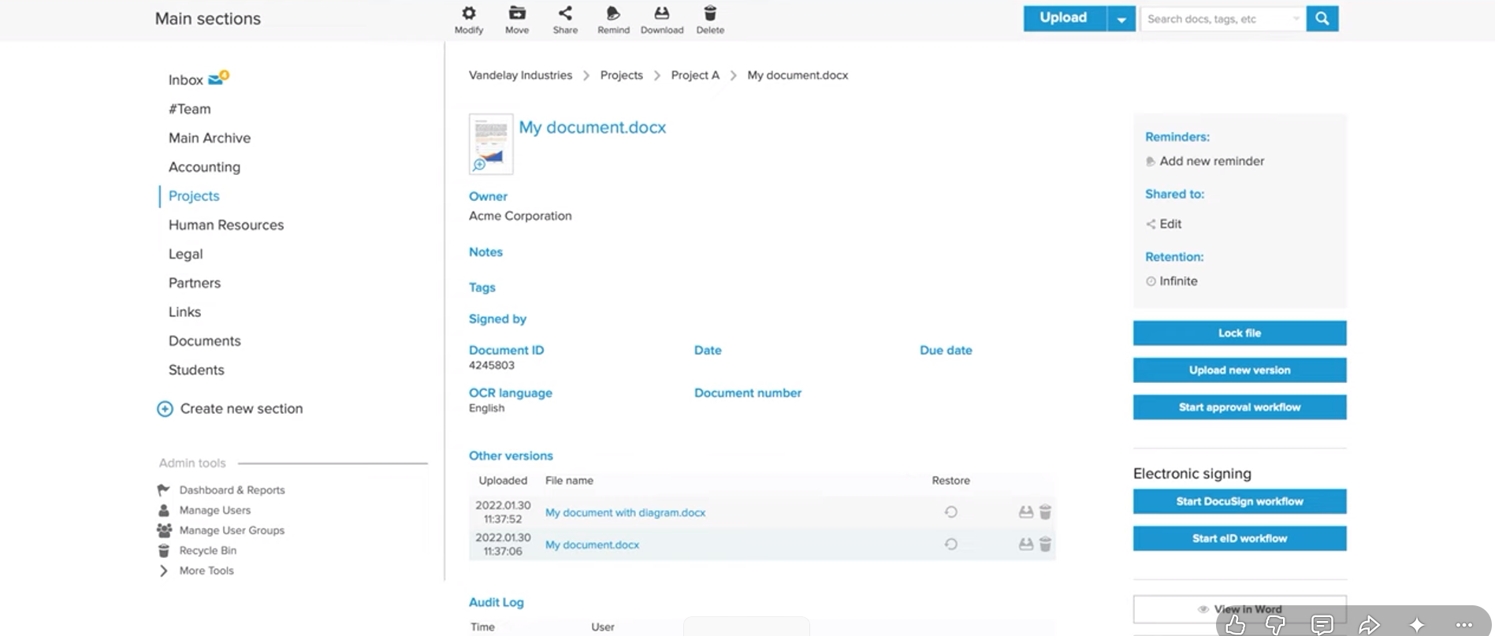
Versioning also there so if user can upload another version of the file it can keep it and stored with the little bit different name
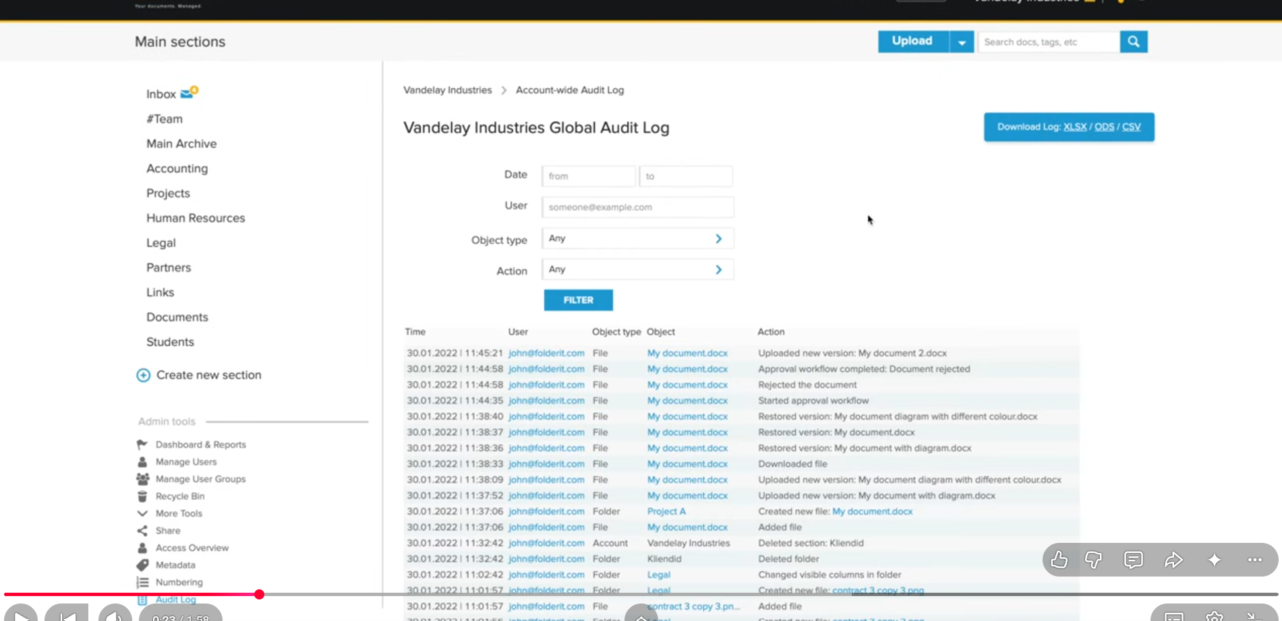
Audit log – where it stored all the action taken by everyone like which user ask for which document and at what time it got approved and whole workflow
here we have filters too like what type of document and time range and other factors

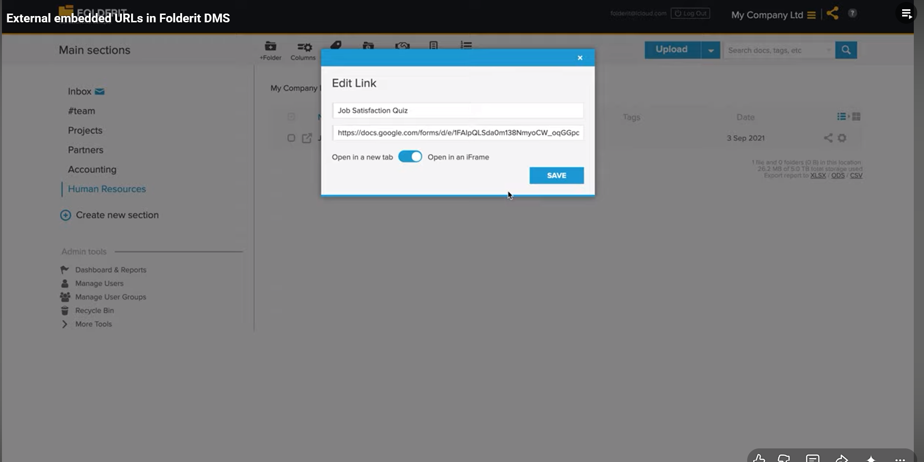
Add link option is the database like doc file or google document filed and we can open it inside the system
Video link can also be included or mp3 and mp4 type

