Data brief template for X-LINUX

*See notes on last page

EVALUATION BOARD/KIT TITLE

|  |
| --- |
| X-LINUX-GNSS1 |
| STM32 MPU OpenSTLinux software expansion package for GNSS based Applications |

EVALUATION BOARD/KIT PRODUCT SUMMARY

|  |  |  |
| --- | --- | --- |
| ST Boards   * Expansion board (X-NUCLEO- GNSS1A1) * Development board (STM32MP1-DK2) | Tools and software   * X-LINUX-GNSS1 | Relevant ST application pages   * <https://dsh-assetracking.st.com/#/home> * <https://www.st.com/en/embedded-software/stassettracking.html> |

EVALUATION BOARD/KIT DESCRIPTION and FEATURES

|  |  |
| --- | --- |
| *DESCRIPTION*  *[P1] complete by replacing the content in brackets*  *[P2] short description of the package*  *[P3] target applications* | *FEATURES (4 to 12 items)*  *Functional and technical features of the application*  *Terms and conditions*  *The last 2 features below are common* |
| X-LINUX-GNSS1 is an STM32 MPU OpenSTLinux software Expansion Package that runs on the Cortex A7 side of the MP1 microprocessor to demonstrate GNSS based applications.  The X-LINUX-GNSS1 is software expansion package that comprises of user space application, device tree for the Teseo-LIV3F global navigation satellite system (GNSS) device, Library for the NMEA protocol support and POSIX Thread for task scheduling to ensure better asynchronous message parsing  The Software contains various application modules to retrieve the GNSS data and also one package to upload the GNSS live data to ST Asset Tracking Dashboard. The source code is highly portable and can be ported to any Linux platform. | * Standalone applications to read the NMEA data over UART and I2C.(gnss_uart and gnss_i2c) * Complete software to build applications using Teseo-LIV3F GNSS device on Linux. * Middleware for the NMEA protocol * POSIX Thread task scheduling to ensure better asynchronous message parsing. * Easy portability across different Linux Platforms * Sample application example to retrieve and parse GNSS data and send to [ST Asset Tracking Dashboard](https://www.st.com/en/embedded-software/dsh-assetracking.html) for live tracking.(x-linux-gnss) * Python Example(gnss_pynmea2.py) * BSD (3-clause) license terms |

LOGOS and LICENSE INFORMATION

|  |  |  |
| --- | --- | --- |
| The logos indicated below run along the bottom of the first page | License information.  Level 1 heading on page 2.  Replace information in brackets | Software component license agreements.  Level 2 heading under License information. |
|  | X-LINUX-xxx is delivered under the Mix Ultimate Liberty+OSS+3rd-party V1 software license agreement (SLA0048). | The software components provided in this package come with different license schemes. Refer to wiki.st.com/ stm32mpu/index.php/OpenSTLinux_licenses for details. |

**Notes**:

The **Architecture block diagram** must be supplied in vector format. PPT files are acceptable, but the best format is SVG created using Inkscape, available for free download from the software kiosk.

**Inkscape svg image.**

* Copy and paste into Inkscape
* In inkscape, [select all] → [Ungroup]

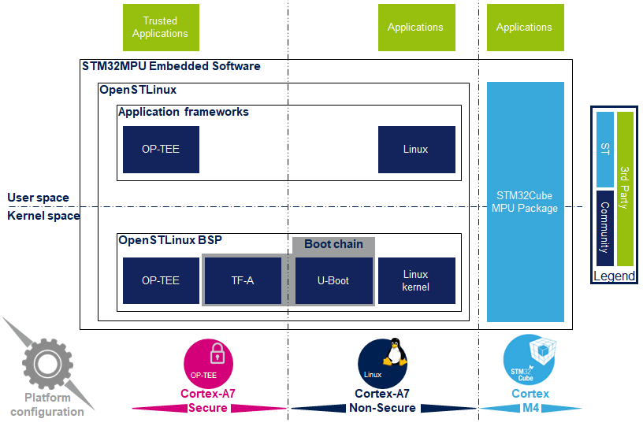

**Windows emf image**

* Select the image border, then copy and paste into PPT

