CAR MARKET TRENDS ANALYSIS
WITH CARDEKHO DATA

Project Report

Student Name | Vishakha Vinod Rawat
Internship ID | IBMUEDA1055
Domain | Automobile / Data Analytics
Development Environment | Jupyter Notebook / Google Colab

Table of Contents
1. Introduction
2. Problem Statement
3. Project Overview
4. Objectives
5. End Users
6. Technology and Tools
7. Dataset Description
8. Data Quality and Preparation
9. Analytical Methodology
10. Exploratory Data Analysis and Visualizations
11. Key Findings
12. Conclusion
13. Future Scope
14. Project Repository
15. Appendix: Notebook Workflow

1. Introduction
This project performs exploratory analysis of CarDekho used-car data using Python. The purpose is to understand the characteristics of the available car listings and examine patterns involving selling price, manufacturing year, fuel type, seller type, transmission and other recorded vehicle attributes.
The report is based directly on the submitted Jupyter Notebook and the accompanying AICTE presentation. The charts reproduced in this report correspond to the visual analyses documented in those project materials.

2. Problem Statement
The project materials describe a need to analyze used-car market data containing variables such as selling price and kilometres driven and to understand factors and market patterns associated with used-car prices. The analysis uses descriptive statistics and visualizations to examine these relationships in the available CarDekho dataset.

3. Project Overview
- Explore the CarDekho dataset and understand its structure.
- Inspect descriptive statistics and data quality.
- Analyze fuel-type and seller-type distributions.
- Compare selling prices across transmission types.
- Study the number of cars recorded by manufacturing year.
- Examine the distribution of selling prices.
- Study the relationship between manufacturing year and selling price.

4. Objectives
- Explore and understand the dataset.
- Perform basic data-quality checks.
- Calculate key selling-price statistics.
- Identify the distribution of fuel and seller categories.
- Compare average selling price by transmission type.
- Analyze year-wise vehicle counts.
- Visualize the distribution of selling prices.
- Investigate the relationship between manufacturing year and selling price.

5. End Users
End User | Use of Analysis
Car Buyers | Understand pricing trends and support purchasing decisions.
Car Sellers | Estimate competitive selling prices for used cars.
Car Dealers | Analyze market trends and vehicle demand.
Automotive Businesses | Understand factors affecting used-car prices.
Data Analysts and Researchers | Perform market analysis and identify useful patterns.

6. Technology and Tools
Tool | Purpose
Python | Core programming language.
Pandas | Data loading, inspection, descriptive statistics and grouping.
NumPy | Numerical computing library imported in the notebook.
Matplotlib | Charts and visualizations.
Seaborn | Statistical and categorical visualizations.
Jupyter Notebook / Google Colab | Development and execution environment.

7. Dataset Description
The notebook loads the CarDekho CSV dataset and reports 301 rows and 9 columns.
Column | Role represented in dataset
Car_Name | Vehicle/car name.
Year | Manufacturing year.
Selling_Price | Selling price of the used car.
Present_Price | Present/current price field recorded in the dataset.
Kms_Driven | Kilometres driven.
Fuel_Type | Fuel category.
Seller_Type | Dealer or individual seller.
Transmission | Manual or automatic transmission.
Owner | Owner-count field.

Dataset Statistics
Measure | Notebook result
Rows | 301
Columns | 9
Duplicate rows | 2
Average selling price | 4.6613 lakh
Highest selling price | 35.0 lakh
Lowest selling price | 0.1 lakh
Average year | 2013.6279
Average kilometres driven | 36,947.21 km

8. Data Quality and Preparation
- The notebook displays the first five and last five records.
- Descriptive statistics are generated with data.describe().
- The dataset shape and column names are inspected.
- data.info() is used to inspect data types and non-null counts.
- Duplicate rows are checked; the notebook reports 2 duplicate rows.
- Frequency counts are generated for car names, fuel type, transmission and year.
- Average, maximum and minimum selling prices are calculated.

9. Analytical Methodology
- Load the CarDekho CSV dataset using Pandas.
- Inspect records, dimensions, columns and data types.
- Generate descriptive statistics.
- Perform a duplicate-row check.
- Analyze categorical distributions.
- Calculate selling-price summary statistics.
- Generate fuel-type and seller-type pie charts.
- Generate a fuel-type count bar chart.
- Compare average selling price by transmission.
- Generate year-wise line and bar charts.
- Generate a selling-price histogram.
- Generate a year versus selling-price scatter plot.

10. Exploratory Data Analysis and Visualizations
The following figures are extracted from the AICTE presentation and correspond to charts produced or documented in the submitted notebook. Where the presentation contains a narrative description, the interpretation below follows that source.

10.1 Cars by Fuel Type
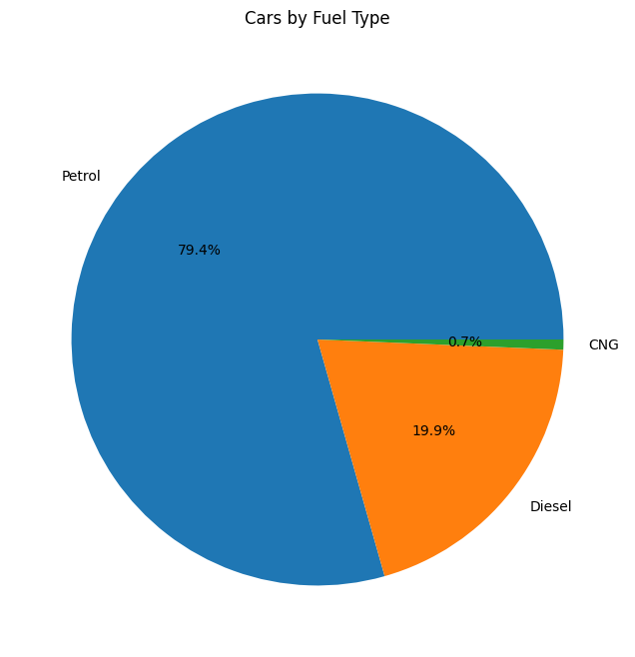
Figure: 10.1 Cars by Fuel Type
Analysis: The notebook records 239 Petrol cars, 60 Diesel cars and 2 CNG cars. The corresponding chart represents approximately 79.4% Petrol, 19.9% Diesel and 0.7% CNG. Petrol is therefore the largest fuel category in the submitted dataset.
Source: Submitted Jupyter Notebook and AICTE presentation, slide 7.

10.2 Distribution of Seller Types
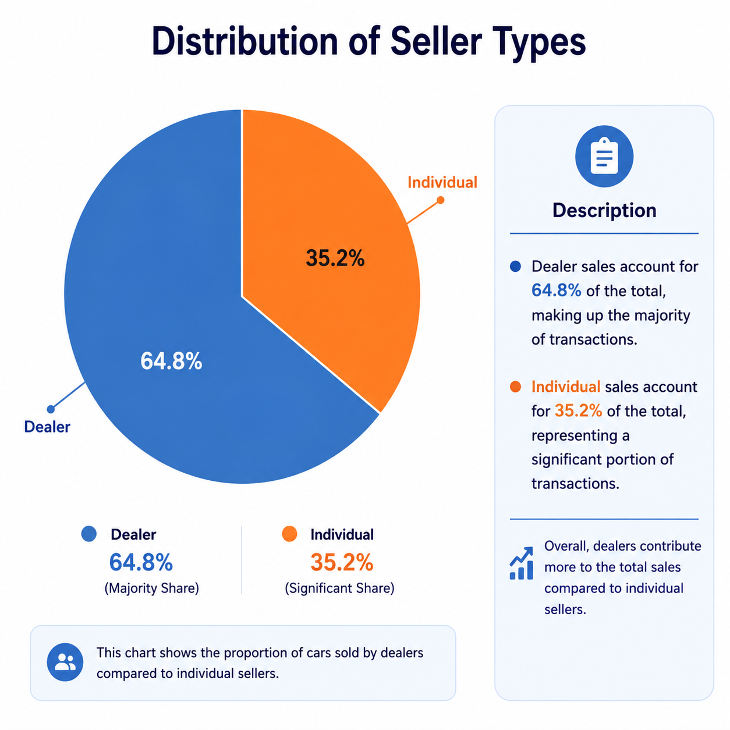
Figure: 10.2 Distribution of Seller Types
Analysis: The notebook records 195 Dealer listings and 106 Individual listings. The presentation visualizes these as approximately 64.8% Dealer and 35.2% Individual.
Source: Submitted Jupyter Notebook and AICTE presentation, slide 8.

10.3 Count of Cars by Fuel Type
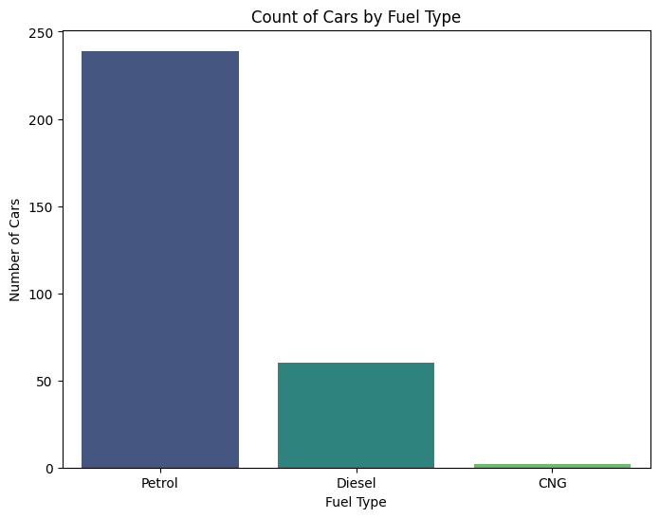
Figure: 10.3 Count of Cars by Fuel Type
Analysis: The bar chart visualizes the fuel-type counts from the notebook: Petrol 239, Diesel 60 and CNG 2. The chart makes the difference in category frequency visually clear.
Source: Submitted Jupyter Notebook and AICTE presentation, slide 9.

10.4 Number of Cars by Year
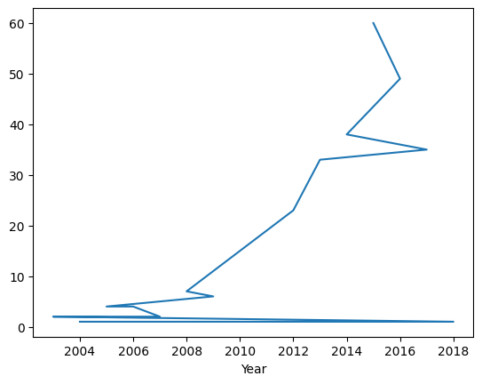
Figure: 10.4 Number of Cars by Year
Analysis: The year-wise line chart shows relatively low counts in the early years, followed by a clear increase from around 2010 onward. The count reaches its highest recorded level around 2015 before declining in later years.
Source: Submitted Jupyter Notebook and AICTE presentation, slide 10.

10.5 Number of Cars per Year
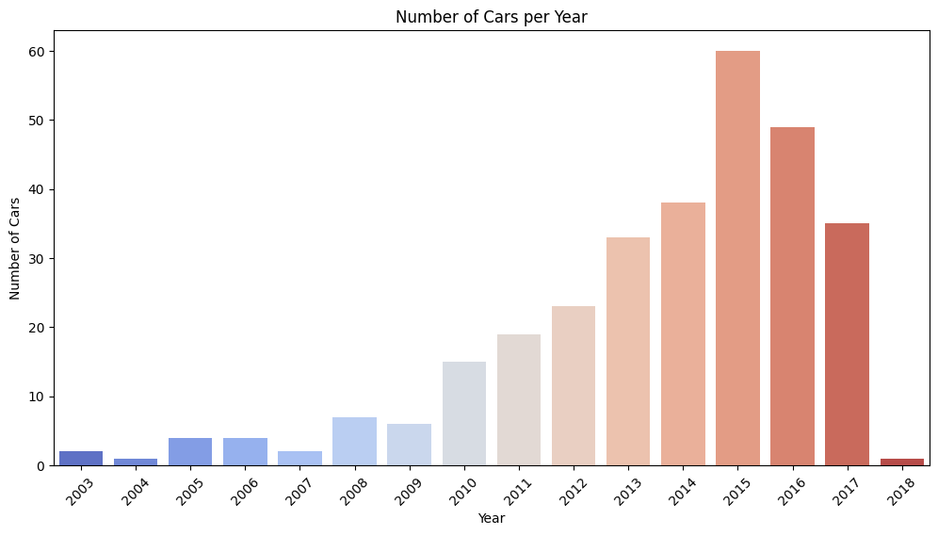
Figure: 10.5 Number of Cars per Year
Analysis: The bar chart confirms the year-wise distribution. The notebook records 61 cars in 2015, 50 in 2016, 38 in 2014, 35 in 2017 and 33 in 2013. The early years contain substantially fewer observations.
Source: Submitted Jupyter Notebook and AICTE presentation, slide 11.

10.6 Year vs Selling Price
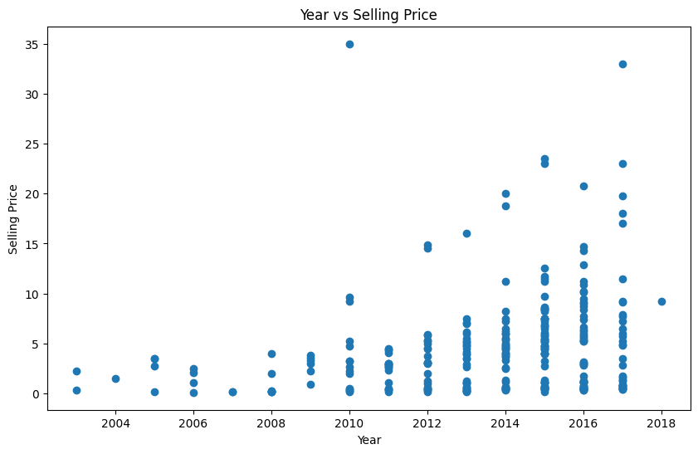
Figure: 10.6 Year vs Selling Price
Analysis: The scatter plot compares manufacturing year with selling price. The project presentation describes newer cars as generally tending toward higher selling prices, while also showing substantial variation within individual years. The notebook's maximum selling price is ₹35 lakh.
Source: Submitted Jupyter Notebook and AICTE presentation, slide 12.

10.7 Distribution of Car Selling Prices
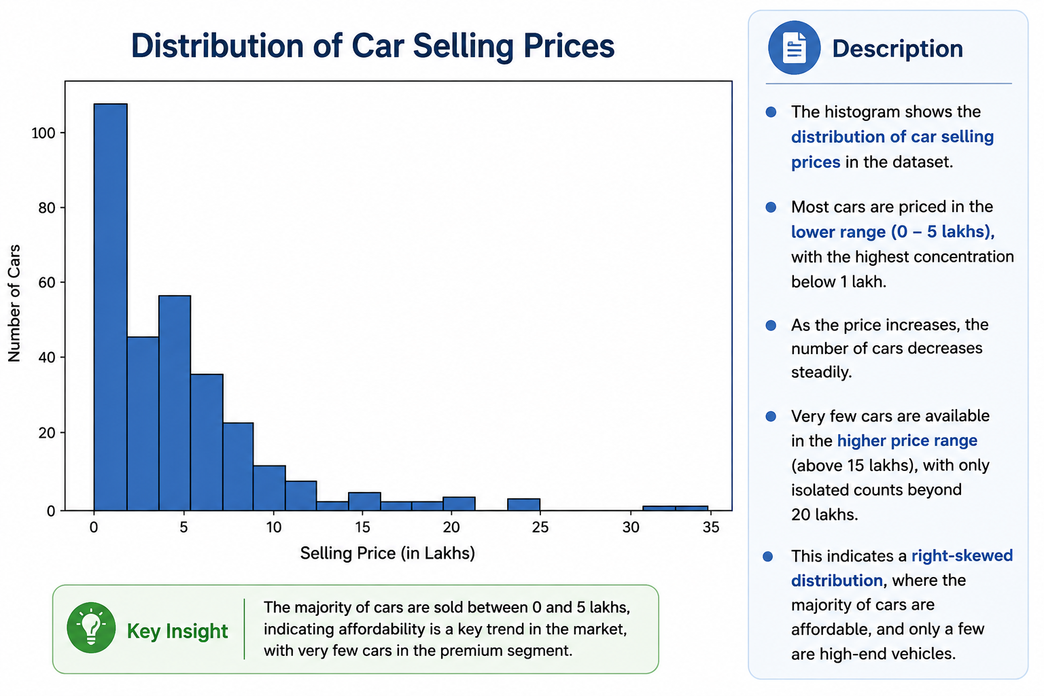
Figure: 10.7 Distribution of Car Selling Prices
Analysis: The histogram shows a concentration of cars in the lower selling-price range and progressively fewer observations at higher prices. The presentation notes that most cars fall between 0 and 5 lakh and that only a small number of observations occur above 15 lakh.
Source: AICTE presentation, slide 13.

10.8 Year vs Selling Price — Project Insight View
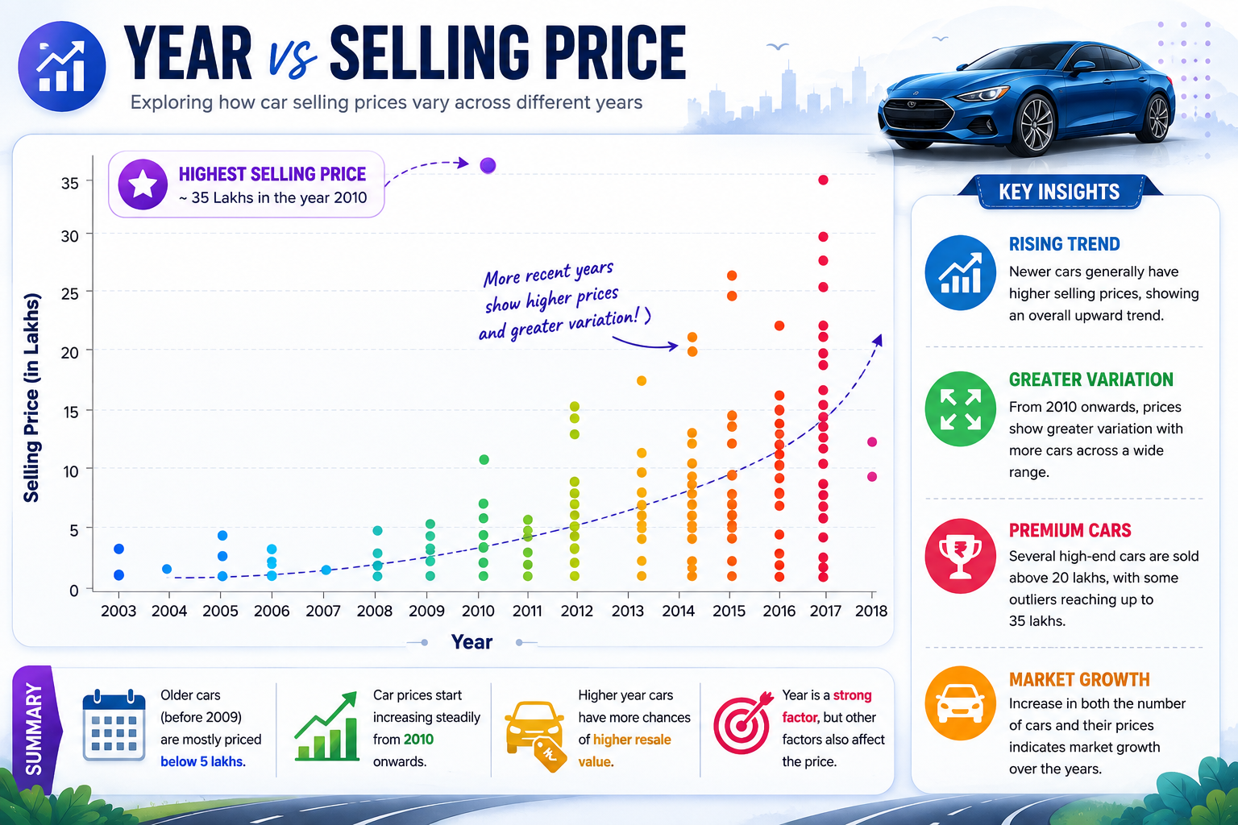
Figure: 10.8 Year vs Selling Price — Project Insight View
Analysis: The presentation's detailed insight slide emphasizes that older cars, particularly before 2009, are mostly priced below ₹5 lakh, while later years contain a wider range of prices and several higher-priced observations. It also highlights a maximum around ₹35 lakh.
Source: AICTE presentation, slide 14.

10.9 Average Selling Price by Transmission Type
The notebook creates a bar chart by grouping Selling_Price by Transmission. The AICTE presentation's result summary reports approximately ₹4.8 lakh for Manual and ₹7.2 lakh for Automatic. This is a descriptive comparison within the submitted dataset and does not by itself establish causation.
Transmission | Average selling price reported in presentation
Manual | ≈ ₹4.8 lakh
Automatic | ≈ ₹7.2 lakh

11. Key Findings
- The dataset contains 301 records and 9 columns.
- The notebook reports 2 duplicate rows.
- Petrol is the dominant fuel category with 239 records, followed by Diesel with 60 and CNG with 2.
- Dealer listings number 195, while Individual listings number 106.
- The average selling price is approximately ₹4.6613 lakh.
- The maximum selling price is ₹35 lakh and the minimum is ₹0.1 lakh.
- The dataset contains the largest number of records for 2015, with 61 cars.
- The number of recorded cars increases noticeably from 2010 to 2015 and then decreases.
- Selling prices are concentrated in the lower range, with relatively few high-price observations.
- The Year vs Selling Price analysis shows an overall tendency for newer cars to have higher selling prices, while individual observations vary considerably.
- The presentation reports a higher average selling price for automatic cars than manual cars in the submitted transmission comparison.

12. Conclusion
The Car Market Trends Analysis project demonstrates how exploratory data analysis can be applied to used-car market data. The submitted notebook combines data inspection, descriptive statistics, categorical analysis and visualization to understand the structure of the CarDekho dataset.
The analysis identifies clear differences in fuel-type representation, seller type, year-wise listing counts and selling-price distribution. The year-versus-price visualization also provides a descriptive view of how vehicle age relates to observed selling prices in the dataset.
The findings are limited to the variables and observations available in the submitted dataset and should be interpreted as exploratory rather than as causal conclusions.

13. Future Scope
- Develop a machine-learning model for used-car price prediction.
- Perform feature engineering using vehicle age, kilometres driven and price-related variables.
- Expand analysis to brand/model-level patterns.
- Build an interactive dashboard for used-car market exploration.
- Add geographical information for location-wise price analysis if available.
- Compare additional vehicle characteristics and market segments.

14. Project Repository
The AICTE presentation provides the following GitHub repository:
https://github.com/Mruunali/car-dekho

15. Appendix: Notebook Workflow
- Import NumPy, Pandas, Matplotlib and Seaborn.
- Read the CarDekho CSV dataset.
- Display the top five records.
- Display the bottom five records.
- Generate descriptive statistics.
- Check dataset dimensions.
- List column names.
- Inspect data information and data types.
- Check duplicate rows.
- Inspect car-name frequencies.
- Inspect fuel-type frequencies.
- Inspect transmission frequencies.
- Inspect year frequencies.
- Calculate average selling price.
- Calculate highest selling price.
- Calculate lowest selling price.
- Create fuel-type pie chart.
- Create seller-type pie chart.
- Create fuel-type bar chart.
- Create average selling price by transmission chart.
- Create year-wise line chart.
- Create year-wise count plot.
- Create selling-price histogram.
- Create year versus selling-price scatter plot.

Report basis: This report is based on the submitted CarDekho Jupyter Notebook and AICTE presentation. It preserves the project's terminology, statistics and documented chart interpretations.

