Unicore – Project Planning & Management
DEPI – Digital Egypt Pioneers Initiative | Track: Front-End React
Team: Rawda Eslam Mohamed (Leader), Mariem Nasser Ebrahim, Rawan Ahmed Abdelhamed, Bassant Hamdy Abdelhalim, Khaled Reda Mohamed

1. Project Proposal
Unicore is a web app that turns a faculty’s confusing timetable into a personal one. The student chooses university, college, year, group and section, and sees only their own lectures and sections. We start with Benha University and one faculty, then scale to other faculties and universities.
Problem. Faculty timetables mix groups, sections and halls in one big sheet. Students lose time finding their own lectures, the doctor or TA, and the room.
Objectives
- Show each student a clean, personal weekly timetable in 5 selections or fewer.
- Show subject, doctor or TA, time, type (lecture or section) and place (amphitheater, hall or lab).
- Remind the student before each lecture or section, with a lead time the student chooses (for example 15 minutes).
- Help students find places (faculty guide) and find a doctor or TA (search).
- Publish exam schedules and announcements about changes.
- Design the app so more faculties and universities can be added without changing the code.
Scope
In scope | Out of scope
Front-end web app in React (responsive, mobile-first) | Building the back end and database (provided ready by the track)
Student selection flow and personal timetable | AI assistant (decided not to include)
Notifications before lectures and sections | Native mobile apps
Faculty guide and doctor/TA search | Student accounts with grades or attendance
Exam schedule and announcements | Admin dashboard for entering timetables (optional, if time allows)

2. Project Plan
DEPI deadlines: Implementation (source code and execution) on 30 Nov 2026, and Final Presentation, Testing and Reports on 4 Dec 2026. Planning, Literature Review and Requirements were due on 16 Oct 2026 and System Analysis & Design on 6 Nov 2026, so these documents are submitted now.
Gantt chart
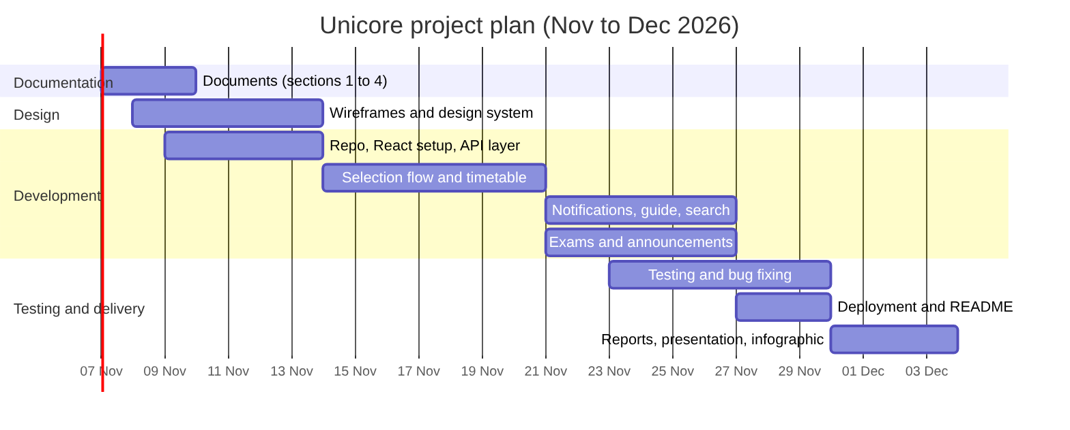
Milestones and deliverables
Milestone | Deliverables | Target date
M1 Documentation complete | Sections 1 to 4 reviewed and uploaded to GitHub | 10 Nov 2026
M2 UI design and setup | Wireframes, design system, repo, React project, API layer | 14 Nov 2026
M3 Core features | Selection flow, personal timetable | 21 Nov 2026
M4 Extra features | Notifications, faculty guide, search, exams, announcements | 27 Nov 2026
M5 Implementation delivered | Tested code, README, deployed link | 30 Nov 2026
M6 Final delivery | Test report, user manual, technical docs, presentation, infographic | 4 Dec 2026
Resources: 5 front-end developers, GitHub repository, ready back-end API and database, free static hosting for the React build, Figma for wireframes.

3. Task Assignment & Roles
The back end is ready, so all five members work on the front end. This is a proposed split; the team confirms it with the trainer within the deadline.
Member | Role | Main responsibilities
Rawda Eslam Mohamed | Team leader | Planning, GitHub repo and reviews, app shell and routing, integration, deployment, final presentation
Mariem Nasser Ebrahim | Front-end developer | Selection flow (university, college, year, group, section), saving the student’s choice
Rawan Ahmed Abdelhamed | Front-end developer | Doctor/TA search, faculty guide (halls, amphitheaters, labs)
Bassant Hamdy Abdelhalim | UI/UX and front-end developer | Wireframes, design system, personal timetable screen, notification settings screen
Khaled Reda Mohamed | Front-end developer | API service layer, state management, exam schedule, announcements, automated tests
Everyone also documents their own features and presents them in the final discussion, because each member’s work is evaluated individually.

4. Risk Assessment & Mitigation Plan
Risk | Likelihood | Impact | Mitigation
Late start: three document deadlines already passed | High | High | Write all documents now; split by section
Back-end API changes or is unavailable | Medium | High | Agree on the API contract early; use mock data during development
Real timetable data is incomplete or wrong | Medium | High | Show a “last updated” date; allow reporting an error; test with one faculty first
Browser notifications blocked or unsupported on some phones | Medium | Medium | Ask permission with a clear explanation; show in-app reminders as a fallback
Merge conflicts in a 5-person team | Medium | Medium | Feature branches, small pull requests, review by the leader
Poor performance on slow mobile networks | Medium | Medium | Code splitting, lazy loading, cache the timetable locally
A member is absent or overloaded | Low | High | Pair ownership of each feature; weekly progress check

5. KPIs (Key Performance Indicators)
KPI | Target
Time for a new student to see their timetable | Under 30 seconds, 5 selections or fewer
Page load time on 4G | Under 3 seconds
Lighthouse scores (performance, accessibility, best practices) | 90 or more
Unit test coverage of core logic | 70% or more
Pilot adoption in the first faculty | 50 students tried the app
Task success in user testing | 90% of testers find their next lecture and its room
Availability of the deployed app | 99% during evaluation week

