Unicore – System Analysis & Design
DEPI – Digital Egypt Pioneers Initiative | Track: Front-End React
Team: Rawda Eslam Mohamed (Leader), Mariem Nasser Ebrahim, Rawan Ahmed Abdelhamed, Bassant Hamdy Abdelhalim, Khaled Reda Mohamed
The database and API are provided ready by the track. Before submitting, compare section 2 and the API table in section 6 with the real schema and endpoints, and correct any names that differ.

1. Problem Statement & Objectives
Students at Egyptian universities receive timetables that mix many groups, sections, halls and staff in one sheet. They get lost between groups and sections, miss changes, and do not know where a hall is. Unicore gives each student a personal, organized timetable, plus reminders, a faculty guide, staff search, exams and announcements.
Actors: Student (main user) and Administrator (maintains data through the existing back end).

1.1 Use Case Diagram
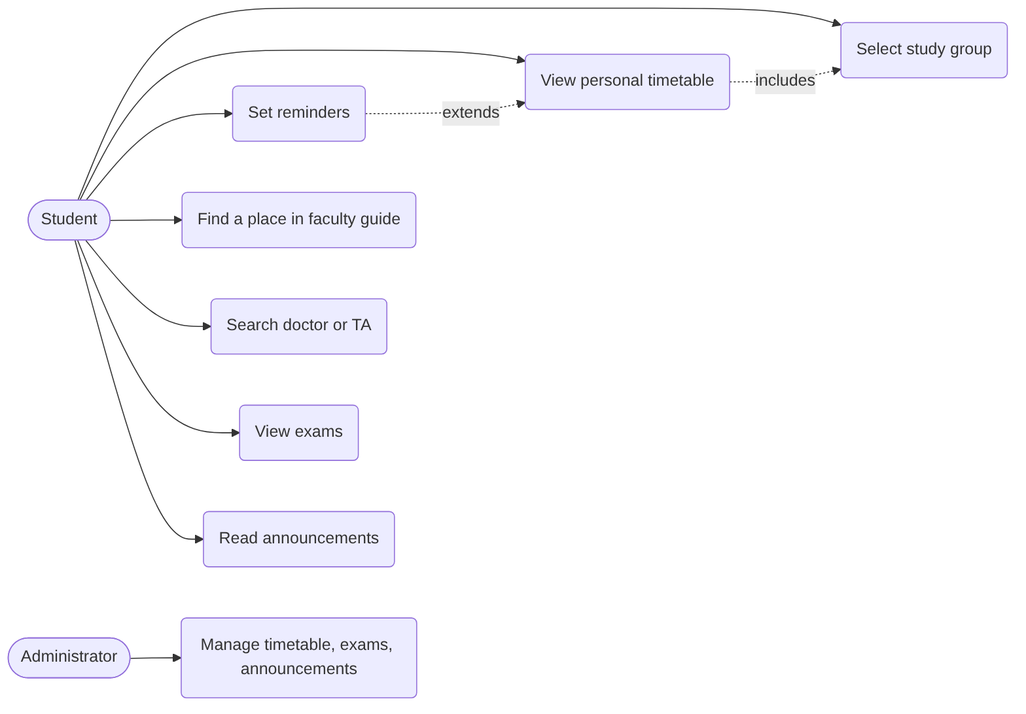
Use case descriptions, and the functional and non-functional requirements, are in the Requirements Gathering file.

1.2 Software Architecture
Single-page application in React using a component-based, layered style: pages, reusable components, a state layer, and a service layer that calls the REST API of the ready back end.
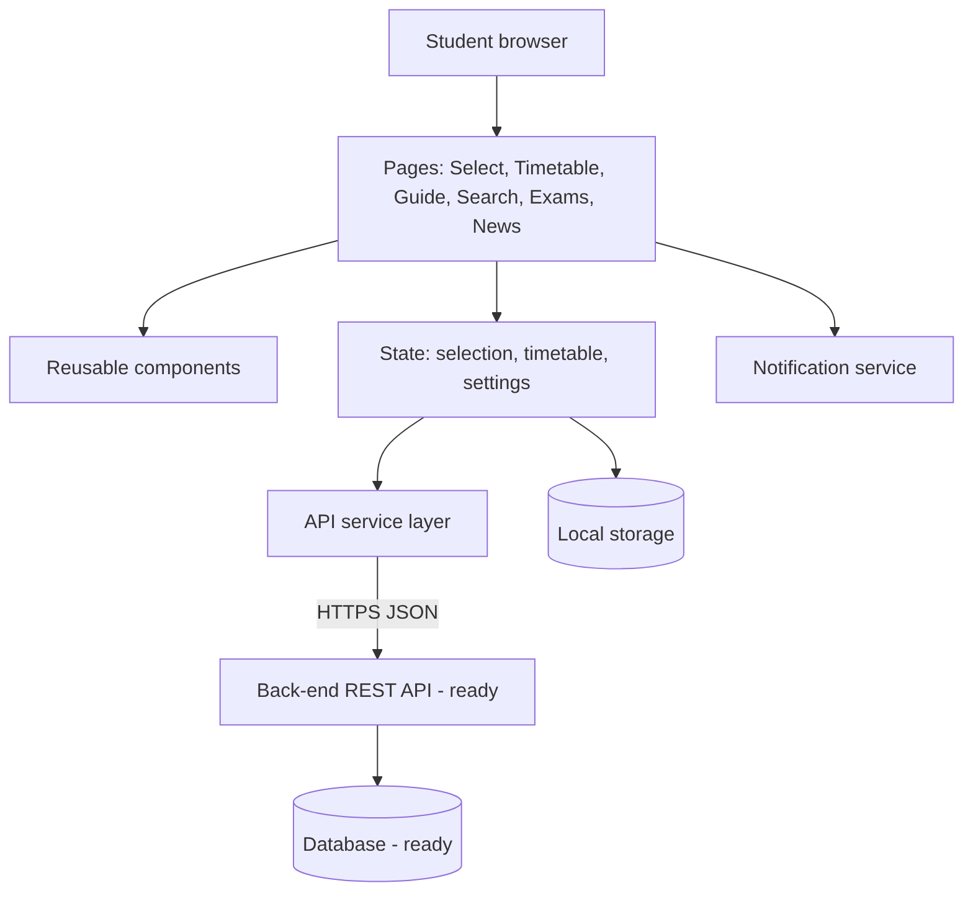

2. Database Design & Data Modeling

2.1 ER Diagram
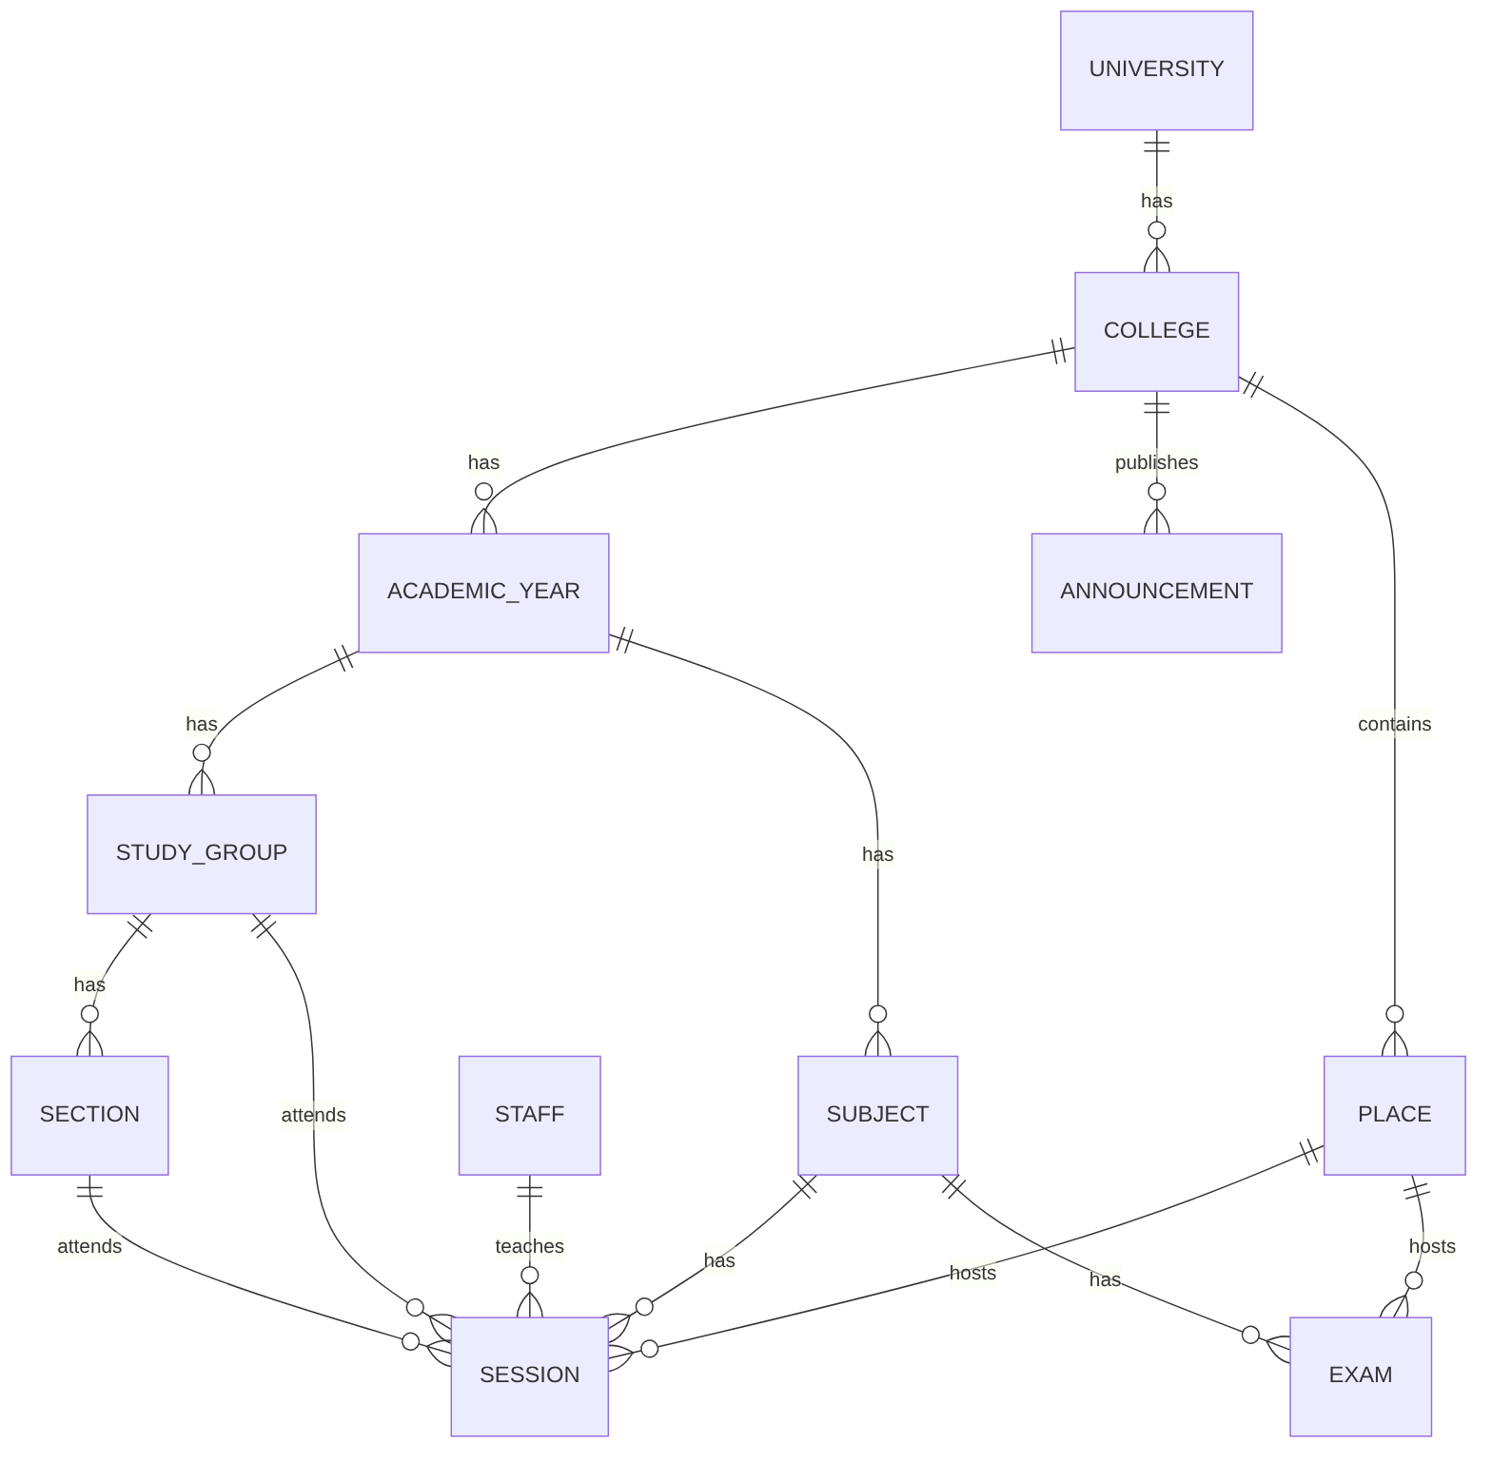

2.2 Logical & Physical Schema
Table | Main attributes | Keys
university | id, name | PK id
college | id, university_id, name | PK id, FK university_id
academic_year | id, college_id, name | PK id, FK college_id
study_group | id, academic_year_id, name | PK id, FK academic_year_id
section | id, group_id, name | PK id, FK group_id
subject | id, academic_year_id, name, code | PK id, FK academic_year_id
staff | id, name, title (doctor or TA), email | PK id
place | id, college_id, name, type (amphitheater, hall, lab), building, floor, directions | PK id, FK college_id
session | id, subject_id, staff_id, place_id, group_id, section_id (optional), type (lecture or section), day, start_time, end_time | PK id, FKs
exam | id, subject_id, place_id, date, start_time, end_time | PK id, FKs
announcement | id, college_id, title, body, date, affects_group_id (optional) | PK id, FKs
The tables are in third normal form: names of places, staff and subjects are stored once and referenced by key.

3. Data Flow & System Behavior

3.1 DFD Level 0 (Context)
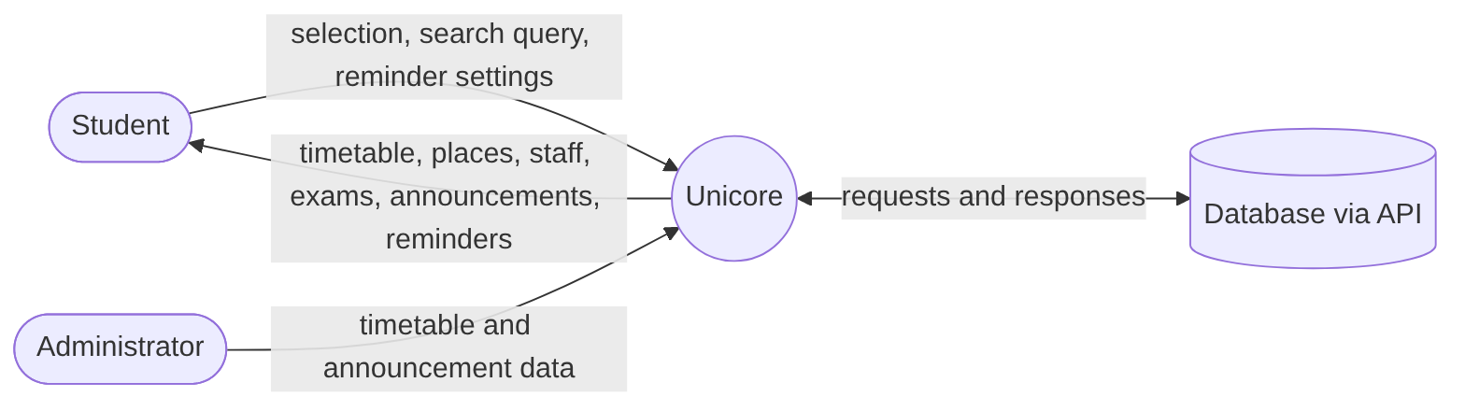

3.2 DFD Level 1
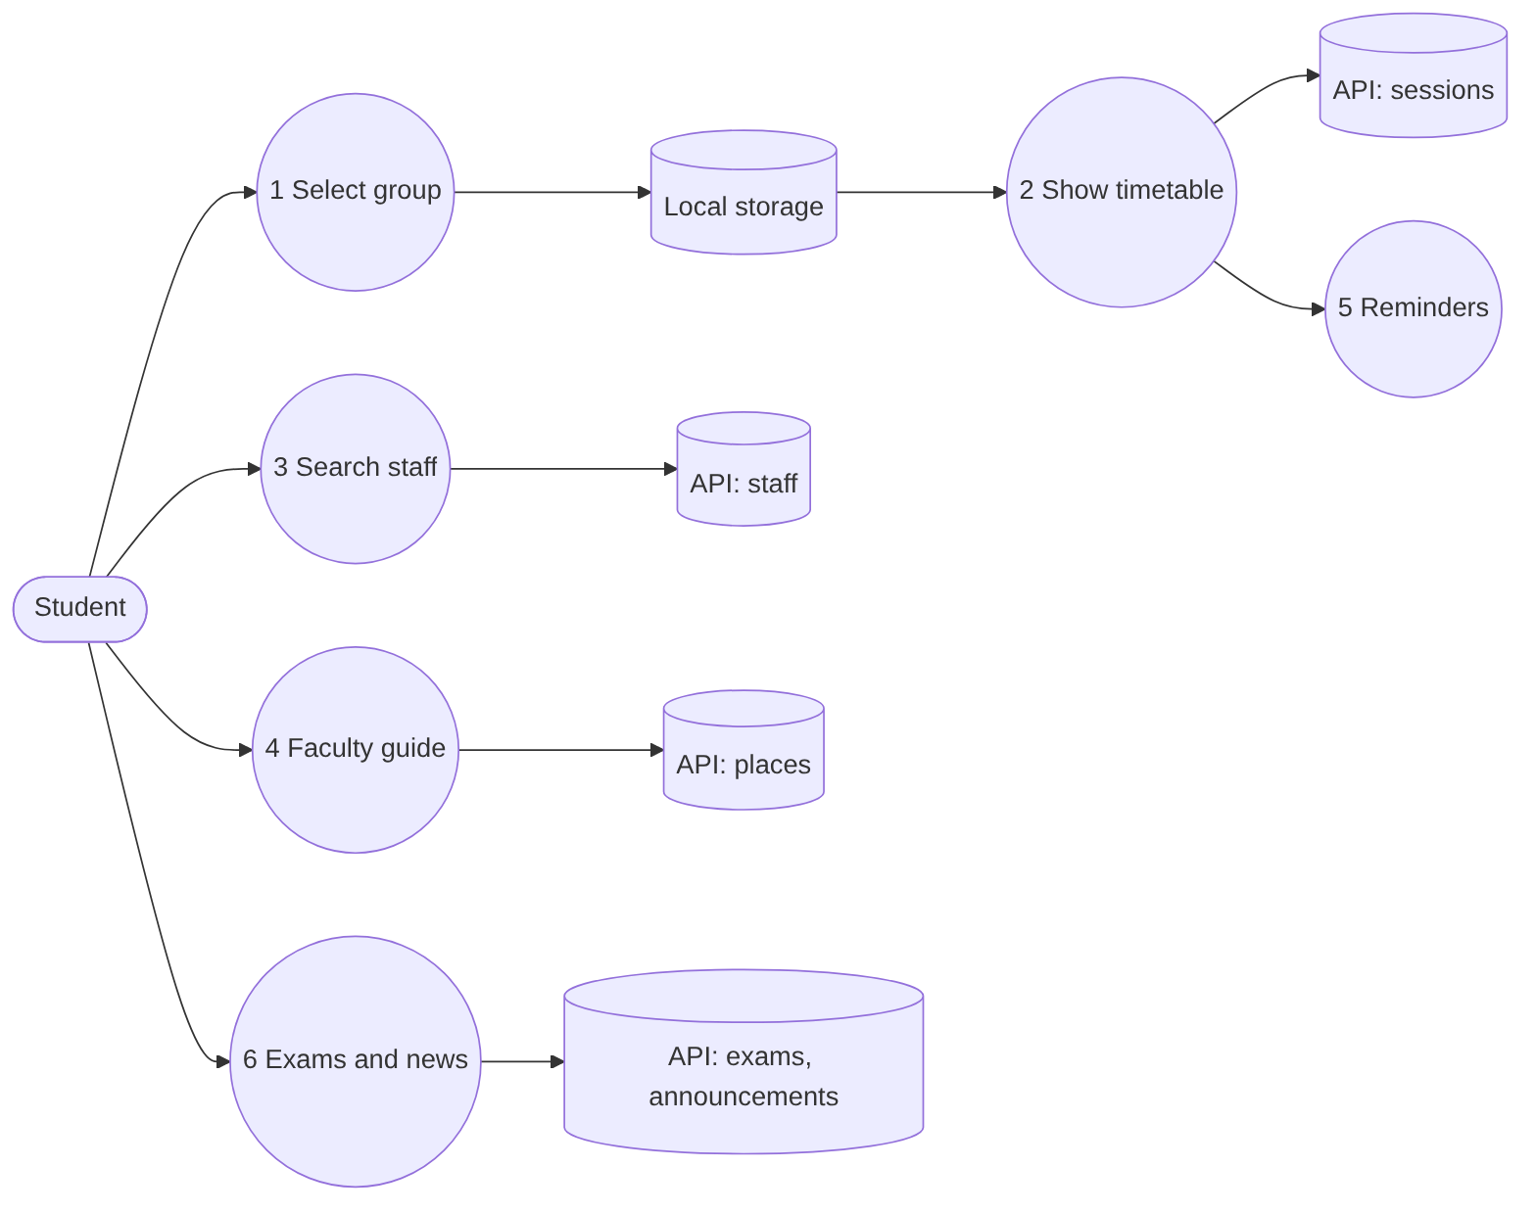

3.3 Sequence Diagram: Viewing the Timetable
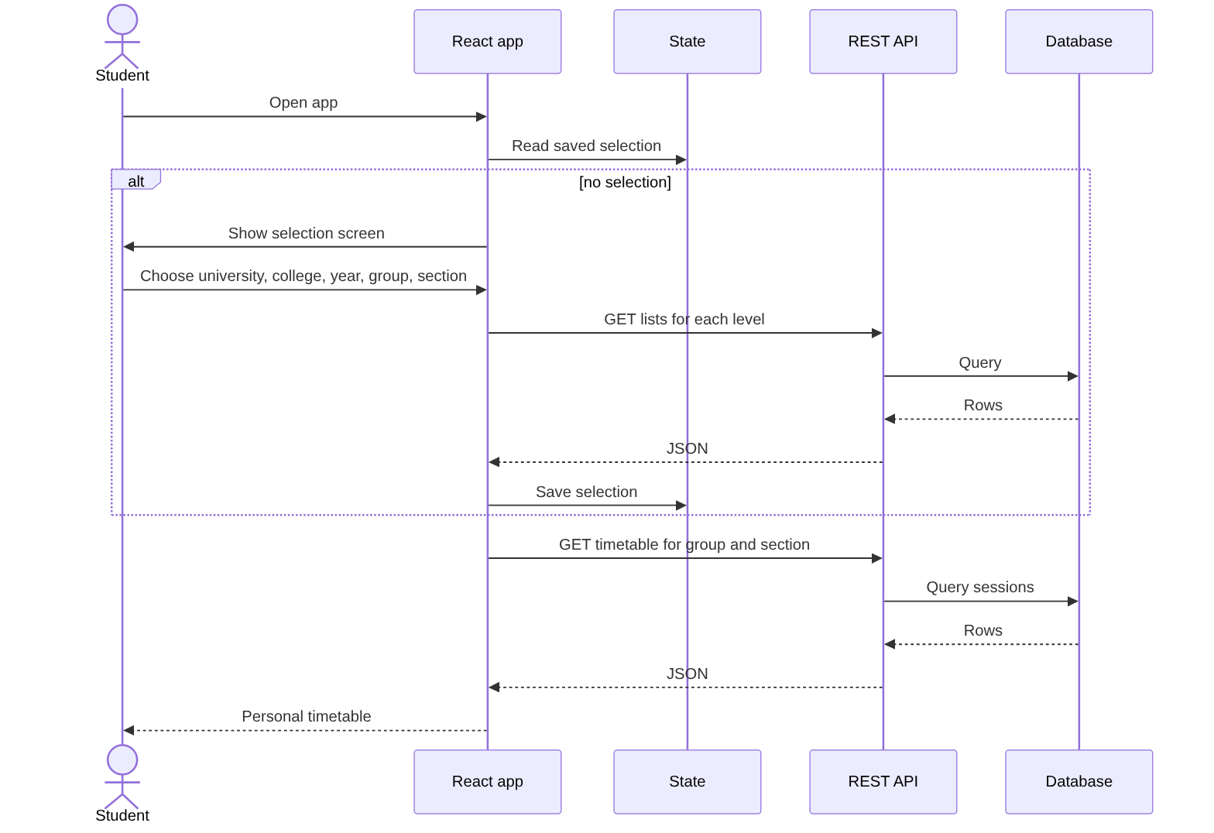

3.4 Activity Diagram: First Visit
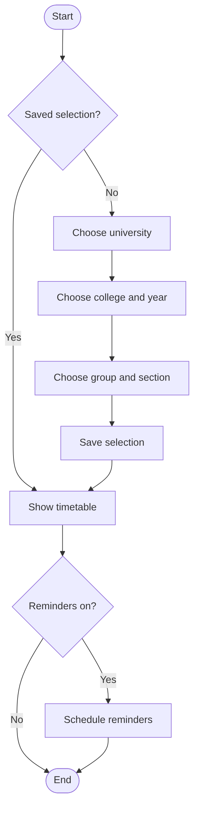

3.5 State Diagram: A Reminder
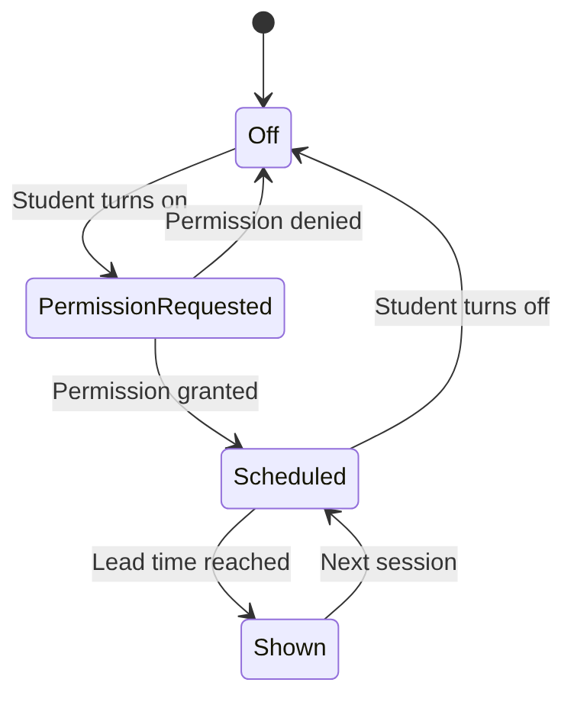

3.6 Class Diagram (front-end models and services)
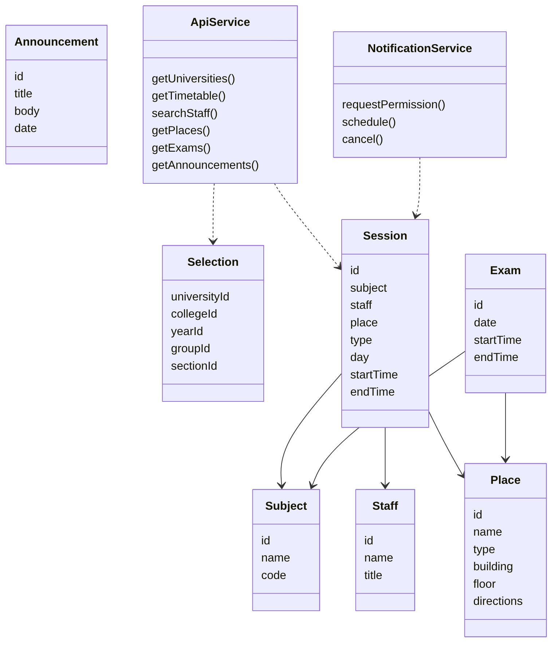

4. UI/UX Design & Prototyping

4.1 Wireframes & Mockups
The wireframes are designed in Figma (add the link here when ready). Screens to design:
# | Screen | Main elements
1 | Welcome and selection | Step-by-step selectors (university, college, year, group, section), progress bar
2 | Personal timetable | Day tabs, today highlighted, cards with subject, doctor/TA, time, place
3 | Session details | Full info, place directions, set reminder
4 | Faculty guide | List and filter of amphitheaters, halls, labs; place detail
5 | Staff search | Search box, result list, staff detail with schedule
6 | Exams | Table or cards by date
7 | Announcements | List with date and “affects my group” label
8 | Settings | Change selection, reminder lead time, language, theme

4.2 UI/UX Guidelines
- Principles: mobile-first, one task per screen, at most 5 selections to reach the timetable, always show the next class first.
- Colors: a deep blue primary, a lighter accent, and distinct colors for lecture and section; text contrast at least 4.5:1.
- Typography: one clear sans-serif family that supports Arabic and Latin text; body text 16 px minimum; support right-to-left layout.
- Accessibility: visible keyboard focus, labels on all inputs, alt text, never use color alone to show the session type, respect the reduced-motion setting.

5. System Deployment & Integration

5.1 Technology Stack (proposed; the team confirms it)
Layer | Technology
Front end | React, React Router, CSS framework or CSS modules
State and data | React hooks, Context or Redux Toolkit, fetch or Axios
Back end and database | Ready, provided by the track (REST API)
Notifications | Browser Notifications API
Version control | Git and GitHub
Testing | Jest and React Testing Library
Hosting | Static hosting for the React build

5.2 Deployment Diagram
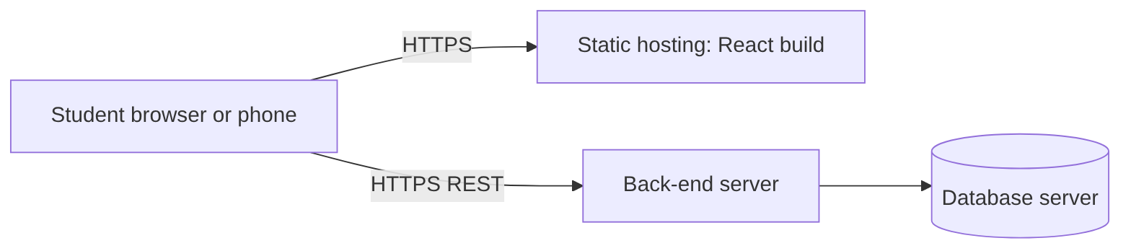

5.3 Component Diagram
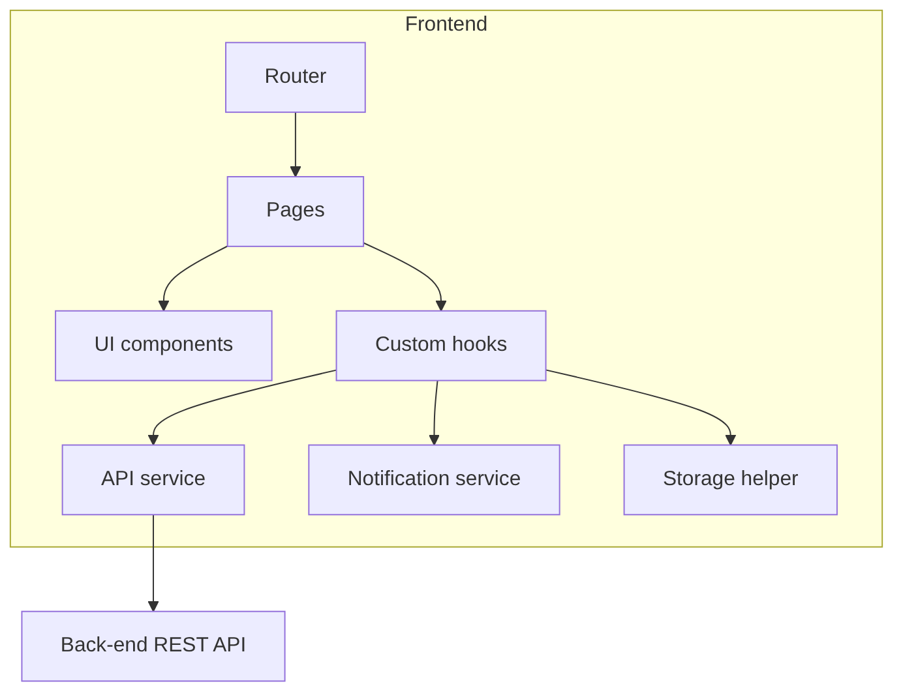

6. Additional Deliverables

6.1 API Documentation (front-end usage)
Endpoint names are placeholders: replace them with the real ones from the back-end team.
Method | Endpoint (placeholder) | Purpose
GET | /universities | List universities
GET | /universities/{id}/colleges | List colleges
GET | /colleges/{id}/years | List academic years
GET | /years/{id}/groups | List groups and their sections
GET | /timetable?groupId=&sectionId= | Personal timetable
GET | /staff?search= | Search doctors and TAs
GET | /colleges/{id}/places | Faculty guide
GET | /exams?yearId=&groupId= | Exam schedule
GET | /announcements?collegeId= | Announcements

6.2 Testing & Validation
See the Testing and Quality Assurance file.

6.3 Deployment Strategy
Build with the production command, host the static files, set the API URL through an environment variable, and deploy from the main branch after the tests pass.

