**Pretty Chat**

Software Requirements Specifications

Rawda Yasser

30 January 2019

Contents

Document Purpose and Audience 3

Introduction 3

Software Purpose 3

Software Scope 4

Definitions, acronyms, and abbreviations 4

Requirements 4

Functional Requirements 4

Non Functional Requirements 4

System Models 5

Use Case Model 5

Use Case Tables 5

# Author

* Rawda Yasser Mohamed

# Document Purpose and Audience

* This Document is about Software Requirement Specification. It is a detailed description of all the software application requirements. These requirements are two types: Functional and Non Functional requirements. It should be an agreement between customer and the developer.
* Target audience to read this document is Project Manager and Customer

## Software Purpose

The purpose of this software is to provide an easy-to-use social network for users to communicate with each other.

## Software Scope

This software will be based on android platform. It is a social network application. It will not contain games for users. It does not run on IOS platform, it is for android only.

## Definitions, acronyms, and abbreviations

# 

# Requirements

## Functional Requirements

|  |  |
| --- | --- |
| Register: | User will register to create an account in the system. |
| Login | User will login if he/she has an account |
| Forgot Password: | User will press this button if he/she has forgotten their password. |
| Comment: | User will comment on their accessible posts. |
| Post: | Users will be able to post on their timeline, friends’ timeline or in a group will be able to send messages to other users |
| Message: | User will send messages to other friends |
| Search: | Users will search for other users or groups. |
| Send Friend Request: | User will send friend requests to users who are not his/her friend |
| Block User: | User will block another user account from sending him messages, viewing their profile or find them on Pretty Chat. |
| Upgrade: | Normal user will be able to upgrade his account to a premium account. |

## Non Functional Requirements

|  |  |
| --- | --- |
| **Performance** | * **Response time for message send is maximum 2 seconds** * **Response time for posting and commenting is 1 second** * **Response time for searching is maximum 5 seconds** |
| **Scalability** | * **System should be able to support up to 10000 simultaneous users using the app at the same time** |
| **Usability** | * **System will have easy-use UI and UX** |

# System Models

## Use Case Model

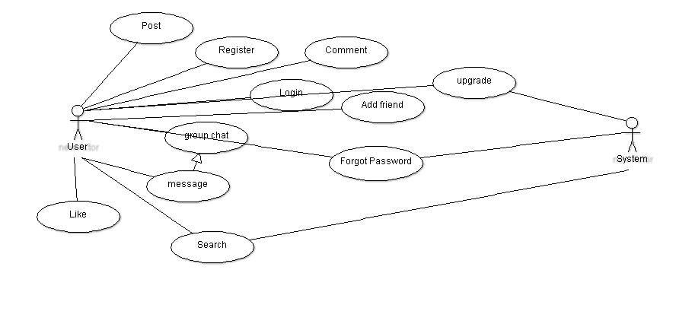

## Use Case Tables

|  |  |  |
| --- | --- | --- |
| Use Case ID: | 1 | |
| Use Case Name: | Register | |
| Actors: | User | |
| Pre-conditions: | User does not have an account | |
| Post-conditions: | User have created an account | |
| Flow of events: | **User Action** | **System Action** |
| 1- User enter data |  |
|  | 2- System Verify user data |
| Exceptions: | **User Action** | **System Action** |
| 1- User Enter email and Password. |  |
|  | 2- email is not valid or data are wrong  3- System rejects registration. |
| Includes: |  | |
| Notes and Issues: |  | |

|  |  |  |
| --- | --- | --- |
| Use Case ID: | 2 | |
| Use Case Name: | Forgot password | |
| Actors: | User | |
| Pre-conditions: | User forgot his/her password and cannot login. | |
| Post-conditions: | User have a new password and can login | |
| Flow of events: | **User Action** | **System Action** |
| 1- User email address |  |
|  | 2- System Verify user data  3- System sends an email to the email address. |
|  | 3- User changes his password through the mail  4- User Login |  |
|  |  |  |
| Exceptions: | **User Action** | **System Action** |
| 1- User Enter email |  |
|  | 2- email is not valid or data are wrong  3- System rejects registration. |
| Includes: |  | |
| Notes and Issues: |  | |

|  |  |  |
| --- | --- | --- |
| Use Case ID: | 3 | |
| Use Case Name: | Search | |
| Actors: | User | |
| Pre-conditions: | User is in the home page. | |
| Post-conditions: | User found the User | |
| Flow of events: | **User Action** | **System Action** |
| 1- User enter data in search button. |  |
|  | 2- System Verify user data  3- System searches for the data |
| 4- User can access the user/ group searched. |  |
| Exceptions: | **User Action** | **System Action** |
| 1. User enter data |  |
|  | 1. Data not found 2. System displays error message. |
| Includes: |  | |
| Notes and Issues: |  |  |

|  |  |  |
| --- | --- | --- |
| Use Case ID: | 4 | |
| Use Case Name: | Upgrade | |
| Actors: | User | |
| Pre-conditions: | User has a normal(free) account | |
| Post-conditions: | User has a premium account | |
| Flow of events: | **User Action** | **System Action** |
| 1- User requests premium account. |  |
|  | 2- System Verify user data   1. System withdraw price from credit card. |
| Exceptions: | **User Action** | **System Action** |
| 1- User request premium account |  |
|  | 2- Visa card number is not valid or not having enough money.  3- System rejects request. |
| Includes: |  | |
| Notes and Issues: |  | |