Detection of Credibility of Online Media Posts Using Deep Neural Network
Ravi Ranjan Mallik
Dept. of Computer Science and System Engineering
AU. College of Engineering, Andhra University
raviranjanmallikbe@gmail.com

Abstract-- Nowadays, Internet and social media have became the one of the primary medium to share the information. Everyday, we come across hundreds of online media posts and blogs. This paper shows an approach to detect the credibility of the posts and the sources of the post over online media. In this letter, we have performed posts detection method based on one of the artificial intelligence algorithms – Deep Neural Network. While there exist different other mechanisms for the similar work, we have obtained that the proposed method, for this given large labeled news data set, works better.
Keywords-- Deep learning, Long Short-term Memory (LSTM), Deep Neural Network (DNN), Online media post, spam detection, Text classification, Natural Language Processing (NLP).

- Introduction
The News media is one of the most important form to share news to the audiences and has widen its reach through different mediums: either printed, broadcast or through Internet. Due to the vast influence of Internet and ease of access of the reader, the online media posts and blogs have become one of the main sources for news broadcasting. The news through these posts and blogs spread real fast across the web world. Since most of the blogs and posts are produced by social or self journalist, most of the time, they are biased. These mass-media play a vital role in influencing the society. As the news goes viral, it's always challenging to determine whether they or their sources are genuine or fake. Most of the time, there’s someone who can take advantage of these fake news and manipulates the public opinion over a certain matter. These posts appear most frequent before or during election year.
There are several articles proposed describing detection of such posts. In [1] the author have described their method for fake news detection using Naive Bayes Classifier. In [2] the author have developed a method using Random Forest algorithm and classifying on the basis of different features. In [3] the authors provide an novel approach to define available techniques for the matter.
In this paper, the classification of those posts on the basis of their credibility is performed. With a large amount of data available, an artificial intelligence algorithm - Deep Learning approach is preferred in training the model for the detection of credibility of the post. The aim of the study is to examine how this particular method works for this particular problem given a manually labeled news dataset. The difference between these article and articles on the similar topics is that in this paper deep neural network along with the concept of word embedding and LSTM was to obtain the credibility of those posts. It was later, tested on a relatively new data set, which gave an opportunity to evaluate its performance on a recent data.
The concept of word embedding and LSTM to the deep neural network model to enhance the proposed model performance.
Rest of the article is organized as follows:
Section II will present an overview of the domain fields and its features that are employed in the proposed work
Section III describes the detailed methodology followed for the proposed work using the techniques mentioned in section II.
Section IV will visualize the result obtained on the selected dataset using proposed work and in Section V will discuss about what modification could be performed in near future.

- Deep Neural Network
“Deep learning, as a sub-class of machine learning, attempts to learn in multiple levels, corresponding to different levels of abstraction of information using artificial neural networks.”[4] In past several years, its researches have made vast impact on wide range of data processing areas.
Deep learning methods, in the field of NLP, is being used for tasks such as language modeling, part-of-speech tagging, machine translation, named entity recognition, sentiment analysis, and paraphrase detection which are performed without external hand-designed resources or time-intensive feature engineering. It develops and uses “embedding,” which refers to the representation of symbolic information in natural language text at word-level, phrase-level, and even sentence-level in terms of continuous valued vectors.

- LSTM
First introduced in[12], this feature of RNN bypasses the vanishing gradient problem during training by isolating the memory unit and the output unit where the current memory unit linearly depends upon the previous memory unit in a chained process. The architecture having three gates: input gate providing set of input to neuron, the forget gate to eliminate the unwanted information from input set based on previous input and the output gate to represent the expected output, it enhances the performance of the model. As proposed in [13], we found that word embedding suited LSTM than one-hot encoding.

- Word Embedding
As in paper[14], the Deep Neural network Embedding trains the network from high dimensional data space to low dimensional data space of embedding by minimizing both the objective function of dimensionality reduction algorithm and the reconstruction error of the input. It was introduced to bypass the “out-of-sample” problem which occur in one hot encoding for larger data sets.

- Methodology
In this paper, the data is being processed with the deep neural network models with Embedding and LSTM, where Word Embedding overcomes the out-of-sample problem and LSTM controls the loss of relevant information while training.
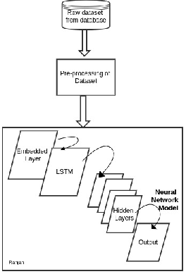

The proposed methodology is scheduled in five steps:

- Data Preprocessing:
The major challenge is to find out dataset of the posts or blogs on which detail analysis is to be performed and here, we have taken the labeled dataset from the Buzz Feed, collected from different stream pages. From the available 20 fields, we have select some relevant fields to retrieve news articles as our input dataset. With over 14000 record to work on, we have split the data into train and test in the ratio of 4:1 (train data: 80%, test data: 20%). Further, we have performed the steps of data preprocessing techniques over both, training dataset and test dataset. Since, the input to our model is only numeric tensor values, the data preprocessing on these dataset are carried on these set of steps:

  - Data Cleaning:
In this step, the data collected from different stream are parsed and their completeness is checked. Based on this step, the selection of relevant field is determined.
The field having null value or missing value is ignored and then are forwarded to the next step.

  - Vectorization:
This is the process of converting the input texts into numeric tensors that is to be fed to the model. For our model, we have conducted this process in two steps:
First, the test string are broken into n-grams chunks (Tokenization) and then their associated numeric vector are created. To create associated numeric vectors, we have used word embedding concept, where we have embedded a predefined word embedding Global Vectors for Word Representation (GloVe)[4].
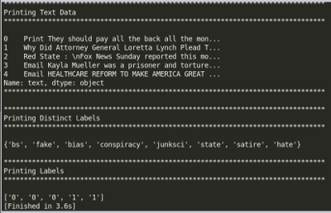

- Embedding Preprocessing
Deep neural network model requires a large dataset to learn powerful features, in failing in feeding that, we have here used a predefined word embedding stacked to the model through Embedding Layer. As the predefined embedding is an archive, to add it to model, we have followed two steps:
  - Parse the file into map index.
{ word --> vector }
word :
vector:
  - Construct an embedding matrix to pass it to the layer.
embedding_matrix=[max,dim]
max:
dim:
This matrix has shape of max_words (m) and embedding_dimension (d),
The size of matrix is as same as the size of our dataset, thus there won’t be input-output mismatch.
- Building the Network Model
In this section, we have described our proposed network model for classification.

  - The network architecture
It is the core building block of the network model. And our proposed model follows the Sequential Network Model Architecture, where each nodes in a layer is connected to each nodes of adjacent layer. As in fig[1], our model is composed of four different layers:
    - Embedding Layer
    - LSTM Layer
    - Dense Layers
    - Dropout Layer
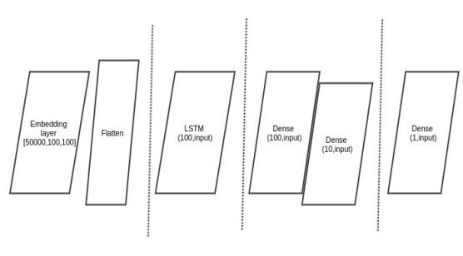

Fig. 1 Proposed Network Layered Model

  - The activation function
The activation function, also known as tensor operations, defines the behavior of output from the node for given input or set of inputs. When activated, it helps the neural network model to reduce the learning transformation of tensors by deciding which information from the input is relevant by transforming them non linearly.

With different types of activation function available, our network model has used :
  - ReLU
ReLU or Rectified Linear Unit function, defined as:
F(x) = x⁺ = max(0,x)
where x is the input, is a non linear function that back propagates the errors. Depending on the input behaviour, relevant (+ve) or irrelevant (-ve), it activates the neurons making the network parse and easy to compute.

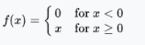
  - Sigmoid function:
This function is preferred when the model is expected to generate binary output or in range[0,1].
Mathematically,
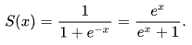
where x is a large set of output from previous layer. We have used Sigmoid function in our output layer of the network for the binary classification of the posts.

- Compiling the Network Model:
In this section, the compilation of the proposed network model is performed based on two primary factors:

  - Loss function :
This function is employed to minimizes the loss in quality of selected set of parameters based on their induced score with ground truth labels, and for our data set, we have choose binary cross-entropy to obtain the probabilistic output.
Binary cross-entropy is considered to be an ideal loss function while using Sigmoid function in output layer and expected output is either in the range of 0 and 1.

  - Optimizer:
The optimizer reduces the different cost function that determines the update of network based on loss function. For the proposed model, we have choose RMSprop algorithm for deep learning model.
RMSprop [15] has proven its effectiveness as a modification of Adagrad algorithm by discarding the extreme past history. The exponentially decaying average and the learning rate of 0.001 helps to optimize the model. It minimizes the loss during training due to loss function and mini-batch samples.
- Classification of posts
For the better distribution, we have made random shuffle to the dataset, and after that, we divided them into three subsets: training dataset, validation dataset, test dataset. The neural network will then use the training dataset for training classifier model whereas it will use validation dataset for tuning some global parameters of the classifier. The model then uses test dataset to estimate how well the model performs on new data.
At this final module, we are going to feed the test dataset to the trained model to analyze the prediction accuracy of the model. Based on obtained accuracy, we are going to evaluate different classification parameters and if possible, even enhancing the accuracy.

- RESULTS AND DISCUSSION
We randomly selected 600 posts and tested on our model. In the experiment we found that, model have acheved an accuracy of 89%. We have tested our test dataset on the model with and without LSTM, and found that model with LSTM worked exceptionally well. The figure [] show that how the training and test data have performed over the epoches count of 10.
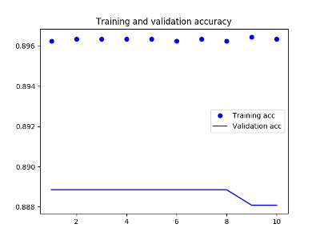
Figure 5. Training and Testing Accuracy
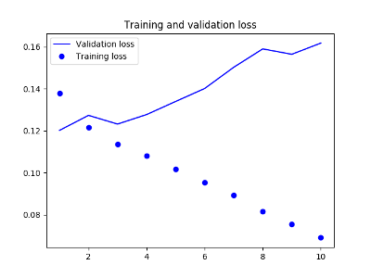
Figure 6. Training and Testing Loss

- CONCLUSION
In this paper, a model with LSTM is proposed to detect the credibility of the online media posts. In the comparision performed in betwee the DNN model with and without LSTM, we have found that the proposed model with LSTM have outperformed than the without one. The model is expected to work more acccurate when the size of dataset increases.

ACKNOWLEDGEMENT
The authors would like to thank P. Kaviti who assisted in the proofreading of this letter.
REFERENCES

- Mykhailo Granik, Volodymyr Mesyura (2017), Fake News Detection Using Naive Bayes Classifier, IEEE First Ukraine Conference on Electrical and Computer Engineering (UKRCON)
- .P. and Bhatia, K. (2018). Spam Detection using Naive Bayes Classifier. International Journal of Computer Sciences and Engineering, 6(7), pp.934-938.
- Suman Ravuri, Andreas Stolcke, A COMPARATIVE STUDY OF NEURAL NETWORK MODELS FOR LEXICAL INTENT CLASSIFICATION
- Julien Fontanarava, Gabriella Pasi, Marco Viviani, Feature Analysis for Fake Review Detection through Supervised Classification,
- Yan Huang, Wei Wang, Liang Wang, Tieniu Tan, A General Nonlinear Embedding Framework Based on Deep Neural Network
- G. Shanmugasundaram S. Preethi, I. Nivedha, Investigation on Social Media Spam Detection
- GloVe
- Deep Learning Book
- Felix A. Gers, Jiirgen Schmidhuber, Fred Cummins, Learning to Forget: Continual Prediction with LSTM, Artificial Neural Networks, 1999, Conference Publication No. 470 0 IEE 1999
- BuzzFeed

