**Great Catch**

**H**azards **E**liminating **L**eague **P**rofessionals

(HELP)

**Launch Report**

[Cycle 2]

**Date:**

[01/13/2017]

**Team Members (Initials):**

Name: Tiane Bai (TB)

Name: Daniel Grayson (DG)

Name: Alex Manning (AM)

Name: Yupeng Sun (YS)

Name: Wenyu Xin (WX)

Contents

**The System/Product****3**

Major Changes from LR_C1_G2 3

System/Product Name: 3

Introduction: 3

Highlighted Features: 4

Existing Devices Comparison 5

Sponsor or Proxy User: 6

Issues: 6

**The Team****6**

Team Name: 6

Team Members and their specialties: 7

Roles: 7

Specialties: 7

Team Communication: 8

Team Issues: 8

**The Plan****8**

Objectives: 8

Schedule: 9

**References****11**

**Table of Contributions****12**

# The System/Product

## Major Changes from LR_C1_G2

*Table 1. Overview of sections and their changes, using feedbacks received from LR_C1_G2*

|  |  |
| --- | --- |
| **Section** | **Changes** |
| Introduction | Added a paragraph on “Problem Needs” |
| Highlighted Features | Expanded fifth bullet  Added sixth bullet |
| Existing Devices Comparisons | Added this section |
| Issues | Updated third item |
| Team Name | Added group number |
| Specialties | Updated Daniel Grayson’s section |
| Team Issues | Updated issues |
| Schedule | Updated time and tasks |
| Reference | Added this section |
| Table of Contribution | Updated contributors |
| Entire Report | Light spelling and grammar editing |

## System/Product Name:

Great Catch

## Introduction:

According to a 2014 report [1] by Administration for Community Living, there were 46.2 million persons 65 years or older, which equivalent to 14.2% of total U.S. population at the time of survey. Moreover, prediction shows, by 2060, there will be 98 million elderly populations. Among those who are elderly, roughly 28% or 12.5 million seniors live alone. Based on a 2009 article [2] by Kaiser Family Foundation, people age 65 or older had the highest average spending per person in health care, which was $9,744 per person. If we combine the amount of older people and the average healthcare spending, we can roughly estimate the cost to caring elderly will reach staggering $460 billion per year. A study by Kalpa Kharicha [3] also highlighted that elderly who live alone tend to have poorer health, poorer vision, poorer diet, higher risk of social isolation, alcohol abuse, and other health hazards than those who live with someone. Combination of these studies and statistics indicates there should be something to be done on this issue of elderly who live alone are prone to more health issues and higher health care costs.

The Great Catch is a medical alert system that provides continuous health monitoring supports by collecting and analyzing wearable devices data. The system will use data from wearable sensors and user input information to detect any abnormal patterns compared with previous data trends, providing appropriate alerts to a pre-assigned contact person, such as caretakers and health professionals. The Great Catch is a valuable tool because most of the current devices and systems, such as FitBit and iWatch, do not offer any data analysis capabilities. These current systems are only acting as a fitness and wellness promoter that encourages users to move more by tracking their steps counts, number of floor climbed, and amount of sleep logged. This data tracking is great, but there is an underutilization of these collected data to monitor health issues

There are millions of seniors living by themselves who are in social isolation and need constant health monitoring. These seniors often ignore the signs and symptoms of a larger health issue because no one is around to care for them, or for fear of inconveniencing others. These seniors often face unnecessary hospital admissions and even preventable death. With Great Catch, these issues will be mitigated. The Great Catch will expand on top of current systems by not only providing wellness and fitness data, but also adding health monitoring features. The Great Catch will wirelessly and automatically transfer data from wearable sensors such as FitBit to a personal computer, where all data will be stored locally and securely. The sensor data will be numerical such as number of steps taken, floor climbed, and calories eaten. The Great Catch system will also allow textual or binary user input data such as medicine being taken at the moment and trivial yes-or-no questions like “do you feel pain”.

All information will be compiled and processed using machine learning algorithms and applied statistics to determine any abnormal patterns. If any questionable patterns are detected, text or email alerts will be sent to designated contacts. The system will also send different alerts based on various level of severity. Non-severe patterns such as a drop in step counts or increase in caloric intake will be alerted to family members or close friends. Family or friends from far away can provide the user with some attention and determine if there are larger issues. Severe patterns such as irregular heart rates or sudden high blood pressures will be directly alerted to health professionals who then will take a deeper look at the pattern to determine if there are any underlying health issues. Seniors are the targeted audiences for the system, but the system will target especially those who live alone, as they are more prone to neglect health issues. Once the Great System is in production, seniors will be able to download the application onto their computers and start living a healthier and happier life knowing that Great Catch is watching their backs.

## Highlighted Features:

* Enables wirelessly and automatically syncing data between wearable sensors and the application
* Allows optional user data input
* Protects users’ private data
* Utilizes machine learning algorithms to detect abnormal data trends
* Offers alert features to notify designed contact person

1. Senior users: reminders to take medicine or exercise; alerts sent to caretakers or health professionals
2. Caretakers: any abnormal patterns detected
3. Health professional: any life-threatening situations such as long periods without reply to alerts, multiple failures of the system to send alerts, or serious drops in vital signs

* Provides reporting options on selected data
* Easy to use and affordable

## Existing Devices Comparison

*Table 2. side by side comparison of Great Catch and other existing systems using Highlighted Features*

|  |  |  |  |  |
| --- | --- | --- | --- | --- |
|  | **Great Catch** | **Fitbit** | **iWatch** | **Lively Wearable by GreatCall** |
| **Wirelessly and automatically syncing data between wearable sensors and application** | Yes | Yes | Yes | Yes |
| **Allows optional user data input** | Yes, but with more focus on medical information | Yes, but limited to sleep and other fitness information | Yes, but limited to sleep and other fitness information | No |
| **Protects user’s private data** | Yes | Yes | Yes | Yes |
| **Has built-in intelligence using machine learning algorithms to detect abnormal data trends** | Yes | No | No | No |
| **Offers alert features to notify designed contact person** | Yes, but can send different alerts to different contacts base on issue severity | Yes, limited function as reminder | Yes, limited function as reminder | Yes, only if fall detected |
| **Provides reporting option on selected data** | Yes, integrated into the main system | Yes, integrated into the main system | No, need 3rd party tool | No, need 3rd party tool |
| **Is easy to use and affordable** | Yes | Yes | Yes | Yes |

## Sponsor or Proxy User:

The Great Catch team is very honored to have its external sponsor and technical advisor, Dr. Christopher C. Yang, on board. Assuming both of these roles, Dr. Yang will be the main contact person throughout the project. Besides the weekly scheduled meeting on Mondays with Dr. Yang as technical advisor to work on technicalities, the team will also try to arrange bi-weekly meetings with Dr. Yang as sponsor to verify desired user requirements. Actual users will be senior house staff located nearby or any seniors who are willing to participate, but these have yet to be finalized. Aside from the arranged in person weekly meetings, most of the contacting between Dr. Yang and the team will be via emails.

## Issues:

Currently, the Great Catch faces following issues with no immediate solutions:

1. The team is unsure the best route to easily transfer data wirelessly from devices to a desired database.
2. How often does the application sync the data and alert the designated contact? Too frequently will scare users away and too rarely will undermine the alert functions.
3. The team has little experiences with React.JS, which will be used to develop the front-end application.

# The Team

## Team Name:

G2 - Hazards Eliminating League Professionals (HELP)

## Team Members and their specialties:

### Roles:

Team Leader: Alex Manning

Database Designer: Daniel Grayson

Functional Designer: Yupeng Sun, Wenyu Xin

User Interface Designer: Tiane Bai

### Specialties:

Tiane Bai

I am a senior at Drexel University who is graduating in 2017 with a Bachelor in Computer Science. I concentrate on computing and UI design. Also, I developed lots of testing strategies during my last coop which was a testing role at Megger. I’ll do my best to help the team and deploy the product on time.

Daniel Grayson

I am a senior at Drexel University who is graduating in 2017 with a Bachelor in Information Systems. I concentrated on Information Security and Information Assurance. I worked a variety of jobs while in the Navy before Drexel, but my final job was ensuring my computer network was compliant with DoD standards and received accreditation to operate. In my co-op I continued working in cybersecurity implementing a client-server based laptop encryption solution. I also wrote a Powershell script to discover Personally Identifiable Information on shared network drives. In addition I have skills in database administration, PHP & MySQL based web servers, and Python coding.

Alex Manning

I am a senior studying Computer Science on track to graduate in 2017 with a Bachelor’s degree.  I have extensive experience with web technology, including full stacks.  My co-op experience also contributed to these skills, as I built sophisticated dashboards to surface content from multiple complex scientific data sets.  I have also worked with numerous databases and server architectures, in both JavaScript and Python. The biggest challenge for me on this project will be the machine learning aspects, the interaction with wearable hardware, and potentially working with mobile application development.

Yupeng Sun

I am a senior in the Computer Science Program at Drexel University. So I learned a lot of coursework about computer science. such as Database System Implementation, Computer Graphics, Programming Languages and UI interface. I have work experience with an internship in computer science last year. In the summer of 2014, I worked as a web developer at flychina.com, this was a small Internet company about sale flight tickets. I was responsible for maintaining and updating the company’s website data. I used MySQL software to develop these databases and stored data to support website for any users easy to buy tickets. This internship gave me experience in working and solution problems with end users.

Wenyu Xin

I am a Drexel senior who is pursuing 5-year accelerated degrees in Bachelor and Master of Science in Biomedical Engineering along with undergraduate and graduate minors in Computer Science. If you wonder how many Drexel credits will I have upon graduation in 2017, it is 271.5 credits. However, my specialty is neither in engineering nor in programming. Instead, my strength lies in quick learning. With strong and diverse education backgrounds, I am confident and capable of picking up any skill relatively fast. At my last co-op, for example, I was able to become a mediocre .NET developer after only a week of learning. Although I found a lot of fields interesting, I still favor the field of big data which is something I have worked on for past 2 co-ops and been working on current 2 projects. Enough said, I hope to use my limited skills to help out this product development cycle.

## Team Communication:

Team communications will be done via three main methods: email, Slack, and in-person. Email communication is done using group messaging using Drexel domain email addresses. Slack is a cloud-based application that allows all team members to exchange ideas and question instantaneously in a private group chat setting. Lastly, in-person meetings are done when needed. Regarding meeting schedules, online team communications (email and Slack) are done whenever is needed.

## Team Issues:

Here are some of the issues that the team face at the moment and suggested solutions:

1. Limited knowledge of machine learning techniques among all team members.

* Solution: consult with advisor Chris Yang and other professors with artificial intelligence background.

# The Plan

## Objectives:

In this project cycle, the three main objectives are team building, system analysis and design, and product prototyping. For team building, the goal is to allow all team members, the project advisor, and the stakeholder to get a chance to work with each other and sort out any issues. For system analysis and design, the idea is for all team members to get hands-on experience in how a software product is formally designed from start to finish. The goal is for team members to be more comfortable in the software design cycle throughout this and the next term. Lastly, product prototyping is where initial development on the final product, which needs to be delivered in June of 2017, begins. There will be ample time for troubleshooting and pivoting based on issues which arise during this segment. A summary of the timeline, resources, and tasks is shown below in Schedule section.

## Schedule:

*Table 3. Overview of dates, responsibility, and tasks for project period 1/9/2017 - 3/20/2017*

|  |  |  |
| --- | --- | --- |
| **Week of** | **Person** | **Task Summary/Contribution** |
| 01/09/2017 | TB, DG, AM, YS, WX | Launch Report |
| 01/16/2017 | TB, DG, AM, YS, WX | Celebrate MLK |
| 01/23/2017 | TB, DG, AM, YS, WX | Group Meet: Graduation information |
| 01/30/2017 | TB, DG, AM, YS, WX | SRS |
| 02/06/2017 | TB, DG, AM, YS, WX | Group Meet: Unknown |
| 02/13/2017 | TB, DG, AM, YS, WX | Prototype |
| 02/20/2017 | TB, DG, AM, YS, WX | SDS |
| 02/27/2017 | TB, DG, AM, YS, WX | Group Meet: Unknown |
| 03/06/2017 | TB, DG, AM, YS, WX | User Document |
| 03/13/2017 | TB, DG, AM, YS, WX | Group Meet: Unknown |
| 03/20/2017 | TB, DG, AM, YS, WX | Presentation |

Table 3 is used to summarize the beginning date of each task and the initials of team members who are responsible for each task. Overall, the main requirement is documentation and prototyping for this project cycle. Few product development tasks are scheduled for this quarter. More details are listed in Gantt charts below.

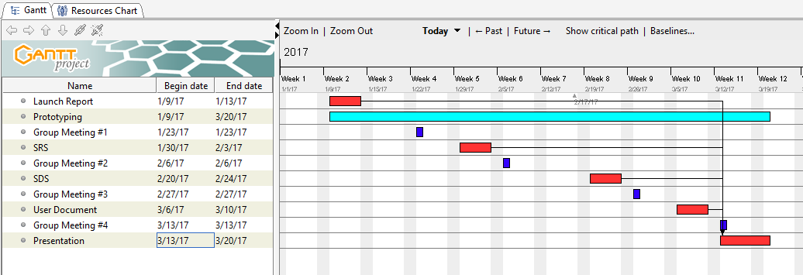

*Figure 1. Gantt Chart tasks scheduled for project period 1/9/2017 - 3/20/2017. Different colors are used for different tasks. Red pertains to the most important tasks. The arrows imply dependency between tasks. Dark Blue indicates meetings. Light blue indicates prototyping.*

The task pattern of the current project cycle is documentation and group meeting alternating. First is Launch Report, then Group Meeting #1. SRS and Group Meeting #2 follows. SDS and Group Meeting #3 are next. Final pair is User Document and Final Presentation. In order to make best of Final Presentation, it is important to complete Launch Report, SRS, SDS, and User Document, which are indicated using dependency arrays. The Prototyping is on-going task for entire cycle period. Sub-tasks of Prototyping are not listed.

In Figure 2, team members are considered as resources and tasks are assigned to all resources respectively. The detail of tasks is not depicted in the figure. All resources are participated in all tasks scheduled. Red label is indication of task overloading. However, due to the even distribution of tasks among all members, the overloading does not apply here. Blue indicates normal task load.

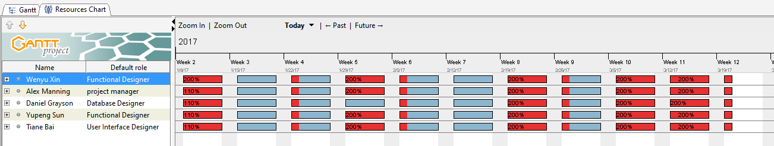

*Figure 2. resources Gantt Chart needed for project period 1/9/2017 - 3/20/2017. Red color indicates potential tasks overloading. Blue color indicates normal tasks load.*

# References

[1] Administration for Community Living, “Administration on Aging - highlights”, Administration for Community Living, 2014. [Online]. Available:  http://www.aoa.acl.gov/aging_statistics/profile/2014/2.aspx/. [Accessed Nov. 27, 2016]

[2] Kaiser Family Foundation, “Health Care Costs: A Primer”, Kaiser Family Foundation, May 01, 2012. [Online]. Available:  http://kff.org/report-section/health-care-costs-a-primer-2012-report/. [Accessed Nov. 27, 2016]

[3] K. Kharicha, D. Harari, C. Swift, G. Gillmann, A.E. Stuck, “Health risk appraisal in older people 1: ara older people living alone an ‘at-risk’ group?”, *BJGP*, 57(537): 271-276, April 2007.

# Table of Contributions

*Table 4. Contributions to this Launch Report with respected section and initials of contributors*

|  |  |  |  |
| --- | --- | --- | --- |
|  | **Section** | **Writing** | **Editing** |
| **1** | **Project** | WX | DG, AM |
| **2** | **Team** | AM, TB, YS, WX, DG | DG, AM |
| **3** | **Plan** | WX | DG, AM |

Very Good.   
  
A+

I certify that:

* This paper/project/exam is entirely my own work.
* I have not quoted the words of any other person from a printed source or a website without indicating what has been quoted and providing an appropriate citation.
* I have not submitted this paper / project to satisfy the requirements of any other course.

Signature: __________________________ Date:       ____________________

Signature: __________________________ Date:       ____________________

Signature: __________________________ Date:       ____________________

Signature: __________________________ Date:       ____________________

**Grading**

The grade is given on the basis of quality, clarity, presentation, completeness, and writing of each section in the report. This is the grade of the group. Individual grades will be assigned at the end of the term when peer reviews are collected.