**Great Catch**

**H**azards **E**liminating **L**eague **P**rofessionals

(HELP)

**User Document**

[Cycle 3]

**Date:**

[5/15/2017]

**Team Members (Initials):**

Name: Tiane Bai (TB)

Name: Daniel Grayson (DG)

Name: Alex Manning (AM)

Name: Yupeng Sun (YS)

Name: Wenyu Xin (WX)

**Table of Contents**

**Introduction** **3**

Overview 3

References 3

**System Installation** **3**

System package 3

System Requirements 3

Installation Instructions 3

**System Use** **4**

Basic Features 4

Fitbit User signup 4

Log in 4

Sign out 5

View Alert History 5

View Report 7

**System Maintenance** **7**

## Introduction

The Great Catch is a web platform which allows seniors and their caretakers to monitor their lifestyle and behaviors and obtain detailed statistics and analysis.

### Overview

The system aims to prevent issues from occurring by alerting caretakers and seniors of potentially harmful behavior. The system interacts with FitBit in order to integrate seniors’ wearable data into powerful statistical analysis to provide useful data to the users. This document provides details about the composition of the system, as well as detailed usage instructions in order to guide users in operating with the system. This document contains installation and usage instructions, along with detailed screenshots of the system.

### References

No external references were used in creating this documentation.

### Limitations

Great Catch uses data analytics to find correlations in activity data obtained by users wearing a Fitbit. The system is designed to detect trends and provide a warning if trends suggest ill health. The data can be used to augment a doctor's decisions, but the system should not be used in place of a doctor’s decisions.

## System Installation

### System package

The system requires access to the FitBit API via a standard user account on the website.

### System Requirements

The system requires users to have a modern web browser (Chrome, Firefox, Edge, or similar). Users must also have access to a mouse and keyboard. The system will be usable from mobile devices, but is not explicitly designed around it.

### Installation Instructions

The system is wholly web-based, so there is no installation step. Users must synchronize their data with FitBit in order to utilize the data tracking and analytics section of the system.

## System Use

#### Fitbit User Signup

Senior users can sign up using this form by providing some basic information, such as first and last name, email address, and a password (Figure 3.1). Pressing the Get Started button will process the new user account.

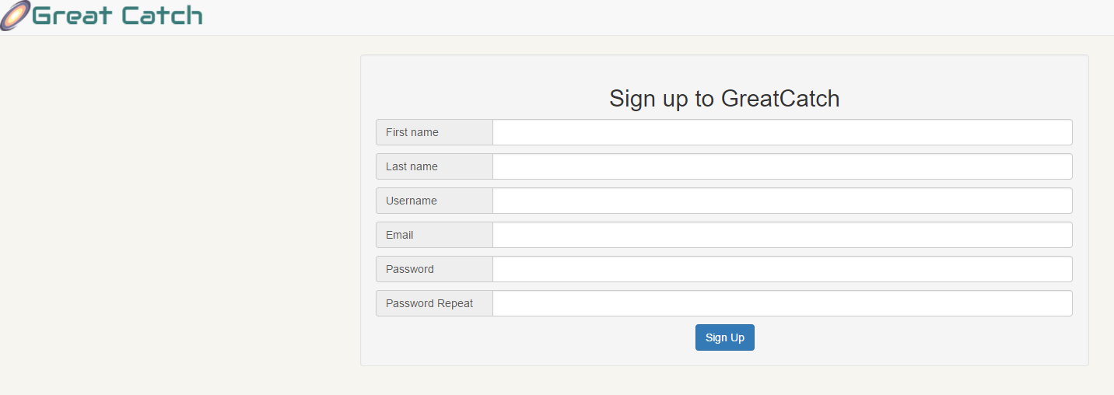

Figure 3.1 User Sign-up

#### Log in

Senior users and caretakers can log into the system by providing the email address and password associated with their previously created user account (Figure 3.3). Pressing the Login button will authenticate the user with the system.

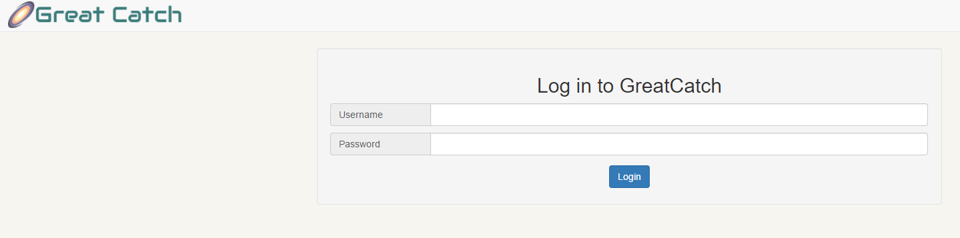

Figure 3.2 User Login

#### Authorizing with Fitbit

After creating an account with Great Help the user must authorize Great Help to access the user’s Fitbit data (Figure 3.3). Upon clicking the Authorize Fitbit, a popup will open from the Fitbit website in which the user can allow Great Catch access to their Fitbit data (Figure 3.4).

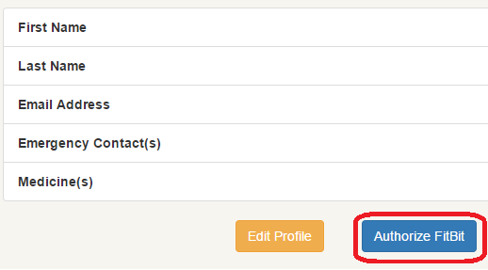

Figure 3.3 Authorize Fitbit

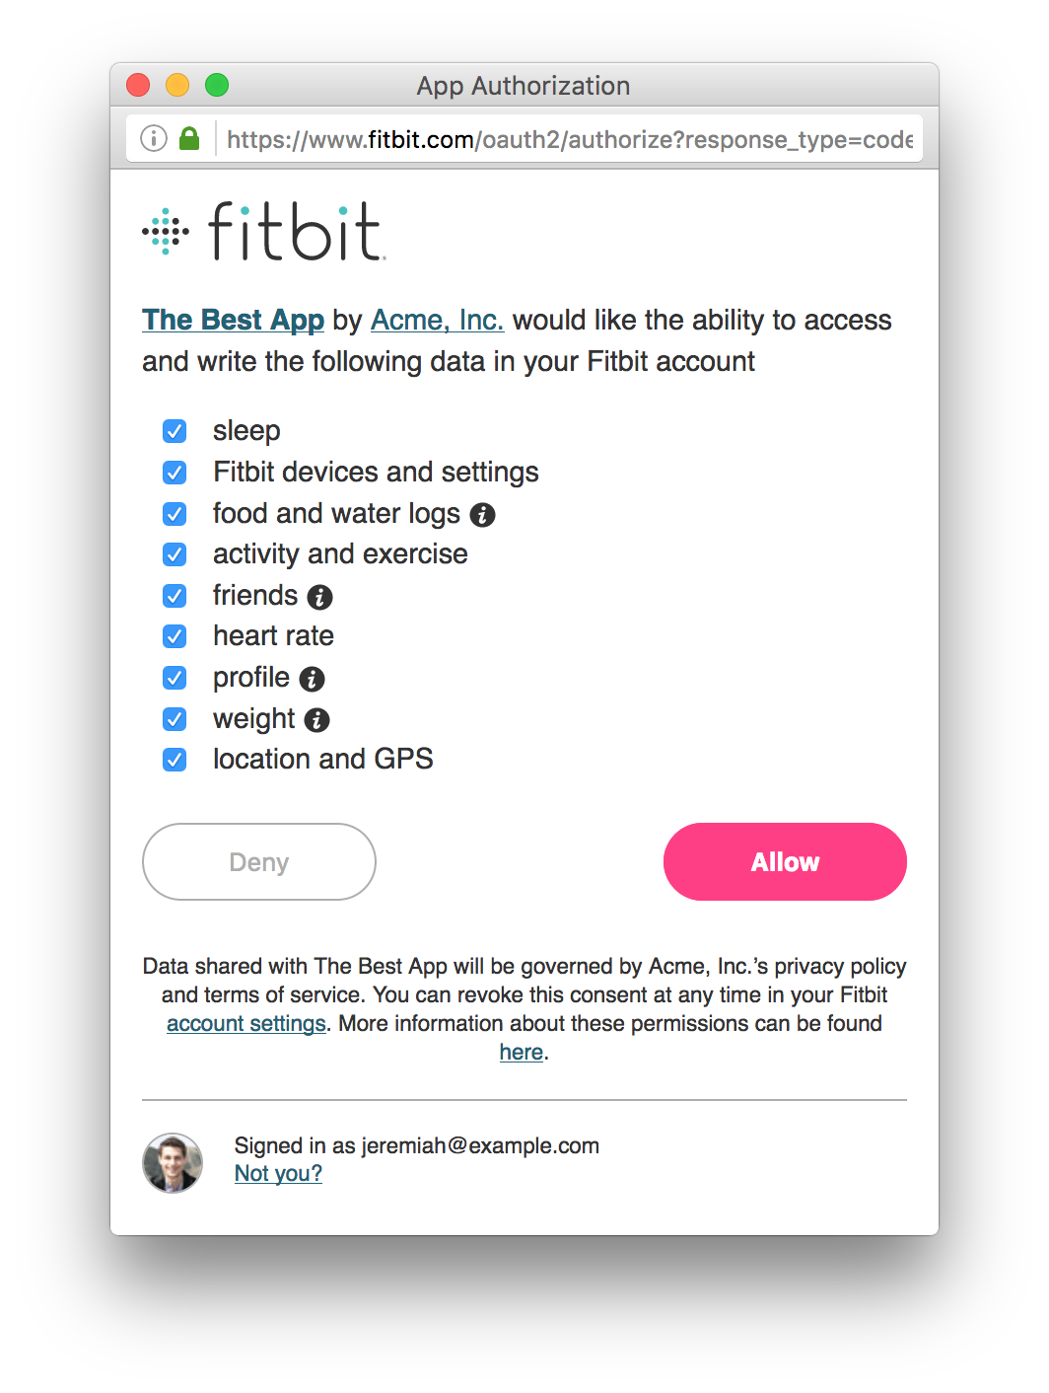

Figure 3.4 Fitbit Authorization Popup

* 1. **Editing Profile**

Users can edit their profile information using the “Edit Profile” button at their dashboard page.

Adjust the content in the fields as shown below.

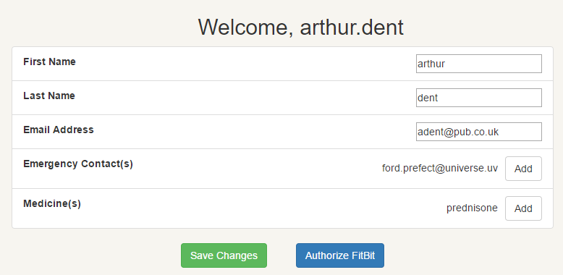

Figure 3.5 Update Profile

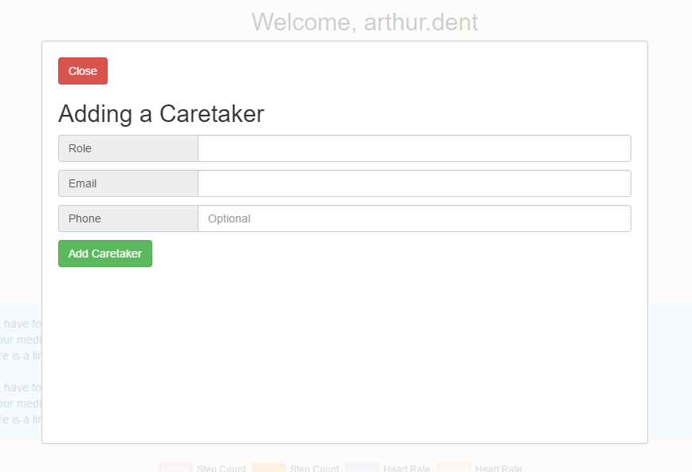

Figure 3.6 Add Caretaker

The user can press “Save Changes” to update their existing profile information.

* 1. **Logging Out**

Users can sign out of the system via the Log Out link along the navigation bar (Figure 3.5). This will deauthenticate the user from the system, allowing for safe exiting.

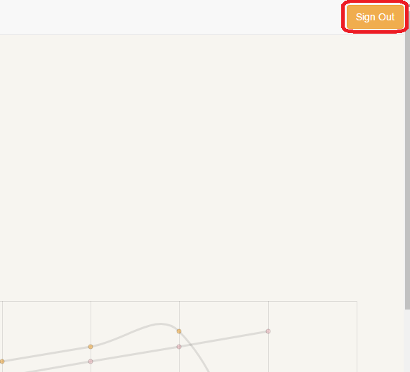

Figure 3.7 User Sign Out

#### View Alert History

Users can select the Alert History tab to view any alerts that were produced by the system and sent to seniors and caretakers (Figure 3.6). For seniors, this list will state all alerts attached to that senior, whereas caretakers will see alerts which were sent to them. Each alert will have the date, level, and caretakers contacted.

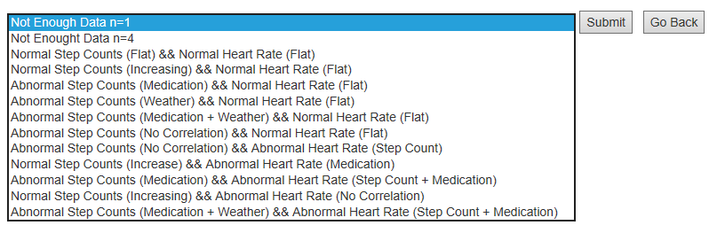

Figure 3.8 Alert History

#### View Report

Seniors can view reports on health and activities by selecting the Report section (Figure 3.6). The user can select an alert to view a report on the alert. The alert will show any medication that might have caused the alert and a graph of the 14 days period containing the alert.

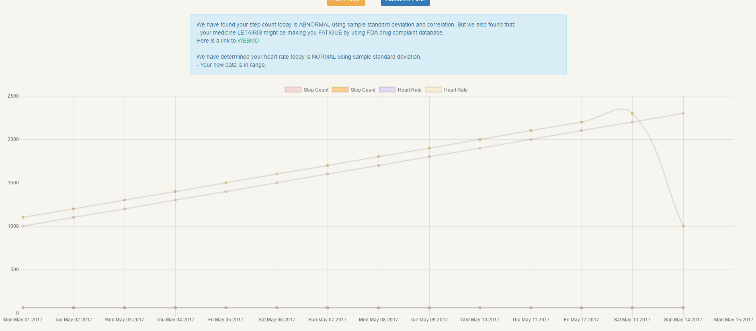

Figure 3.9 Report

## System Maintenance

The current system does not plan on users conducting any system maintenance functions.

**Table of Contributions**

The table below identifies contributors to various sections of this document.

|  |  |  |  |
| --- | --- | --- | --- |
|  | **Section** | **Writing** | **Editing** |
| 1 | Introduction | AM | DG, AM |
| 2 | Installation | AM | DG, AM |
| 3 | Use | WX, AM, TZ, YS | DG, AM |

I certify that:

* This paper/project/exam is entirely my own work.
* I have not quoted the words of any other person from a printed source or a website without indicating what has been quoted and providing an appropriate citation.
* I have not submitted this paper / project to satisfy the requirements of any other course.

Signature: __________________________ Date:       ____________________

Signature: __________________________ Date:       ____________________

Signature: __________________________ Date:       ____________________

Signature: __________________________ Date:       ____________________

**Grading**

The grade is given on the basis of quality, clarity, presentation, completeness, and writing of each section in the report. This is the grade of the group. Individual grades will be assigned at the end of the term when peer reviews are collected.