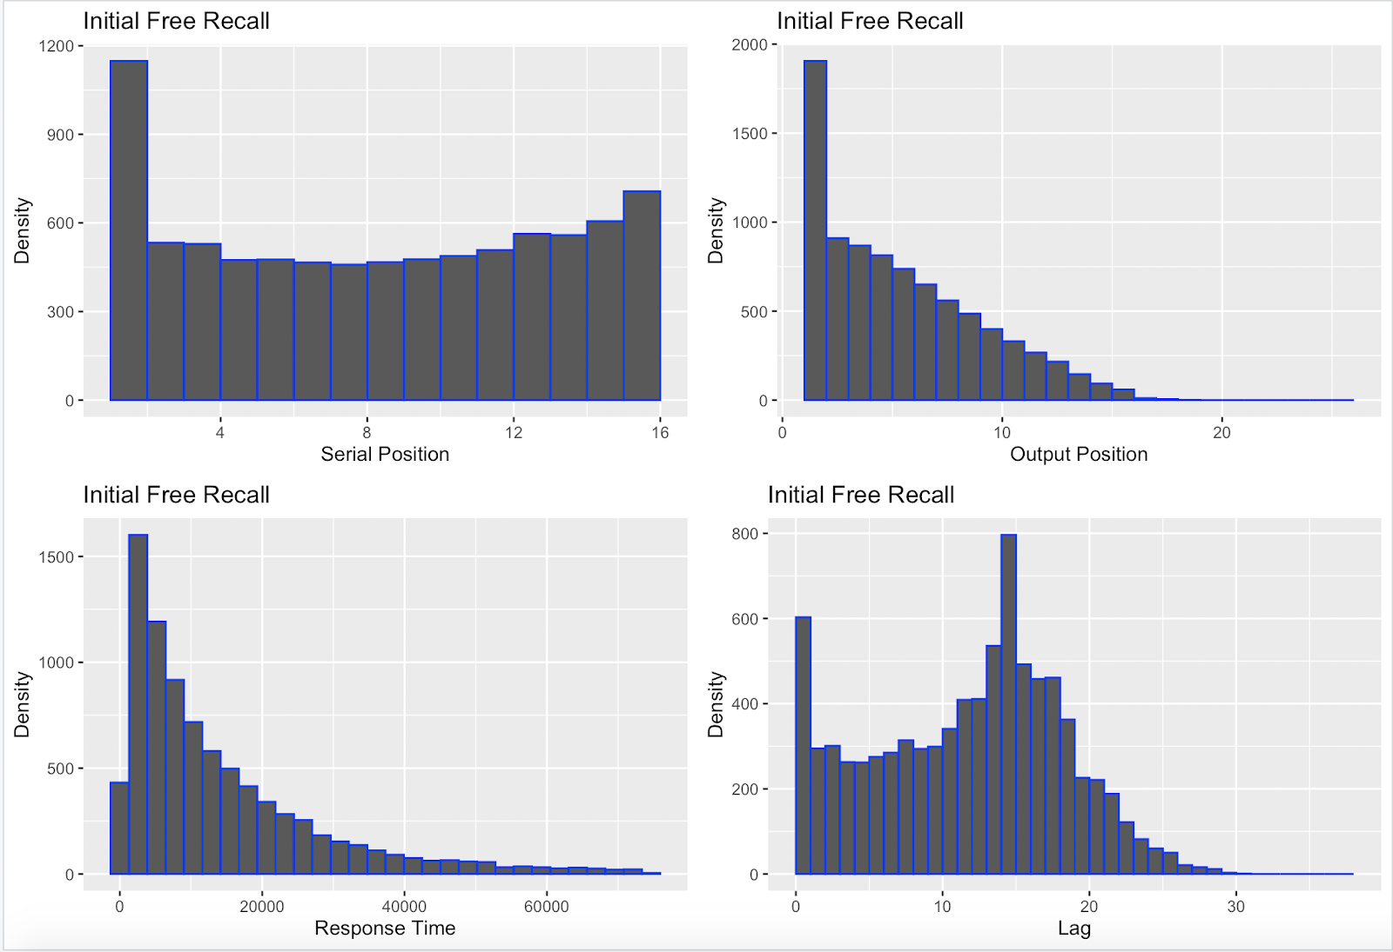

**IFR Only**

* Grid 1