**video-to-barcode**

This document describes a program made by me called "video-to-barcode". The program takes a video or a set of videos, and create a graph. A barcode graph whereas each bar in the barcode represents a frame in the movie. Then using the resulted barcode of each movie, we can do some visual analysis to try and understand what the movie.

Some examples (I used the trailer of the movies in all examples and not the whole movie):

1. I took an horror movie called "**texas chainsaw massacre (2012)".**  From the following barcode, we can see that the movie start with some non-dark color (blue), which means it starts with no scary/horror scene, but later the horror scenes start.

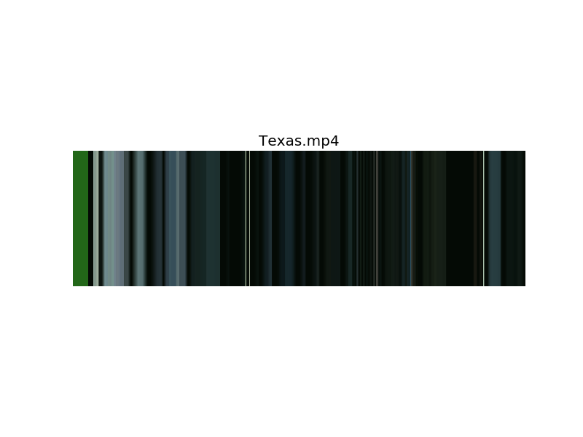

1. I used the "**Titanic**" movie, From the following barcode, we can see it has many blue frames, because the movie happens in the ocean. also some dark frames, because most of the scenes happen in the night.

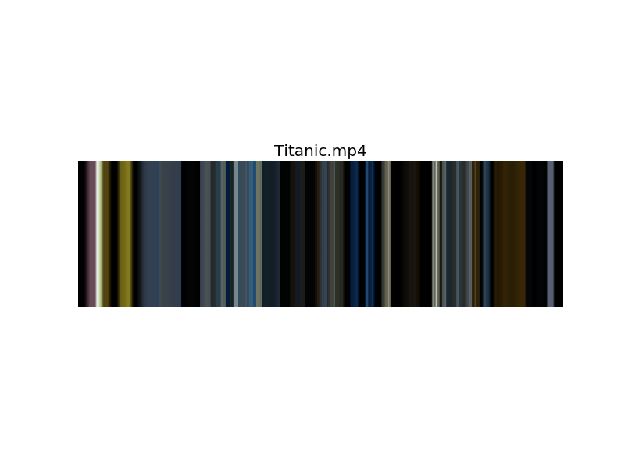

1. Comparing 2 movies from different genres : comedy and action.

I took the comedy movie: "**The dumb and dumber**",

And the action movie: "**Harry Potter and the Deathly Hallows - Part 2**".

We can see the difference between both movies in the following barcode.

We can see that in the comedy movie, the dominant color is the light color. And in the action movie, it is dark and black.

which is obviously why, in the action movie they want to make people feel a little bit scared by making it dark. while in the comedy movie they want people to feel happy so they avoid dark color and keep it "happy".

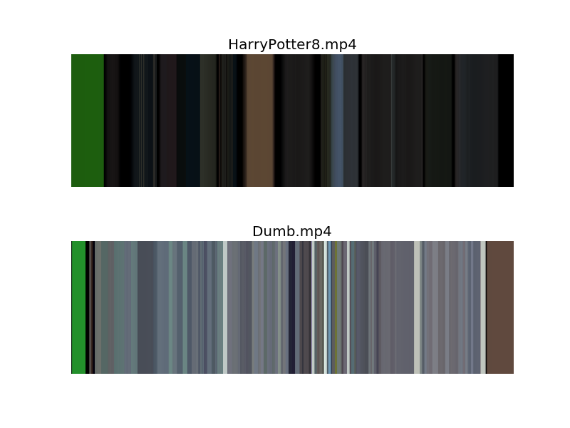

1. For the last example, I took a video which can be downloaded from the following link :

http://www.sample-videos.com/video/mp4/720/big_buck_bunny_720p_1mb.mp4

For each frame I split it to 100 rows (for each row I took the dominant color), The following barcode shows the result.

From the barcode, we can see the bunny movement same as it moves in the movie. from the left to right, where it goes out of the cave and start moving. also we can see the grass it moves on.

