* **1 To configure a switch**

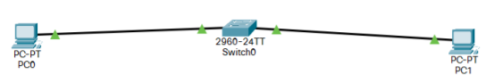

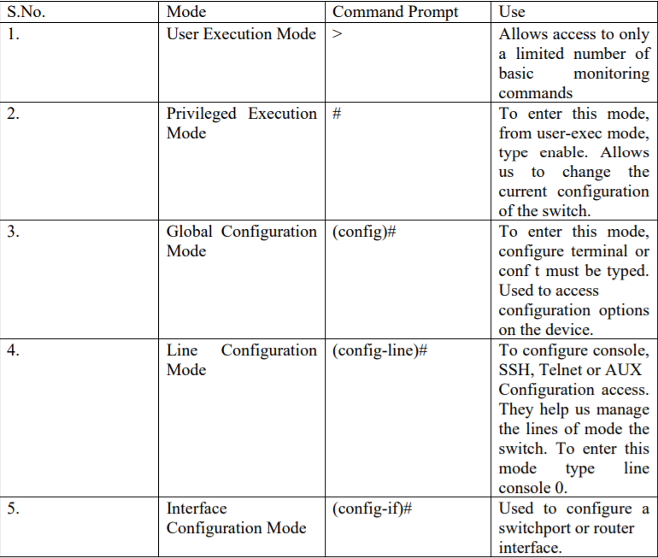

Switch>en

Switch#conf t

**Switch(config)#hostname *switch***

Switch(config)#**interface** *vlan1*

Switch(config-if)#**ip address** *172.16.10.2* *255.255.255.0*

Switch(config-if)#**exit**

Switch(config)#**ip default-gateway** *172.16.10.1*

**Switch(config)#enable secret *somestrongpass***

GfgSwitch(config)#line console 0

GfgSwitch(config-line)#password GFG

GfgSwitch(config-line)#login

Switch(config)#end

* **2 To configure router**

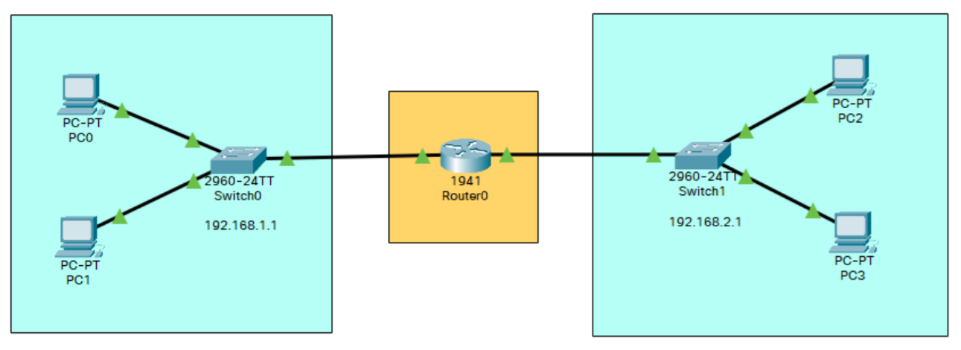

Router>en

Router#conf t

Router(config)#hostname MyRouter

MyRouter(config)#interface g0/0

MyRouter(config-if)#ip address 192.168.1.1 255.255.255.0

MyRouter(config-if)#no shut

MyRouter(config-if)#interface g0/1

MyRouter(config-if)#ip address 192.168.2.1 255.255.255.0

MyRouter(config-if)#no shut

MyRouter(config-if)#exit

MyRouter(config)#exit

MyRouter#show ip interface brief

MyRouter>en

MyRouter#conf t

MyRouter(config)#interface loopback 0

MyRouter(config-if)#ip address 100.0.0.1 255.255.255.0

MyRouter(config-if)#interface loopback1

MyRouter(config-if)#end

MyRouter#show ip interface brief

* **3 To configure VLAN**

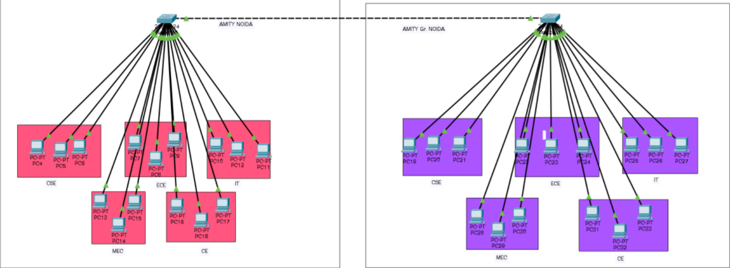

**(For Switch 1)**

Switch>en

Switch#conf t

Switch(config)#vlan 60

Switch(config-vlan)#name CSE1

Switch(config-vlan)#exit

(Repeat for each dept)

Switch(config)#interface fa0/4

Switch(config-if)#switchport mode access

Switch(config-if)#switchport access vlan 60

Switch(config-if)#exit

(Repeat 3 times for each dept)

Switch(config)#exit

Switch#show vlan brief

**(Repeat For Switch 2)**

* **4 To configure router as a DHCP server**

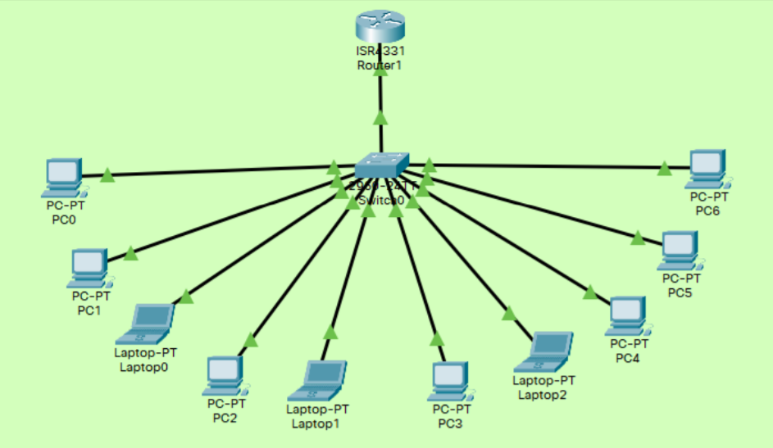

For Router 0

Router>en

Router#conf t

Router(config)#hostname Router

Router(config)#interface GigabitEthernet0/0/0

Router(config-if)#ip add 192.168.1.1 255.255.255.0

Router(config-if)#no shut

Router(config-if)#exit

Router(config)#ip DHCP pool abc

Router(dhcp-config)#default-router 192.168.1.1

Router(dhcp-config)#network 192.168.1.0 255.255.255.0

Router(dhcp-config)#exit

Router(config)#do wr

* Trunk

S1# **conf t**

S1(config)# **interface** *interface_id*

S1(config-if)# **switchport mode trunk**

S1(config-if)# **switchport trunk native vlan** *vlan_id*

S1(config-if)# **switchport trunk allowed vlan** *vlan-list*

S1(config-if)# **end**

* RIP

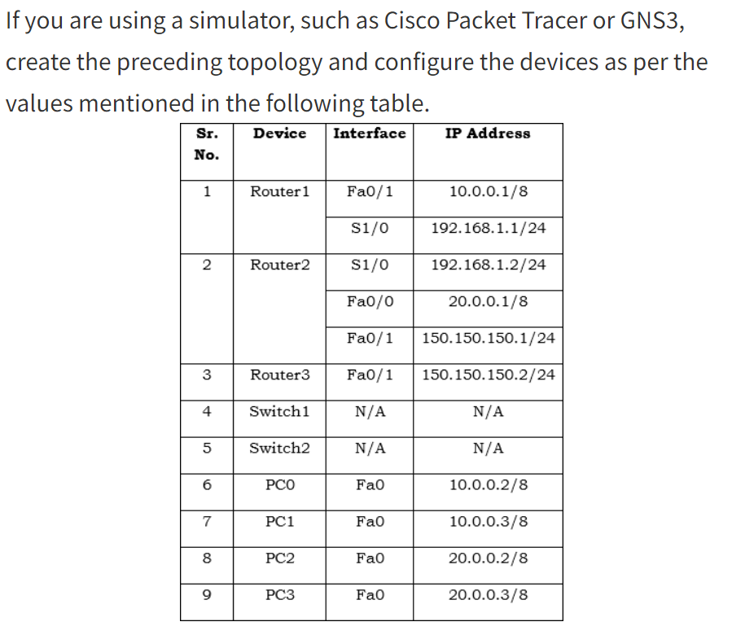

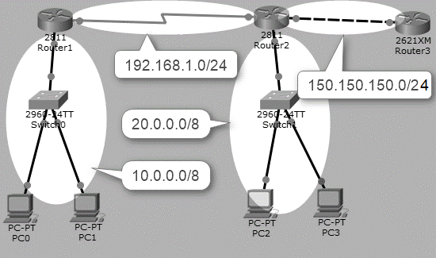

1. On **Router1**, execute the following commands to configure **RIP** routing.

Router1(config)#router rip

Router1(config-router)#network 10.0.0.0

Router1(config-router)#network 192.168.1.0

Router1(config-router)#exit

1. On **Router2**, execute the following commands to configure**RIP**routing.

Router2(config)#router rip

Router2(config-router)#network 20.0.0.0

Router2(config-router)#network 192.168.1.0

Router2(config-router)#network 150.150.150.0

Router2(config-router)#exit

1. On Router3, execute the following commands to configure RIP routing.

Router3(config)#router rip

Router3(config-router)#network 150.150.150.0

Router3(config-if)#exit

1. Once you have configured RIP routing protocol on each router, wait for a few seconds (let complete the convergence process), and then execute the show ip route command on any router to show the routing information.

Router(config)#do show ip route