Name: Sheikh Hasan Bin Bakhtiar

Id: 2023-1-60-053

Sec:05

Cse200

Date: 22/9/24

Final exam

**1**.3d:

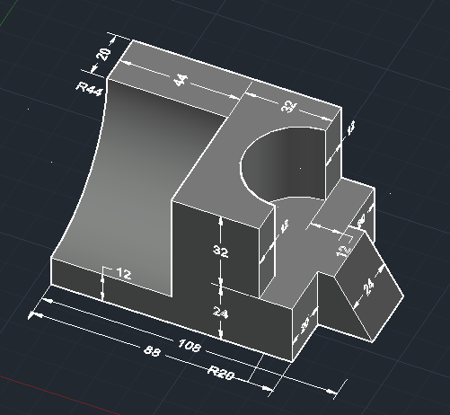

2d:

\

Section view:

**2**.3D:

