SEKA KAMA

A Spatial Decision Support System for Lion Conservation
System architecture, predictive workflow, and methodological limits
Technical research paper | Greater Mara ecosystem | Repository review: 28 September 2026

Abstract
Seka Kama is an open-source geospatial decision-support platform intended to help users examine relationships between human activity, landscape conditions, and modeled lion abundance in the Greater Mara ecosystem. This paper reconstructs the system from its source repository: a Next.js mapping interface calls a FastAPI service, which retrieves intersecting grid cells through Supabase/PostGIS, prepares ordered feature vectors, applies a fitted scaler and an XGBoost regressor, and returns cell-level and aggregated scenario contrasts. Optional ecological enrichment uses NASA POWER precipitation and GBIF occurrence counts; a configurable language-model service can translate scenario text into feature changes and produce narrative context. The implemented scenario is a snapshot counterfactual. Although the API schema contains a simulation-years field, the route rejects nonzero horizons because validated time-indexed inputs are not available. The repository also contains model-performance values in API metadata, but this review did not reproduce those metrics from a training and validation pipeline. Seka Kama should therefore be read as an interactive modeling and exploration system whose outputs depend on the supplied data, fitted artifacts, and assumptions, rather than as a validated population forecast or autonomous ecological digital twin.
Keywords: spatial decision support; lion conservation; XGBoost; PostGIS; scenario analysis; Greater Mara

1. Introduction
Land-use change can alter habitat quality, connectivity, and exposure to human activity. Seka Kama addresses this planning problem by combining a gridded ecological data model, interactive maps, and a prediction service that lets users perturb selected features and compare model outputs. The project describes its purpose as examining how human expansion and land-use change relate to East African lion viability [1].
This paper documents the system as implemented in the repository, not as a field evaluation. It covers the software stack, data flow, model interface, scenario mathematics, supporting services, operational boundaries, and reproducibility needs. It distinguishes executable behavior from claims in narrative documentation and model metadata.

2. System overview
The platform has a browser-based client, Python API, spatial database interface, model-inference layer, and optional external-data and language-model integrations. Grid-cell records provide the spatial unit of analysis. Users select a polygon and optional management units; the API retrieves intersecting records, enriches available environmental context, changes selected model features, and evaluates baseline and modified feature arrays with the same regressor.
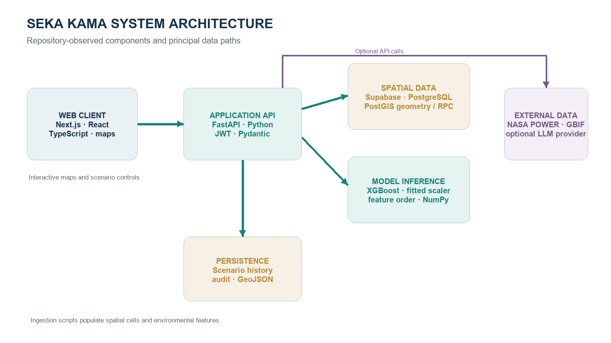
Figure 1. Component architecture inferred from source code and deployment configuration. External calls and persistence are optional or environment-dependent.

2.1 Software stack
Layer | Repository implementation | Role in the system
Web client | Next.js 16, React 19, TypeScript; MapLibre GL, deck.gl, Kepler.gl; Recharts | Pages, map layers, scenario controls, charts, and API calls.
API and orchestration | FastAPI 0.115, Python; Pydantic; Uvicorn | REST endpoints, validation, authentication dependencies, and request orchestration.
Spatial persistence | Supabase client; PostgreSQL with PostGIS schema/RPC functions | Grid cells, geometry intersections, protected areas, scenario history, and account records.
Predictive computation | XGBoost CPU 2.1.4, NumPy, joblib, fitted scaler | Transforms ordered feature vectors and computes cell-level regression outputs.
External enrichment | NASA POWER rainfall endpoint; GBIF occurrence API | Optional annual precipitation and occurrence-count context; failures can fall back to stored data.
Narrative and operations | OpenAI-compatible LLM client; optional Prometheus/Grafana in production compose | Text-to-feature interpretation/narrative; operational metrics in configured deployment.

The default compose file is a compact local arrangement with PostGIS, FastAPI, and the web application. A separate production compose file describes PostgreSQL, Redis, backend, frontend, Prometheus, Grafana, exporters, and an optional Nginx proxy. These manifests represent deployment configurations; the repository alone does not prove that all services are deployed or operational.

2.2 Frontend and API boundary
The Next.js client exposes map and dashboard experiences and uses a typed API service to request baselines, scenarios, explanations, ecosystem indicators, exports, and API-key operations. The API defines REST routes with Pydantic request and response models. Scenario requests carry GeoJSON geometry, a map of feature modifications, optional management-unit filters, an optional natural-language query, and a simulation-years value. Authenticated scenario execution persists a request and result when database access succeeds [2, 3].

3. Data model and spatial processing
The core analytical record is a polygon grid cell in EPSG:4326. The initialization schema stores geometry and centroid, management-unit label, nightlight and population summaries, distance to protected areas, selected seasonal statistics, year, and baseline/model outputs. Ingestion scripts populate or enrich layers; examples include grid-cell import, land-cover and NDVI ingestion, protected-area import, and rainfall retrieval [4]. The schema and runtime data can differ as migrations and external sources evolve, so column availability and completeness should be checked for each deployment.
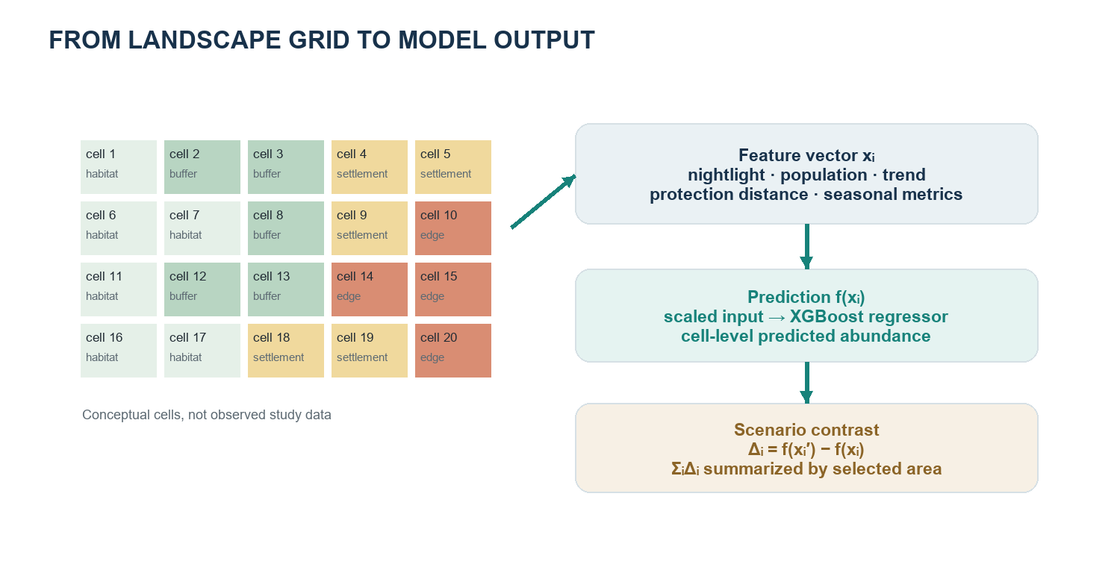
Figure 2. Conceptual cell-to-model transformation. Colors and labels are illustrative and do not depict observed Mara measurements.

3.1 Geometry selection
For a user-drawn polygon, the spatial service normalizes GeoJSON and calls a PostGIS RPC function to retrieve intersecting grid cells. If that path raises an exception, it attempts a table query and in-memory geometry intersection using Shapely. Optional management units constrain the selection. The API may also enrich selected records with rainfall, prey-occurrence, and derived human-wildlife-conflict context. This enrichment is best understood as auxiliary context: the feature vector used for inference is governed by the serialized feature-name artifact and model contract.

3.2 Feature representation and preprocessing
At process initialization, the backend attempts to load three versioned artifacts: the XGBoost model, fitted scaler, and ordered feature-name list. The prediction service constructs each row in that exact order, converts values to numeric form, and substitutes zero for missing or invalid values in selected paths. It then applies the fitted scaler before model inference. Missing-value substitution preserves execution but can conflate an unknown measurement with a genuine zero; data completeness should therefore be tracked separately when interpreting results.
zᵢⱼ = (xᵢⱼ − μⱼ) / sⱼ and ŷᵢ = fₓ₉ᵦₒₒₛₜ(zᵢ)
(1) Feature scaling and cell prediction. μⱼ and sⱼ are learned by the serialized scaler; the fitted model is loaded from repository artifacts.
The stored estimator is an XGBoost regressor and the API metadata identifies the objective as squared-error regression. The source establishes the inference path but does not, in this checkout, provide a complete training notebook or a reproducible validation protocol tied to the artifacts. Model version and performance values returned by the metadata endpoint are software metadata, not independently confirmed study results.

4. Scenario method
A scenario compares predictions on the selected cells before and after feature perturbation. It does not simulate demographic processes, individual movement, births, deaths, or year-by-year population transitions. The standard endpoint rejects requests with a nonzero simulation horizon and returns an HTTP 422 response until time-indexed inputs are available [2].
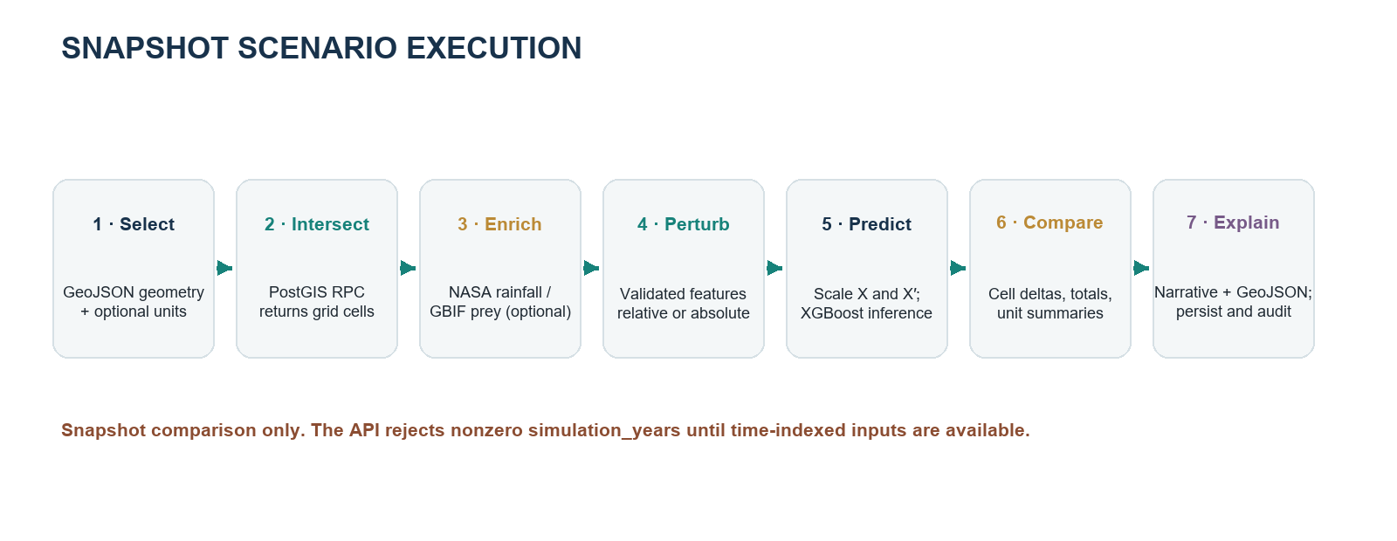
Figure 3. Executable scenario workflow. Enrichment and narrative generation are optional integrations subject to configuration and service availability.

4.1 Feature perturbations
Modification keys are checked against the trained feature list. In percentage mode, non-near-zero continuous features are multiplied by one plus the requested fraction. Near-zero values (absolute magnitude below 0.01) instead receive the fraction as an additive shift. In absolute mode, the requested value is added directly. The implementation skips percentage-style modification for a short hard-coded set of categorical or index features. These semantics should be considered when translating a user instruction into numeric changes.
x′ᵢⱼ = xᵢⱼ(1 + δⱼ), |xᵢⱼ| ≥ 0.01; x′ᵢⱼ = xᵢⱼ + δⱼ, |xᵢⱼ| < 0.01
(2) Implemented percentage-mode rule for a modified feature. δⱼ is supplied as a fraction, e.g., 0.15 for a 15% increase; the near-zero branch acts additively.
x′ᵢⱼ = xᵢⱼ + aⱼ
(3) Implemented absolute-mode rule, where aⱼ is the requested additive change.

4.2 Prediction contrasts and aggregation
For each selected cell, the service predicts baseline and modified outputs using the same preprocessing and regressor. The difference is a model-output contrast. Totals are sums across selected cells and management-unit summaries aggregate cell-level outputs. Percent change is calculated from summed scenario and baseline predictions; if the baseline sum is zero, the implementation returns zero percent change to avoid division by zero.
Δᵢ = f(z′ᵢ) − f(zᵢ); ΔΣ = Σᵢ Δᵢ; Δ%Σ = 100(Σᵢ f(z′ᵢ) / Σᵢ f(zᵢ) − 1)
(4) Cell-level and selected-area scenario contrasts, when the baseline sum is nonzero.
The response schema labels these aggregates as lion totals and deltas. Scientifically, the values inherit the target definition and units of the fitted model and grid. Unless the target is documented as an abundance per cell with compatible area weighting, summing cell predictions should not be interpreted automatically as a census population total. The source repository should be supplemented with target-unit metadata before consequential use.

5. Ecological context and interpretive services

5.1 Auxiliary indicators
The ecological-data service requests annual precipitation from NASA POWER and queries GBIF for selected herbivore occurrence records around a coordinate. The GBIF-derived quantity is occurrence records divided by an approximate square bounding area; it is a data-availability proxy, not a calibrated animal-density estimate. The service also defines a bounded human-wildlife-conflict (HWC) index using nightlight intensity, proximity to protected areas, and rainfall scarcity. The weights and thresholds are explicit engineering assumptions in code, rather than coefficients estimated from a labeled conflict dataset.
H = min(1, 0.50·min(L,1) + 0.35·max(0,(10−D)/10) + 0.15·max(0,(800−R)/800))
(5) Implemented HWC score where L is nightlight intensity, D is distance in km, and R is annual rainfall in mm; if rainfall is absent, a neutral 0.075 contribution is used.
External lookups are optional and can fail or return incomplete records. Some routes provide fallback context when enrichment fails. Values used in a narrative must consequently be labeled with their provenance and date if the resulting analysis is to be reproducible.

5.2 Natural-language interpretation
The scenario route passes a user query, explicit modifications, and selected-area averages to an OpenAI-compatible provider configured through environment settings. Climate-related wording can trigger an on-demand rainfall lookup. The service is asked to map natural language into model-feature changes and generate a narrative from computed results. This layer is an interface and explanation aid; it does not replace the numerical model and should not be treated as independent validation, causal evidence, or ecological ground truth.

5.3 Corridor heuristic
The corridor service fetches protected-area centroid anchors and searches for cells whose stored baseline lion density exceeds a threshold while nightlight intensity is low. It then connects qualifying cells to nearby anchors using a simple degree-distance cutoff and an approximate conversion to kilometres. Despite the service description’s reference to a resistance surface, the inspected implementation is a nearest-anchor screening heuristic, not a least-cost-path algorithm over a rasterized resistance surface. Corridor outputs should be interpreted as candidate links for inspection, not validated movement routes.

6. Reliability, security, and auditability
The backend uses JWT-based authentication, password hashing, endpoint dependencies, request validation, structured logging, and circuit-breaker objects for selected upstream services. Scenario calls save request parameters, aggregate outputs, narrative text, and GeoJSON where persistence succeeds, and invoke an audit service. Health responses report model and database state plus required environment-variable presence. Deployment configurations include health checks and optional metrics infrastructure.
Operational safeguards do not by themselves establish scientific reliability. A production assessment should verify secret management and row-level access policies, database geometry validity and spatial reference, input provenance, model-artifact integrity, upstream-data timestamps, and behavior under missing or stale features. Health checks report service availability, not ecological predictive validity.

7. Evidence, limitations, and reproducibility
Evidence category | Repository-grounded finding | Implication
Executable model path | Artifact load → ordered vector → fitted scaler → XGBoost predict. | Supports reproducible inference only when matching artifacts and inputs are retained.
Snapshot scenarios | Feature changes are applied to selected cells and outputs are contrasted. | A conditional model sensitivity analysis; not a time-forward population forecast.
Temporal projections | Nonzero simulation_years is rejected by the API. | No implemented multi-year trajectory should be reported.
Reported metrics | API metadata contains R² 0.892, test RMSE 3.42, validation score 0.885. | Values are hard-coded metadata in the route; training split, data, and reproduction steps were not verified here.
External prey proxy | GBIF occurrence counts are normalized by an approximate area. | Records are not equivalent to abundance or density without detectability correction.
Corridor output | Thresholded cells are linked by simple proximity. | Candidate visualization only; no validated movement or least-cost analysis demonstrated.
Population totals | Per-cell outputs are summed in the scenario service. | Interpret totals only after confirming response target units and any required area weights.

7.1 Reproduction checklist
- Record the commit hash, runtime settings, and versions of all three model artifacts.
- Publish training labels, feature definitions and units, spatial/temporal coverage, exclusions, and missing-data rules.
- Provide a leakage-aware spatial or temporal holdout protocol and scripts that recompute every metric with uncertainty intervals.
- Version raw data snapshots and record source, retrieval time, geographic coverage, and transformations for each layer.
- Test prediction stability under missing features, unit-level aggregation, zero baselines, and alternate perturbation semantics.
- Validate scenario effects and candidate corridors against independent ecological observations before decision use.

8. Conclusion
Seka Kama integrates web mapping, geospatial queries, tabular environmental features, and XGBoost inference in a usable scenario-exploration workflow. Its strongest implemented analytical function is a spatially selected, snapshot comparison between baseline and perturbed model outputs. NASA POWER, GBIF, and language-model integrations can add context, while the system records scenario requests and results for review. Current source does not support a multi-year projection, a validated movement corridor, or a verified population forecast. Publication-grade ecological conclusions require explicit target units, provenance, reproducible model evaluation, and external validation of the scenario and corridor interpretations.

References and repository sources
[1] Seka Kama project overview. README.md. Repository source documentation, reviewed 28 September 2026.
[2] Seka Kama backend API. backend/api/routes.py; backend/api/models.py. Scenario route and request/response definitions.
[3] PredictionService. backend/services/prediction_service.py. Feature preparation, scaling, scenario calculation, and aggregation.
[4] Database schema and ingestion workflow. backend/sql/init_database.sql; backend/scripts/; docs/workflow.md.
[5] Spatial and ecological services. backend/services/spatial_service.py; corridor_service.py; ecological_data_service.py; llm_service.py.
[6] Client and deployment configuration. web-app/seka_kama/package.json; web-app/seka_kama/services/api.ts; docker-compose.yml; docker-compose.prod.yml.
[7] Model metadata endpoint. backend/api/routes.py, /model/metadata. Values reported by software endpoint; not independently re-estimated for this paper.

