1. Create a Bank class and declare an instance variable named amount of type double.Create parameterized constructor to initialize variable “amount” with value 10000.Create two methods withdraw(double withdrawalAmount) and deposit(double depositAmount).Calculate withdrawal based on some condition (using ternary operator) like If amount is sufficient then “withdraw successful” message will be printed on the console and amount should be updated after withdraw. Later on, deposit 5000 in the account balance.At the end display total balance on the console.

**package** labQuestions;

**public** **class** Bank {

//instance variable amount

**private** **double** amount;

// Parameterized constructor to initialize amount = 10000

**public** Bank(**double** amount) {

**this**.amount = amount;

}

// Method withdraw with double withdrawalAmount

**public** **void** withdraw(**double** withdrawalAmount) {

//ternary operator to check if the amount is sufficient for withdrawal

String message = (amount >= withdrawalAmount)

? "Withdraw successful"

: "Insufficient balance";

System.***out***.println(message);

// Update amount if withdrawal successful

amount = (amount >= withdrawalAmount) ? amount - withdrawalAmount : amount;

}

// Method deposit with depositAmount

**public** **void** deposit(**double** depositAmount) {

amount += depositAmount;

System.***out***.println("Deposit successful");

}

// Method to display balance

**public** **void** displayBalance() {

System.***out***.println("Total Balance: " + amount);

}

**public** **static** **void** main(String[] args) {

//class Bank object and initialize amount to 10000

Bank account = **new** Bank(10000);

// Try to withdraw 3000

account.withdraw(3000);

// Deposit 5000

account.deposit(5000);

// Display the total balance

account.displayBalance();

}

}

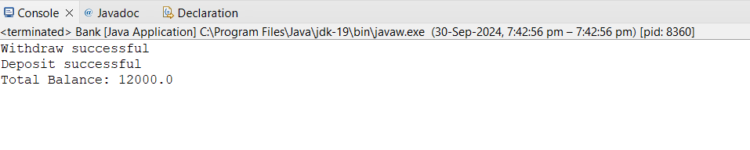

2. Write a program to input two numbers and find the maximum between two numbers using the conditional/ternary operator.

**package** labQuestions;

**import** java.util.Scanner;

**public** **class** GreaterOfTwo {

**public** **static** **void** main(String[] args) {

//Scanner object

Scanner sc = **new** Scanner(System.***in***);

//input 2 numbers

System.***out***.println("Enter first number");

**int** a = sc.nextInt();

System.***out***.println("Enter second number");

**int** b = sc.nextInt();

// check for Greater using ternary operator

**int** max = (a > b)? a : b;

//Print the maximum

System.***out***.println("Maximum number is :"+max);

}

}

