//Write a program to check whether a number is a Strong number or not. Strong number is a special number whose sum of factorial of digits is equal to the original number. For example: 145 is a strong number. Since, 1! + 4! + 5! = 145

**package** labQuestions;

**import** java.util.Scanner;

**public** **class** StrongNumber {

**public** **static** **void** main(String[] args) {

Scanner sc = **new** Scanner(System.***in***);

System.***out***.print("enter the number:");

**int** n = sc.nextInt();

**int** i,fact,sum=0,r;

**int** copy=n;

**while** (n > 0) {

r = n % 10;

fact=1;

**for**(i = 1; i <= r; i++) {

fact *= i;

}

sum += fact;

n = n/10;

}

**if**(sum==copy)

System.***out***.println("strong number");

**else**

System.***out***.println("not a strong number");

}

}

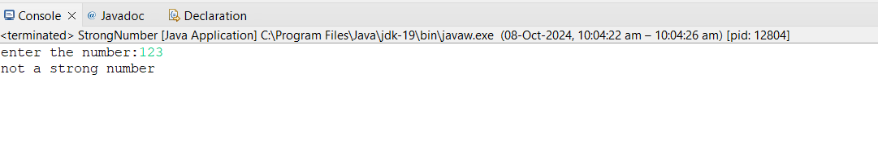

//Write a program to check leap year using if else. How to check whether a given year is a leap year or not. [Hint:Take an input of any number. Store it in some variable say year. If a year is exactly divisible by 4 and not divisible by 100, then it is a leap year. Or if a year is exactly divisible by 400 then it is a leap year.]

**package** labQuestions;

**import** java.util.*;

**public** **class** LeapYearOrNot {

**public** **static** **void** main(String[] args) {

Scanner year =**new** Scanner(System.***in***);

System.***out***.println("enter the year to check for leep year or not :");

**int** n=year.nextInt();

**if**(n%4==0&&n%100!=0){

System.***out***.println("this is a leep year");

}

**else** **if**(n%400==0){

System.***out***.println("this is the leep year :");

}

**else** System.***out***.println("not a leep year");

}

}

