LAB 7

1.Write a Java program to associate the specified value with the specified key in a HashMap.

package src;  
import java.util.HashMap;  
  
public class HashMapExample {  
 public static void main(String[] args) {  
 // Create a HashMap to store key-value pairs  
 HashMap<String, Integer> map = new HashMap<>();  
  
 // Adding key and values to map  
 map.put("Apple", 10);  
 map.put("Banana", 20);  
 map.put("Cherry", 30);  
  
 // Display all key-value pairs in the HashMap  
 System.*out*.println("All key-value pairs in the HashMap:");  
 for (String k : map.keySet()) {  
 System.*out*.println(k + ": " + map.get(k));  
 }  
 }  
}

Output :

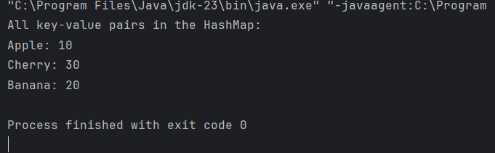

2. Write a Java program to check whether a HashMap contains key-value mappings (empty) or not.

package src;  
import java.util.HashMap;  
  
public class HashMapCheck {  
 public static void main(String[] args) {  
 // Create a HashMap  
 HashMap<String, Integer> map = new HashMap<>();  
  
 // Check if the HashMap is empty  
 if (map.isEmpty()) {  
 System.*out*.println("The HashMap is empty.");  
 } else {  
 System.*out*.println("The HashMap contains key-value mappings.");  
 }  
  
 // Adding a key-value pair to the HashMap  
 map.put("One", 1);  
  
 // Check again if the HashMap is empty  
 if (map.isEmpty()) {  
 System.*out*.println("The HashMap is empty.");  
 } else {  
 System.*out*.println("The HashMap contains key-value .");  
 }  
 }  
}

Output :

