LAB 5

1.Write a program to reverse a given List of strings.
import java.util.ArrayList;
import java.util.Collections;
import java.util.List;

public class AJPlab5a {
public static void main(String[] args) {
// Create a List of strings
List<String> stringList = new ArrayList<>();
stringList.add("Apple");
stringList.add("Banana");
stringList.add("Cherry");
stringList.add("Date");

// Display the original list
System.out.println("Original List: " + stringList);

// Reverse the list
Collections.reverse(stringList);

// Display the reversed list
System.out.println("Reversed List: " + stringList);
}
}
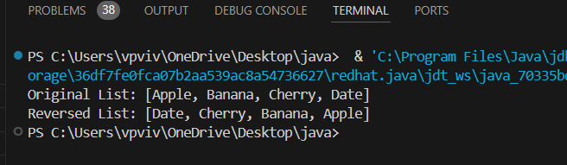

2.Write a Java program that calculates the sum of all even numbers present in an ArrayList of integers.

import java.util.ArrayList;
public class AJPlab5b {
public static void main(String[] args) {
// Create an ArrayList of integers
ArrayList<Integer> numbers = new ArrayList<>();
numbers.add(10);
numbers.add(15);
numbers.add(20);
numbers.add(25);
numbers.add(30);
numbers.add(35);
numbers.add(40);

// Calculate the sum of even numbers
int sum = 0;
for (int number : numbers) {
if (number % 2 == 0) { // Check if the number is even
sum += number; // Add to sum
}
}

// Display the result
System.out.println("Sum of even numbers: " + sum);
}
}
