LAB – 6

1.Write a Java program to append the specified element to the end of a HashSet.
import java.util.HashSet;
public class AppendToHashSet {
public static void main(String[] args) {
// Create a HashSet
HashSet<String> hashSet = new HashSet<>();

// Add elements to the HashSet
hashSet.add("Apple");
hashSet.add("Cherry");

// Print the original HashSet
System.out.println("Original HashSet: " + hashSet);

// Element to append
String elementToAdd = "Mango";

// Append the specified element to the end of the HashSet
hashSet.add(elementToAdd);

// Print the updated HashSet
System.out.println("Updated HashSet after appending " + elementToAdd + ": " + hashSet);
}
}
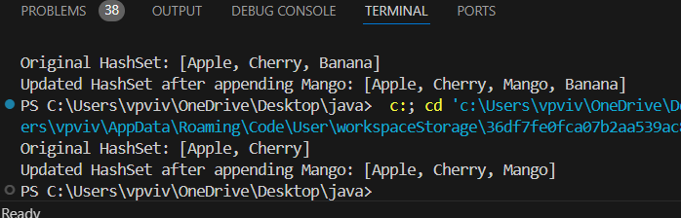

2. Write a program to declare stack.Store 10 elements into it.Remove 4 elements from stack and display it.
import java.util.Stack;
public class StackOperations {
public static void main(String[] args) {
// Create a stack
Stack<Integer> stack = new Stack<>();

// Store 10 elements in the stack
for (int i = 1; i <= 10; i++) {
stack.push(i);
}

// Display the stack
System.out.println("Stack after adding 10 elements: " + stack);

// Remove 4 elements from the stack
for (int i = 0; i < 4; i++) {
stack.pop();
}

// Display the stack after removing elements
System.out.println("Stack after removing 4 elements: " + stack);
}
}