Lab 9
1.Write a program to prints numbers from 0 to 4 using thread
public class AJPlab8a extends Thread {
public void run() {
for (int i = 0; i < 5; i++) {
System.out.println(i);
try {
Thread.sleep(500); // Sleep for 500 milliseconds
} catch (InterruptedException e) {
System.out.println("Thread interrupted: " + e.getMessage());
}
}
}

public static void main(String[] args) {
// Create an instance of the NumberPrinter thread
AJPlab8a thread = new AJPlab8a();

// Start the thread
thread.start();

// Wait for the thread to finish
try {
thread.join();
} catch (InterruptedException e) {
System.out.println("Main thread interrupted: " + e.getMessage());
}

System.out.println("Done!");
}
}
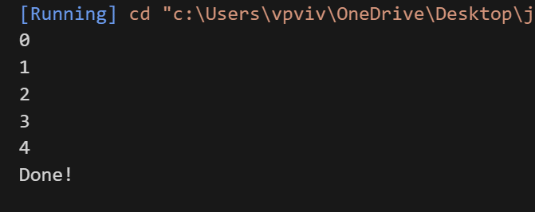

2.Write a program to prints 1 to 10 and sleep for 500ms using thread
public class AJPlab8b implements Runnable {
public void run() {
for (int i = 1; i <= 10; i++) {
System.out.println(i);
try {
Thread.sleep(500); // Sleep for 500 milliseconds
} catch (InterruptedException e) {
System.out.println("Thread interrupted: " + e.getMessage());
}
}
}

public static void main(String[] args) {
// Create a Runnable instance
AJPlab8b printer = new AJPlab8b();

// Create a thread with the Runnable
Thread thread = new Thread(printer);

// Start the thread
thread.start();

// Wait for the thread to finish
try {
thread.join();
} catch (InterruptedException e) {
System.out.println("Main thread interrupted: " + e.getMessage());
}

System.out.println("Done!");
}
}
