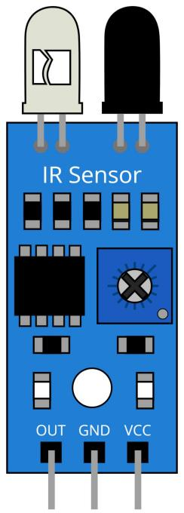

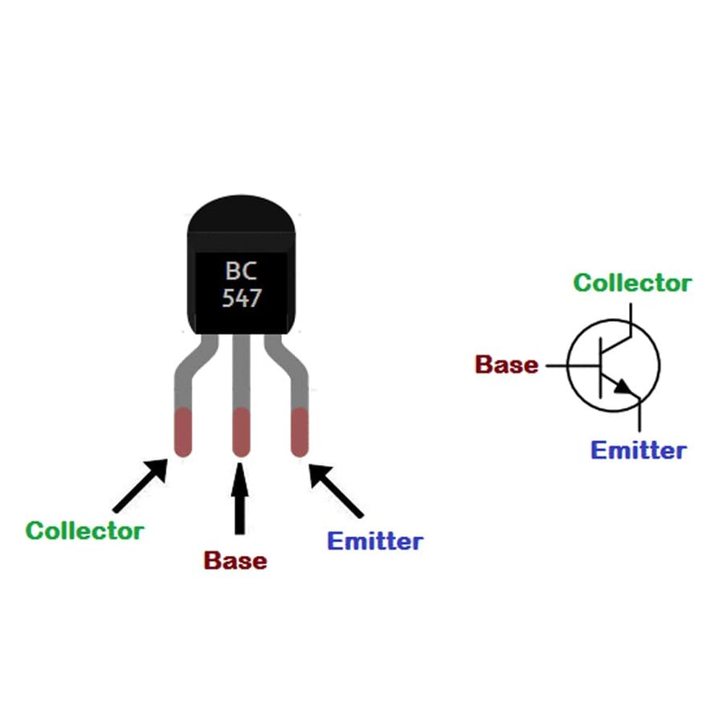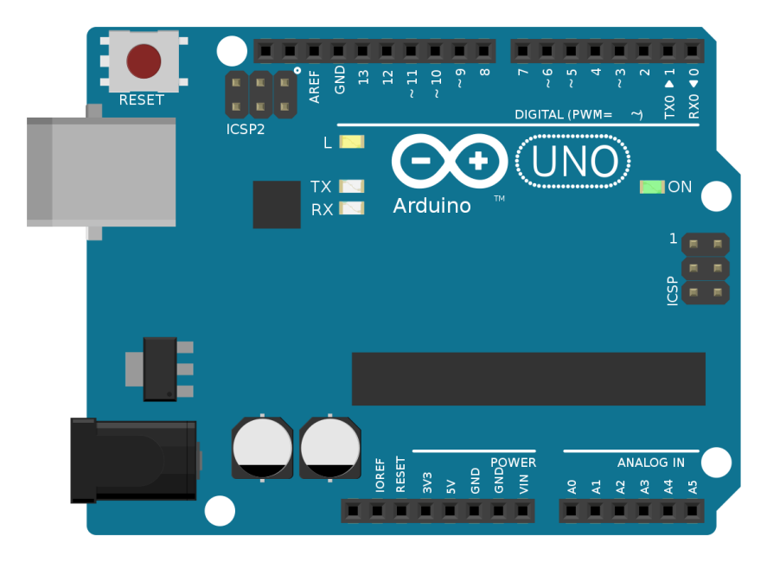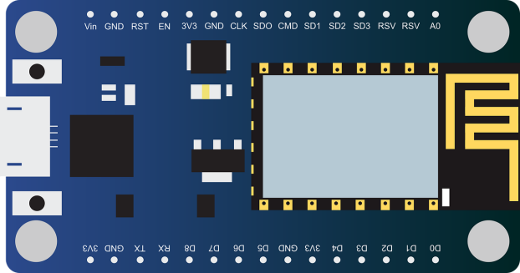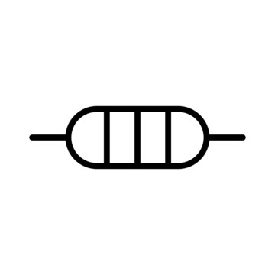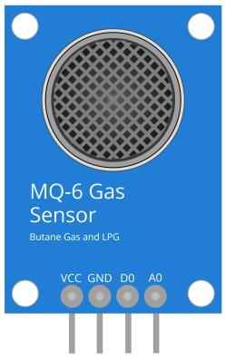

1k

10k

|  |  |
| --- | --- |
| Item | Quantity |
| IR Sensor | 1 |
| MQ 3 Sensor | 1 |
| Photo Diode | 1 |
| 10k ohm | 1 |
| 1k ohm | 1 |
| 547 Transistor | 2 |
| Buzzer | 1 |
| Node MCU ESP 8266 | 1 |
| Arduino Uno | 1 |
| Relay | 3 |

Pinaka || Fatima Sana