# Mirth Connect - Transformer JavaScript Reader SQL Server Database

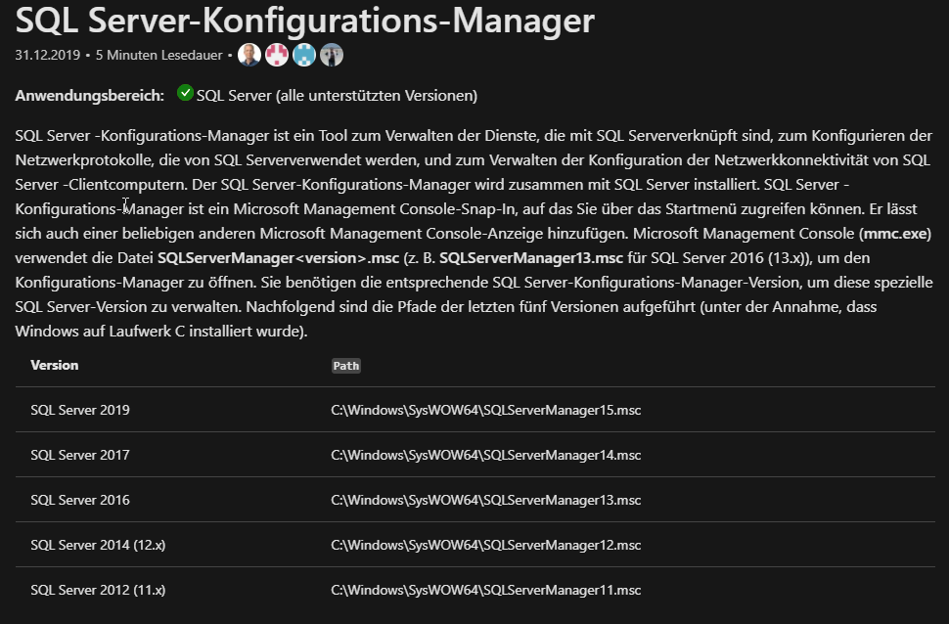

Version Path

SQL Server 2019 C:\Windows\SysWOW64\SQLServerManager15.msc

SQL Server 2017 C:\Windows\SysWOW64\SQLServerManager14.msc

SQL Server 2016 C:\Windows\SysWOW64\SQLServerManager13.msc

SQL Server 2014 (12.x) C:\Windows\SysWOW64\SQLServerManager12.msc

SQL Server 2012 (11.x) C:\Windows\SysWOW64\SQLServerManager11.msc

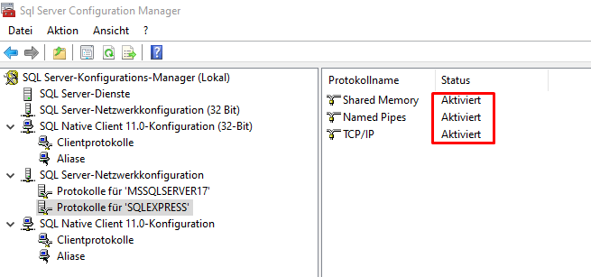

SQL Server Dienst neu starten

## Channel erstellen

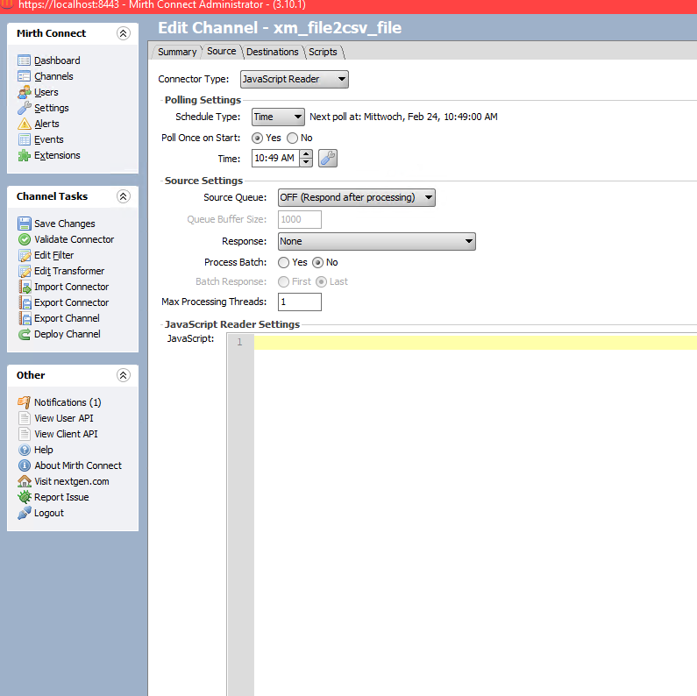

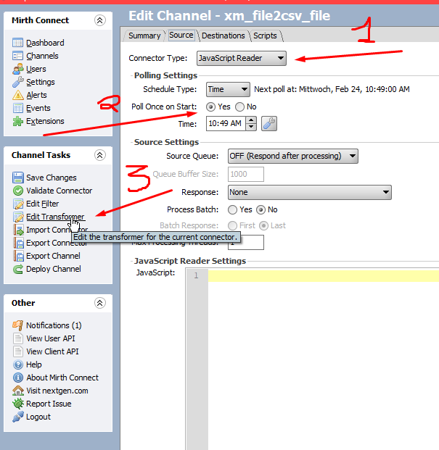

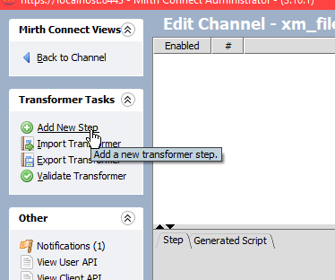

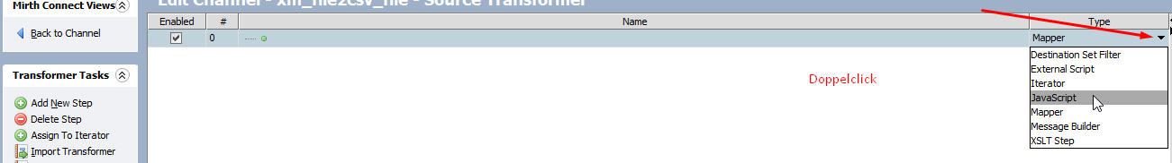

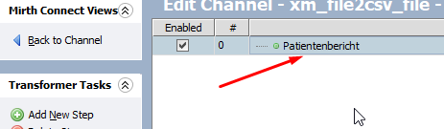

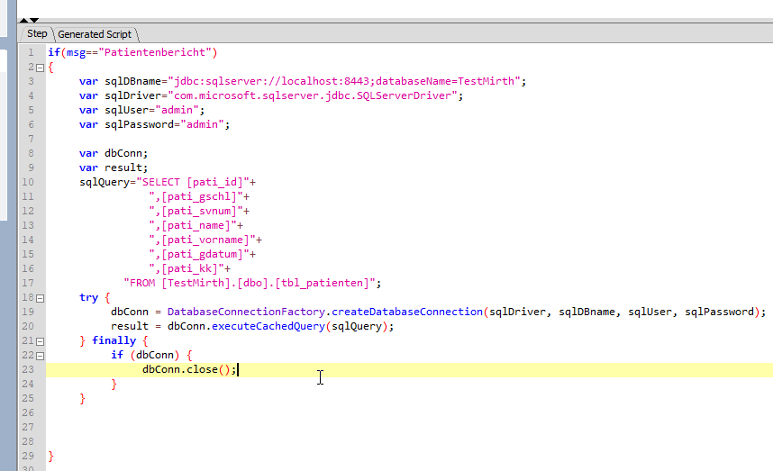

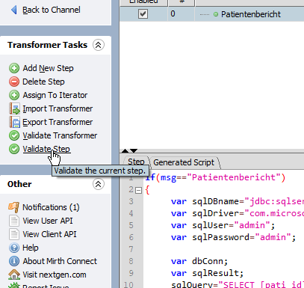

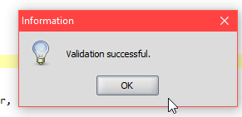

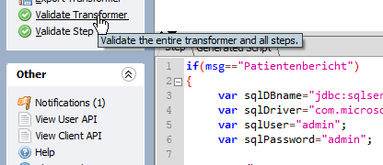

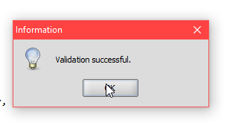

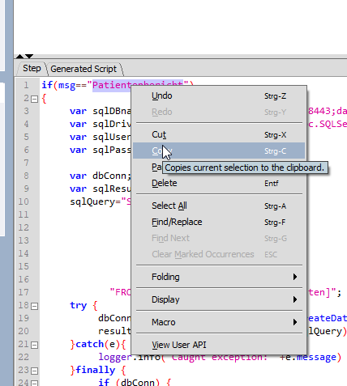

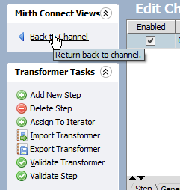

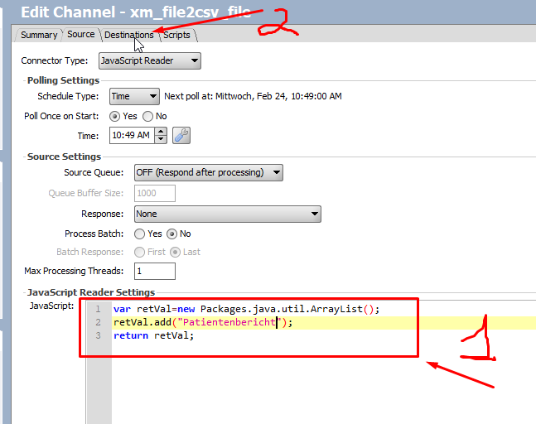

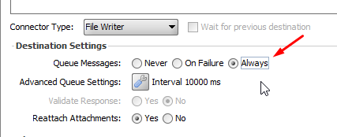

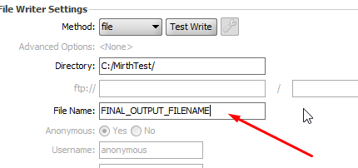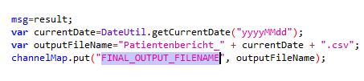

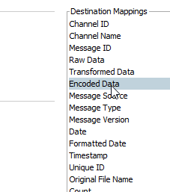

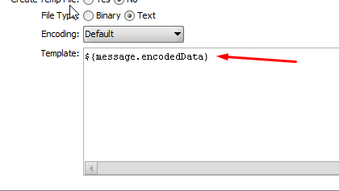

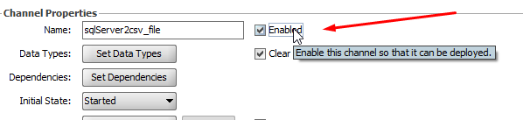

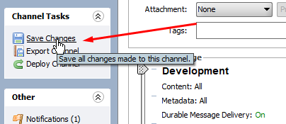

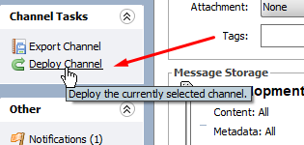

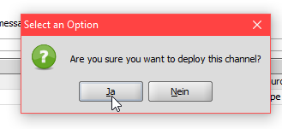

# Mirth Connect using SQL Server

Make sure that TCP/IP is enabled under Client Protocols.

Then go into "SQL Server Network Configuration" and double click TCP/IP. Click the "IP Addresses" tab and scroll to the bottom. Under "IP All" remove TCP Dynamic Ports if it is present and set TCP Port to 1433. Click OK and then go back to "SQL Server Services" and restart SQL Server instance. Now you can connect via localhost, at least I could.

[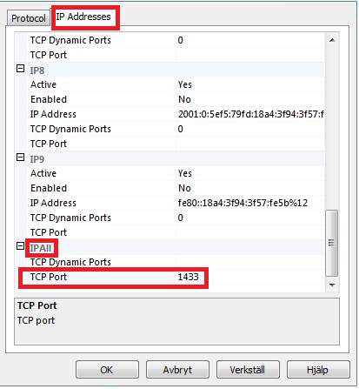](https://i.stack.imgur.com/ogkmm.png)

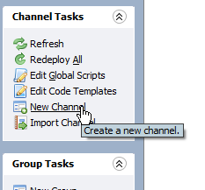

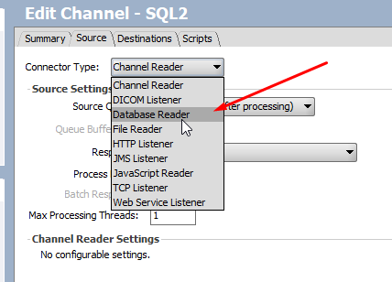

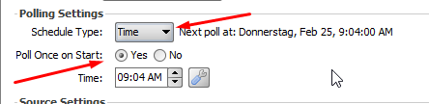

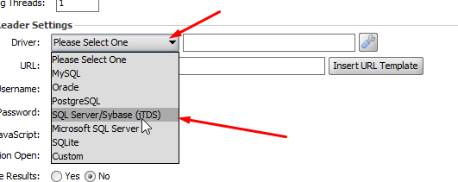

net.sourceforge.jtds.jdbc.Driver

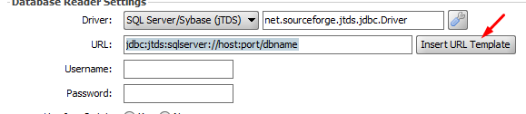

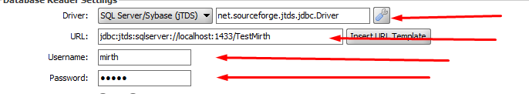

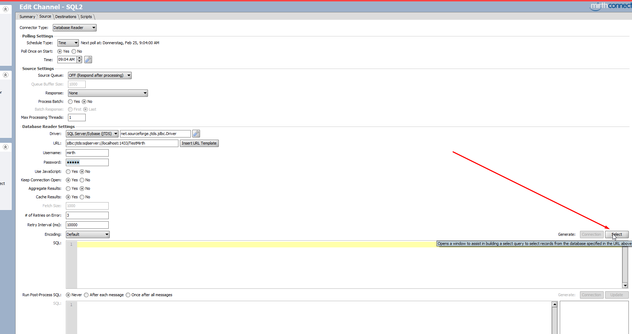

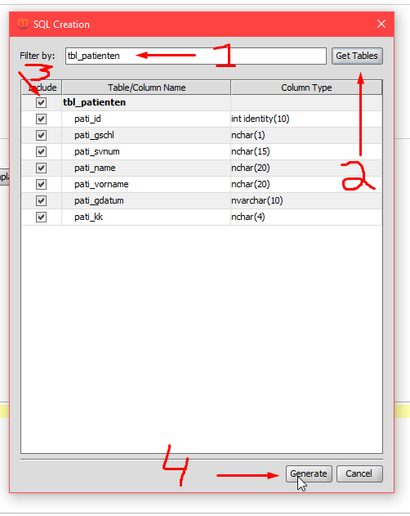 [dbo].[tbl_patienten]

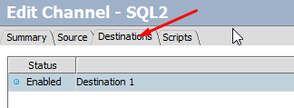

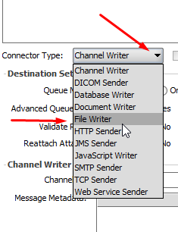

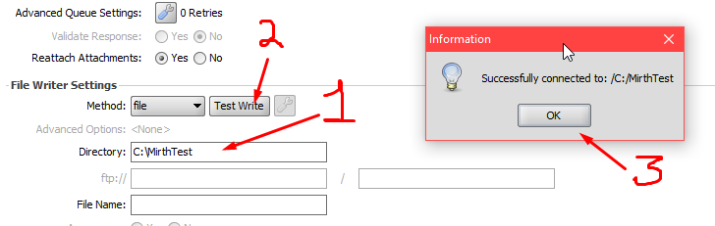



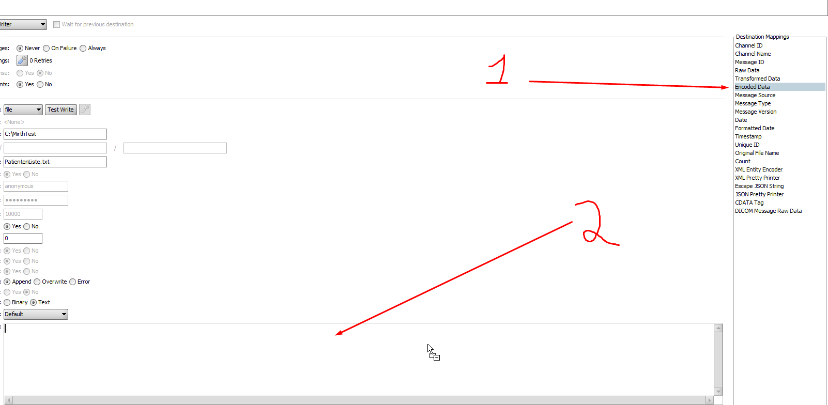

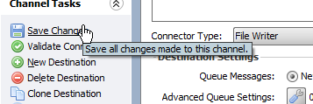

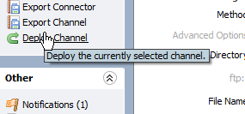

jdbc:jtds:sqlserver://localhost:1433/TestMirth