INSTALLATION

GUIDE

Version 1.0.0.1

# CONTENTS

1. **Preface**
   1. Introduction ………………………………………………………………………………………… 3

1. **System Requirements** 
   1. Windows ……………………………………………………………………………………………….. 4

2.1.1 Hardware …………………………………………………………………………………. 6

2.1.2 Software ……………………………………………………………………………………. 6

2.1.3 Others ………………………………………………………………………………………… 6

1. **Installation** 
   1. Prerequisites ………………………………………………………………………………………… 6

3.1.1 FlightGear setup ……………………………………………………………………… 6

3.1.2 Environment setup ………………………………………………………………… 6

* 1. Windows ………………………………………………………………………………………………… 6

3.2.1 Running setup …………………………………………………………………………. 6

3.2.2 Install …………………………………………………………………………………………. 6

3.2.3 Uninstall ……………………………………………………………………………………. 6

1. **Post-Installation Setup** 
   1. Environment variables …………………………………………………………….……… 13
   2. Working directory…………………………………………………………….………………… 13
   3. Directory structure …………………………………………………………….……………… 13

**5 Troubleshooting** …………………………………………………………………………………………… 16

5.1 FlightGear …………………………………………………………….…………………………………. 13

5.1.1 Not launching …………………………………………………………………………….. 15

5.1.2 Sound warning …………………………………………………………………………… 15

5.1.3 Aircraft not found ……………………………………………………………………… 15

5.2 MERS_X ……………………………………………………………………………………………………….. 15

5.2.1 Not showing map ………………………………………………………………………. 15

5.2.2 Simulation not working ……………………………………………………………. 15

# Preface

RF Simulator division

Defence Avionics Research Establishment

Defence Research & Development Organisation

Ministry of Defence, Government of India

### Introduction

The MERS application simulate the different types of threats such as Airborne emitter, Ground emitter and Moving ground emitter and based on their positions it calculates Angle of Arrival (A.o.A) in degrees, Azimuth in degress, Range in kilometers and Elevation in meters using DF algorithm. This application uses open source simualtor FlightGear as a backend to provide realtime aircraft details such as Latitude, Longitude, Altitude, Roll, Pitch, Yaw, etc.

# System Requirements

To run this software on any system, it has minimum hardware and software requirements that needs to be satisfied before installation.

### Windows

To run this on Windows platform,

#### 2.1.1 Hardware

Processor : Intel or AMD with core (s) [ 8 ]

Architecture : 64 bit

Speed : 3.0 GHz

RAM : 8 Gb [ Depends on number of FlightGear instance used ]

HDD or SSD : 5 Gb space [ space requirements depends on simulation time ]

Graphics card : 2 Gb [ depends on number of FlightGear instance used ]

Screen resolution : 1278 x 785

#### 2.1.2 Software

Operating system : Windows 7, Windows 8, Windows 10

Bit : 64 bit

FlightGear : FlightGear version 2016.2.1 & above

#### 2.1.3 Other

Administrator : Make sure you have administrator access/rights to modify environment variables.

Internet : To load detailed map with different zoom level

# Installation

Installation of the below software required Administrator rights/access.

### Prerequisites

Before installation of this software follow the prerequisites of the installation of FlightGear software.

#### FlightGear Setup

FlightGear is a free, open source multi-platform flight simulator. Click on the FlightGear setup and follow the guidelines in each step as well as screen shots.

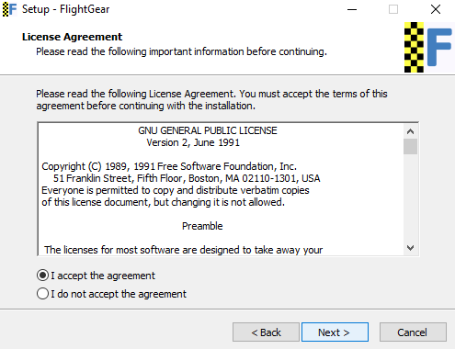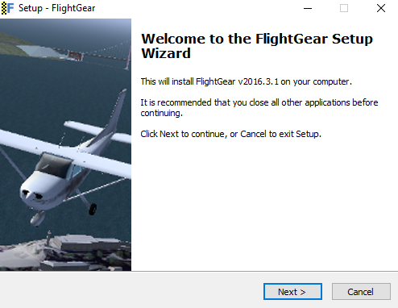Step 1 : Launch the setup wizard Step 2 : Accept the license terms

Fig. 3.1.1.(1) [ Setup wizard ] Fig. 3.1.1.(2) [ Accept license agreement ]

Step 3 : Disable antivirus if any installed Step 4 : Don’t install in C: drive

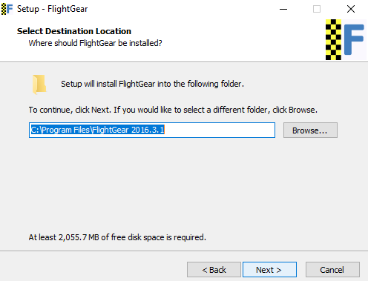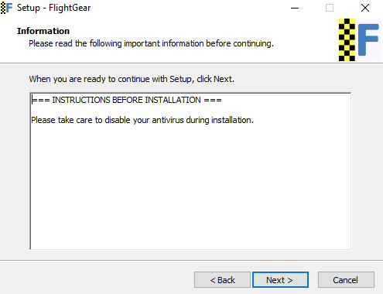

Fig. 3.1.1.(3) [ Disable antivirus ] Fig. 3.1.1.(4) [ Hold on step to change directory ]

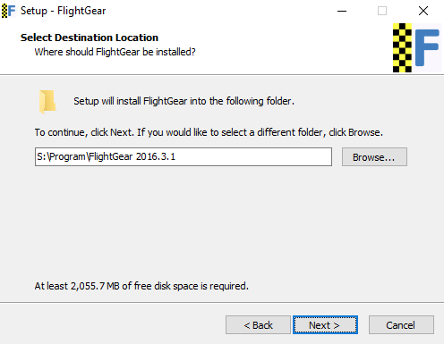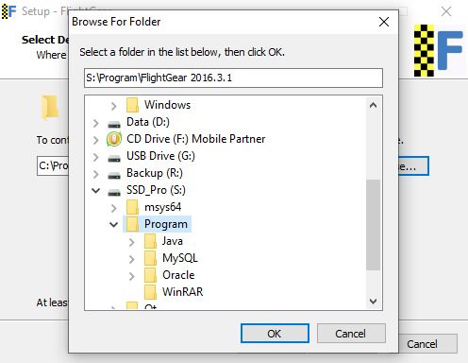Step 5 : Change directory other than C: Step 6 : Directory should have write permission

Fig. 3.1.1.(5) [ Change directory ] Fig. 3.1.1.(6) [ Directory with write permission ]

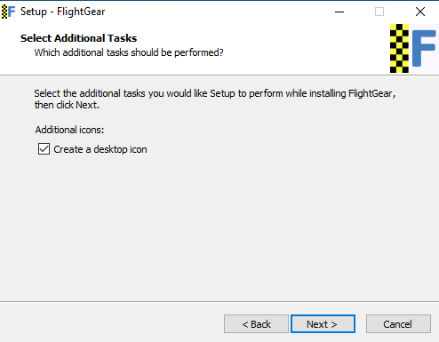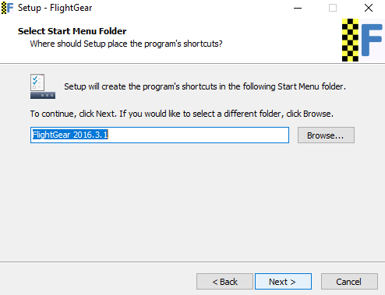Step 7 : Click next Step 8 : Check to create desktop shortcut icon

Fig. 3.1.1.(7) [ Start menu entry ] Fig. 3.1.1.(8) [ Desktop shortcut ]

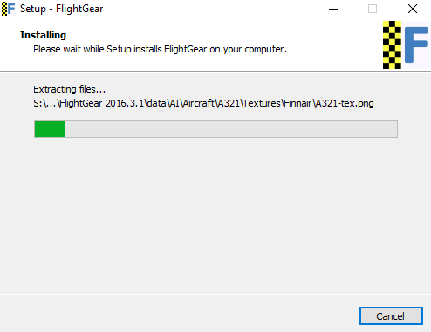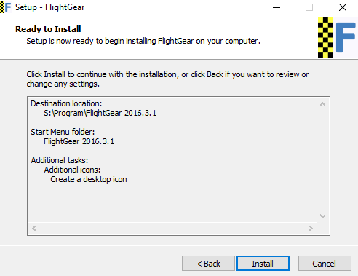Step 9 : Click install button Step 10 : Installation in progress

Fg. 3.1.1.(9) [ Click install button ] Fg. 3.1.1.(10) [ Installation progress ]

Step 11 : Finish installation

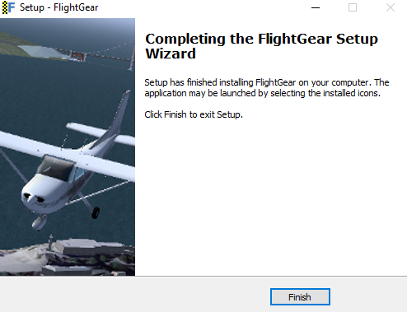

Fig. 3.1.1.(11) [Finish installation ]

After finishing FlightGear installation successfully, it’s time to setup its path to system variable.

#### Environment Setup

Environment variable need to be set first to call FlightGear instance from command line or other process. Follow the steps to setup system environment variable for windows platform.

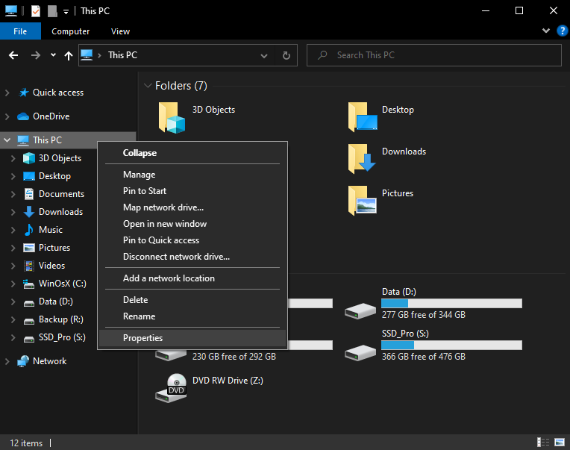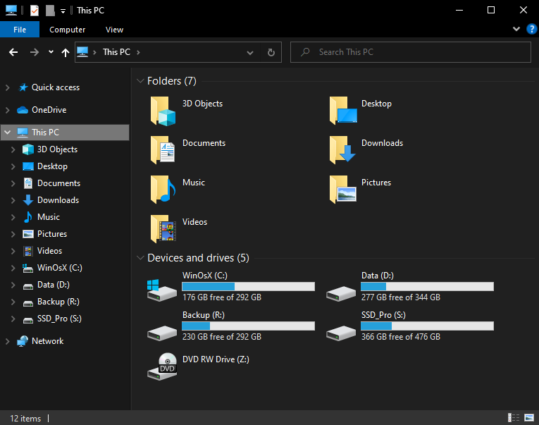Step 1 : Go to This PC or My Computer Step 2 : Right click This PC & click on Properties

Fig. 3.1.2.(1) [ Go to This PC ] Fig. 3.1.2.(2)[Right Click This PC & click Properties]

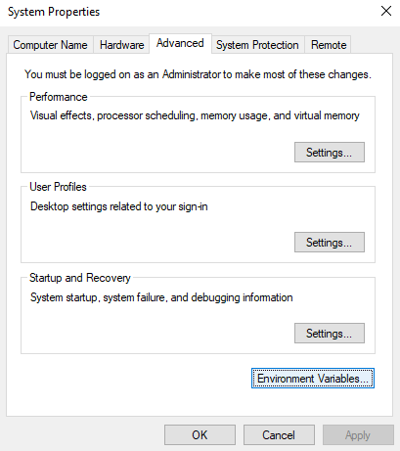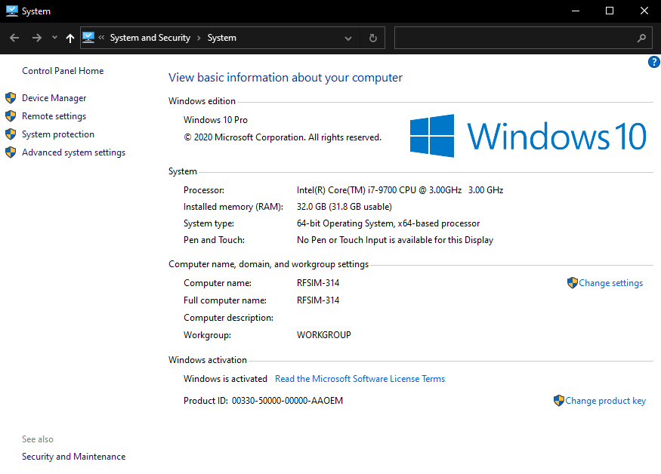Step 3 : Click on Advanced system settings Step 4 : Click on environment variable

Fig. 3.1.2.(3) [ System properties] Fig. 3.1.2.(4) [ Environment variable ]

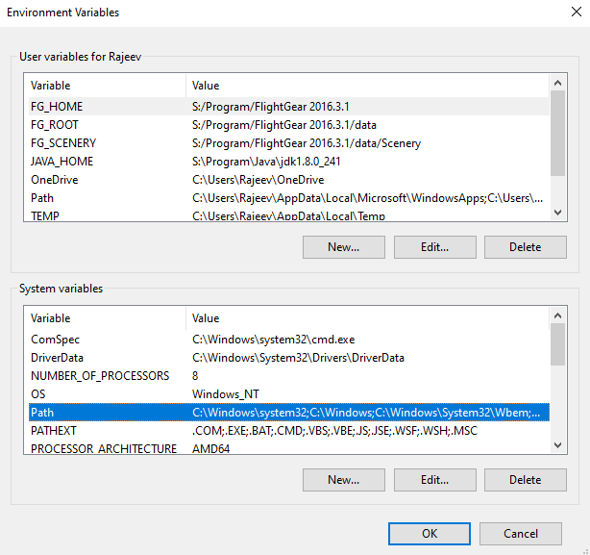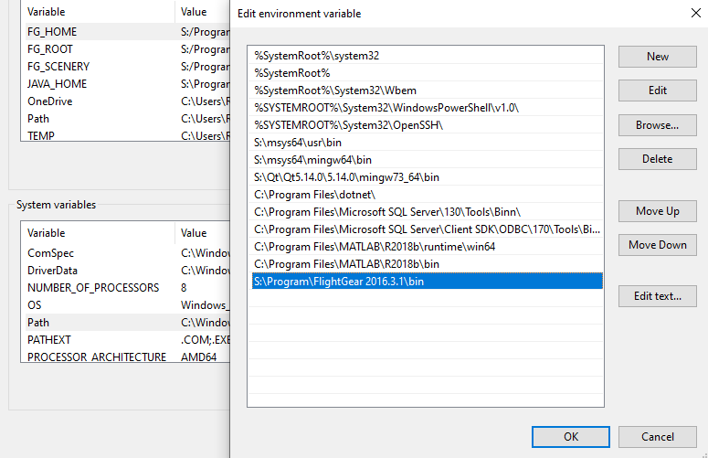Step 5 : Click on System variable Path Step 6 :Click new & add FlightGear installation bin path

Fig. 3.1.2.(5) [ System variable path] Fig. 3.1.2.(6) [Click New & add FlightGear install bin path]

Note : FlightGear installation bin path is directory where FlightGear installed in previous section. 3.1.1 [Prerequisite- FlightGear setup : Step 6].

### Windows

The software is built to run on 64 bit Windows platforms i.e. Windows 7, Windows 8 & Windows 10. In it’s very basic version it is recommended to install it in other than C: drive due to write permission issue.

#### Running Setup

Click on the MERS_X_setup.exe installer and allow to run on system.

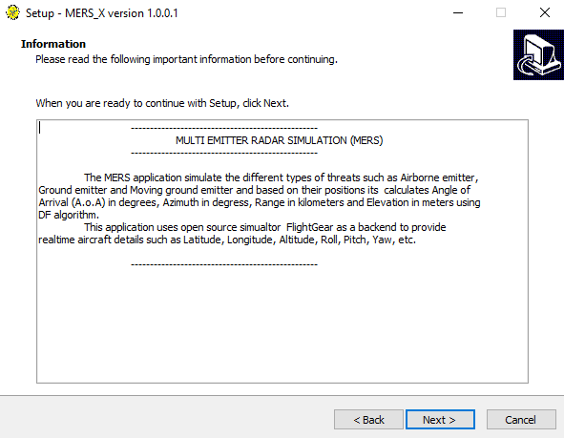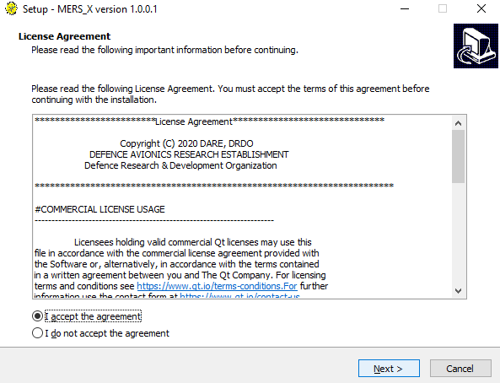Step 1 : Accept the license & click next Step 2 : Just read the information & click next

Fig. 3.2.1.(1) [ Accept license ] Fig. 3.2.1.(2) [ Read information ]

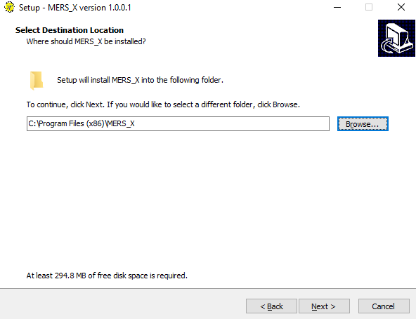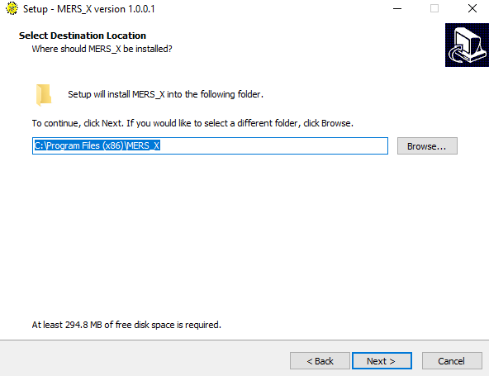Step 3 : Don’t install in C: drive Step 4 : Browse different directory other than C:

Fig. 3.2.1.(3) [ Don’t install in C: ] Fig. 3.2.1.(4) [ Browse different location ]

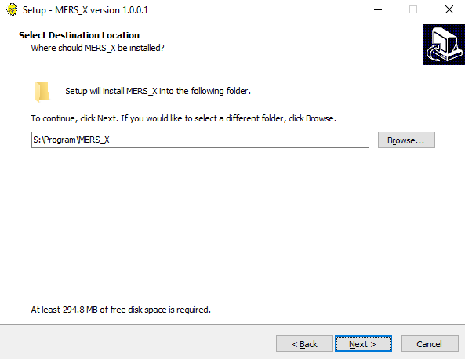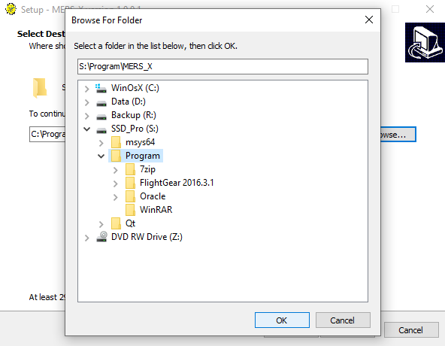Step 5 : Select other drive folder Step 6 : Verify directory & click next

Fig. 3.2.1.(5) [ Select folder ] Fig. 3.2.1.(6) [ Verify directory ]

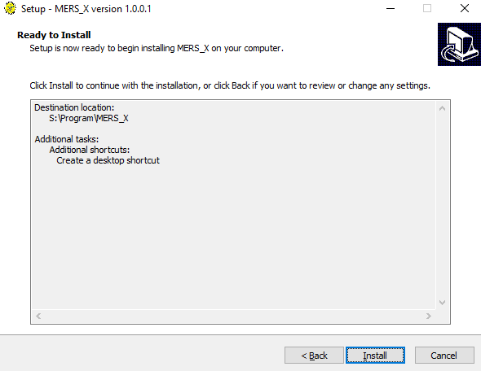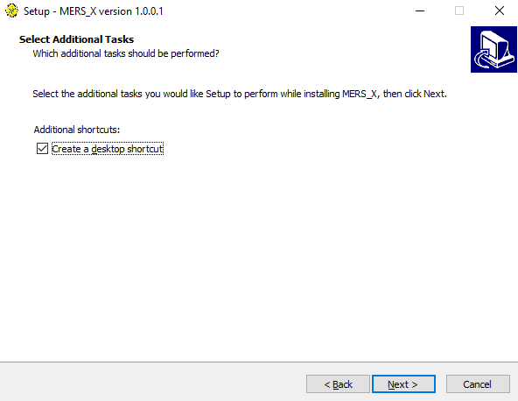Step 7 : Check for desktop shortcut Step 8 : Click install

Fig. 3.2.1.(7) [ Desktop shortcut ] Fig. 3.2.1.(8) [ Install ]

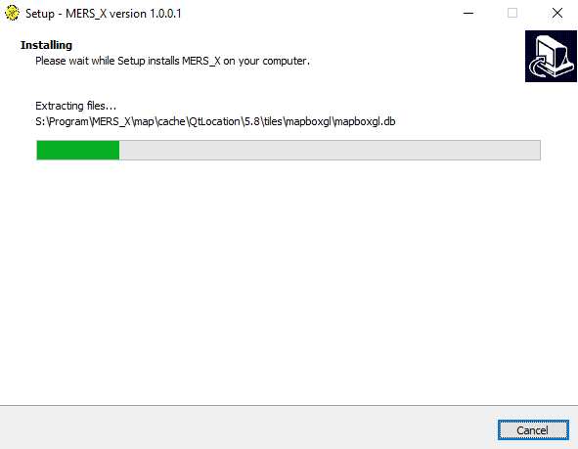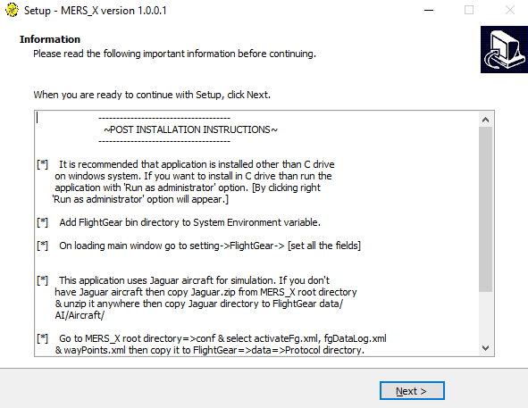Step 9 : Installation progress Step 10 : Read post installation instructions

Fig. 3.2.1.(9) [ Installation progress ] Fig. 3.2.1.(10) [ Post installation instructions ]

Step 11 : Finish to launch application ]

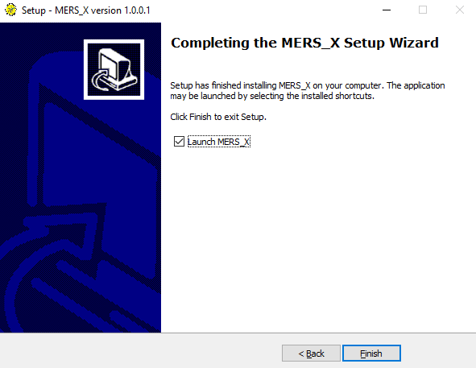

Fig. 3.2.1.(11) [ Finish to launch application ]

#### Install

After successful installation, the main application window will be launch.

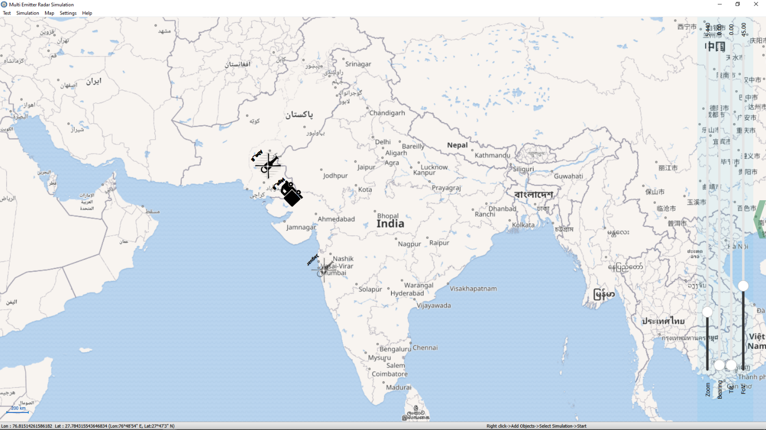

Fig. 3.2.1.(12) Application main window

# Post-installation setup

### Environment variables

Environment variable

### Working directory

In this basic version, the working directory is the installation directory. So the all read and write of files would be done only in this directory.

Dir