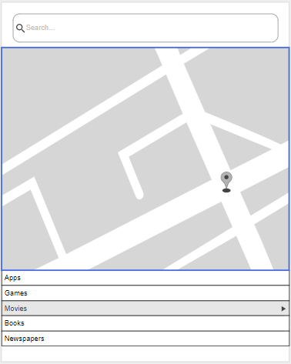

search

This will be the wireframe from the application I have concepted. An application that allows you to fully navigate the place; lets you know the entertainments, dining and different features of the area. This will also show the crime rate and how the place is socially active.

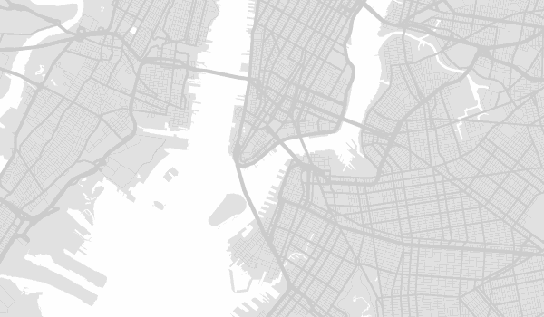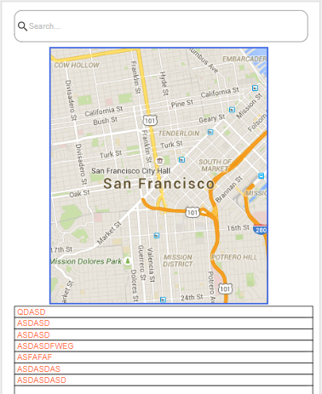

As shown in the picture, this will be the mockup representation of the main page

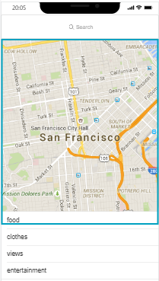Final outcome, the main page displays clickable buttons and other touchpoints that allows you to navigate the application’s whole feature.