Development of Spatial data application using GeoTools library (a Java GIS toolkit) for visualization of water resource data

¹Rakshit B. Majithiya, ² Shreelekha H. Tanna, ³Viral B. Vasara and ⁴Naveenchandra N. Srivastava

^{1, 2,3} Department of Computer Engineering, V.V.P. Engineering College, Rajkot, Gujarat
⁴ Bhaskaracharya Institute for Space Applications and Geo-informatics
Near Ch-0 Circle, Indulal Yagnik Marg, Gandhinagar - 382007, Gujarat

¹rakshit@thetechtime.com, ²shree@thetechtime.com, ³viral_vasara@yahoo.com and ⁴naveen0504@yahoo.com

ABSTRACT: Present work describes visualization of water resource data using GeoTools library. This library allows programmers, who are developing geospatial applications to concentrate on building the interesting parts of an application, while reusing generic tools for basic functions. Basic components required for spatial data processing are provided by GeoTools. With the help of GeoTools, water resource data, pertaining to a basin in U.S.A. viz. drainages, springs, geology, groundwater wells , lakes, Groundwater vulnerability etc. was visualized. Some inferences pertaining to basin characteristics and hydrology of study area were derived based on visualization. Different functionalities of GeoTools viz. overlay of thematic layers, overlay of raster and vector data, spatial query, map legend, display of attribute data etc. are presented in this paper. As GeoTools library is free and open source, repeatability of outcome can be achieved by scientific community. Present visualization, based on GeoTools, facilitates data exploration and knowledge construction pertaining to water resources.

Keywords—GIS, GeoTools, Java, Visualization, Open source, spatial, application, map, software

I: INTRODUCTION
A Geographic Information System (GIS) is defined as an information system that is used to input, store, retrieve, manipulate, analyse and output geographically referenced data in order to support decision making and solve complex problems regarding the planning and management of resource.
For many types of geographic operation the end result is best visualized as a map or graph. Maps are very efficient at storing and communicating geographic information.

While cartographers have created maps for millennia, GIS provides new and exciting tools to extend the art and science of cartography (http://www.sfu.ca/rdl/GIS/tour/gis_task.html).
GIS integrates these five key components: hardware, software, data, people, and methods (http://www.sfu.ca/rdl/GIS/tour/comp_gis.html). Various components of GIS are shown in Fig. 1. GIS offers powerful tools for the collection, storage, management, and display of map related information.
As GIS becomes more technical, developers and users in general have two distinct choices in their use of the available tools. On the one hand, they can accept the standardized functions of their commercial software packages and simply learn which button to push for any operation, or they can choose solutions which allow them to look “beneath the hood” to see the workings of the software so they can truly understand what is going on when they press a button. Only the latter path provides a true education that will help advance careers, and only by choosing an
OS approach will freedom be provided to explore the workings of the software that is available (Turton, 2008).
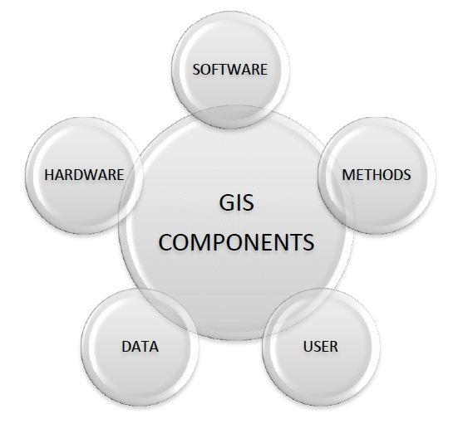
Fig 1. Components of GIS
II: OBJECTIVE
The primary objective of present work is to visualize water resource data using open source Java GIS toolkit – GeoTools.

III: GIS DATA TYPES

GIS has enabled government agencies and private organizations to extend the delivery of their data from numerical tables to maps and to support various forms of spatial searches for relevant data. GIS technology utilizes two basic types of data (http://bgis.sanbi.org/GIS-primer/page_14.htm). These are:
1. Spatial data : describes the absolute and relative location of geographic features.
2. Attribute data : describes characteristics of the spatial features. These characteristics can be quantitative and/or qualitative in nature. Attribute data is often referred to as tabular data. In a thematic map, GIS requires both spatial data and attribute data: information attached to each object in a layer.
Map data: Map data contains the location and shape of geographic features (http://www.gis.com/content/data-types-and-models). Maps use three basic shapes to present real-world features: points, lines, and areas (called polygons).
Image data: Image data ranges from satellite images and aerial photographs to scanned maps (maps that have been converted from printed to digital format).

There is also importance of metadata (i.e., information about where, when, and by whom the data were collected, its projection, datum, coordinate system, and accuracy). GIS provides facilities for data capture, data management, data manipulation and analysis, and the presentation of results in both graphic and report form, with a particular emphasis upon preserving and utilizing inherent characteristics of spatial data.

IV: LOCATION OF STUDY AREA

Location of basin (study area) in U.S.A. is shown in Fig. 2. Total area of basin is 11233.73 km².
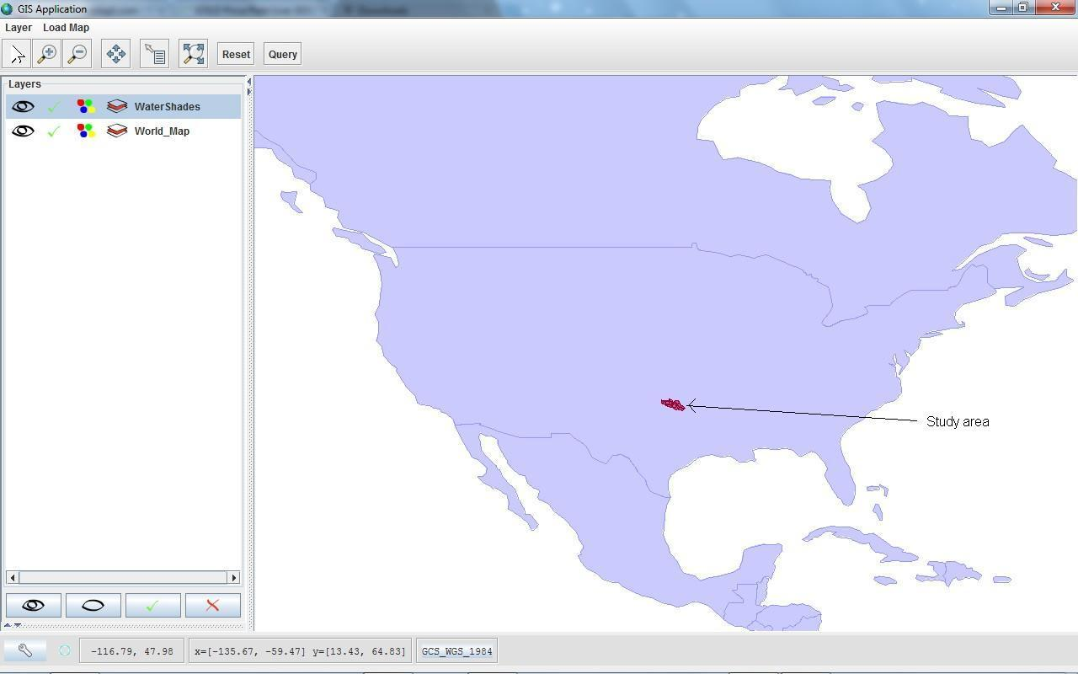
Fig. 2. Location of study area (basin) in U.S.A.

V: VISUALIZATION

Visualization systems are developed as a part of application-driven research concerned with management and planning of water resources.Scientific visualization facilitates visual interpretation of massive data sets. Thus, visualization is driven by the needs of a broad spectrum of research areas (Nair, 2007). Visualization provides the most dominant means to handle the geo spatial information for knowledge discovery processes.

VI: WATER RESOURCE INFORMATION

An important element of a water resources information system is knowledge of the features within that system: watersheds, streams, geology, springs etc. that make up the hydrological system. To develop and deliver water resources information, location of these features is vital. Spatial visualisation refers to the portrayal of water resource information that has a geographic location in a way that displays the relationships between points in space. GIS is a powerful tool for developing solutions for water resources such as managing water resources on a local or regional scale (http://www.esri.com/industries/water_resources/index.html).

VII: GEOTOOLS – BACKGROUND

GeoTools is a Java library for geographic information system (GIS) applications (http://geotools.org). It is used as the base of several well known free and open source for geospatial (FOSS4G) products including GeoServer, uDig, and GeoVISTA studio. By building on top of other open source (OS) libraries, such as the Java Topology Suite (Vivid Solutions) and the Open Geospatial Consortium’s (OGC) GeoAPI, GeoTools leverages the best of these lower level libraries to provide a mid-level library of functions that simplifies the construction of complex spatial data processing applications, while hiding the complexities of data sources, feature models, and projections from the end user. The basic design principal of GeoTools is, wherever possible, to use the simplest solution for a problem. GeoTools is designed as a library to be used by programmers building spatial data applications, rather than by end users looking to make maps. GeoTools has grown over the last many years from a small individual research project to become a multinational project that is actively developed by various developers.

VIII: REPEATABLE OUTCOME IN GEOTOOLS

As scientists developing software to support science, the primary interest was, and continues to be, in producing repeatable outcomes. This was something that was especially difficult to achieve in the emerging field of computational science in general and computational geography in particular during the 1990s. GeoTools was written in part to avoid this problem by allowing everyone to base their experiments on the same code. There are three specific types of openness that the developers sought to support in the development of GeoTools, namely open standards, open source, and open science.

IX: FEATURE DISPLAY AND LABELING USING GEOTOOLS

Each theme in GIS contains a set of spatially defined characters, shapes, or areas called features, each is defined by the attributes or characteristics it represents. A theme can display all features with a specific attribute or a feature selection within it. A feature dataset is a collection of feature classes that share the same spatial reference (http://www.crwr.utexas.edu/gis/gishydro03/Classroom/Exercises/ex12002.htm). A feature class is a collection of features with similar geometry. There are point, line, and polygon feature classes. A shapefile includes geometric features and their attributes. Label is a descriptive text, usually based on one or more feature attributes. Labels are added to maps. Labels are a simple way to add text descriptions to a map. They can provide clarity for the end-user and emphasize certain features (http://www.maine.gov/dep/gis/training/a9bc/labeling.shtml). Labels showing length of various streams are shown in Fig. 3.

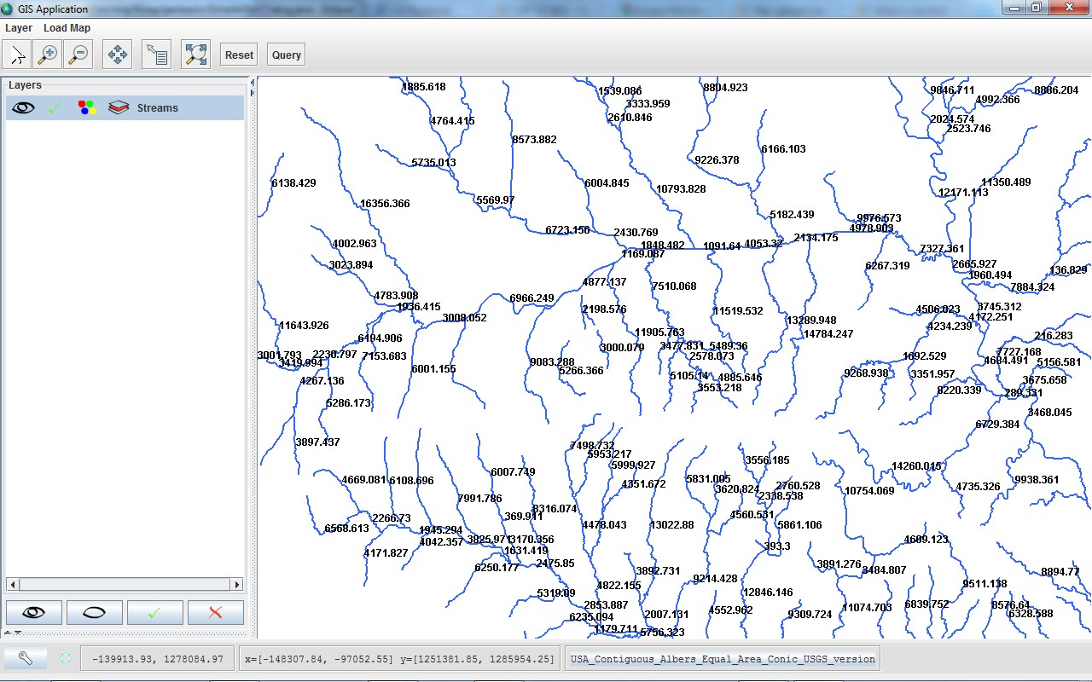

Fig 3. Labeling various streams to show their length using GeoTools

X: MAP OVERLAY IN GIS

Map overlay is the process of taking two different thematic maps of the same area and overlaying them one on top of the other to form a new map layer. The ability to integrate data from two sources using map overlay is perhaps the key GIS analysis function (http://www.gis.unbc.ca/courses/geog300/lectures/powerpoint2003/march_12.pdf). Map overlay addresses the relationship of the intersection and overlap between spatial features. Map overlay combines the spatial and attribute data of two input themes. Union, Intersect and Identity are different overlay methods. Overlay of watershed and drainage is shown in Fig. 4.

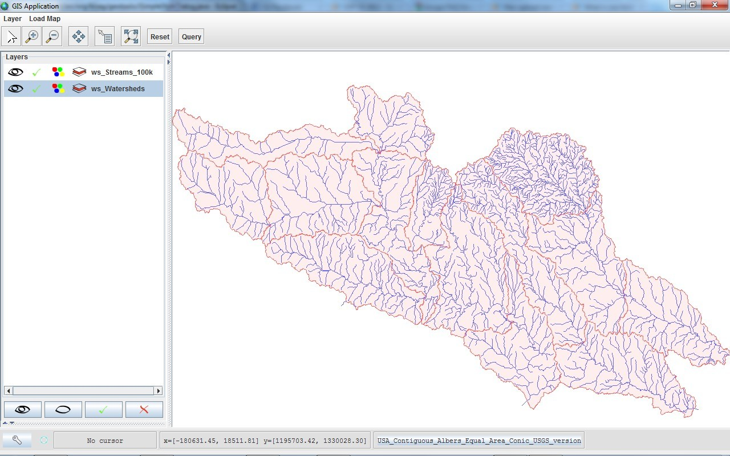

Fig 4. Displaying overlay of two thematic layers- watershed and drainages using GeoTools

XI: RASTER DATA

Raster data represents geographic space as a matrix of cells; map features are defined by numeric values assigned to the cells (http://en.mimi.hu/gis/raster_data.html). Raster data is characterized by pixel values. A raster data structure is a cellular data structure composed of rows and columns. Groups of cells represent features. The value of each cell represents the value of the feature. Image data is stored using this structure (http://www.pasda.psu.edu/tutorials/arcgis/glossary.asp). Raster data is used in a GIS application when we want to display information that is continuous across an area and cannot easily be divided into vector features. Some data are difficult to display in the form of map. For example, grasslands have many variations in colour and density of cover. So, raster data is used to overcome this problem. Vector overlay over raster is shown in Fig. 5.

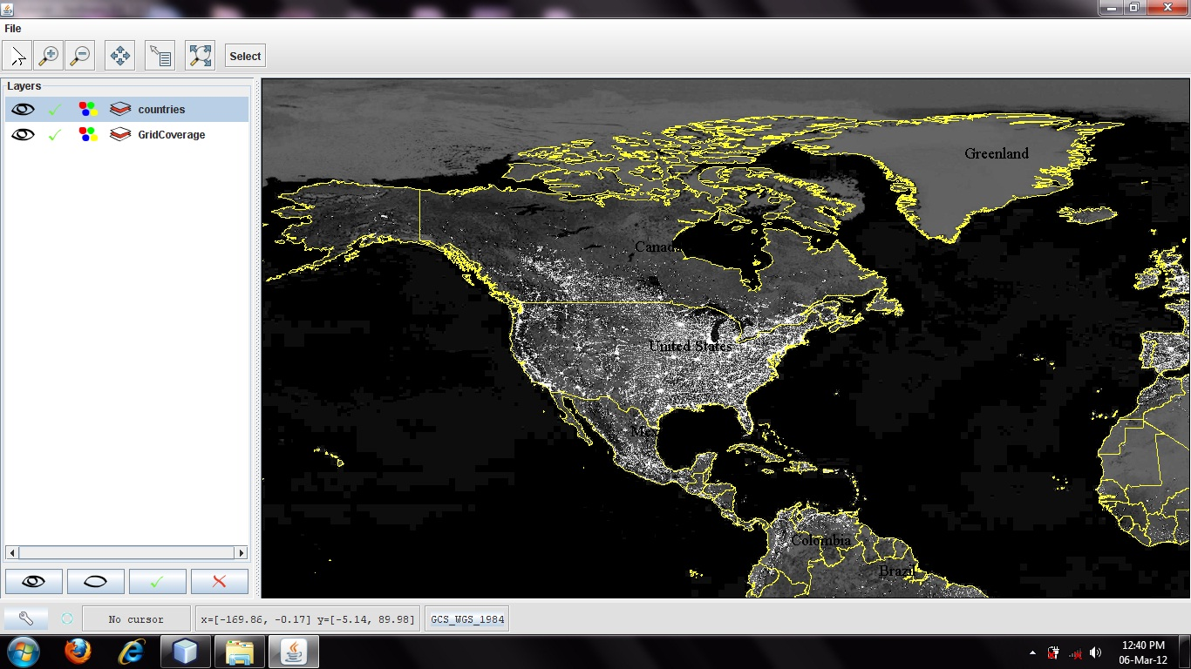

Fig 5. Overlay of vector data over raster using GeoTools

Raster data can be obtained in a number of ways. Two of the most common ways are aerial photography and satellite imagery.
XII: ATTRIBUTE DATA

Attributes are different characteristics within a set of data to be mapped into GIS (http://www.pasda.psu.edu/tutorials/arcgis/glossary.asp). Attributes are defined within a table and displayed on a theme. Attribute (tabular) data is the descriptive data that GIS links to map features. Attribute data is collected and compiled for specific areas like states, census tracts, cities, and so on and often comes packaged with map data (http://www.gis.com/content/data-types-and-models). The fact that features have attributes as well geometry in a GIS application opens up many possibilities. For example user can use the attribute values to tell the GIS what colours and style to use when drawing features. The process of setting colours and drawing styles is often referred to as setting feature symbology. For GIS, attributes need to be coded in a form in which they can be used for data analysis (http://bgis.sanbi.org/GIS-primer/page_06.htm). Attribute data can also be useful when creating map labels. Most GIS applications will have a facility to select an attribute that should be used to label each feature. Attribute data can be very useful in carrying out spatial analysis. Spatial analysis combines the spatial information stored in the geometry of features with their attribute information. This allows user to study features and how they relate to each other. There are many types of spatial analysis that can be carried out. Attributes for a vector feature are stored in a table. Usually the information in the attribute table is stored in some kind of database. The GIS application links the attribute records with the feature geometry so that user can find records in the table by selecting features on the map, and find features on the map by selecting features in the table. Each field in the attribute table contains a specific type of data – text, numeric or date. Deciding what attributes to use for a feature requires some thought and planning. Attribute data table pertaining to sub watershed of study area is shown in Fig. 6.
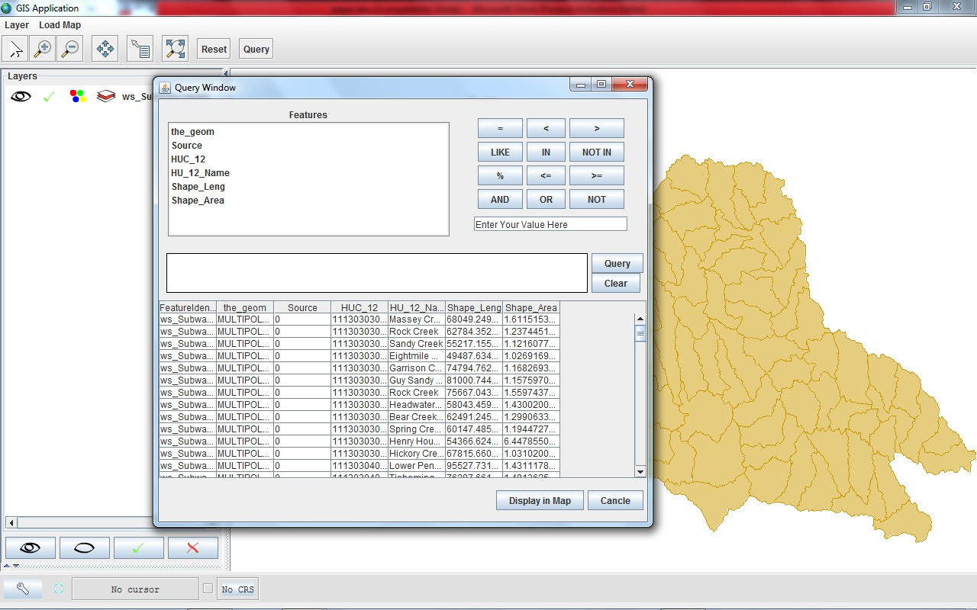

Fig 6. Attribute data table of sub watersheds

XIII: QUERY INTERFACE
To answer spatial questions is the distinctive characteristic of geographic information systems. In order for the user to select particular elements or sets of information that are of interest, some method of forming questions against data holdings is required. The design of this query interface is critical to the usability of the system – users must be able to easily retrieve the information they require from the data available to them. Querying interface is an important functionality in Geotools. It is helpful to identify special features from the attribute data. It is helpful in database searching. It reduces the effort for identifying the features required. Query operation on geospatial database and query result for sub basin of study area are shown in Fig. 7 and Fig. 8.

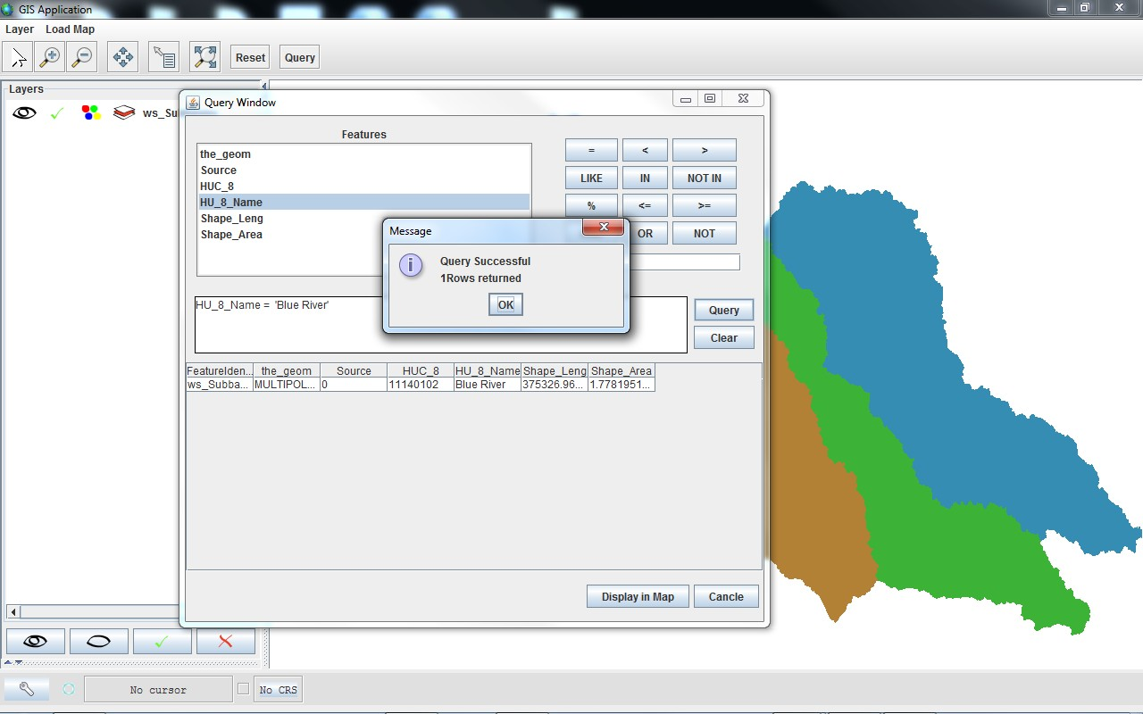

Fig. 7. Query operation for sub-basin

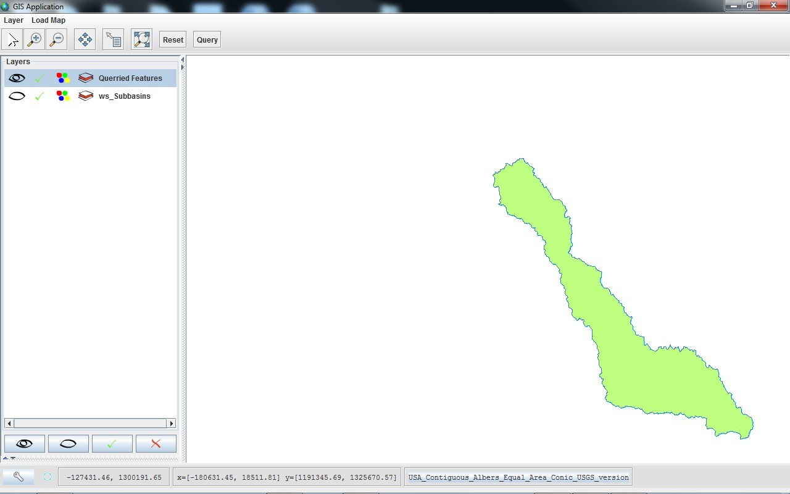

Fig. 8. Query result for sub-basin

XIV: LEGEND FOR MAP ANALYSIS

The map legend is the key linking the attributes to the geographic features. It is a list of the symbols appearing on a map. Attributes are typically represented graphically by use of different symbology and/or color (http://bgis.sanbi.org/GIS-primer/page_06.htm). Legend is useful to visualize every places with different colours according to the range of features. By legend, user can easily and efficiently analyse the features of map. Classification and display of basin into sub-basins and sub-watersheds using legend wizard are shown in Fig. 9 and Fig. 10.
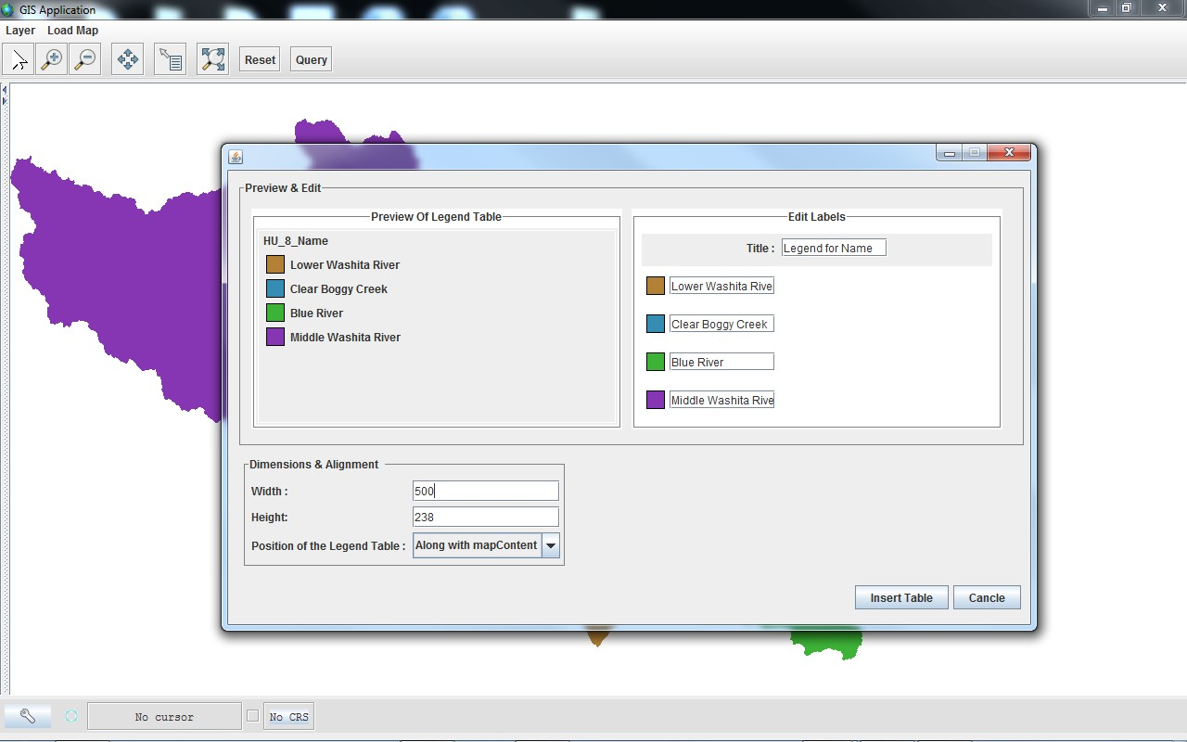

Fig. 9. Classification and display of basin into sub-basins using legend wizard of GeoTools

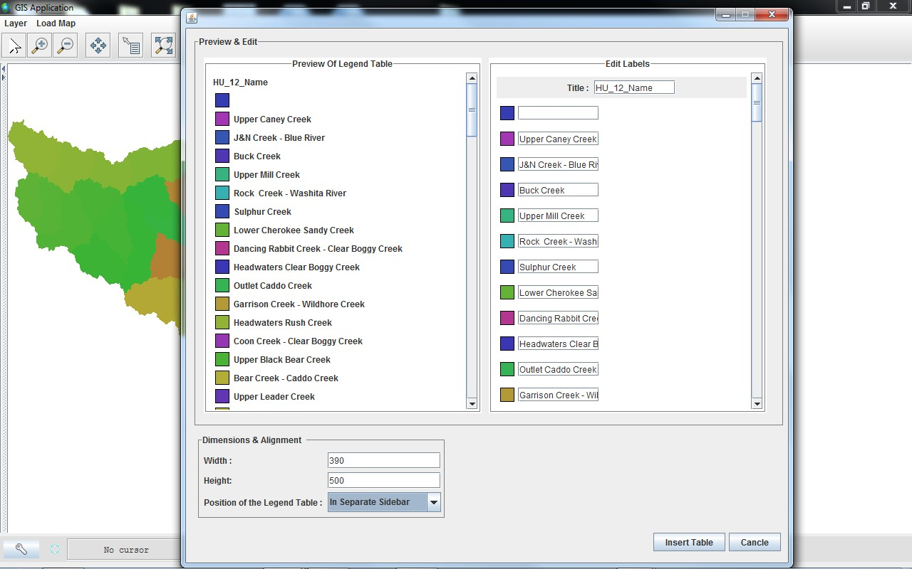

Fig. 10. Classification and display of basin into sub-watersheds using legend wizard of GeoTools

XV: VISUALIZATION OF WATER RESOURCE DATA

Some thematic data was visualized using GeoTools library. This visualization tool was applied to the water resource data of a watershed pertaining to USA. Shapefiles displayed were downloaded from http://www.owrb.ok.gov. This tool allows user to visualize hydrological details of above mentioned study area. Moreover, the tools is a useful educational system due to its user-friendly characteristics. Visualization of water resource data viz. sub basins, watersheds, sub-watersheds, surficial geology, springs, groundwater wells, lakes, Groundwater vulnerability are shown in Fig. 11, Fig. 12, Fig. 13, Fig. 14, Fig. 15, Fig. 16 and Fig. 17.
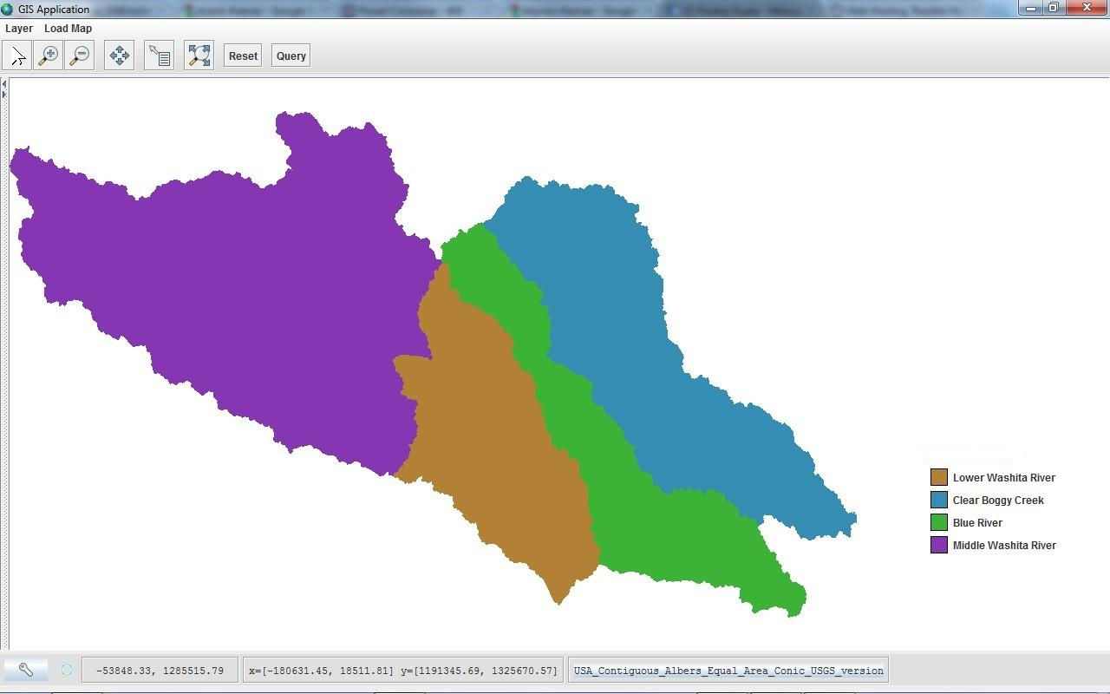
Fig. 11. Visualization of sub-basins of study area
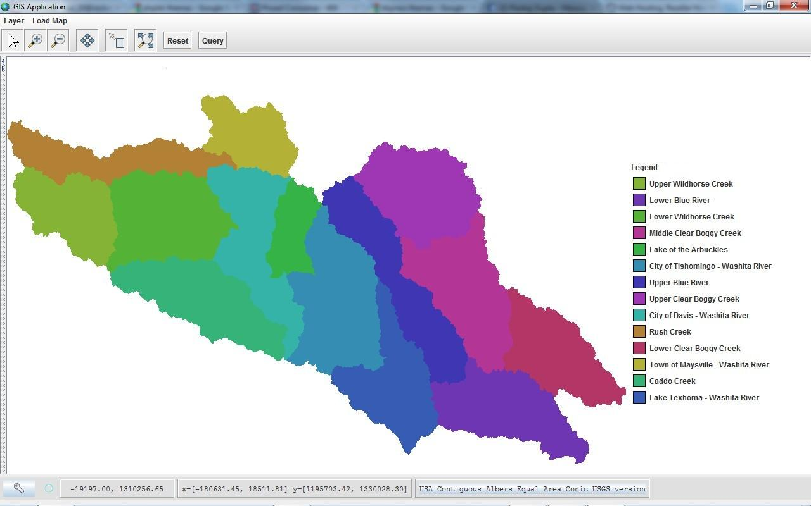

Fig. 12. Visualization of watersheds of study area

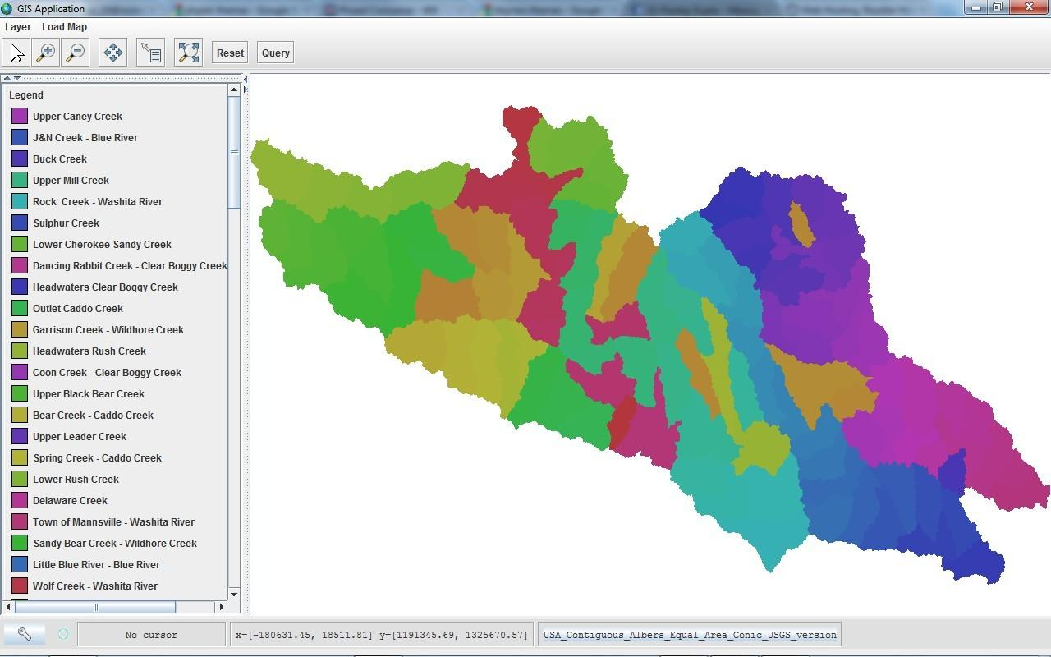

Fig. 13. Visualization of sub-watersheds of study area

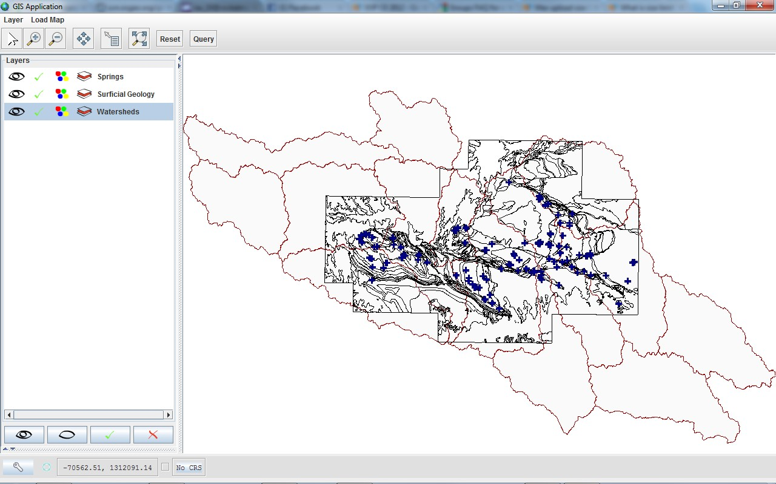

Fig. 14. Visualization of Watershed, surficial geology and springs of study area

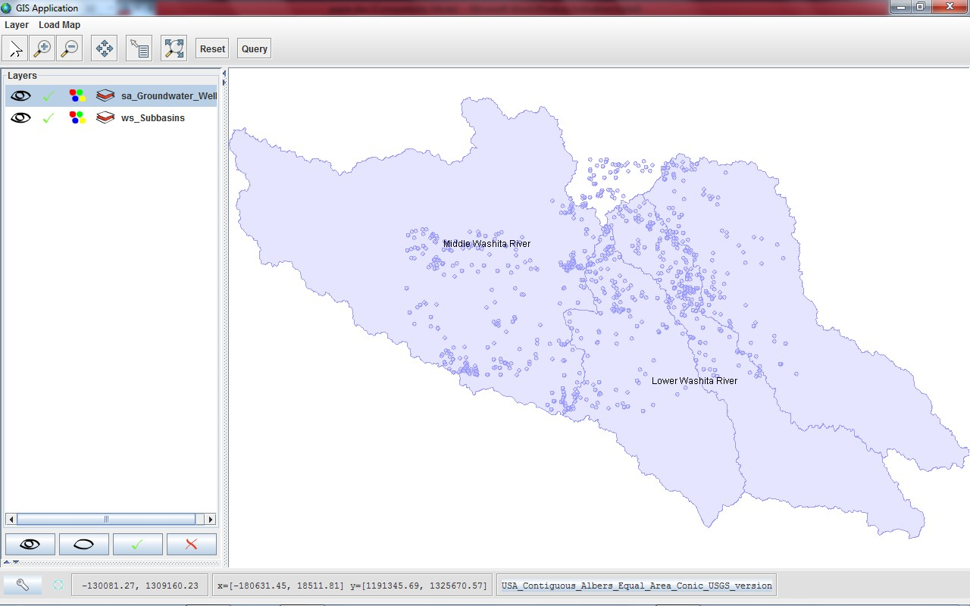

Fig. 15. Location of groundwater wells in basin

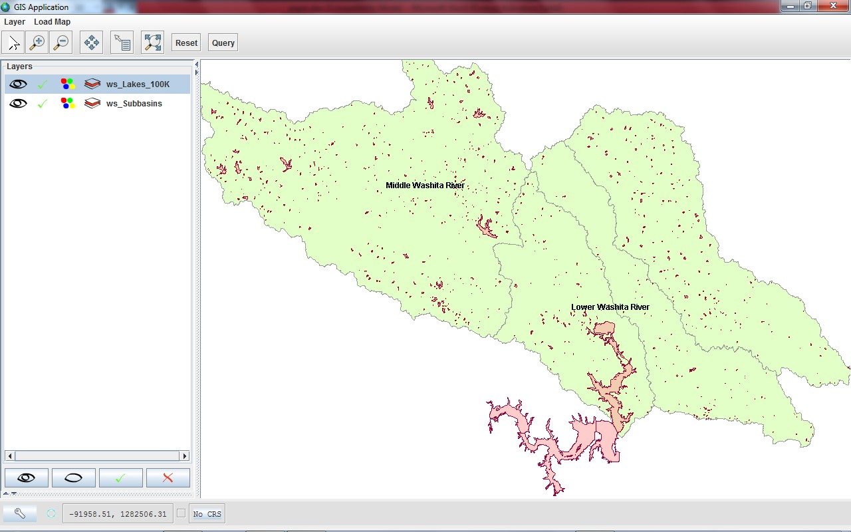

Fig. 16. Location of lakes in basin

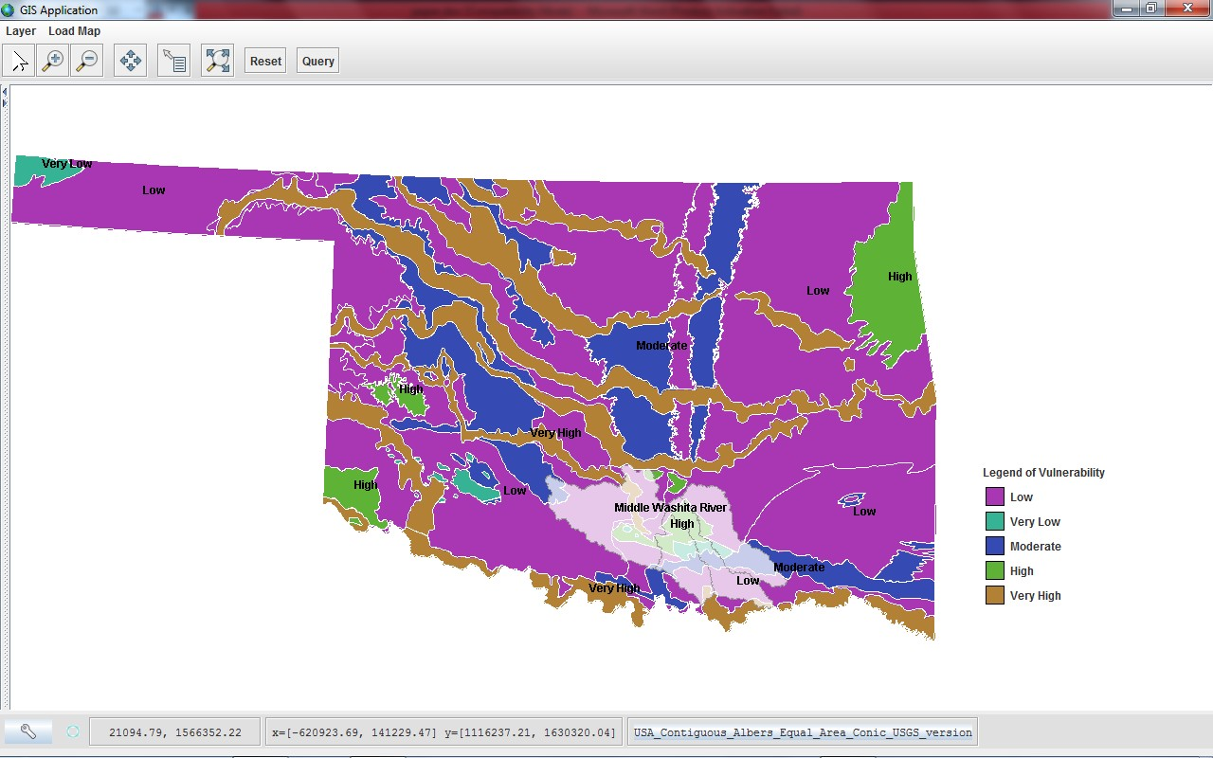

Fig. 17. Groundwater vulnerability map of basin

XVI: INFERENCES

Area is drained by SE flowing streams. Hence, slope of the study area is in SE direction. Drainage pattern is dendritic. There is relatively high drainage density in some parts of northern area. It indicates high runoff and low infiltration. There are four sub-basins and many watersheds and sub watersheds. There is a presence of number of springs. There are large numbers of groundwater wells. It shows significant groundwater development. Numerous small lakes are spreaded all over the basin, hence there is availability of significant surface water resource. Few major lakes are located in southern part of basin. Presence of number of springs indicates that there is sufficient pressure in aquifer system for groundwater discharge processes. Within basin groundwater vulnerability varies from low to very high. Most of the area is having low vulnerability. Area having high groundwater vulnerability is having relatively high density of groundwater wells. Area having low groundwater vulnerability is having relatively high density of lakes.

XVII: SUMMARY

GeoTools based visualization of water resource information provides significant inferences pertaining to basin. Inferences are also based on analysis of different thematic layers. These inferences may serve as an input for water resource management of basin. Different functionalities of GeoTools aided in visualization. Present work exemplifies the role of Geospatial technology in water resource management.
As GeoTools library is free and open source, repeatability of outcome can be achieved.

XVIII: FUTUREWORK

GeoTools is a living project which is constantly in development with many developers. As a result of this diverse development team and the distributed leadership approach, future work in GeoTools may seem at first glance somewhat random and uncoordinated. GeoTools is in the process of changing its feature model to allow the support of more complex features than are currently allowed.

ACKNOWLEDGEMENTS

The authors express their gratitude to Shri T.P. Singh, Director, BISAG, Gandhinagar for providing necessary support for this work.

Disclaimer: Maps presented in this paper are indicative only. Maps are not to scale.

REFRENCES

Nair, J.S., 2007. Computational and interactive visualization with a focus on topological analysis, dual contouring and water-resource data representation, Doctoral Dissertation, University of California, Davis, CA, USA, http://dl.acm.org/citation.cfm?id=1329647, accessed on

Turton I.,2008. GeoTools, G.B. Hall, M.G. Leahy (eds.), Open Source Approaches in Spatial Data Handling. Advances in Geographic Information Science 2, Springer-Verlag Berlin Heidelberg, pp. 153 – 169.

http://geotools.org, accessed on March 9, 2012.
http://bgis.sanbi.org/GIS-primer/page_14.htm, accessed on March 9, 2012.
http://www.esri.com/industries/water_resources/index.html, accessed on March 9, 2012.
http://www.gis.com/content/data-types-and-models, accessed on March 9, 2012.
http://www.sfu.ca/rdl/GIS/tour/comp_gis.html, accessed on March 9, 2012.
http://www.sfu.ca/rdl/GIS/tour/gis_task.html, accessed on March 9, 2012.
http://www.maine.gov/dep/gis/training/a9bc/labeling.shtml, accessed on March 9, 2012.
http://www.pasda.psu.edu/tutorials/arcgis/glossary.asp, accessed on March 9, 2012. http://en.mimi.hu/gis/raster_data.html, accessed on March 9, 2012.

