V11 Metrics and Model Comparison
This document summarizes the strongest validated model in the project, the patient-aware V11 tri-expert fusion. It also shows how to read the main metrics and how V11 compares with V9, V8, and the handcrafted XGBoost expert.

Key Result
V11 fusion achieved Macro F1 = 0.8818 +/- 0.0074, Accuracy = 0.8837, and AUROC = 0.9634.
Compared with V9, the gain is +0.0070 Macro F1 on the same honest 5-fold patient-aware protocol.

Summary Table
Model | Macro F1 | F1 Std | Accuracy | AUROC
v11_fusion | 0.8818 | 0.0074 | 0.8837 | 0.9634
v9_expert | 0.8747 | 0.0072 | 0.8769 | 0.9622
v8_expert | 0.8714 | 0.0045 | 0.8737 | 0.9589
xgb_expert | 0.6221 | 0.0086 | 0.6260 | 0.8028

How To Read The Table
Macro F1 is the best single summary for this 3-class problem because it treats each class equally.
Accuracy is easier to read but can hide class imbalance.
AUROC tells us how well the model separates classes before choosing a threshold.

Visual Comparison
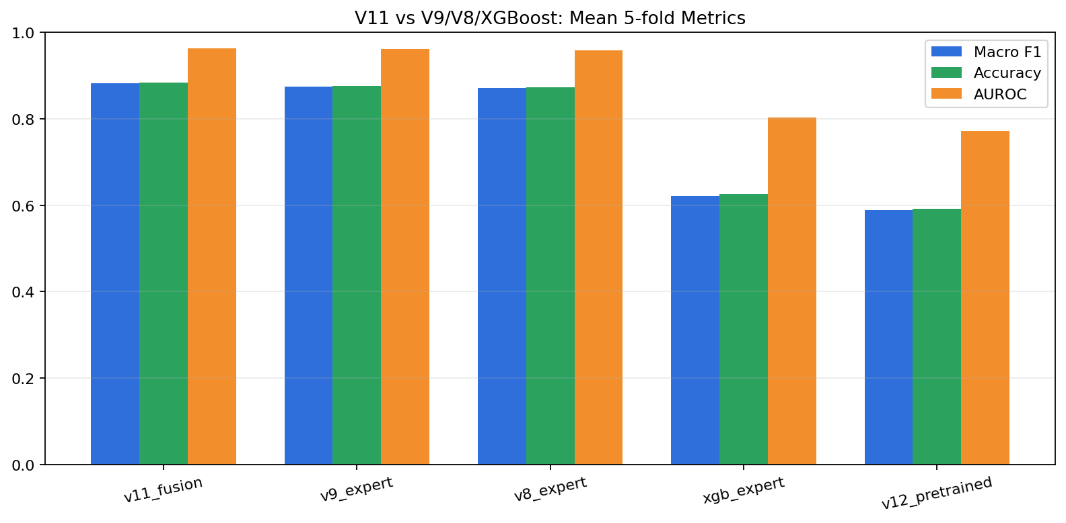
This bar chart shows that V11 is consistently above V9, V8, and the standalone XGBoost expert.

Out-of-Fold Diagnostics
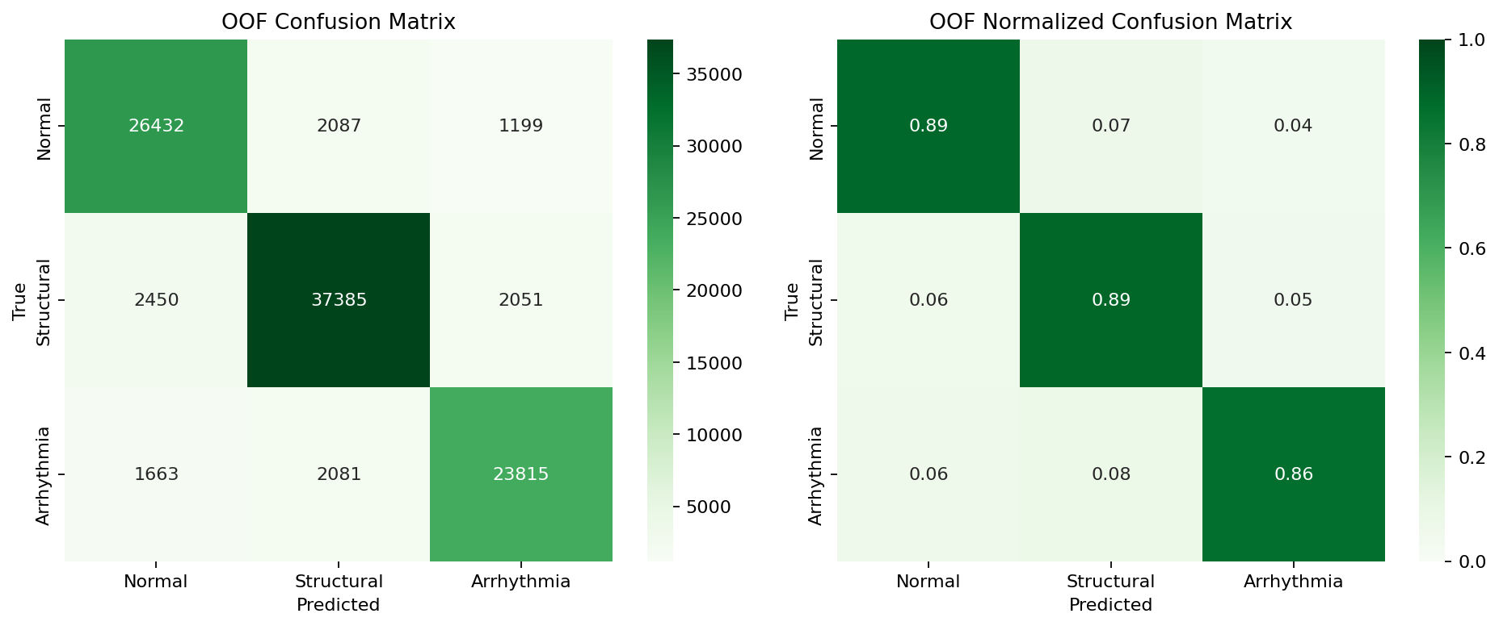
Read the left panel as raw counts and the right panel as class-wise recall. A stronger diagonal means fewer confusions between pediatric cardiac classes.
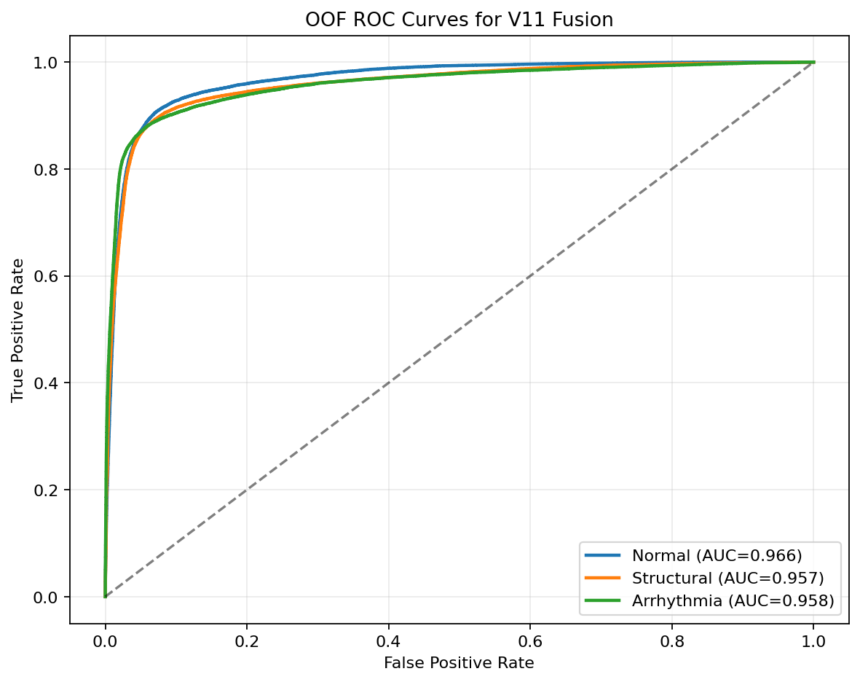
The ROC curves show class separability across the entire operating range. Curves closer to the top-left corner are better.

Interpretation Notes
V11 is a late-fusion model, so its novelty is not only architecture depth but also patient-aware calibration and expert combination. That makes it easier to explain in a paper than a single opaque end-to-end network.
The public pretrained ECG baseline (V12) reached Macro F1 = 0.5886, Accuracy = 0.5924, and AUROC = 0.7726. This is far below V11 on the same pediatric task, so V11 remains the main paper model.

