V9/V11 XAI Report
This document collects the explainability plots already produced in the project and pairs them with the research-backed methods most appropriate for ECG models.

Why These XAI Methods
Integrated Gradients is well suited to raw ECG waveforms because it attributes the output along a path from a baseline to the input and satisfies attribution axioms.
Grad-CAM is appropriate for convolutional branches because it highlights the final convolutional feature maps that drive the prediction.
SHAP / WindowSHAP style explanations are appropriate for handcrafted RR and morphology features because they give additive feature contributions.
Occlusion sensitivity is a useful sanity check because it measures how the prediction changes when a region is masked.

What The Layers Mean
Waveform-level explanations target the ECG beats themselves.
Lead-level heatmaps show which ECG leads matter most.
Feature-level explanations show which handcrafted descriptors and RR values carry the decision.
Fusion-level plots show how the model combines experts.

V11 Fusion-Level XAI Plots
How often each fusion strategy was selected across folds.
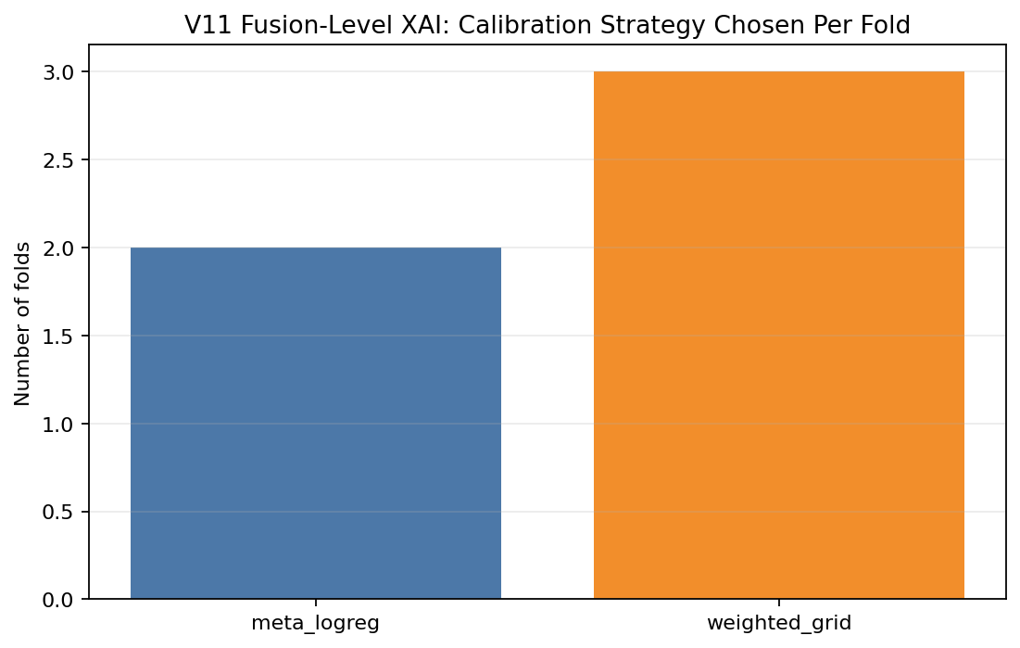
Fold-wise improvement of V11 over the core V9 deep expert.
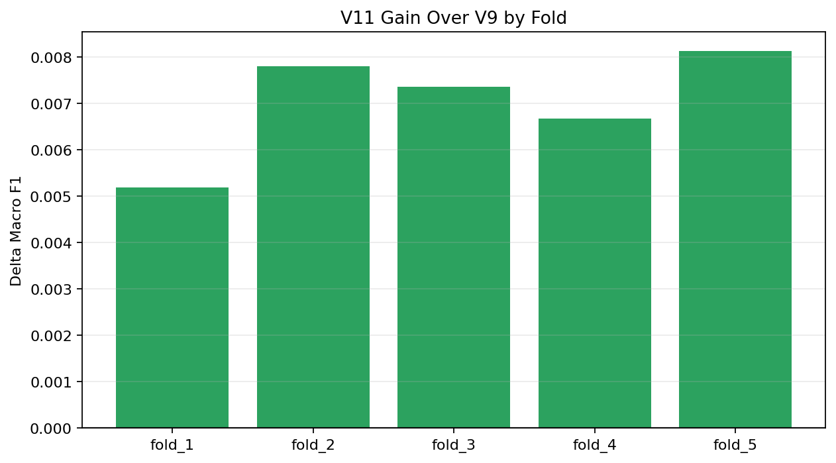
Relative reliance on V8, V9, and XGBoost in folds where weighted-grid fusion won.
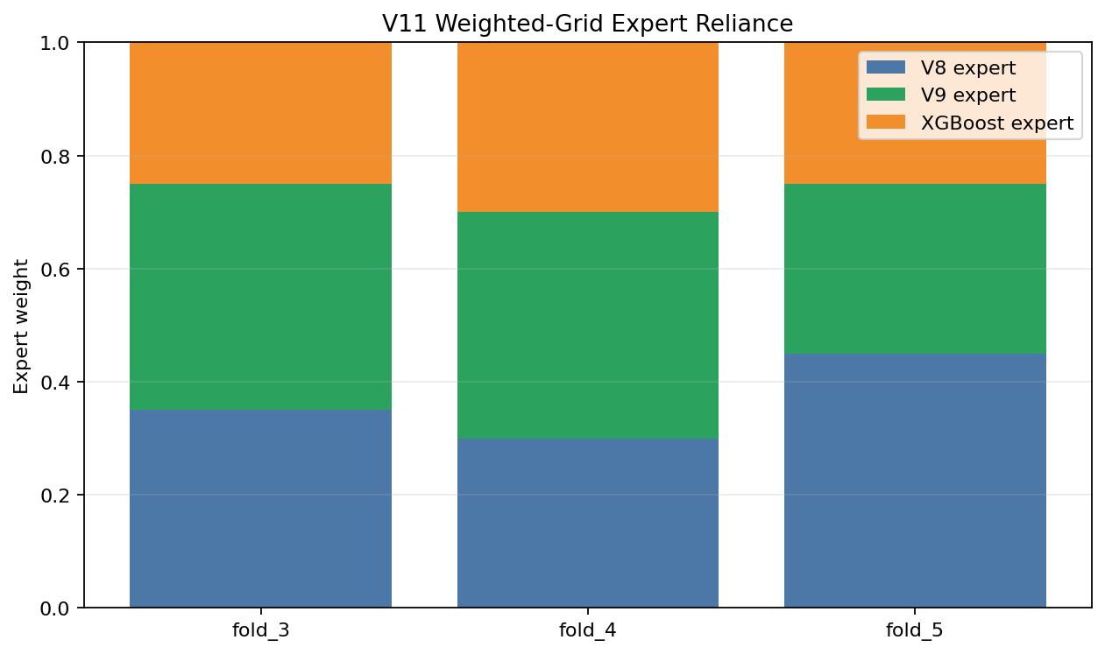
Method matrix CSV saved at: C:\Users\Admin\Desktop\Projects\8th Sem\Codex\reports\assets\v11_xai_method_matrix.csv

Saved XAI Plots
xai1_integrated_gradients_per_class.png
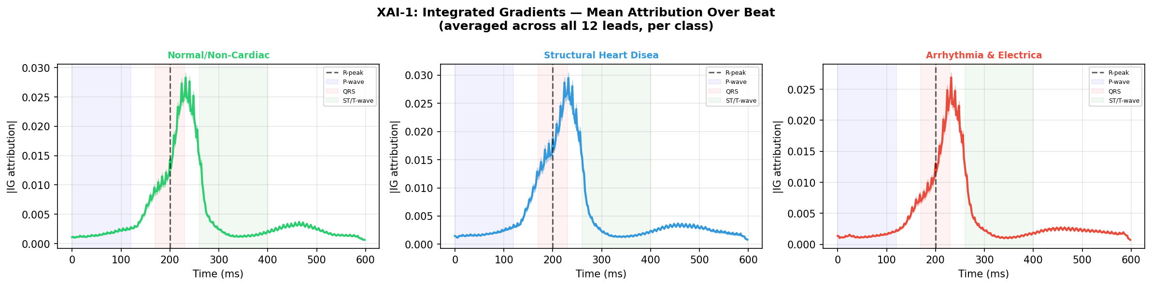
xai1_ig_lead_heatmap.png
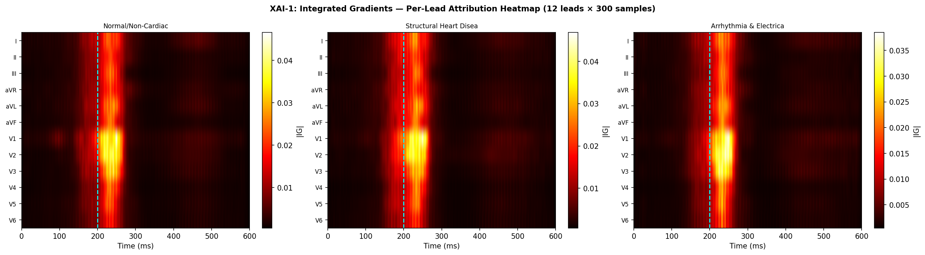
xai2_gradcam_per_class.png
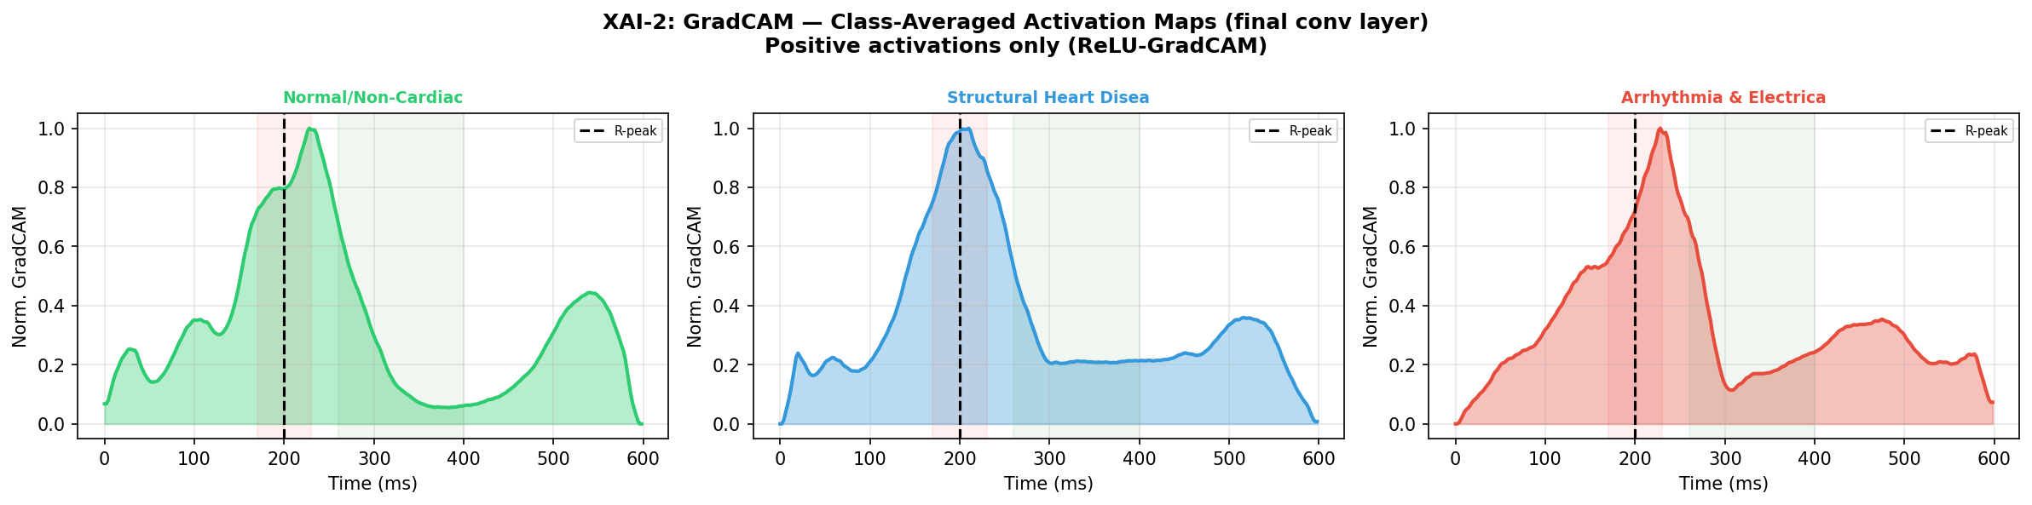
xai2_gradcam_vs_ig_agreement.png
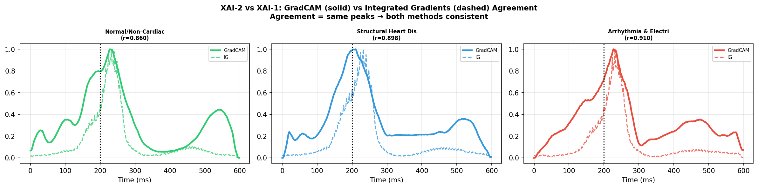
xai4_occlusion_sensitivity.png
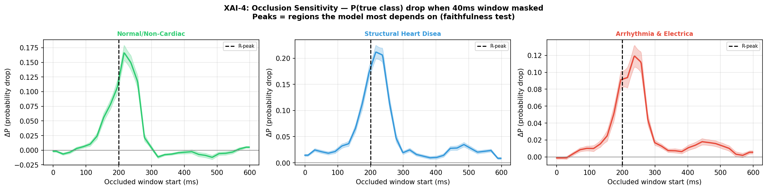
xai5_cross_attention_weights.png
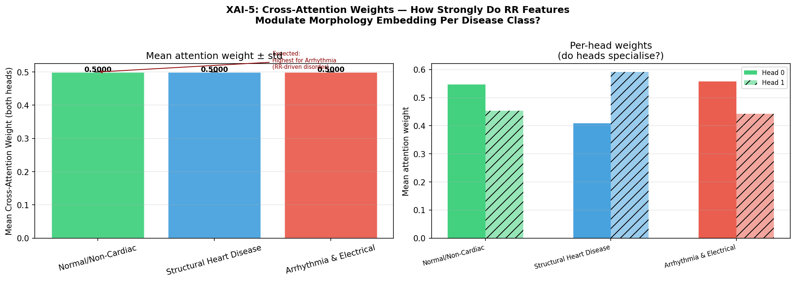
shap_global_importance.png
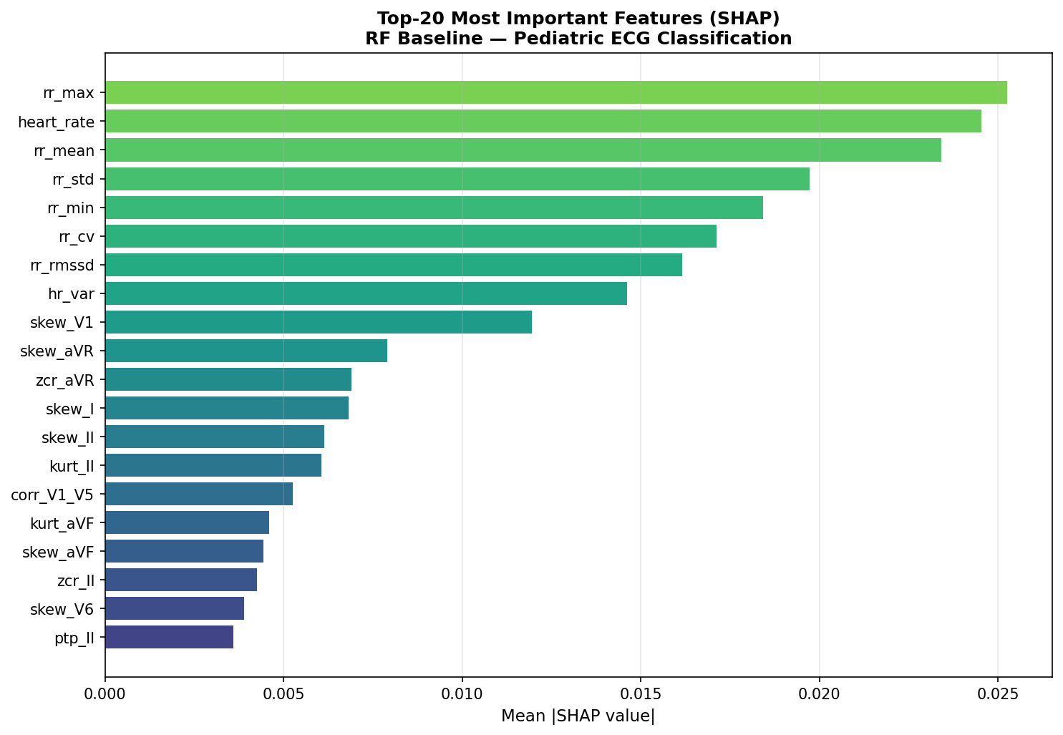
shap_summary_normal_non-cardiac.png
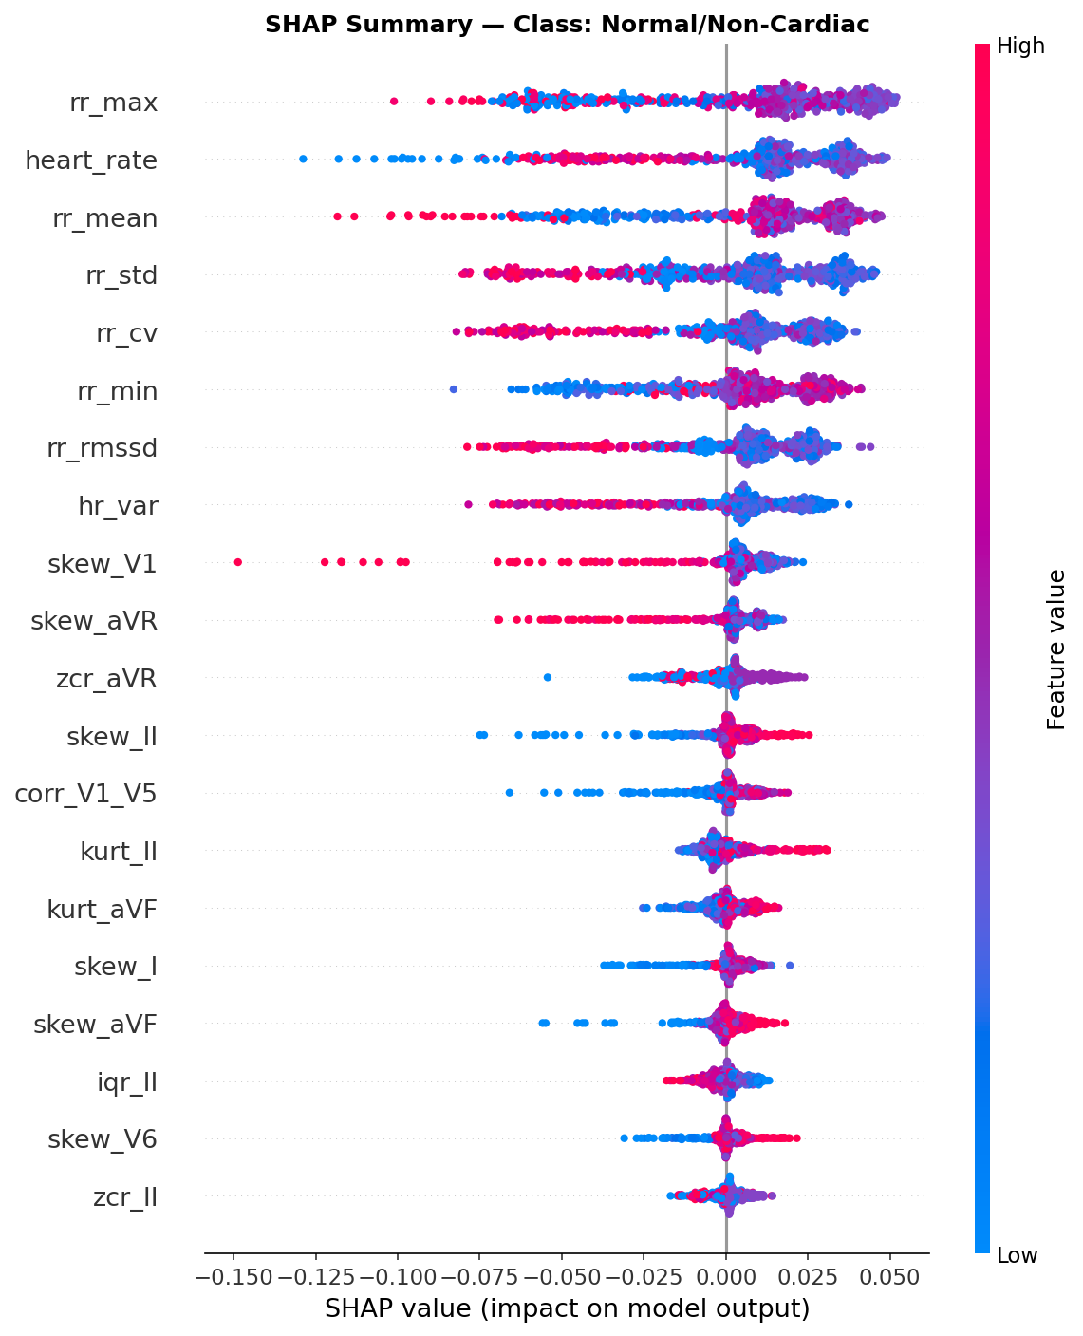
shap_summary_structural heart disease.png
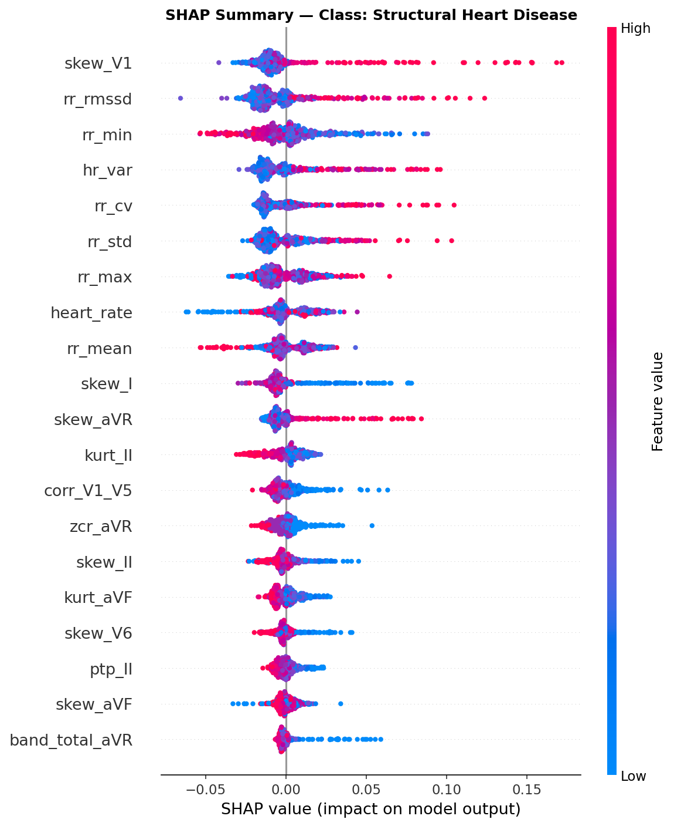
shap_summary_arrhythmia & electrical.png
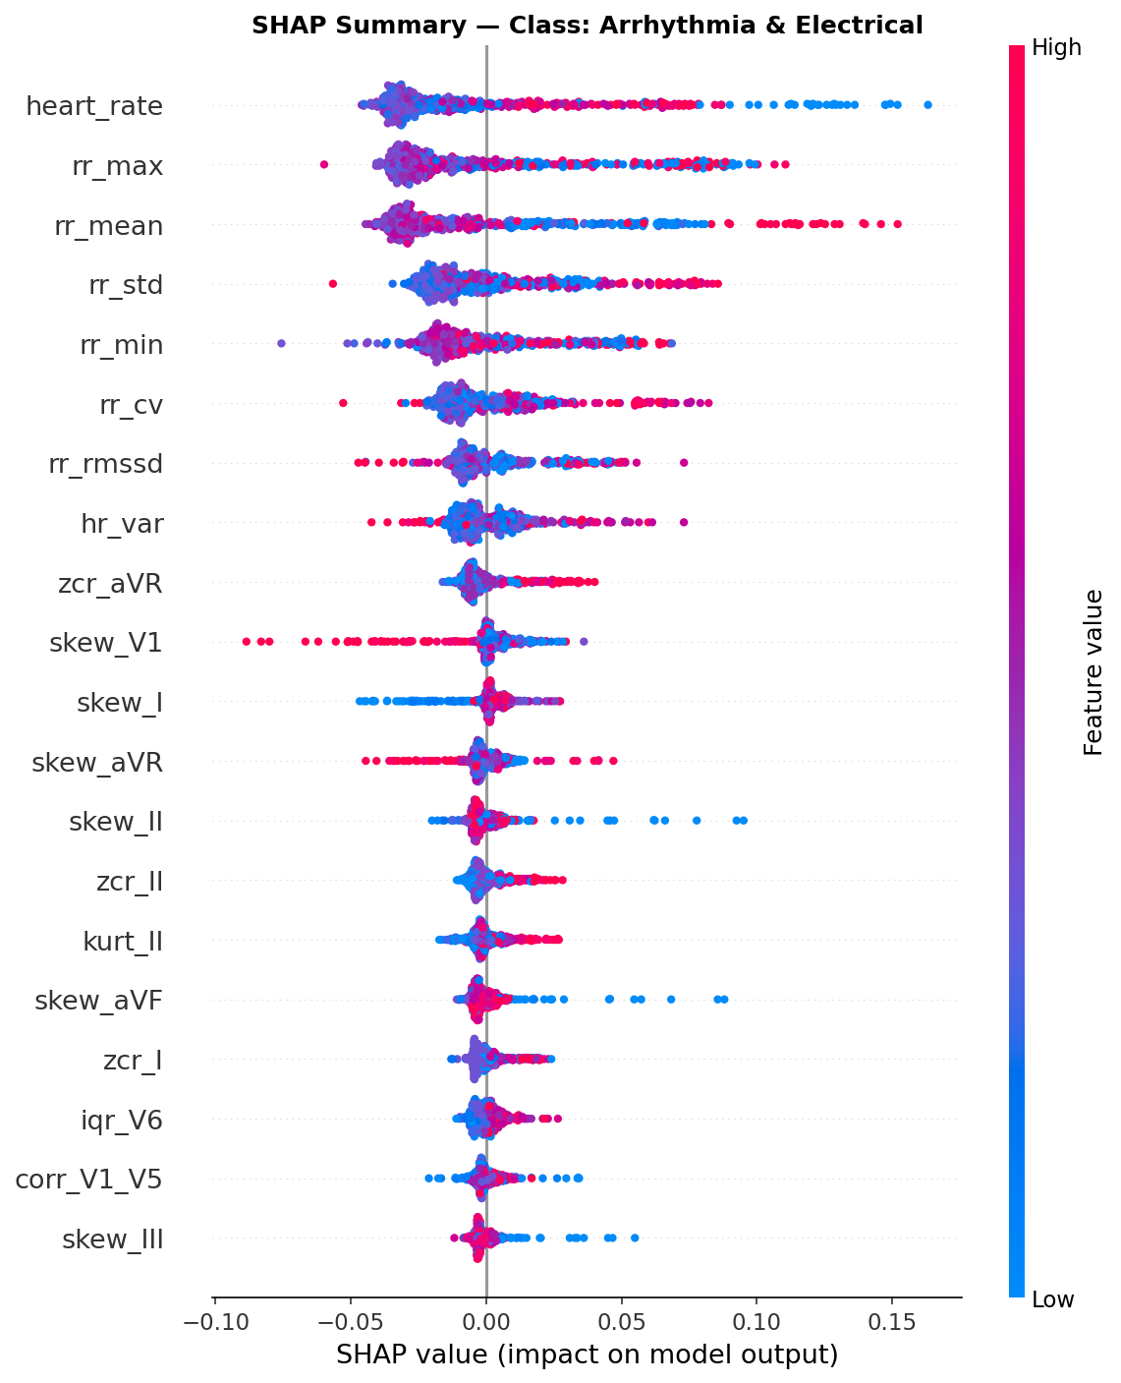

How To Interpret The Figures
Integrated Gradients: strong positive color around a beat segment means that segment pushes the prediction toward the class.
Grad-CAM: hotter regions mean the final conv layer pays more attention there; this often corresponds to QRS or T-wave morphology.
Occlusion: a large score drop after masking indicates the masked segment is important.
SHAP: features with larger absolute values have stronger global importance; sign indicates direction of contribution.
Cross-attention weights: higher weights indicate the rhythm branch is steering morphology interpretation more strongly.

Recommended XAI Narrative
For the paper, describe XAI at three levels: input waveform, clinical features, and fusion behavior. That matches how pediatric ECG clinicians reason in practice.
If you want, the next step can be to regenerate these explanations for the new pretrained baseline once we finish its benchmark.

References Used For Method Choice
Sundararajan et al., Axiomatic Attribution for Deep Networks, Integrated Gradients.
Selvaraju et al., Grad-CAM: Visual Explanations from Deep Networks via Gradient-based Localization.
Nayebi et al., WindowSHAP: Shapley-based explanations for time-series classifiers.
Evaluating gradient-based explanation methods for neural network ECG analysis using heatmaps.
Explainable artificial intelligence in electrocardiography: A systematic review.

