***SCREENSHOTS OF WORKING OF***

***Eco-Tracker***

1. **USER REGISTRATION SUCCESS (POSTMAN):**

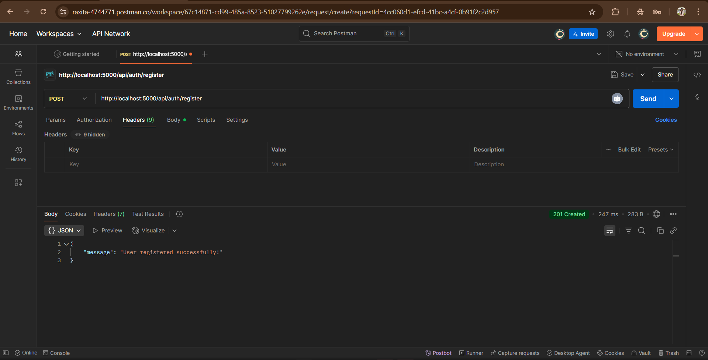

1. **USER LOGIN SUCCESS (POSTMAN):**

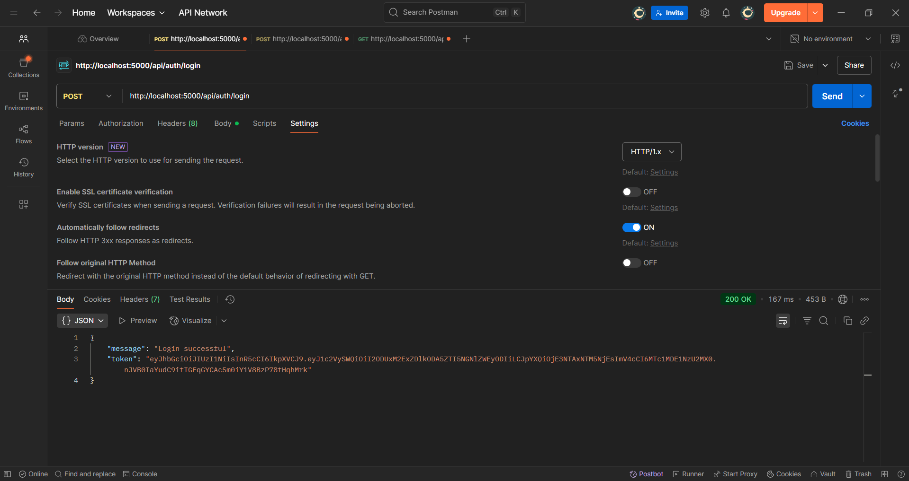

1. **CREATE ACTIVITY (POST/api/activities):**

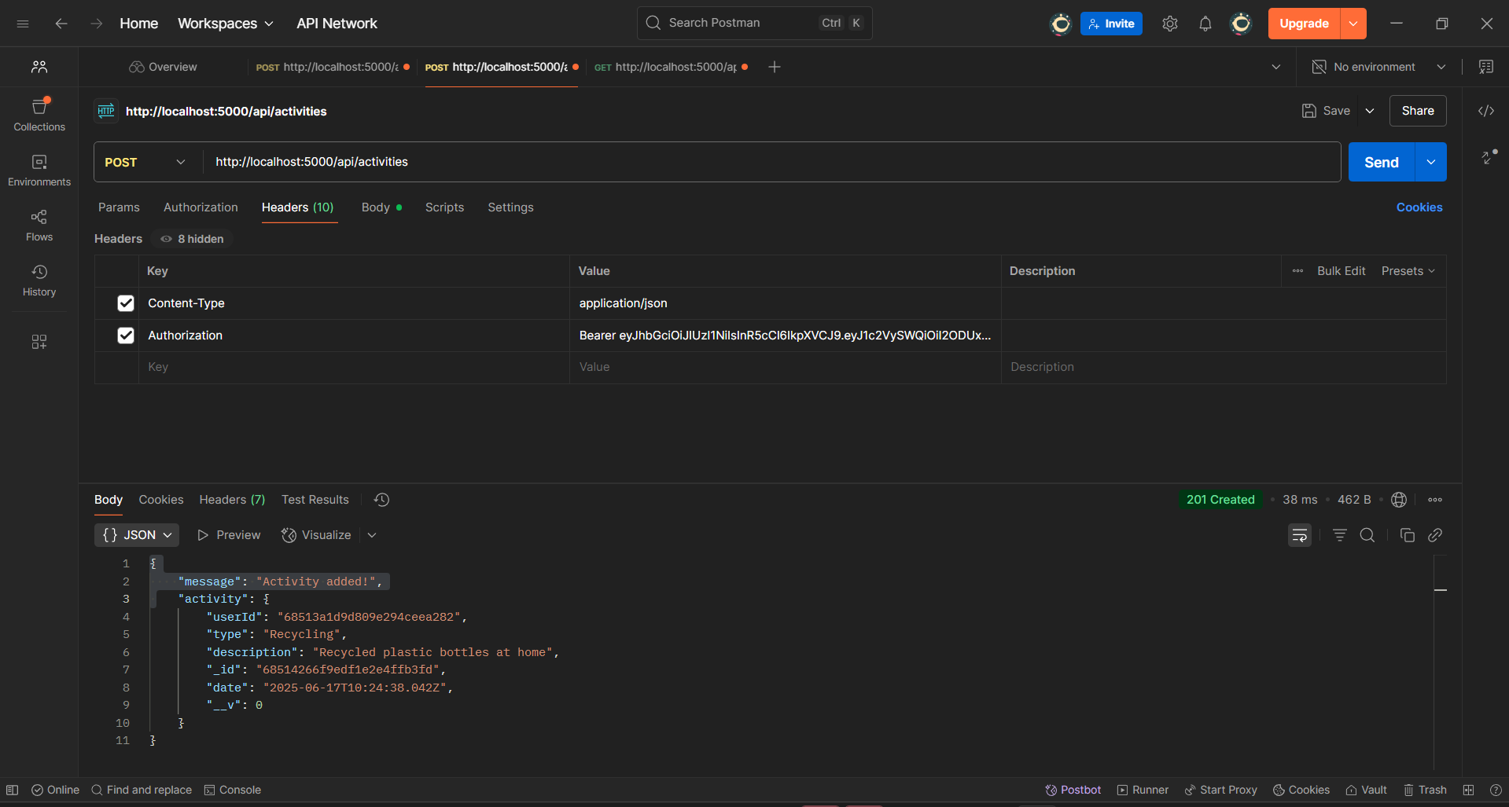

1. **GET Activities (GET/api/activities):**

