db.products.insertMany([

{ "_id" : 1, "name" : "xPhone", "price" : 799, "releaseDate" : ISODate("2011-05-14T00:00:00Z"), "spec" : { "ram" : 4, "screen" : 6.5, "cpu" : 2.66 }, "color" : [ "white", "black" ], "storage" : [ 64, 128, 256 ] },

{ "_id" : 2, "name" : "xTablet", "price" : 899, "releaseDate" : ISODate("2011-09-01T00:00:00Z"), "spec" : { "ram" : 16, "screen" : 9.5, "cpu" : 3.66 }, "color" : [ "white", "black", "purple" ], "storage" : [ 128, 256, 512 ] },

{ "_id" : 3, "name" : "SmartTablet", "price" : 899, "releaseDate" : ISODate("2015-01-14T00:00:00Z"), "spec" : { "ram" : 12, "screen" : 9.7, "cpu" : 3.66 }, "color" : [ "blue" ], "storage" : [ 16, 64, 128 ] },

{ "_id" : 4, "name" : "SmartPad", "price" : 699, "releaseDate" : ISODate("2020-05-14T00:00:00Z"), "spec" : { "ram" : 8, "screen" : 9.7, "cpu" : 1.66 }, "color" : [ "white", "orange", "gold", "gray" ], "storage" : [ 128, 256, 1024 ] },

{ "_id" : 5, "name" : "SmartPhone", "price" : 599, "releaseDate" : ISODate("2022-09-14T00:00:00Z"), "spec" : { "ram" : 4, "screen" : 9.7, "cpu" : 1.66 }, "color" : [ "white", "orange", "gold", "gray" ], "storage" : [ 128, 256 ] }

])

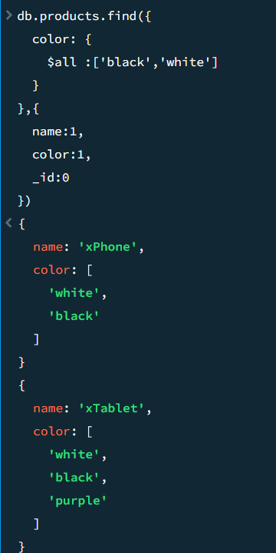

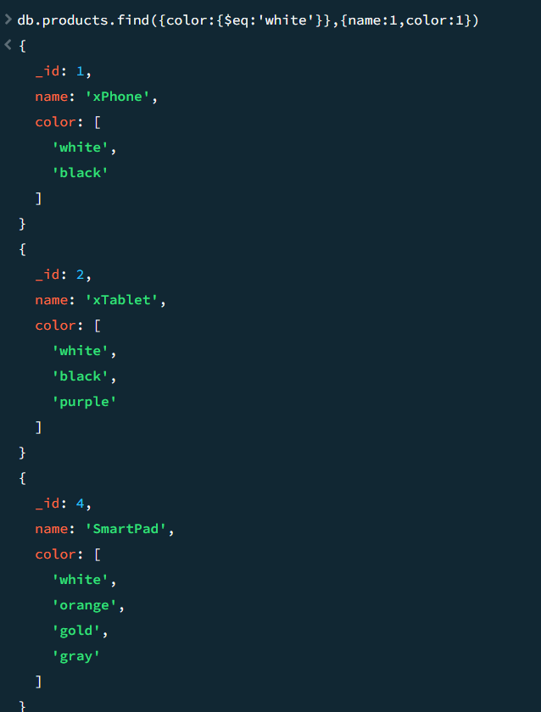

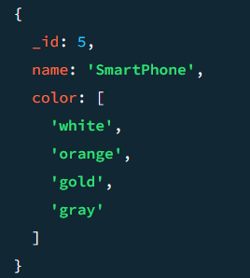

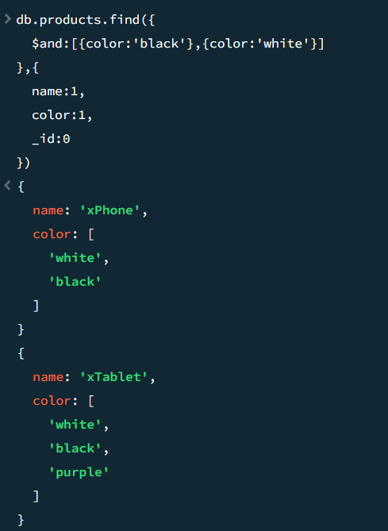

db.products.insertMany([

{ "_id" : 1, "name" : "xPhone", "price" : 799, "releaseDate" : ISODate("2011-05-14T00:00:00Z"), "spec" : { "ram" : 4, "screen" : 6.5, "cpu" : 2.66 }, "color" : [ "white", "black" ], "storage" : [ 64, 128, 256 ] },

{ "_id" : 2, "name" : "xTablet", "price" : 899, "releaseDate" : ISODate("2011-09-01T00:00:00Z"), "spec" : { "ram" : 16, "screen" : 9.5, "cpu" : 3.66 }, "color" : [ "white", "black", "purple" ], "storage" : [ 128, 256, 512 ] },

{ "_id" : 3, "name" : "SmartTablet", "price" : 899, "releaseDate" : ISODate("2015-01-14T00:00:00Z"), "spec" : { "ram" : 12, "screen" : 9.7, "cpu" : 3.66 }, "color" : [ "blue" ], "storage" : [ 16, 64, 128 ] },

{ "_id" : 4, "name" : "SmartPad", "price" : 699, "releaseDate" : ISODate("2020-05-14T00:00:00Z"), "spec" : { "ram" : 8, "screen" : 9.7, "cpu" : 1.66 }, "color" : [ "white", "orange", "gold", "gray" ], "storage" : [ 128, 256, 1024 ] },

{ "_id" : 5, "name" : "SmartPhone", "price" : 599, "releaseDate" : ISODate("2022-09-14T00:00:00Z"), "spec" : { "ram" : 4, "screen" : 9.7, "cpu" : 1.66 }, "color" : [ "white", "orange", "gold", "gray" ], "storage" : [ 128, 256 ] }

])

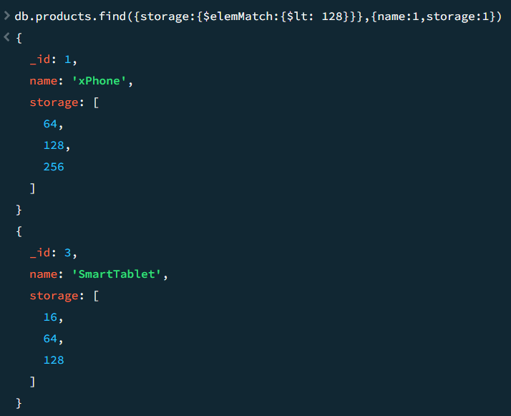

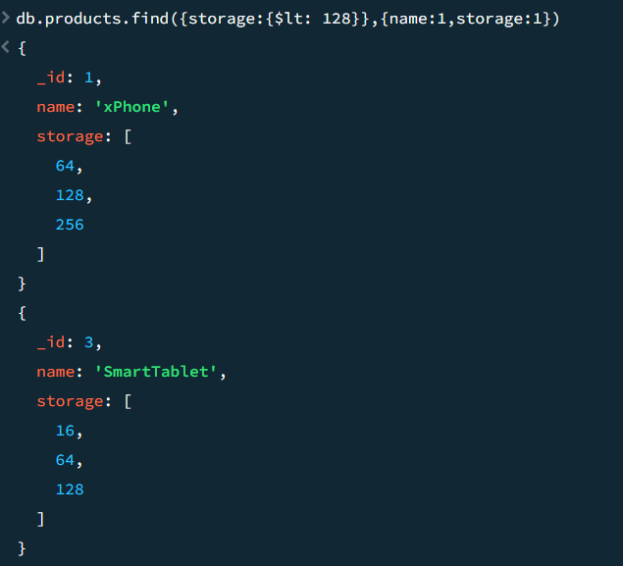

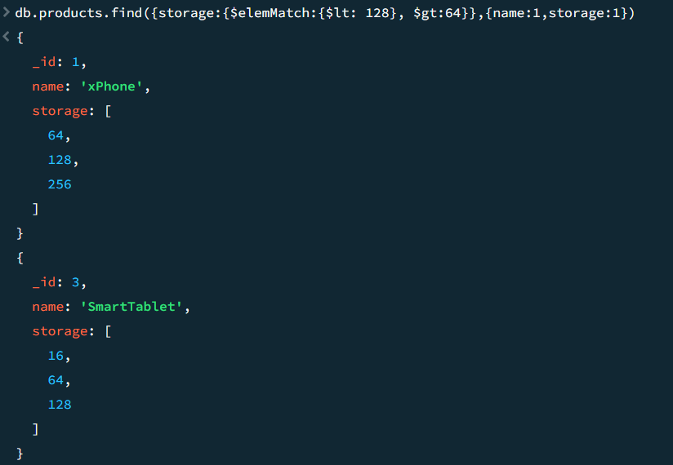

db.products.insertMany([

{ "_id" : 1, "name" : "xPhone", "price" : 799, "releaseDate" : ISODate("2011-05-14T00:00:00Z"), "spec" : { "ram" : 4, "screen" : 6.5, "cpu" : 2.66 }, "color" : [ "white", "black" ], "storage" : [ 64, 128, 256 ] },

{ "_id" : 2, "name" : "xTablet", "price" : 899, "releaseDate" : ISODate("2011-09-01T00:00:00Z"), "spec" : { "ram" : 16, "screen" : 9.5, "cpu" : 3.66 }, "color" : [ "white", "black", "purple" ], "storage" : [ 128, 256, 512 ] },

{ "_id" : 3, "name" : "SmartTablet", "price" : 899, "releaseDate" : ISODate("2015-01-14T00:00:00Z"), "spec" : { "ram" : 12, "screen" : 9.7, "cpu" : 3.66 }, "color" : [ "blue" ], "storage" : [ 16, 64, 128 ] },

{ "_id" : 4, "name" : "SmartPad", "price" : 699, "releaseDate" : ISODate("2020-05-14T00:00:00Z"), "spec" : { "ram" : 8, "screen" : 9.7, "cpu" : 1.66 }, "color" : [ "white", "orange", "gold", "gray" ], "storage" : [ 128, 256, 1024 ] },

{ "_id" : 5, "name" : "SmartPhone", "price" : 599, "releaseDate" : ISODate("2022-09-14T00:00:00Z"), "spec" : { "ram" : 4, "screen" : 9.7, "cpu" : 1.66 }, "color" : [ "white", "orange", "gold", "gray" ], "storage" : [ 128, 256 ] },

{ "_id" : 6, "name" : "xWidget", "spec" : { "ram" : 64, "screen" : 9.7, "cpu" : 3.66 }, "color" : [ "black" ], "storage" : [ 1024 ] },

{ "_id" : 7, "name" : "xReader", "price" : null, "spec" : { "ram" : 64, "screen" : 6.7, "cpu" : 3.66 }, "color" : [ "black", "white" ], "storage" : [ 128 ] }

])

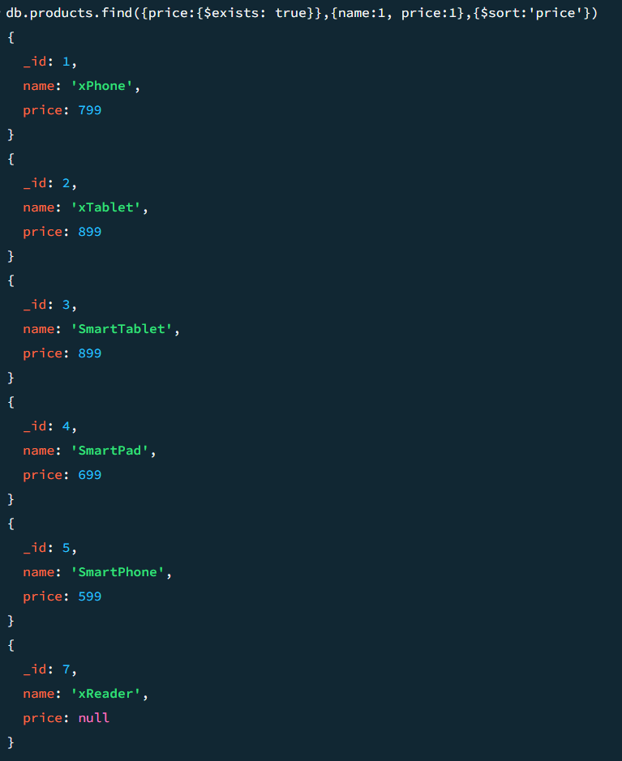

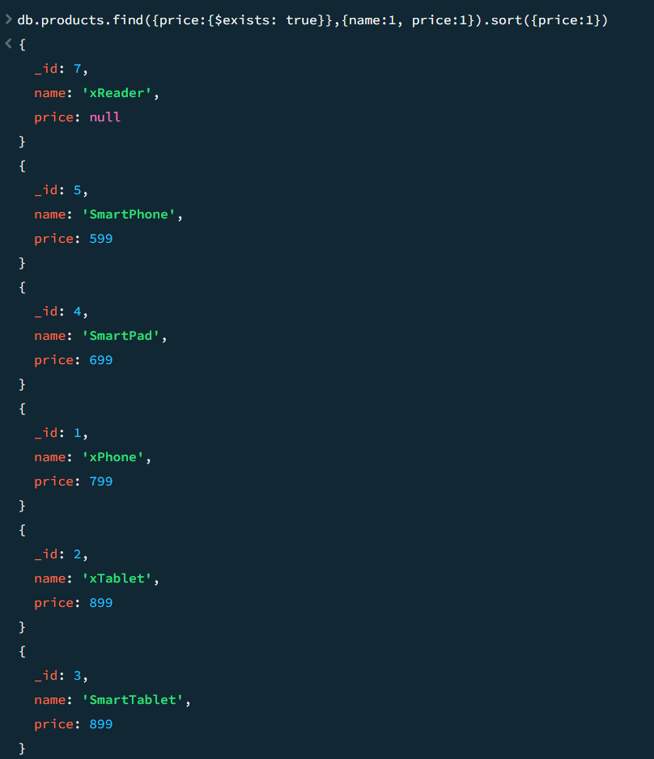

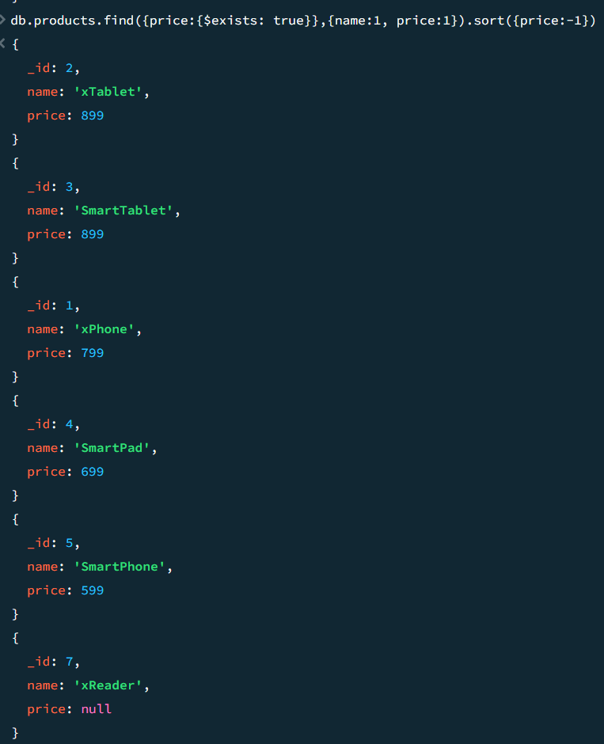

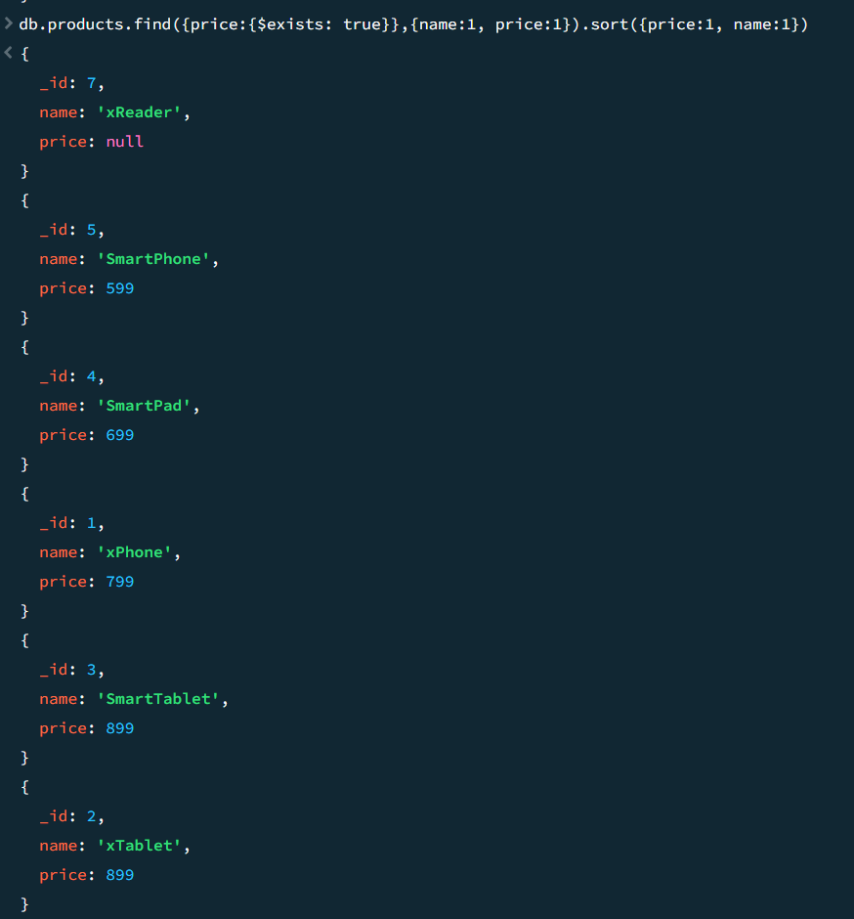

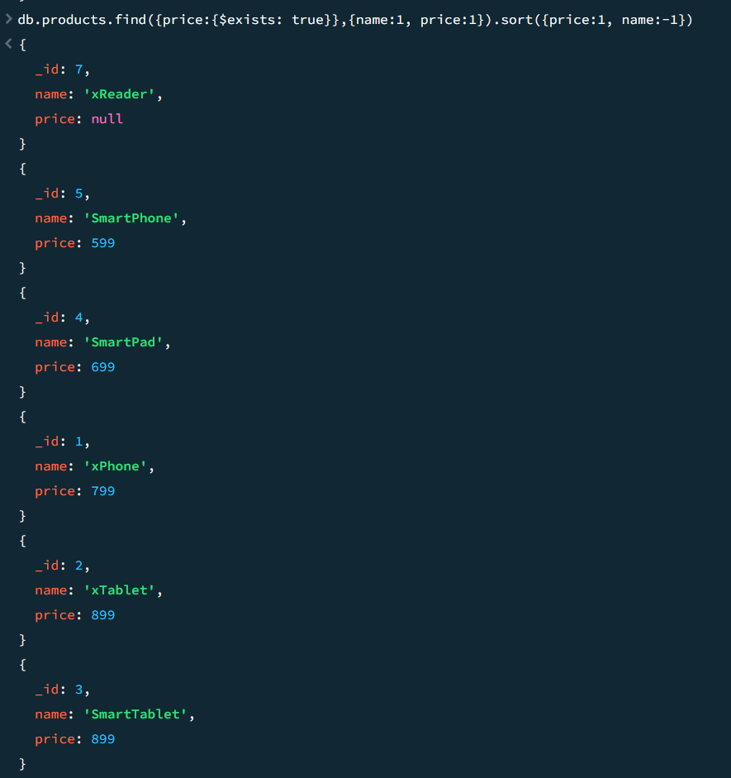

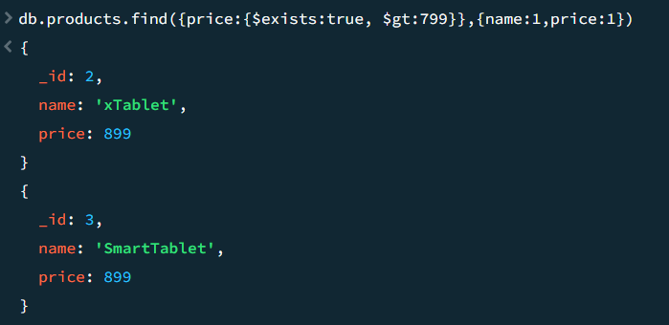

db.products.insertMany([

{ "_id" : 1, "name" : "xPhone", "price" : "799", "releaseDate" : ISODate("2011-05-14T00:00:00Z"), "spec" : { "ram" : 4, "screen" : 6.5, "cpu" : 2.66 }, "color" : [ "white", "black" ], "storage" : [ 64, 128, 256 ] },

{ "_id" : 2, "name" : "xTablet", "price" : NumberInt(899), "releaseDate" : ISODate("2011-09-01T00:00:00Z"), "spec" : { "ram" : 16, "screen" : 9.5, "cpu" : 3.66 }, "color" : [ "white", "black", "purple" ], "storage" : [ 128, 256, 512 ] },

{ "_id" : 3, "name" : "SmartTablet", "price" : NumberLong(899), "releaseDate" : ISODate("2015-01-14T00:00:00Z"), "spec" : { "ram" : 12, "screen" : 9.7, "cpu" : 3.66 }, "color" : [ "blue" ], "storage" : [ 16, 64, 128 ] },

{ "_id" : 4, "name" : "SmartPad", "price" : [599, 699, 799], "releaseDate" : ISODate("2020-05-14T00:00:00Z"), "spec" : { "ram" : 8, "screen" : 9.7, "cpu" : 1.66 }, "color" : [ "white", "orange", "gold", "gray" ], "storage" : [ 128, 256, 1024 ] },

{ "_id" : 5, "name" : "SmartPhone", "price" : ["599",699], "releaseDate" : ISODate("2022-09-14T00:00:00Z"), "spec" : { "ram" : 4, "screen" : 9.7, "cpu" : 1.66 }, "color" : [ "white", "orange", "gold", "gray" ], "storage" : [ 128, 256 ] },

{ "_id" : 6, "name" : "xWidget", "spec" : { "ram" : 64, "screen" : 9.7, "cpu" : 3.66 }, "color" : [ "black" ], "storage" : [ 1024 ] }

])

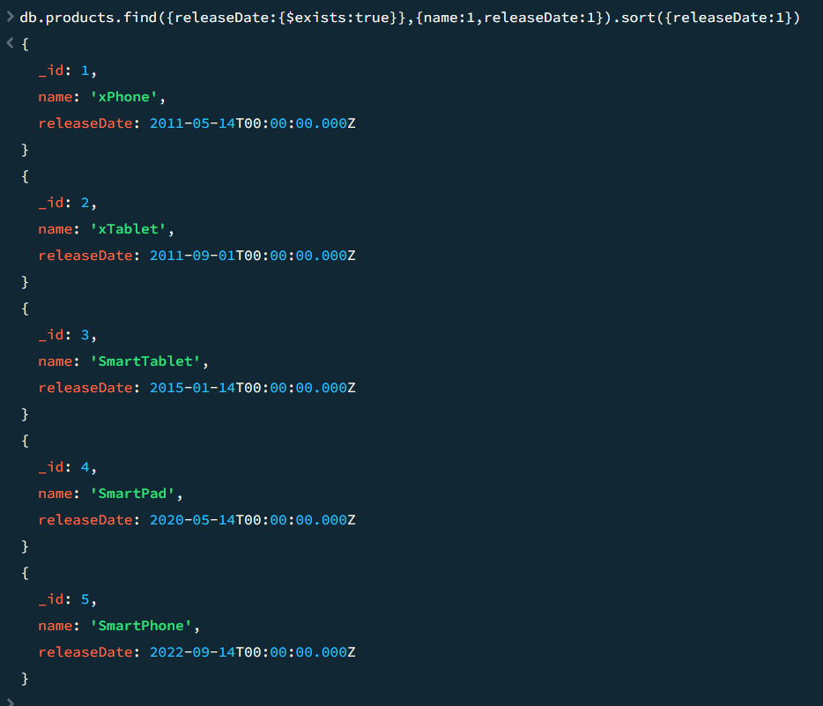

db.products.insertMany([

{ "_id" : 1, "name" : "xPhone", "price" : 799, "releaseDate" : ISODate("2011-05-14T00:00:00Z"), "spec" : { "ram" : 4, "screen" : 6.5, "cpu" : 2.66 }, "color" : [ "white", "black" ], "storage" : [ 64, 128, 256 ] },

{ "_id" : 2, "name" : "xTablet", "price" : 899, "releaseDate" : ISODate("2011-09-01T00:00:00Z"), "spec" : { "ram" : 16, "screen" : 9.5, "cpu" : 3.66 }, "color" : [ "white", "black", "purple" ], "storage" : [ 128, 256, 512 ] },

{ "_id" : 3, "name" : "SmartTablet", "price" : 899, "releaseDate" : ISODate("2015-01-14T00:00:00Z"), "spec" : { "ram" : 12, "screen" : 9.7, "cpu" : 3.66 }, "color" : [ "blue" ], "storage" : [ 16, 64, 128 ] },

{ "_id" : 4, "name" : "SmartPad", "price" : 699, "releaseDate" : ISODate("2020-05-14T00:00:00Z"), "spec" : { "ram" : 8, "screen" : 9.7, "cpu" : 1.66 }, "color" : [ "white", "orange", "gold", "gray" ], "storage" : [ 128, 256, 1024 ] },

{ "_id" : 5, "name" : "SmartPhone", "price" : 599, "releaseDate" : ISODate("2022-09-14T00:00:00Z"), "spec" : { "ram" : 4, "screen" : 9.7, "cpu" : 1.66 }, "color" : [ "white", "orange", "gold", "gray" ], "storage" : [ 128, 256 ] },

{ "_id" : 6, "name" : "xWidget", "spec" : { "ram" : 64, "screen" : 9.7, "cpu" : 3.66 }, "color" : [ "black" ], "storage" : [ 1024 ] },

{ "_id" : 7, "name" : "xReader", "price" : null, "spec" : { "ram" : 64, "screen" : 6.7, "cpu" : 3.66 }, "color" : [ "black", "white" ], "storage" : [ 128 ] }

])

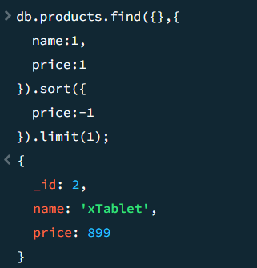

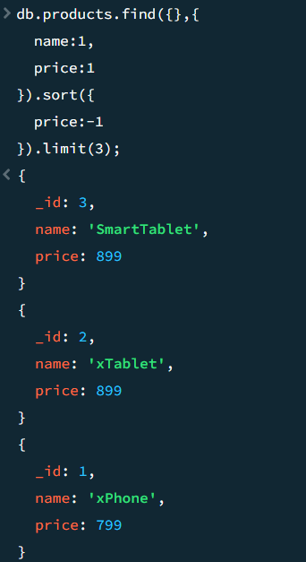

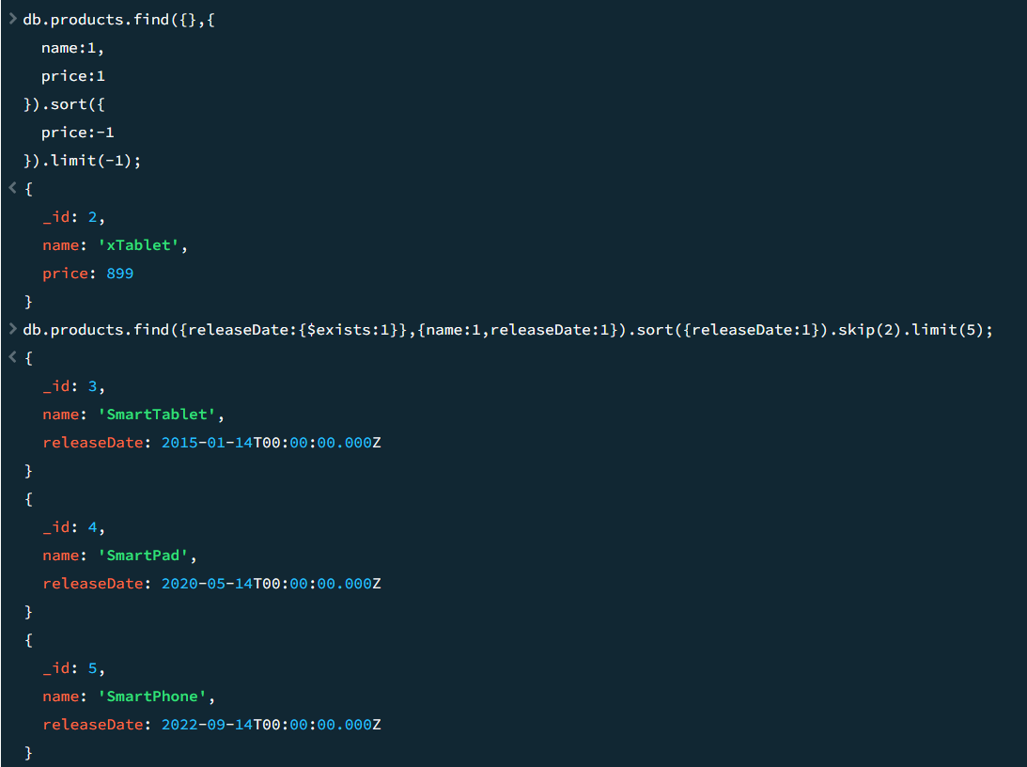

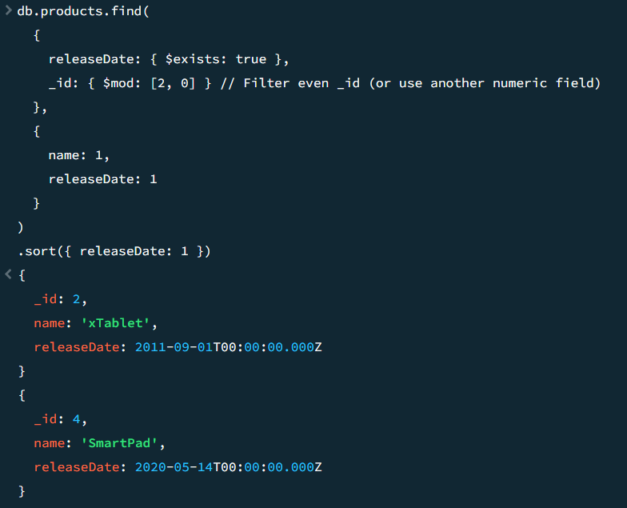

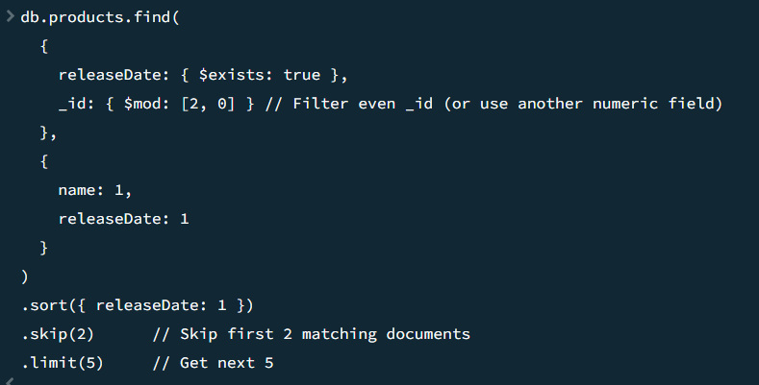

db.products.insertMany([

{ "_id" : 1, "name" : "xPhone", "price" : 799, "releaseDate": ISODate("2011-05-14"), "spec" : { "ram" : 4, "screen" : 6.5, "cpu" : 2.66 },"color":["white","black"],"storage":[64,128,256]},

{ "_id" : 2, "name" : "xTablet", "price" : 899, "releaseDate": ISODate("2011-09-01") , "spec" : { "ram" : 16, "screen" : 9.5, "cpu" : 3.66 },"color":["white","black","purple"],"storage":[128,256,512]},

{ "_id" : 3, "name" : "SmartTablet", "price" : 899, "releaseDate": ISODate("2015-01-14"), "spec" : { "ram" : 12, "screen" : 9.7, "cpu" : 3.66 },"color":["blue"],"storage":[16,64,128]},

{ "_id" : 4, "name" : "SmartPad", "price" : 699, "releaseDate": ISODate("2020-05-14"),"spec" : { "ram" : 8, "screen" : 9.7, "cpu" : 1.66 },"color":["white","orange","gold","gray"],"storage":[128,256,1024]},

{ "_id" : 5, "name" : "SmartPhone", "price" : 599,"releaseDate": ISODate("2022-09-14"), "spec" : { "ram" : 4, "screen" : 5.7, "cpu" : 1.66 },"color":["white","orange","gold","gray"],"storage":[128,256]}

])

