db.products.insertMany([

{ "_id" : 1, "name" : "xPhone", "price" : 799, "releaseDate": ISODate("2011-05-14"), "spec" : { "ram" : 4, "screen" : 6.5, "cpu" : 2.66 },"color":["white","black"],"storage":[64,128,256]},

{ "_id" : 2, "name" : "xTablet", "price" : 899, "releaseDate": ISODate("2011-09-01") , "spec" : { "ram" : 16, "screen" : 9.5, "cpu" : 3.66 },"color":["white","black","purple"],"storage":[128,256,512]},

{ "_id" : 3, "name" : "SmartTablet", "price" : 899, "releaseDate": ISODate("2015-01-14"), "spec" : { "ram" : 12, "screen" : 9.7, "cpu" : 3.66 },"color":["blue"],"storage":[16,64,128]},

{ "_id" : 4, "name" : "SmartPad", "price" : 699, "releaseDate": ISODate("2020-05-14"),"spec" : { "ram" : 8, "screen" : 9.7, "cpu" : 1.66 },"color":["white","orange","gold","gray"],"storage":[128,256,1024]},

{ "_id" : 5, "name" : "SmartPhone", "price" : 599,"releaseDate": ISODate("2022-09-14"), "spec" : { "ram" : 4, "screen" : 5.7, "cpu" : 1.66 },"color":["white","orange","gold","gray"],"storage":[128,256]}

])

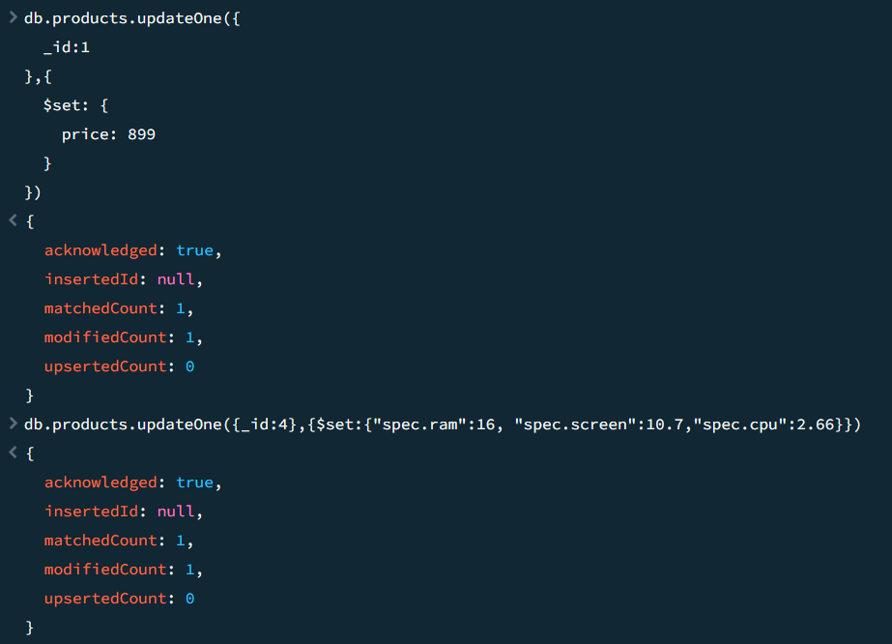

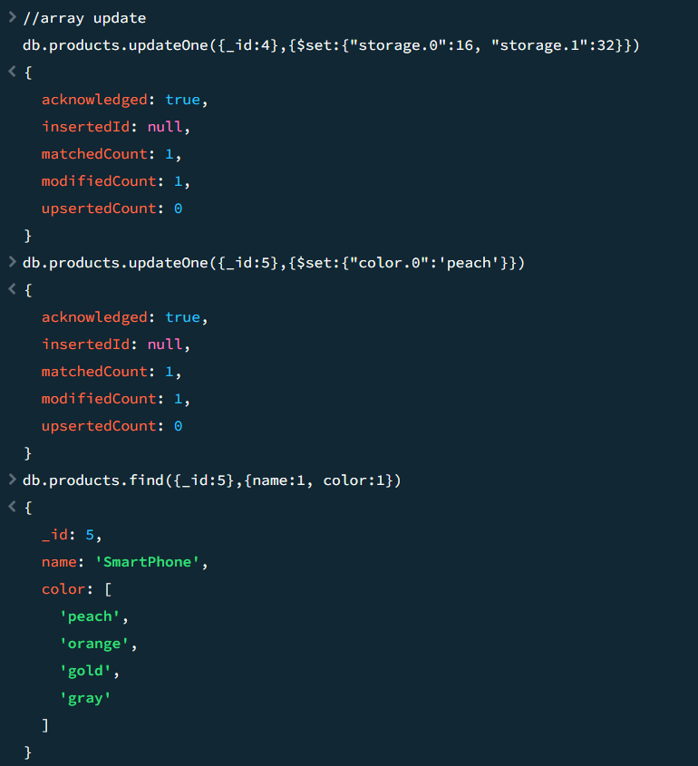

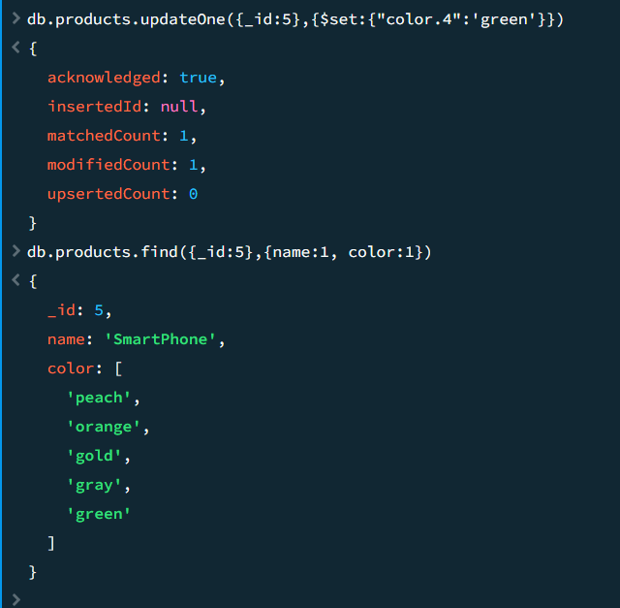

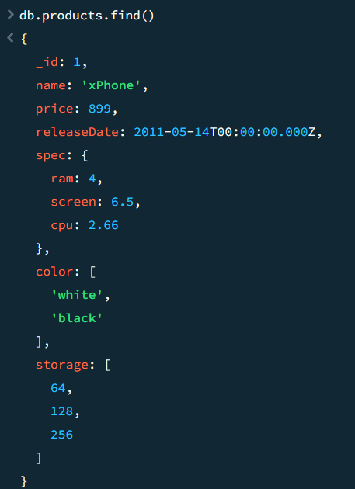

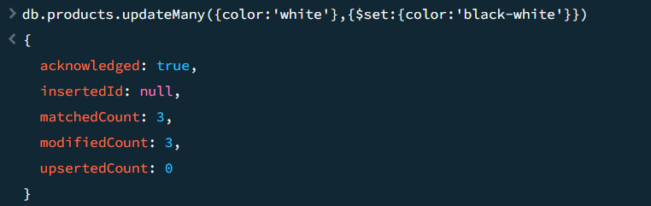

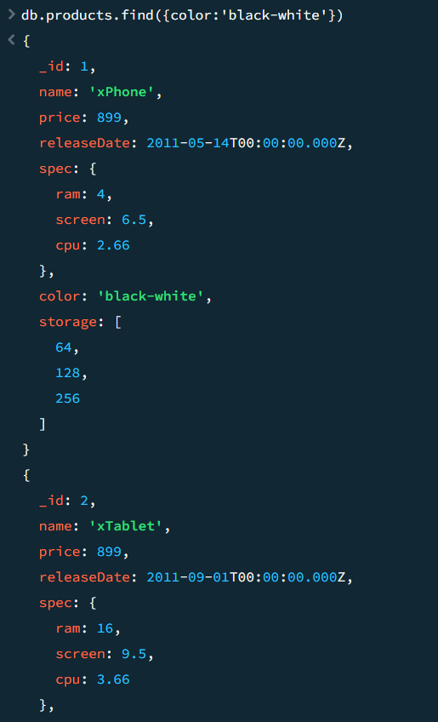

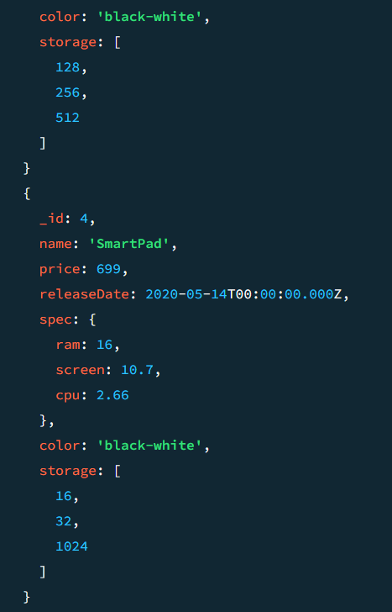

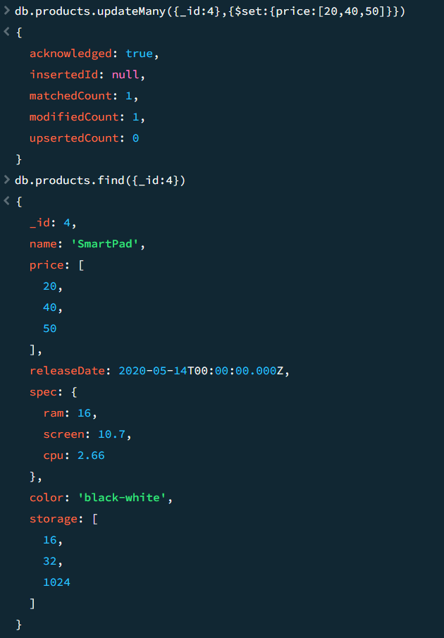

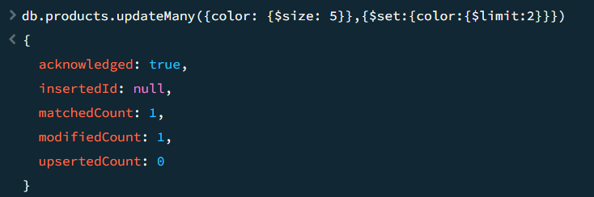

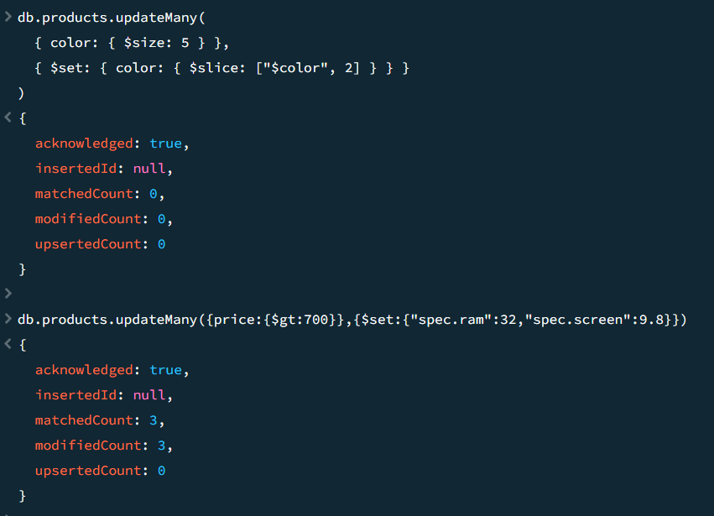

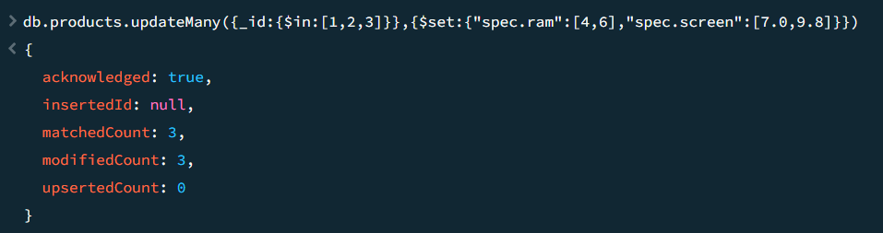

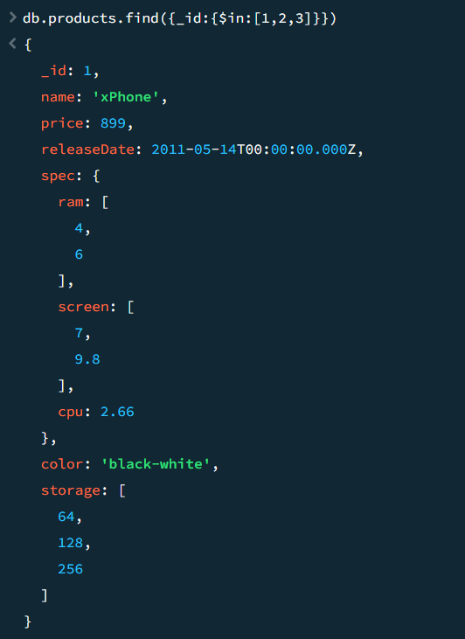

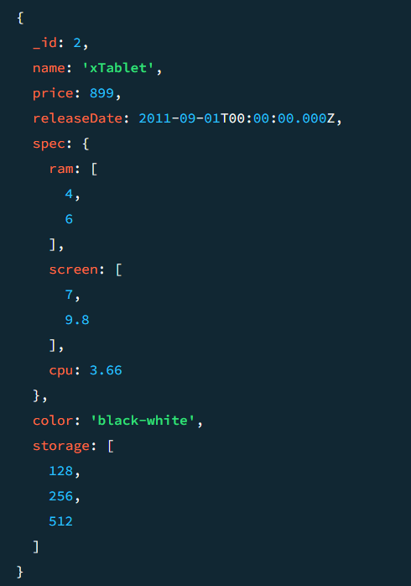

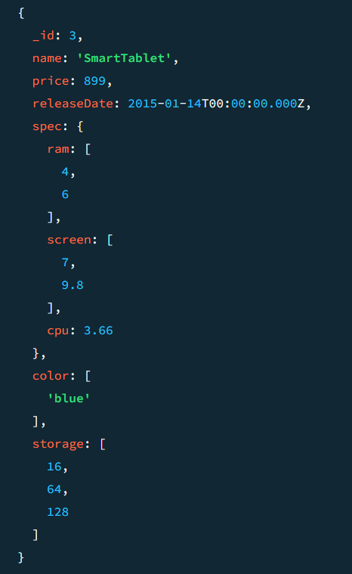

db.products.insertMany([

{ "_id" : 1, "name" : "xPhone", "price" : 799, "releaseDate": ISODate("2011-05-14"), "spec" : { "ram" : 4, "screen" : 6.5, "cpu" : 2.66 },"color":["white","black"],"storage":[64,128,256]},

{ "_id" : 2, "name" : "xTablet", "price" : 899, "releaseDate": ISODate("2011-09-01") , "spec" : { "ram" : 16, "screen" : 9.5, "cpu" : 3.66 },"color":["white","black","purple"],"storage":[128,256,512]},

{ "_id" : 3, "name" : "SmartTablet", "price" : 899, "releaseDate": ISODate("2015-01-14"), "spec" : { "ram" : 12, "screen" : 9.7, "cpu" : 3.66 },"color":["blue"],"storage":[16,64,128]},

{ "_id" : 4, "name" : "SmartPad", "price" : 699, "releaseDate": ISODate("2020-05-14"),"spec" : { "ram" : 8, "screen" : 9.7, "cpu" : 1.66 },"color":["white","orange","gold","gray"],"storage":[128,256,1024]},

{ "_id" : 5, "name" : "SmartPhone", "price" : 599,"releaseDate": ISODate("2022-09-14"), "spec" : { "ram" : 4, "screen" : 5.7, "cpu" : 1.66 },"color":["white","orange","gold","gray"],"storage":[128,256]}

])

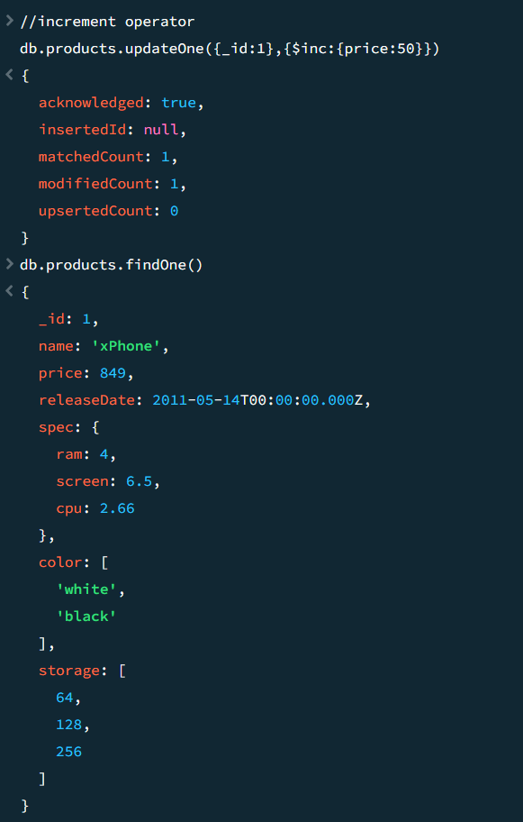

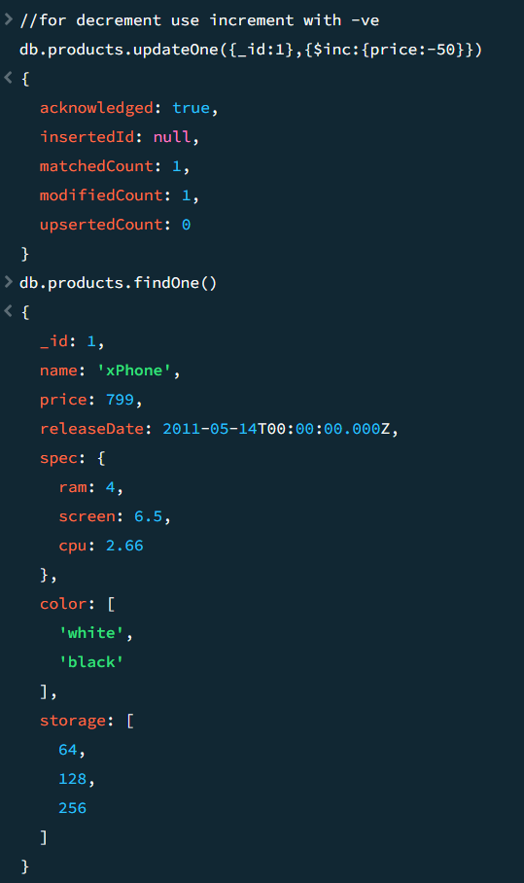

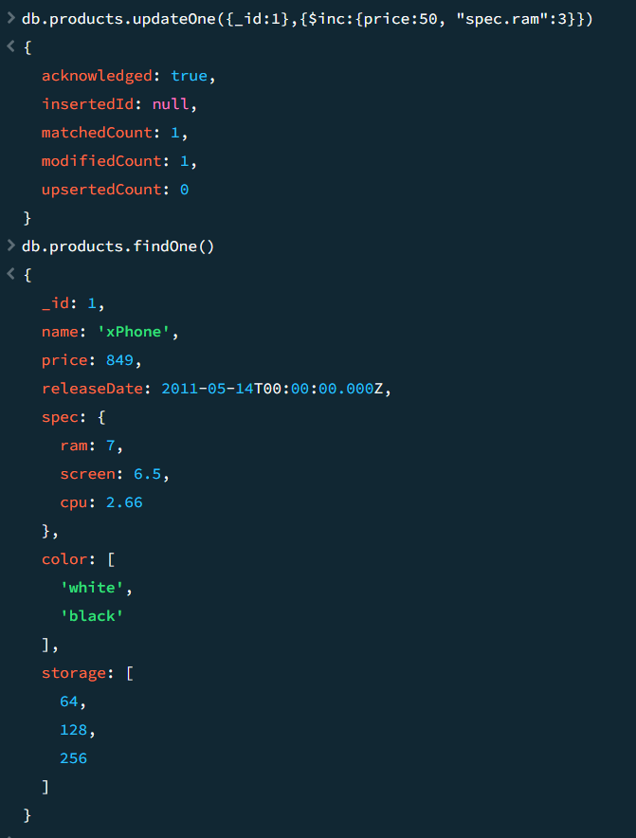

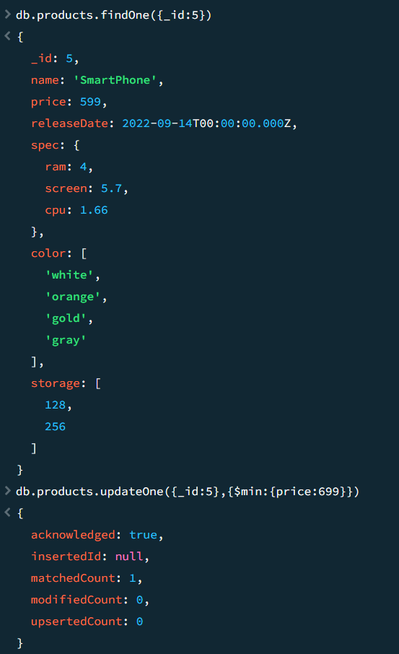

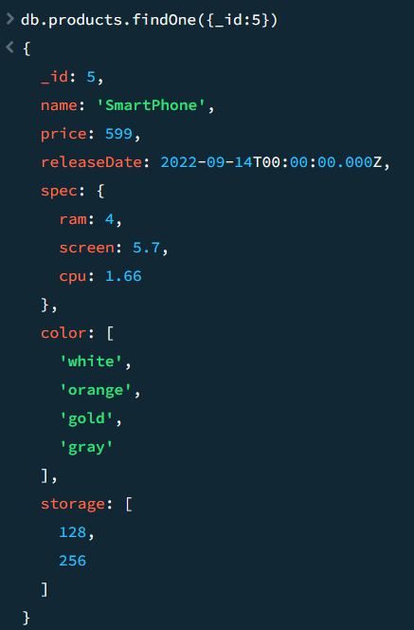

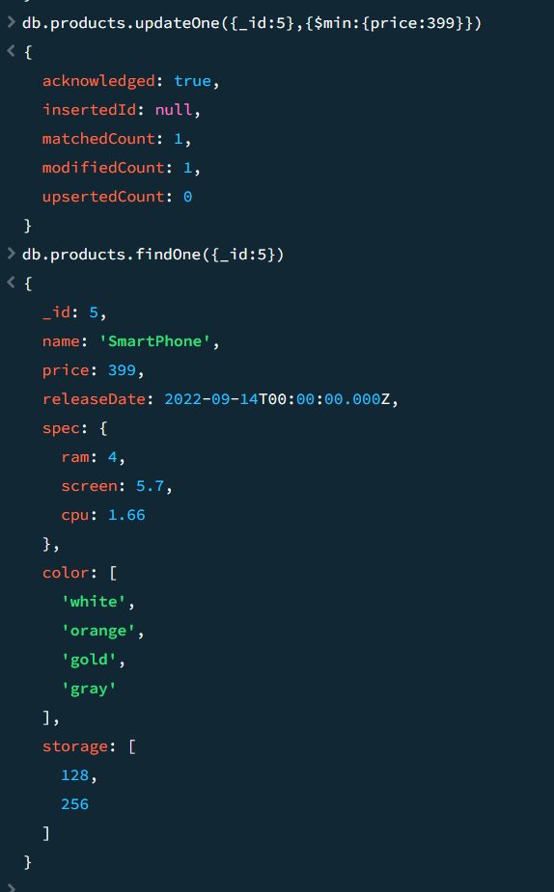

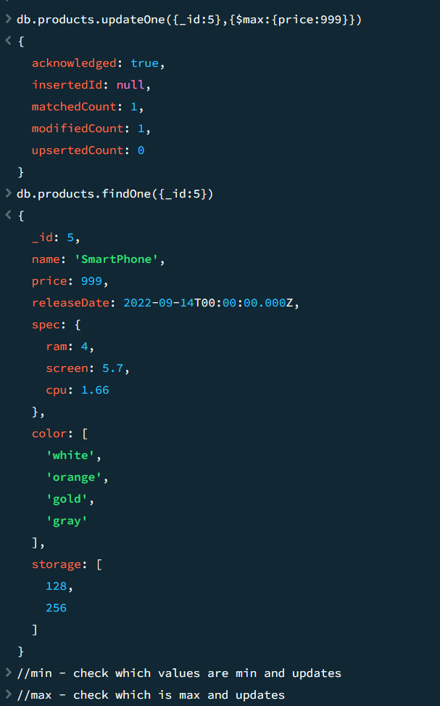

db.products.insertMany([

{ "_id" : 1, "name" : "xPhone", "price" : 799, "releaseDate": ISODate("2011-05-14"), "spec" : { "ram" : 4, "screen" : 6.5, "cpu" : 2.66 },"color":["white","black"],"storage":[64,128,256]},

{ "_id" : 2, "name" : "xTablet", "price" : 899, "releaseDate": ISODate("2011-09-01") , "spec" : { "ram" : 16, "screen" : 9.5, "cpu" : 3.66 },"color":["white","black","purple"],"storage":[128,256,512]},

{ "_id" : 3, "name" : "SmartTablet", "price" : 899, "releaseDate": ISODate("2015-01-14"), "spec" : { "ram" : 12, "screen" : 9.7, "cpu" : 3.66 },"color":["blue"],"storage":[16,64,128]},

{ "_id" : 4, "name" : "SmartPad", "price" : 699, "releaseDate": ISODate("2020-05-14"),"spec" : { "ram" : 8, "screen" : 9.7, "cpu" : 1.66 },"color":["white","orange","gold","gray"],"storage":[128,256,1024]},

{ "_id" : 5, "name" : "SmartPhone", "price" : 599,"releaseDate": ISODate("2022-09-14"), "spec" : { "ram" : 4, "screen" : 5.7, "cpu" : 1.66 },"color":["white","orange","gold","gray"],"storage":[128,256]}

])

db.products.insertMany([

{ "_id" : 1, "name" : "xPhone", "price" : 799, "releaseDate": ISODate("2011-05-14"), "spec" : { "ram" : 4, "screen" : 6.5, "cpu" : 2.66 },"color":["white","black"],"storage":[64,128,256]},

{ "_id" : 2, "name" : "xTablet", "price" : 899, "releaseDate": ISODate("2011-09-01") , "spec" : { "ram" : 16, "screen" : 9.5, "cpu" : 3.66 },"color":["white","black","purple"],"storage":[128,256,512]},

{ "_id" : 3, "name" : "SmartTablet", "price" : 899, "releaseDate": ISODate("2015-01-14"), "spec" : { "ram" : 12, "screen" : 9.7, "cpu" : 3.66 },"color":["blue"],"storage":[16,64,128]},

{ "_id" : 4, "name" : "SmartPad", "price" : 699, "releaseDate": ISODate("2020-05-14"),"spec" : { "ram" : 8, "screen" : 9.7, "cpu" : 1.66 },"color":["white","orange","gold","gray"],"storage":[128,256,1024]},

{ "_id" : 5, "name" : "SmartPhone", "price" : 599,"releaseDate": ISODate("2022-09-14"), "spec" : { "ram" : 4, "screen" : 5.7, "cpu" : 1.66 },"color":["white","orange","gold","gray"],"storage":[128,256]}

])

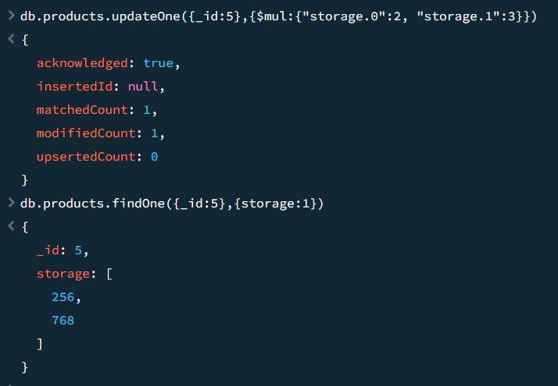

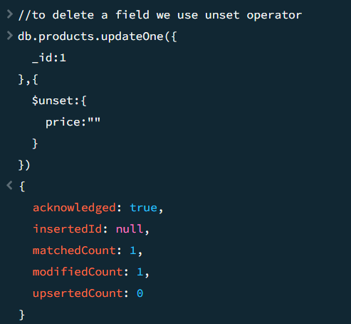

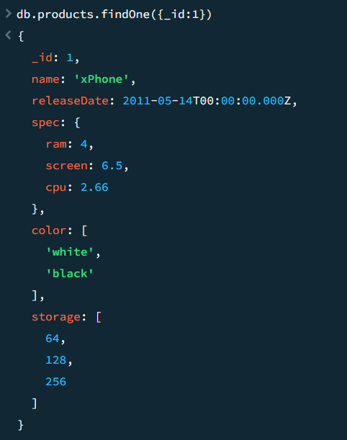

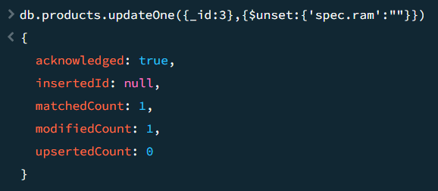

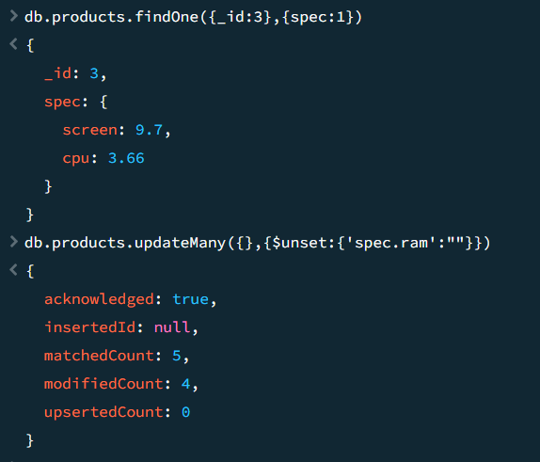

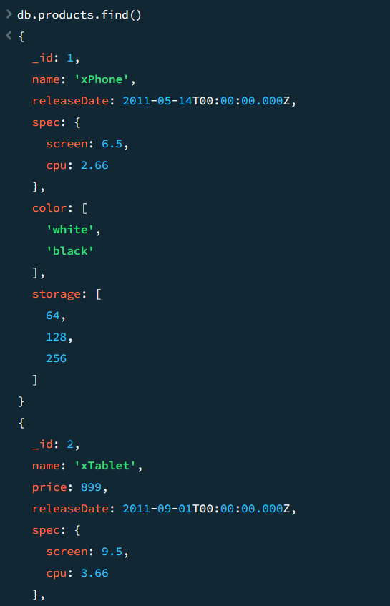

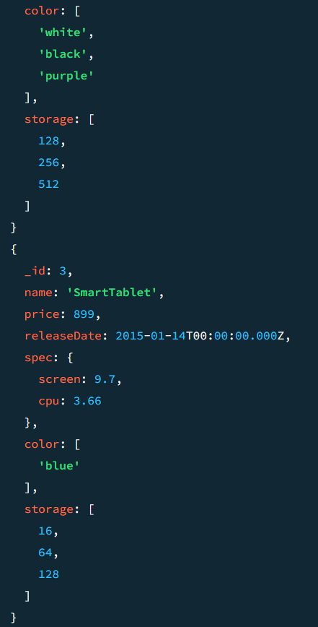

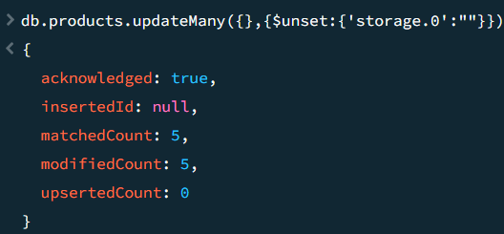

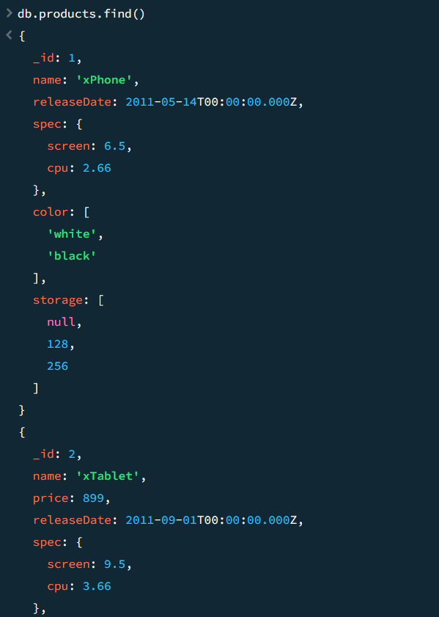

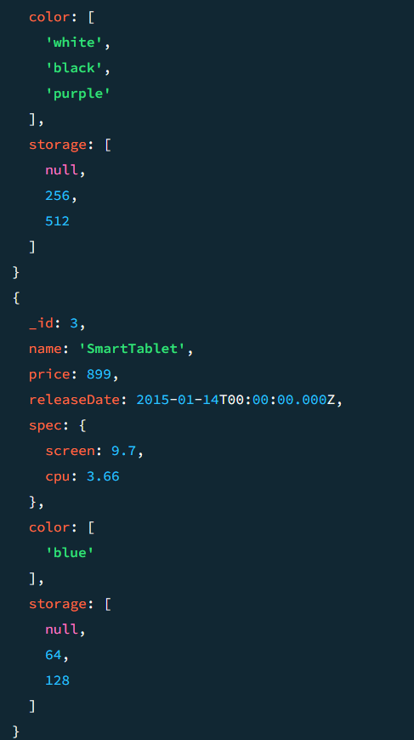

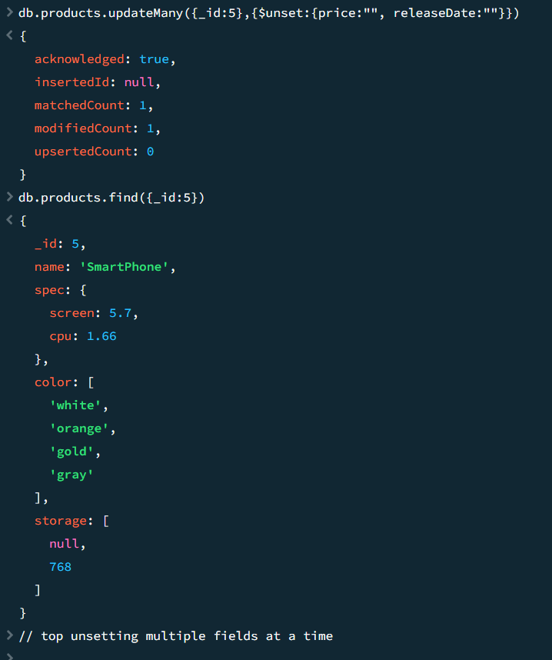

db.products.insertMany([

{ "_id" : 1, "nmea" : "xPhone", "price" : 799, "releaseDate": ISODate("2011-05-14"), "spec" : { "ram" : 4, "screen" : 6.5, "cpu" : 2.66 },"color":["white","black"],"storage":[64,128,256]},

{ "_id" : 2, "nmea" : "xTablet", "price" : 899, "releaseDate": ISODate("2011-09-01") , "spec" : { "ram" : 16, "screen" : 9.5, "cpu" : 3.66 },"color":["white","black","purple"],"storage":[128,256,512]},

{ "_id" : 3, "nmea" : "SmartTablet", "price" : 899, "releaseDate": ISODate("2015-01-14"), "spec" : { "ram" : 12, "screen" : 9.7, "cpu" : 3.66 },"color":["blue"],"storage":[16,64,128]},

{ "_id" : 4, "nmea" : "SmartPad", "price" : 699, "releaseDate": ISODate("2020-05-14"),"spec" : { "ram" : 8, "screen" : 9.7, "cpu" : 1.66 },"color":["white","orange","gold","gray"],"storage":[128,256,1024]},

{ "_id" : 5, "nmea" : "SmartPhone", "price" : 599,"releaseDate": ISODate("2022-09-14"), "spec" : { "ram" : 4, "screen" : 5.7, "cpu" : 1.66 },"color":["white","orange","gold","gray"],"storage":[128,256]}

])

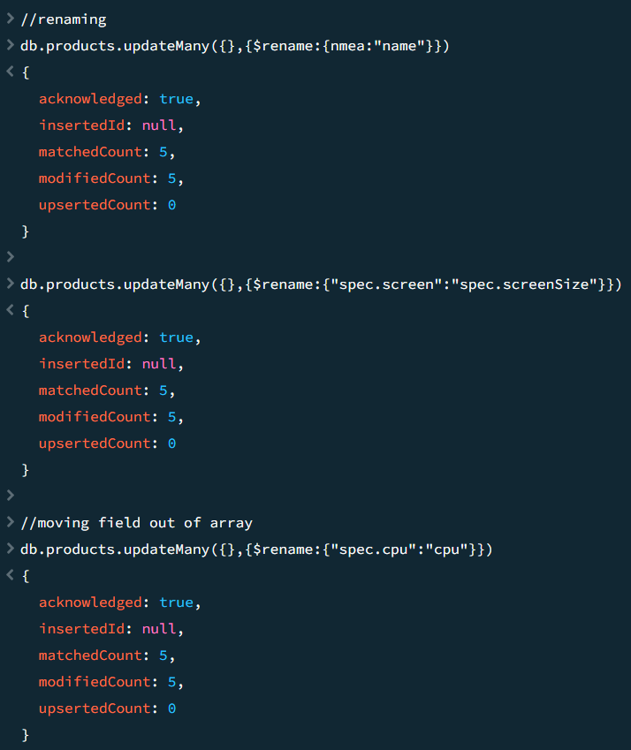

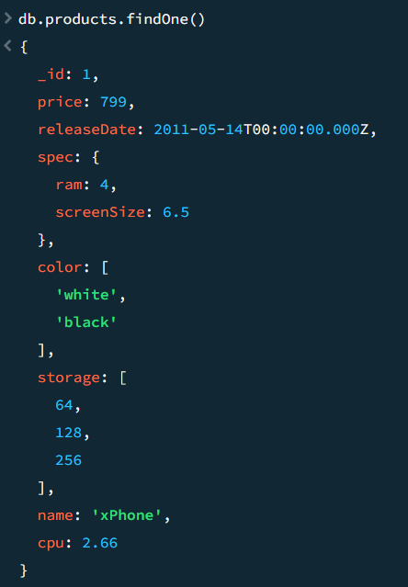

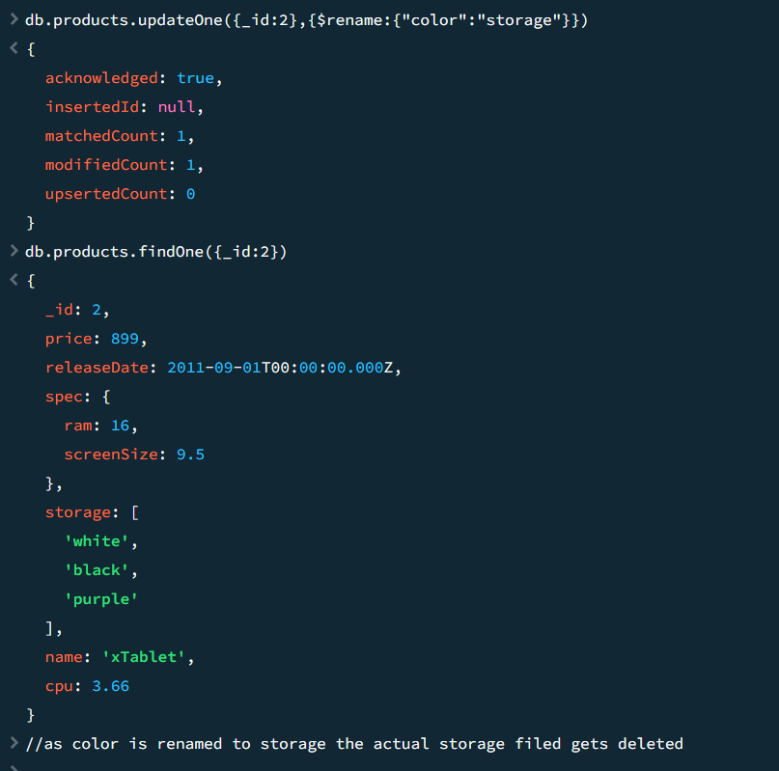

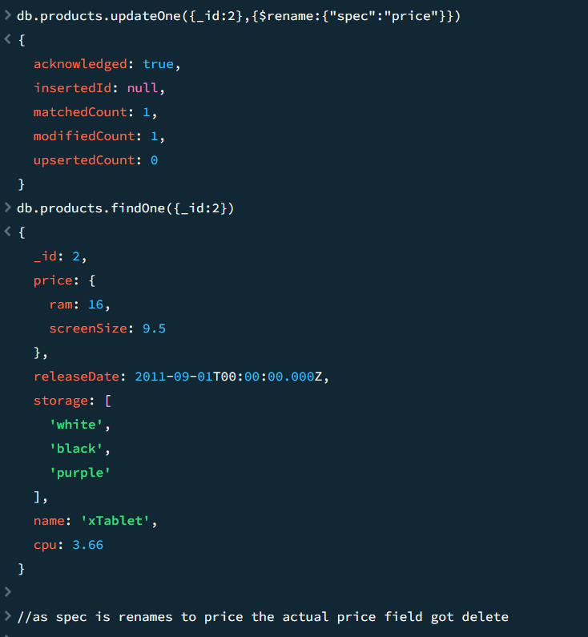

db.products.insertMany([

{ "_id" : 1, "nmea" : "xPhone", "price" : 799, "releaseDate": ISODate("2011-05-14"), "spec" : { "ram" : 4, "screen" : 6.5, "cpu" : 2.66 },"color":["white","black"],"storage":[64,128,256]},

{ "_id" : 2, "nmea" : "xTablet", "price" : 899, "releaseDate": ISODate("2011-09-01") , "spec" : { "ram" : 16, "screen" : 9.5, "cpu" : 3.66 },"color":["white","black","purple"],"storage":[128,256,512]},

{ "_id" : 3, "nmea" : "SmartTablet", "price" : 899, "releaseDate": ISODate("2015-01-14"), "spec" : { "ram" : 12, "screen" : 9.7, "cpu" : 3.66 },"color":["blue"],"storage":[16,64,128]},

{ "_id" : 4, "nmea" : "SmartPad", "price" : 699, "releaseDate": ISODate("2020-05-14"),"spec" : { "ram" : 8, "screen" : 9.7, "cpu" : 1.66 },"color":["white","orange","gold","gray"],"storage":[128,256,1024]},

{ "_id" : 5, "nmea" : "SmartPhone", "price" : 599,"releaseDate": ISODate("2022-09-14"), "spec" : { "ram" : 4, "screen" : 5.7, "cpu" : 1.66 },"color":["white","orange","gold","gray"],"storage":[128,256]}

])

