db.products.insertMany([

{ "_id" : 1, "name" : "xPhone", "price" : 799, "releaseDate": ISODate("2011-05-14"), "spec" : { "ram" : 4, "screen" : 6.5, "cpu" : 2.66 },"color":["white","black"],"storage":[64,128,256]},

{ "_id" : 2, "name" : "xTablet", "price" : 899, "releaseDate": ISODate("2011-09-01") , "spec" : { "ram" : 16, "screen" : 9.5, "cpu" : 3.66 },"color":["white","black","purple"],"storage":[128,256,512]},

{ "_id" : 3, "name" : "SmartTablet", "price" : 899, "releaseDate": ISODate("2015-01-14"), "spec" : { "ram" : 12, "screen" : 9.7, "cpu" : 3.66 },"color":["blue"],"storage":[16,64,128]},

{ "_id" : 4, "name" : "SmartPad", "price" : 699, "releaseDate": ISODate("2020-05-14"),"spec" : { "ram" : 8, "screen" : 9.7, "cpu" : 1.66 },"color":["white","orange","gold","gray"],"storage":[128,256,1024]},

{ "_id" : 5, "name" : "SmartPhone", "price" : 599,"releaseDate": ISODate("2022-09-14"), "spec" : { "ram" : 4, "screen" : 9.7, "cpu" : 1.66 },"color":["white","orange","gold","gray"],"storage":[128,256]}

])

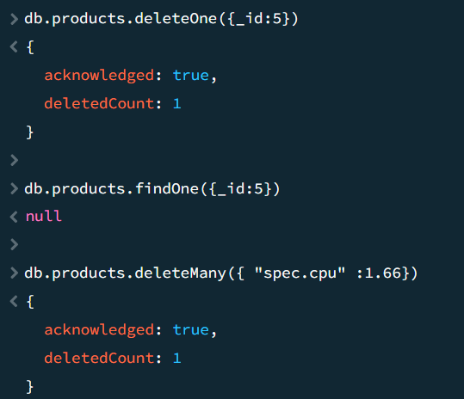

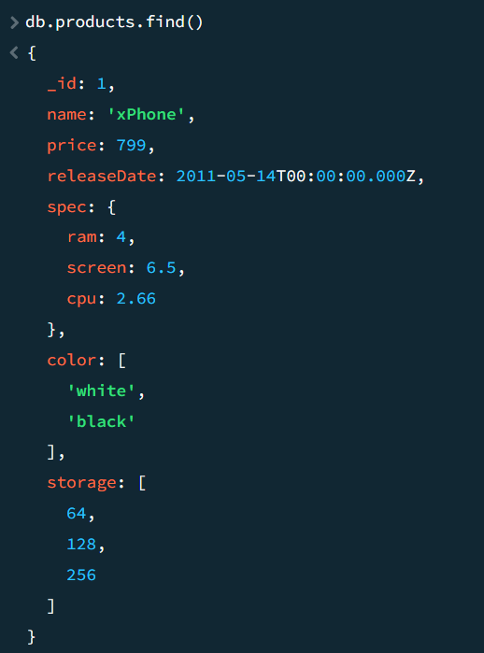

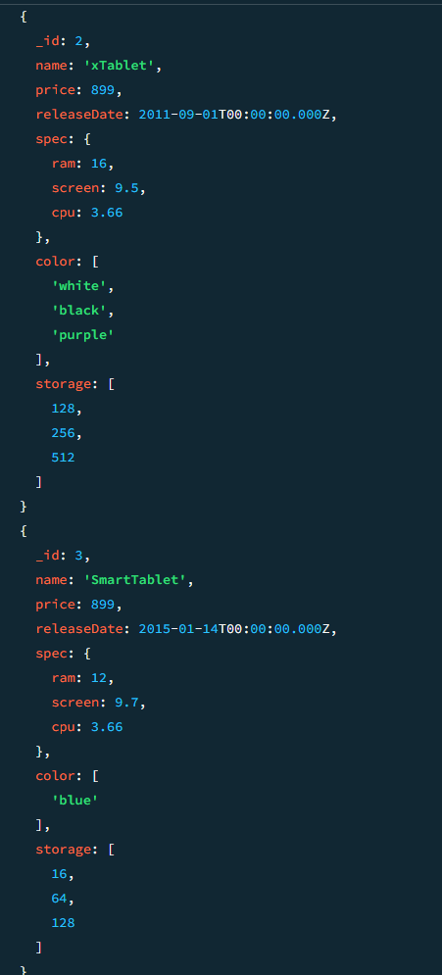

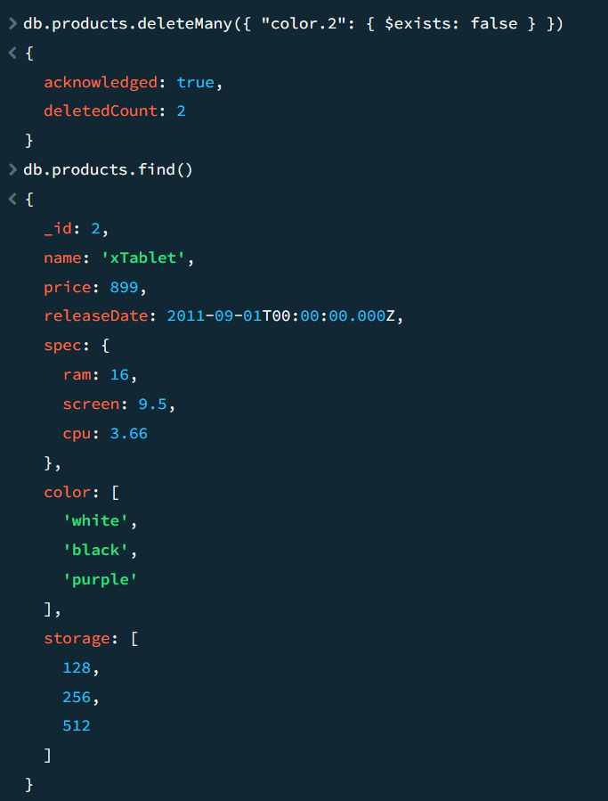

db.products.insertMany([

{ "_id" : 1, "name" : "xPhone", "price" : 799, "releaseDate": ISODate("2011-05-14"), "spec" : { "ram" : 4, "screen" : 6.5, "cpu" : 2.66 },"color":["white","black"],"storage":[64,128,256]},

{ "_id" : 2, "name" : "xTablet", "price" : 899, "releaseDate": ISODate("2011-09-01") , "spec" : { "ram" : 16, "screen" : 9.5, "cpu" : 3.66 },"color":["white","black","purple"],"storage":[128,256,512]},

{ "_id" : 3, "name" : "SmartTablet", "price" : 899, "releaseDate": ISODate("2015-01-14"), "spec" : { "ram" : 12, "screen" : 9.7, "cpu" : 3.66 },"color":["blue"],"storage":[16,64,128]},

{ "_id" : 4, "name" : "SmartPad", "price" : 699, "releaseDate": ISODate("2020-05-14"),"spec" : { "ram" : 8, "screen" : 9.7, "cpu" : 1.66 },"color":["white","orange","gold","gray"],"storage":[128,256,1024]},

{ "_id" : 5, "name" : "SmartPhone", "price" : 599,"releaseDate": ISODate("2022-09-14"), "spec" : { "ram" : 4, "screen" : 9.7, "cpu" : 1.66 },"color":["white","orange","gold","gray"],"storage":[128,256]}

])

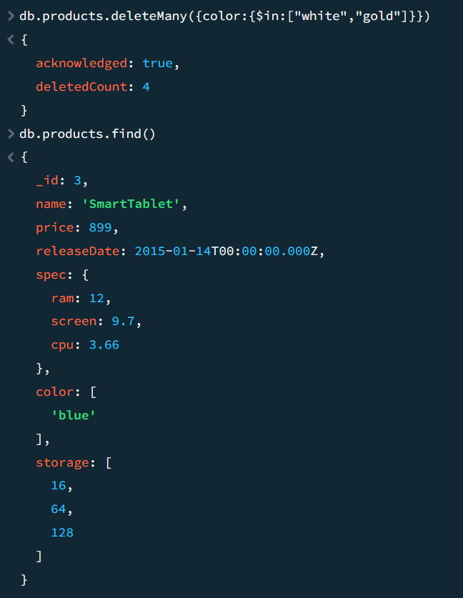

db.products.insertMany([

{ "_id" : 1, "name" : "xPhone", "price" : 799, "releaseDate": ISODate("2011-05-14"), "spec" : { "ram" : 4, "screen" : 6.5, "cpu" : 2.66 },"color":["white","black"],"storage":[64,128,256]},

{ "_id" : 2, "name" : "xTablet", "price" : 899, "releaseDate": ISODate("2011-09-01") , "spec" : { "ram" : 16, "screen" : 9.5, "cpu" : 3.66 },"color":["white","black","purple"],"storage":[128,256,512]},

{ "_id" : 3, "name" : "SmartTablet", "price" : 899, "releaseDate": ISODate("2015-01-14"), "spec" : { "ram" : 12, "screen" : 9.7, "cpu" : 3.66 },"color":["blue"],"storage":[16,64,128]},

{ "_id" : 4, "name" : "SmartPad", "price" : 699, "releaseDate": ISODate("2020-05-14"),"spec" : { "ram" : 8, "screen" : 9.7, "cpu" : 1.66 },"color":["white","orange","gold","gray"],"storage":[128,256,1024]},

{ "_id" : 5, "name" : "SmartPhone", "price" : 599,"releaseDate": ISODate("2022-09-14"), "spec" : { "ram" : 4, "screen" : 9.7, "cpu" : 1.66 },"color":["white","orange","gold","gray"],"storage":[128,256]}

])

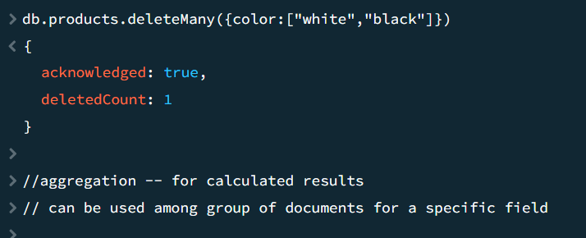

db.sales.insertMany([

{ "_id" : 1, "item" : "Americanos", "price" : 5, "size": "Short", "quantity" : 22, "date" : ISODate("2022-01-15T08:00:00Z") },

{ "_id" : 2, "item" : "Cappuccino", "price" : 6, "size": "Short","quantity" : 12, "date" : ISODate("2022-01-16T09:00:00Z") },

{ "_id" : 3, "item" : "Lattes", "price" : 15, "size": "Grande","quantity" : 25, "date" : ISODate("2022-01-16T09:05:00Z") },

{ "_id" : 4, "item" : "Mochas", "price" : 25,"size": "Tall", "quantity" : 11, "date" : ISODate("2022-02-17T08:00:00Z") },

{ "_id" : 5, "item" : "Americanos", "price" : 10, "size": "Grande","quantity" : 12, "date" : ISODate("2022-02-18T21:06:00Z") },

{ "_id" : 6, "item" : "Cappuccino", "price" : 7, "size": "Tall","quantity" : 20, "date" : ISODate("2022-02-20T10:07:00Z") },

{ "_id" : 7, "item" : "Lattes", "price" : 25,"size": "Tall", "quantity" : 30, "date" : ISODate("2022-02-21T10:08:00Z") },

{ "_id" : 8, "item" : "Americanos", "price" : 10, "size": "Grande","quantity" : 21, "date" : ISODate("2022-02-22T14:09:00Z") },

{ "_id" : 9, "item" : "Cappuccino", "price" : 10, "size": "Grande","quantity" : 17, "date" : ISODate("2022-02-23T14:09:00Z") },

{ "_id" : 10, "item" : "Americanos", "price" : 8, "size": "Tall","quantity" : 15, "date" : ISODate("2022-02-25T14:09:00Z")}

]);

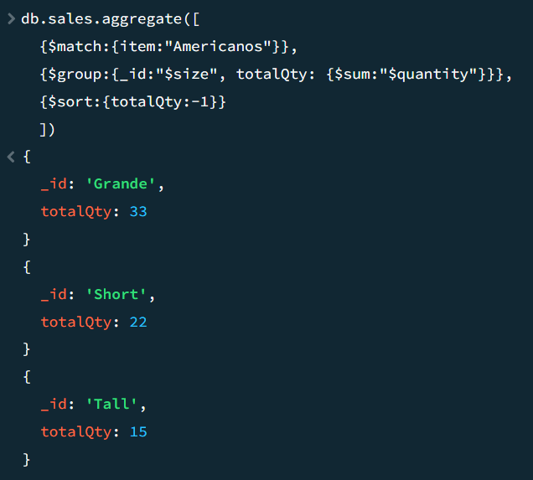

db.sales.insertMany([

{ "_id" : 1, "item" : "Americanos", "price" : 5, "size": "Short", "quantity" : 22, "date" : ISODate("2022-01-15T08:00:00Z") },

{ "_id" : 2, "item" : "Cappuccino", "price" : 6, "size": "Short","quantity" : 12, "date" : ISODate("2022-01-16T09:00:00Z") },

{ "_id" : 3, "item" : "Lattes", "price" : 15, "size": "Grande","quantity" : 25, "date" : ISODate("2022-01-16T09:05:00Z") },

{ "_id" : 4, "item" : "Mochas", "price" : 25,"size": "Tall", "quantity" : 11, "date" : ISODate("2022-02-17T08:00:00Z") },

{ "_id" : 5, "item" : "Americanos", "price" : 10, "size": "Grande","quantity" : 12, "date" : ISODate("2022-02-18T21:06:00Z") },

{ "_id" : 6, "item" : "Cappuccino", "price" : 7, "size": "Tall","quantity" : 20, "date" : ISODate("2022-02-20T10:07:00Z") },

{ "_id" : 7, "item" : "Lattes", "price" : 25,"size": "Tall", "quantity" : 30, "date" : ISODate("2022-02-21T10:08:00Z") },

{ "_id" : 8, "item" : "Americanos", "price" : 10, "size": "Grande","quantity" : 21, "date" : ISODate("2022-02-22T14:09:00Z") },

{ "_id" : 9, "item" : "Cappuccino", "price" : 10, "size": "Grande","quantity" : 17, "date" : ISODate("2022-02-23T14:09:00Z") },

{ "_id" : 10, "item" : "Americanos", "price" : 8, "size": "Tall","quantity" : 15, "date" : ISODate("2022-02-25T14:09:00Z")}

]);

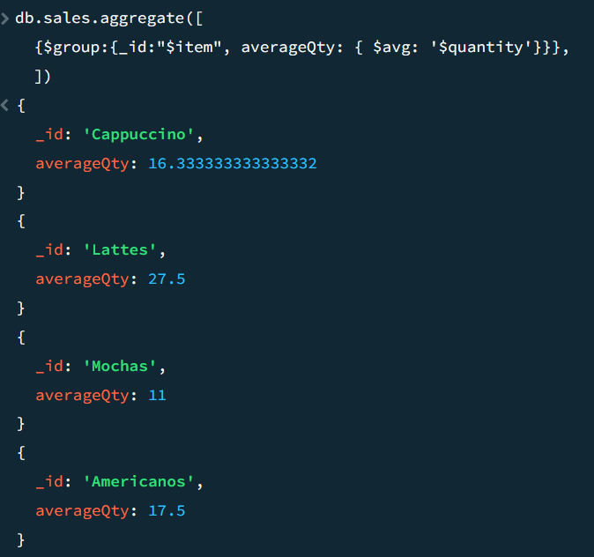

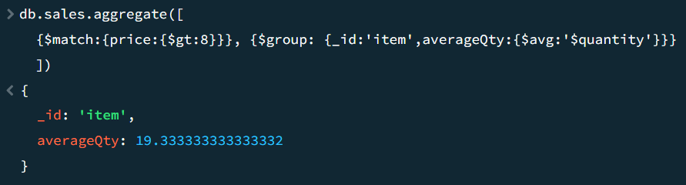

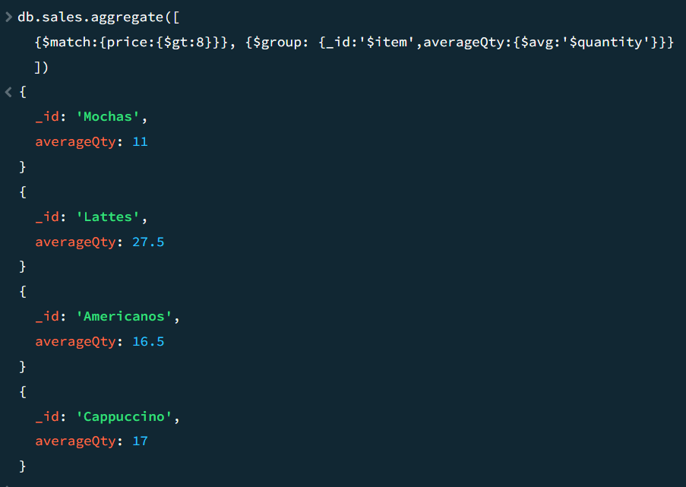

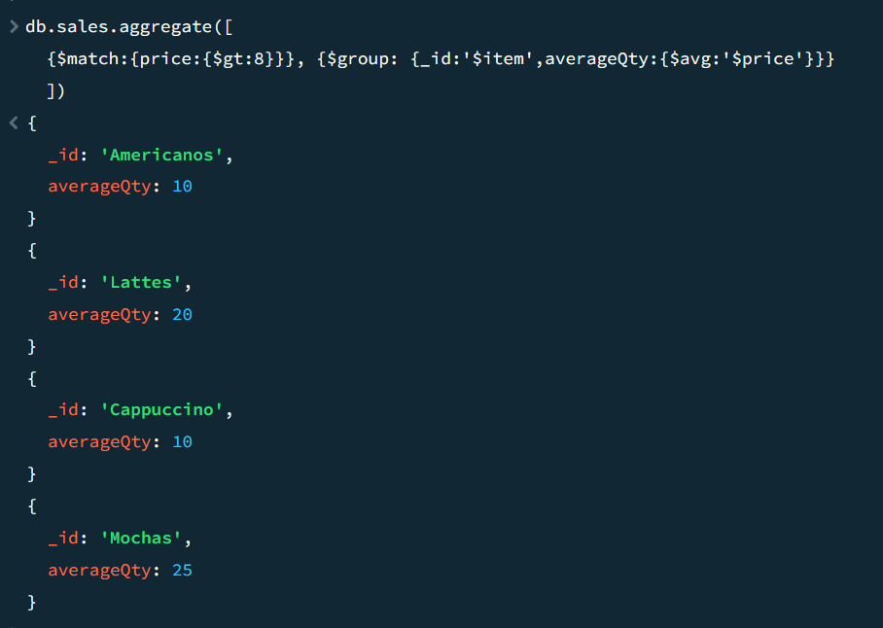

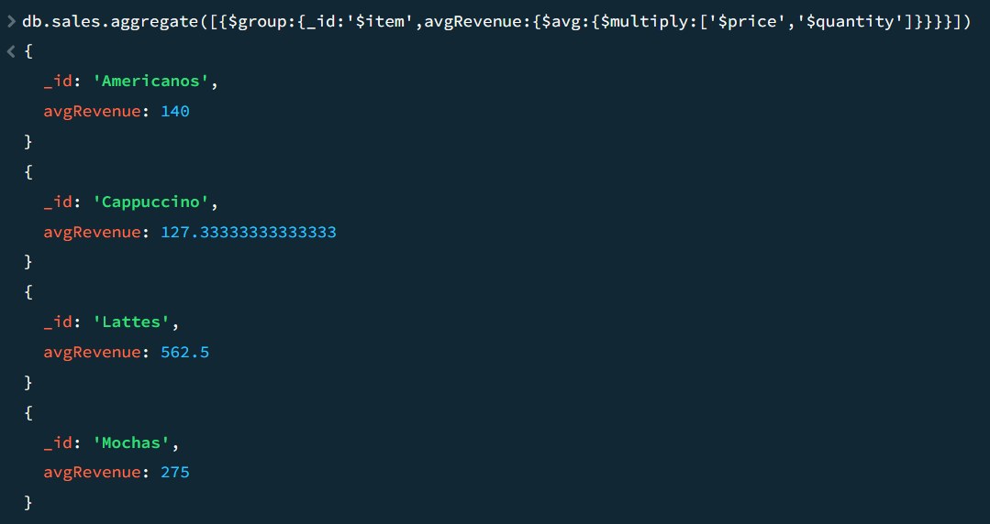

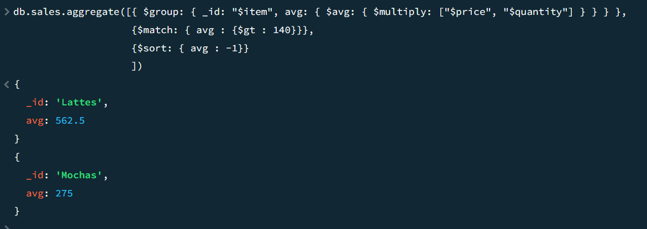

db.sales.insertMany([

{ "_id" : 1, "item" : "Americanos", "price" : 5, "size": "Short", "quantity" : 22, "date" : ISODate("2022-01-15T08:00:00Z") },

{ "_id" : 2, "item" : "Cappuccino", "price" : 6, "size": "Short","quantity" : 12, "date" : ISODate("2022-01-16T09:00:00Z") },

{ "_id" : 3, "item" : "Lattes", "price" : 15, "size": "Grande","quantity" : 25, "date" : ISODate("2022-01-16T09:05:00Z") },

{ "_id" : 4, "item" : "Mochas", "price" : 25,"size": "Tall", "quantity" : 11, "date" : ISODate("2022-02-17T08:00:00Z") },

{ "_id" : 5, "item" : "Americanos", "price" : 10, "size": "Grande","quantity" : 12, "date" : ISODate("2022-02-18T21:06:00Z") },

{ "_id" : 6, "item" : "Cappuccino", "price" : 7, "size": "Tall","quantity" : 20, "date" : ISODate("2022-02-20T10:07:00Z") },

{ "_id" : 7, "item" : "Lattes", "price" : 25,"size": "Tall", "quantity" : 30, "date" : ISODate("2022-02-21T10:08:00Z") },

{ "_id" : 8, "item" : "Americanos", "price" : 10, "size": "Grande","quantity" : 21, "date" : ISODate("2022-02-22T14:09:00Z") },

{ "_id" : 9, "item" : "Cappuccino", "price" : 10, "size": "Grande","quantity" : 17, "date" : ISODate("2022-02-23T14:09:00Z") },

{ "_id" : 10, "item" : "Americanos", "price" : 8, "size": "Tall","quantity" : 15, "date" : ISODate("2022-02-25T14:09:00Z")}

]);

