**Motor Shield GUI**

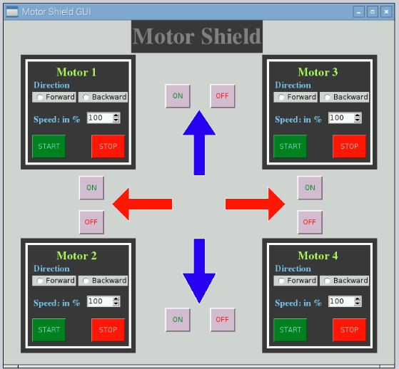

* GUI for Controlling Motors using Motor Shield
* Control 4 DC motors with Direction controlling
* User can also control Speed of each Motor

1. Set the direction (i.e. Forward or Backward) and speed of Motor. Adjust the Speed in percentage i.e. 10 – 100%.

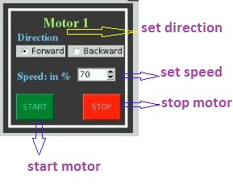

1. Click START button to start the Motor.
2. You can ON/OFF the direction LED also as per the direction of Motor or Robot.
3. You can set all 4 motors at different speed and direction.