Sonos Local Library Controller
Product Requirements Document
A Progressive Web App for controlling Sonos speakers
with a NAS-resident MP3 library
Version 0.1 — Draft
Author: Ray

1. Executive Summary
This document specifies a Progressive Web App (PWA) that controls Sonos speakers on a home LAN, with a primary focus on browsing and playing audio files (.mp3 and similar) hosted on a network-attached storage (NAS) device. The app is installed to the iPhone home screen via Safari and behaves like a native app, but is built with web technologies and a self-hosted Python backend.
The product exists because the official Sonos app, particularly after its May 2024 redesign, is widely regarded as poor at the specific job described above. Volume control has noticeable latency, NAS music libraries became second-class citizens, and basic interactions require many taps. A community of frustrated users has migrated to third-party alternatives such as SonoPhone. This project takes inspiration from those alternatives but builds a self-hosted, ad-free, dependency-light tool that any household member can use on Wi-Fi.
Three product principles drive every decision:
- Speed is the feature. Volume changes feel instantaneous. Library searches return in under half a second. Tapping an album plays it.
- NAS-first. The local music library is the headline experience, not an afterthought.
- Minimum taps. Common actions take one tap; nothing common takes more than three.

2. Vision and Goals

2.1 Vision
A fast, no-nonsense Sonos controller for people whose music lives on their own NAS. The app should make it effortless to walk into any room, open the app, and have music playing in seconds. It should feel like the controller Sonos would have built if they cared about local-library users.

2.2 Measurable goals
- Volume slider produces audible change on the speaker within 100 milliseconds of touch.
- Library search returns results within 500 milliseconds for a library of up to 50,000 tracks.
- From cold app launch to playing music: under 10 seconds end-to-end.
- Common tasks (play album, group two rooms, change volume, skip track) require no more than two taps.
- App is fully usable on the home LAN with no internet connection.
- Backend service runs continuously for 30 days without manual intervention.

2.3 Non-goals (explicitly out of scope)
Calling out non-goals up front prevents scope creep during build. The following are explicitly excluded from version 1 of this product:
- Streaming services (Spotify, Apple Music, Tidal, Amazon Music, etc.).
- Internet radio and TuneIn integration.
- Apple Watch support — impossible from a PWA.
- Lock-screen and Control Center transport controls — also a PWA limitation.
- CarPlay support.
- Speaker setup, firmware updates, and stereo-pair configuration — handled by official Sonos app.
- Alarms and sleep timers — deferred to v2.
- Voice control or Siri integration.
- Public internet access. The app is LAN-only by design. Remote access can be layered on via the existing UDM Pro WireGuard VPN if needed.

3. Personas and User Stories

3.1 Personas
Primary persona — Ray, the owner.
Owns the NAS, the Sonos system, and built the app. Comfortable with technology. Wants the controller to be reliable, fast, and to surface the deep functionality of the Sonos system without burying it. Often interacts from bed or the kitchen counter.
Secondary persona — household member.
Less technical. Wants to walk in, hit play, change rooms, and adjust volume. Will not tolerate complexity or latency. Should never need to think about IP addresses, group coordinators, or library shares.

3.2 User stories
User stories are written as: "As a [persona], I want to [action] so that [outcome]."
- US-01: As Ray, I want to open the app and immediately see what's playing in every room, so that I can take action without navigating menus.
- US-02: As a household member, I want to tap an album cover and have it play in my current room, so that I don't have to pick from a menu of options.
- US-03: As Ray, I want to drag a volume slider and hear the change instantly, so that the experience feels like a physical knob.
- US-04: As a household member lying in bed, I want to pause music in another room without unlocking my phone any further than necessary.
- US-05: As Ray, I want to search across all artists, albums, and tracks at once and see results grouped by category, so that I don't have to switch tabs to find what I want.
- US-06: As Ray, I want to navigate a long alphabetical list using a side-rail jump bar, so that I don't have to scroll through hundreds of items.
- US-07: As a household member, I want to group two rooms together for a party, so that the music plays in both at the same time and stays in sync.
- US-08: As Ray, I want to add an entire album to the existing queue without interrupting the current track, so that I can build a listening session over time.
- US-09: As Ray, I want the app to remember which room I last controlled, so that I land on a useful screen on every launch.
- US-10: As Ray, I want the queue view to show the currently playing track at the top with up-next visible below, so that I never lose my place.
- US-11: As a household member, I want the app to keep working even if the controller machine reboots, with full state recovery within seconds.
- US-12: As Ray, I want to swipe a track out of the queue to remove it, so that pruning a queue is fast and tactile.

4. System Architecture
The system has three parts: an iPhone running the PWA in Safari, a small always-on controller host on the LAN running the backend, and the existing Sonos speakers and NAS. The backend is the only new piece of software being built. The diagram below shows how they fit together.
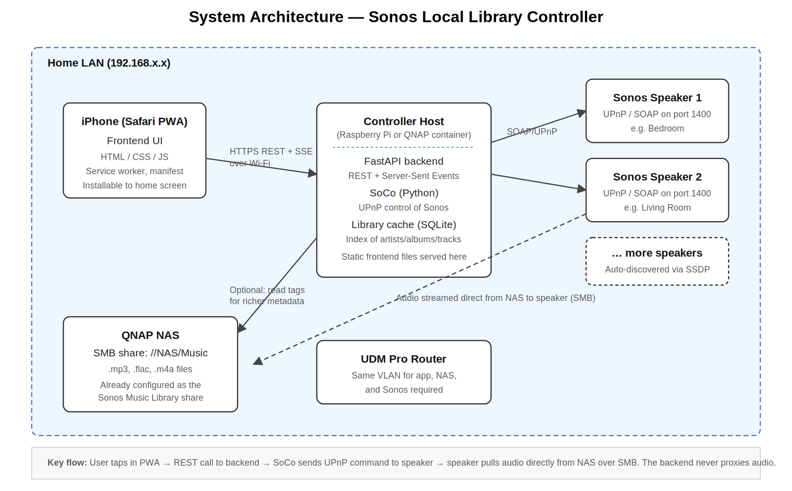
Figure 1 — System architecture. Audio data never flows through the controller host.

4.1 Architectural decisions

4.1.1 Why a PWA, not a native iOS app
Native iOS development requires a Mac running Xcode, an Apple Developer subscription, and Swift expertise. None of those align with the existing development environment (Ubuntu, PHP, Python, JavaScript). A PWA delivers the bulk of the native experience — installable to the home screen, full-screen, app-like behaviour — using only web technologies. The trade-offs are real but acceptable: no lock-screen controls, no Apple Watch, limited background behaviour. Since Sonos is itself a LAN-bound system, those limitations rarely matter in practice.

4.1.2 Why FastAPI + SoCo on the backend
SoCo is the de facto Python library for controlling Sonos via UPnP. It auto-discovers speakers, exposes a music-library API, manages queues, handles grouping, and gracefully tolerates speakers coming and going on the network. FastAPI wraps it in a clean async REST interface with built-in OpenAPI documentation. The combination is well-supported, has small dependencies, and produces a backend that is straightforward to read and maintain.

4.1.3 Why a separate library cache
The Sonos players index the NAS music library themselves, but querying that index through SoCo for every browse operation is slow on large libraries and contributes to UI latency. The backend keeps a SQLite mirror of artists, albums, tracks, genres, and folder structure, refreshed on demand. All browse and search operations hit SQLite directly. This is the single biggest win for perceived speed.

4.1.4 Audio path
The backend never touches audio data. When the user picks a track, the backend tells the Sonos coordinator (via SoCo / UPnP) to play a URI of the form x-file-cifs://NAS/Music/path/track.mp3. The speaker then opens its own SMB connection directly to the NAS and streams from there. This keeps the controller host's CPU and network footprint trivial — a Raspberry Pi Zero would be sufficient hardware.

4.1.5 State synchronisation
The frontend subscribes to a Server-Sent Events (SSE) endpoint at /api/events. The backend pushes state changes (now playing, volume, queue updates, group topology changes) as they happen. SoCo's event subscription system feeds these updates. SSE is chosen over WebSocket because it is simpler, one-way, and adequate — the frontend only needs to receive updates, not send them through the same channel.

5. Functional Requirements
Each requirement carries a priority. Must-haves are necessary for v1 release. Should-haves are strongly desired for v1 if time permits. Nice-to-haves are deferred. Out items are explicitly excluded from v1.
Priority colour key: Must (red) · Should (yellow) · Nice (green) · Out (grey).

5.1 Speaker discovery and management
ID | Requirement | Priority | Source
F-DM-01 | Auto-discover all Sonos speakers on the LAN at backend start. | Must | SoCo
F-DM-02 | Maintain an up-to-date list of speakers, group topology, and coordinator assignments. | Must | SoCo
F-DM-03 | Re-discover speakers when topology changes (speaker added, removed, regrouped). | Must | SoCo
F-DM-04 | Display each speaker's current playback state on the Rooms screen. | Must | Inspired by SonoPhone
F-DM-05 | Show speaker model and firmware version in a details view. | Nice | Sonos app

5.2 Playback control
ID | Requirement | Priority | Source
F-PC-01 | Play, pause, and stop the currently selected room. | Must | All apps
F-PC-02 | Skip to next track and to previous track. | Must | All apps
F-PC-03 | Seek within the current track via a draggable progress bar. | Must | All apps
F-PC-04 | Toggle shuffle and repeat (off / one / all). | Must | All apps
F-PC-05 | Toggle crossfade for the current group. | Should | Sonos app
F-PC-06 | Replay the previously played track in the queue. | Should | SonoPhone feature request
F-PC-07 | Route all transport commands to the group coordinator, raising a clear error if attempted on a follower. | Must | SoCo design

5.3 Volume
ID | Requirement | Priority | Source
F-VL-01 | Per-speaker volume sliders visible on the Rooms screen with no mode change required. | Must | SonoPhone signature
F-VL-02 | Group volume slider that scales all member volumes proportionally. | Must | Sonos behaviour
F-VL-03 | Mute toggle per speaker and per group. | Must | All apps
F-VL-04 | Volume changes appear in the UI optimistically before backend confirmation. | Must | Latency goal
F-VL-05 | Volume changes during a drag are throttled to no more than 20 requests per second per slider. | Must | Performance
F-VL-06 | Numeric volume value popup appears while dragging. | Should | SonoPhone
F-VL-07 | Bass, treble, and loudness EQ controls available in a per-room settings sheet. | Nice | Sonos app

5.4 Music library browsing
ID | Requirement | Priority | Source
F-LB-01 | Browse the library by Artist, Album, Album-Artist, Genre, Track, and Folder. | Must | Sonos library
F-LB-02 | Display album art thumbnails in list views and large album art on detail views. | Must | All apps
F-LB-03 | Alphabet jump-bar on the right edge of long alphabetised lists. | Must | Common feedback gap
F-LB-04 | Tapping an album cover plays it immediately, replacing the queue ("Touch to Play" default). | Must | SonoPhone signature
F-LB-05 | Long-press on any list item reveals a full action sheet (play now, play next, add to end, replace queue, add to playlist). | Must | SonoPhone
F-LB-06 | User-configurable default tap action (play now vs add to end). | Should | SonoPhone
F-LB-07 | Recently added and recently played sections on the Library home screen. | Should | Sonos app
F-LB-08 | Manual library re-index trigger with progress indicator. | Must | Operations
F-LB-09 | Background re-index every 6 hours (configurable). | Should | Operations

5.5 Search
ID | Requirement | Priority | Source
F-SR-01 | Single search field that queries artists, albums, and tracks simultaneously. | Must | SonoPhone aggregated search
F-SR-02 | Results presented as one screen, grouped into Artists / Albums / Tracks sections, with counts visible. | Must | SonoPhone signature
F-SR-03 | Results return within 500ms for libraries up to 50,000 tracks. | Must | Performance goal
F-SR-04 | Search is case-insensitive and matches substrings within metadata fields. | Must | Usability
F-SR-05 | Clear search button and recent searches list. | Should | Modern UX

5.6 Queue management
ID | Requirement | Priority | Source
F-QM-01 | View current queue with the now-playing track always visible at the top. | Must | Common feedback gap
F-QM-02 | Reorder tracks via drag-and-drop with a clear drag handle. | Must | All apps
F-QM-03 | Remove individual tracks via swipe-to-delete. | Must | SonoPhone
F-QM-04 | Clear the entire queue with a confirmation prompt. | Must | All apps
F-QM-05 | Save the current queue as a Sonos playlist. | Should | Sonos app
F-QM-06 | "Add to queue", "Play next", and "Replace queue" available from any track or album action sheet. | Must | SonoPhone
F-QM-07 | Queue automatically follows playback progress. | Must | Common feedback gap

5.7 Multi-room and grouping
ID | Requirement | Priority | Source
F-GR-01 | View all groups and standalone rooms on a single Rooms screen. | Must | All apps
F-GR-02 | Add a room to an existing group via tap or drag. | Must | All apps
F-GR-03 | Remove a room from its group with a single tap. | Must | All apps
F-GR-04 | "Party Mode" button groups all rooms under a single coordinator. | Should | Sonos app
F-GR-05 | Group composition changes propagate to all clients within 1 second. | Must | SSE behaviour
F-GR-06 | UI clearly identifies the coordinator within each group. | Should | Diagnostics

5.8 Playlists and favourites
ID | Requirement | Priority | Source
F-PL-01 | Browse Sonos playlists and Sonos favourites. | Must | Sonos behaviour
F-PL-02 | Create, rename, and delete Sonos playlists. | Should | Sonos app
F-PL-03 | Add tracks, albums, and artists to an existing playlist. | Should | All apps
F-PL-04 | Browse imported playlists from the music library (M3U, etc.). | Should | Sonos behaviour

5.9 Now Playing
ID | Requirement | Priority | Source
F-NP-01 | Full-screen Now Playing view with large album art, track metadata, progress bar, and transport controls. | Must | All apps
F-NP-02 | Volume slider for the active room or group accessible without leaving the Now Playing view. | Must | Latency goal
F-NP-03 | Quick access to the queue from the Now Playing view. | Must | All apps
F-NP-04 | Quick access to the room/group switcher from the Now Playing view. | Must | All apps
F-NP-05 | Album art occupies a large portion of the screen with no peripheral clutter. | Must | SonoPad signature

5.10 Settings and operations
ID | Requirement | Priority | Source
F-OP-01 | Settings screen exposes default tap action, theme (light/dark/auto), and library refresh trigger. | Must | Self-service
F-OP-02 | Backend exposes a /healthz endpoint for monitoring. | Should | Operations
F-OP-03 | Bearer token authentication on all backend endpoints, configurable in a single config file. | Must | Security
F-OP-04 | Logs are written to a file with rotation, accessible via SSH on the controller host. | Must | Diagnostics
F-OP-05 | Backend recovers automatically if Sonos network changes (DHCP renewal, speaker reboot). | Must | Reliability

6. Non-Functional Requirements

6.1 Performance
- Volume slider drag: target latency from touch to audible change is under 100 ms over a quiet LAN.
- Library list initial render: under 500 ms for any browse view.
- Search response: under 500 ms for libraries up to 50,000 tracks.
- App cold start to interactive: under 2 seconds when the service worker has cached the shell.
- Backend memory footprint: under 250 MB resident.

6.2 Reliability
- Backend service uptime: 30 days continuous operation expected; auto-restarts via systemd or container restart policy.
- Speaker disappearance from the network is handled gracefully — the affected room is shown as offline rather than crashing the app.
- Library cache rebuild is incremental where possible and fully self-healing if the cache file is deleted.

6.3 Security
- Backend listens only on the LAN interface; bound to a non-public address.
- All endpoints require a bearer token. The token is generated on first install and stored in the controller-host config and the PWA's localStorage during onboarding.
- No user data is sent off the LAN. No telemetry, no analytics, no cloud.
- If the user enables WireGuard remote access via the UDM Pro, the same token authentication continues to apply.

6.4 Compatibility
- Frontend supports iOS Safari 16 and later. Tested on iPhone 12 and newer hardware.
- Backend supports Sonos S1 and S2 firmware via SoCo's UPnP control.
- Backend runs on Python 3.10+ on Linux (Ubuntu, Raspberry Pi OS, QNAP Container Station).

6.5 Accessibility
- All interactive elements have a tap target of at least 44×44 points.
- Text uses iOS dynamic type sizing where supported.
- Colour contrast ratios meet WCAG AA at minimum.
- Critical state changes (now playing, room switch) are announced via aria-live regions.

7. User Flows
The most common journey through the app is the "play an album in my room" sequence. The diagram below traces what happens when a user goes from a cold app launch to dragging the volume slider on a playing track.
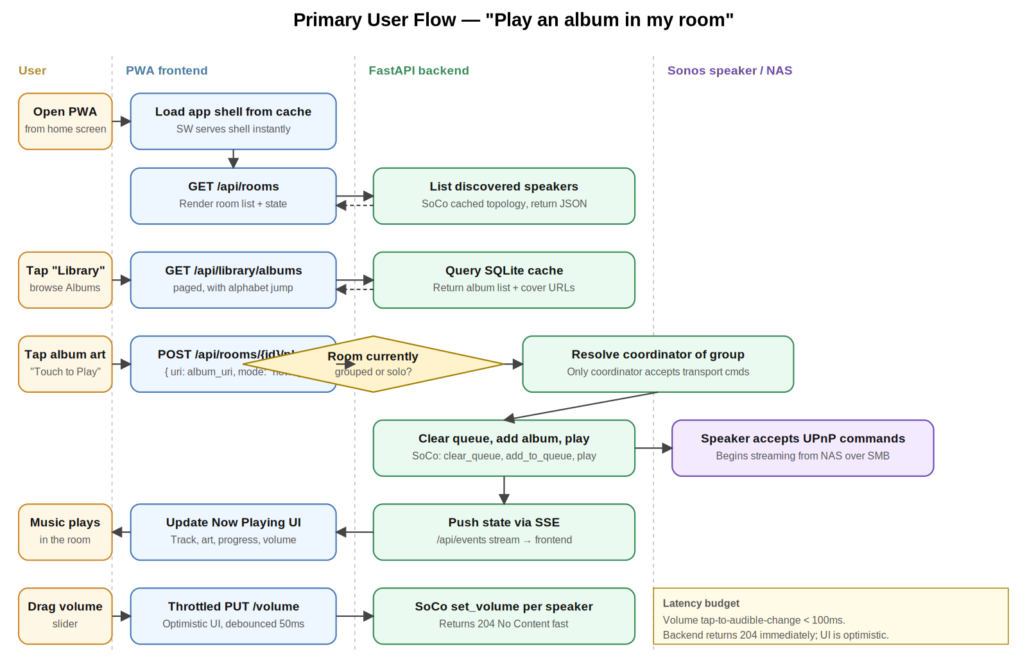
Figure 2 — Primary user flow, swimlane view.

7.1 Other key flows
In addition to the primary flow, the app supports these journeys:
- Group two rooms. User opens Rooms tab → taps 'Add to group' on a solo room → picks the target group → backend calls SoCo join() and confirms via SSE.
- Aggregated search. User opens Search tab → types a query → backend queries SQLite cache → returns Artists / Albums / Tracks groups → user taps any result to play or queue.
- Add album to existing queue. User long-presses album in Library → action sheet → picks 'Add to end of queue' → backend calls SoCo add_to_queue() without clearing → user continues listening.
- Switch the controlled room. User taps the room indicator in any header → room picker sheet appears → user picks new room → entire UI rebinds to that room's state.

8. Wireframes
These are low-fidelity wireframes. They establish information architecture, hierarchy, and interaction patterns. Visual styling (typography, exact colours, spacing) is left to the implementation phase. Wireframes assume an iPhone-sized portrait viewport (around 390 points wide).

8.1 Now Playing
The Now Playing screen is the default landing view. It shows the active room (top-left, tap to switch), large album art, track metadata, a draggable progress bar, transport controls, and a volume slider. Secondary actions (add to queue, shuffle, repeat, queue access) are along the bottom. The room picker is accessed by tapping the room name in the header.
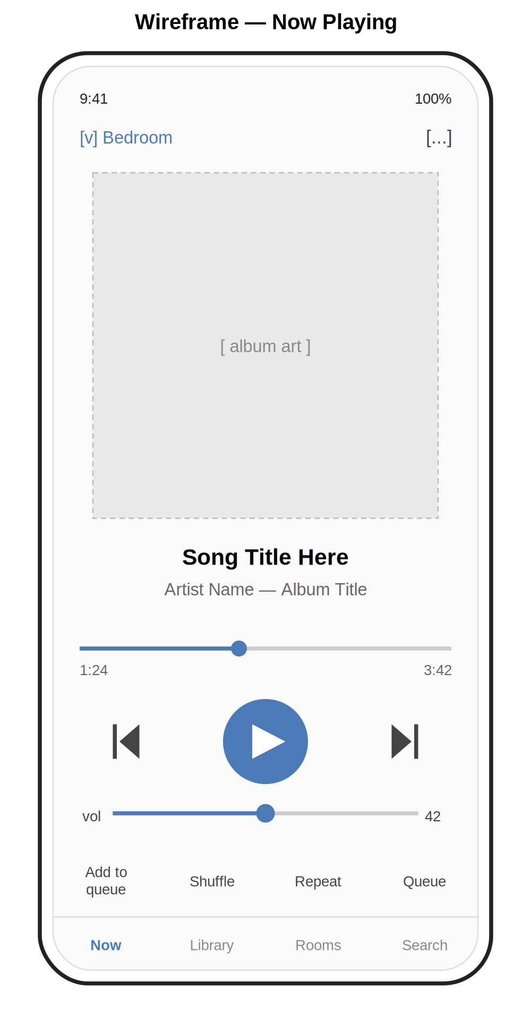
Figure 3 — Now Playing wireframe.

8.2 Library Browse
The Library tab opens to Albums by default with a segmented control to switch between Albums, Artists, Tracks, and Folders. A search field sits above the list. Sections are headed by their starting letter, and an alphabet jump-bar runs down the right edge for fast navigation. Each row shows album art, title, and one line of supporting metadata. A persistent mini Now Playing strip sits above the tab bar.
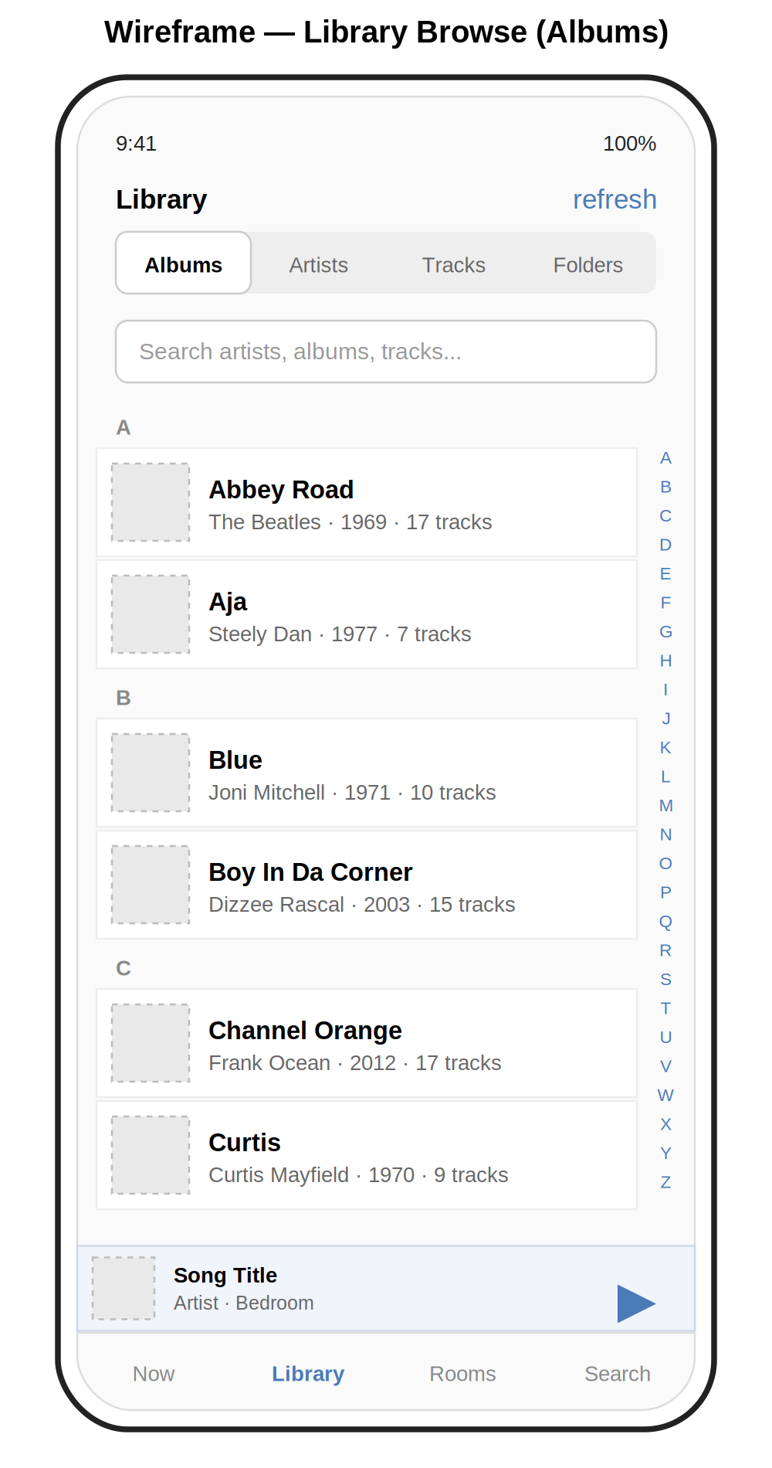
Figure 4 — Library Browse wireframe with alphabet jump-bar.

8.3 Rooms
The Rooms screen shows all rooms and groups on one scrollable view. Groups are visually distinct from solo rooms (subtle blue background) and contain a group volume slider above per-member sliders. Solo rooms show their own slider, current state, and an action to add them to a group. A 'Party Mode' button at the bottom groups all rooms in one tap.
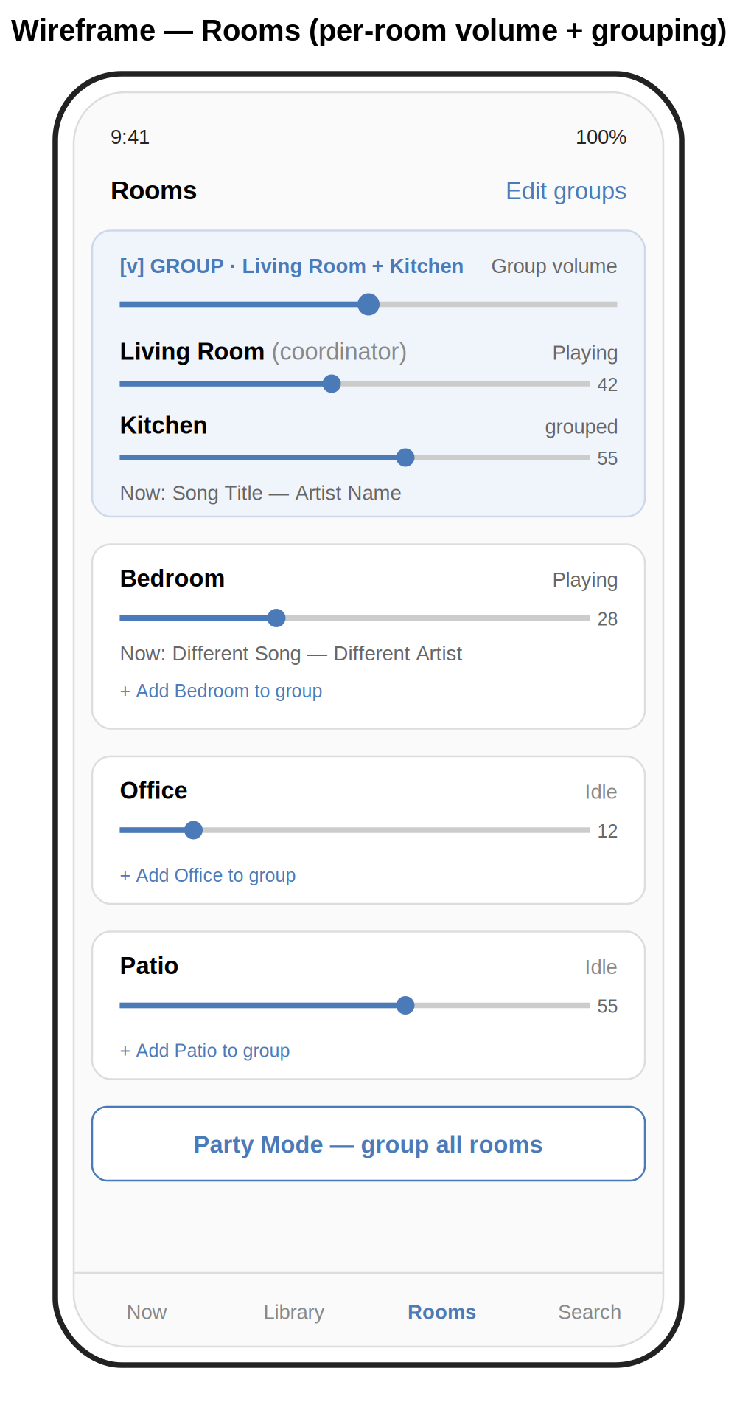
Figure 5 — Rooms wireframe with grouped and standalone speakers.

8.4 Queue
The Queue view always shows the currently playing track at the top in a highlighted row. Up Next tracks follow with their queue position numbered. Each row has a drag handle on the right for reordering. Swiping a row left reveals a Delete action. Mode toggles for shuffle, repeat, and crossfade sit above the tab bar.
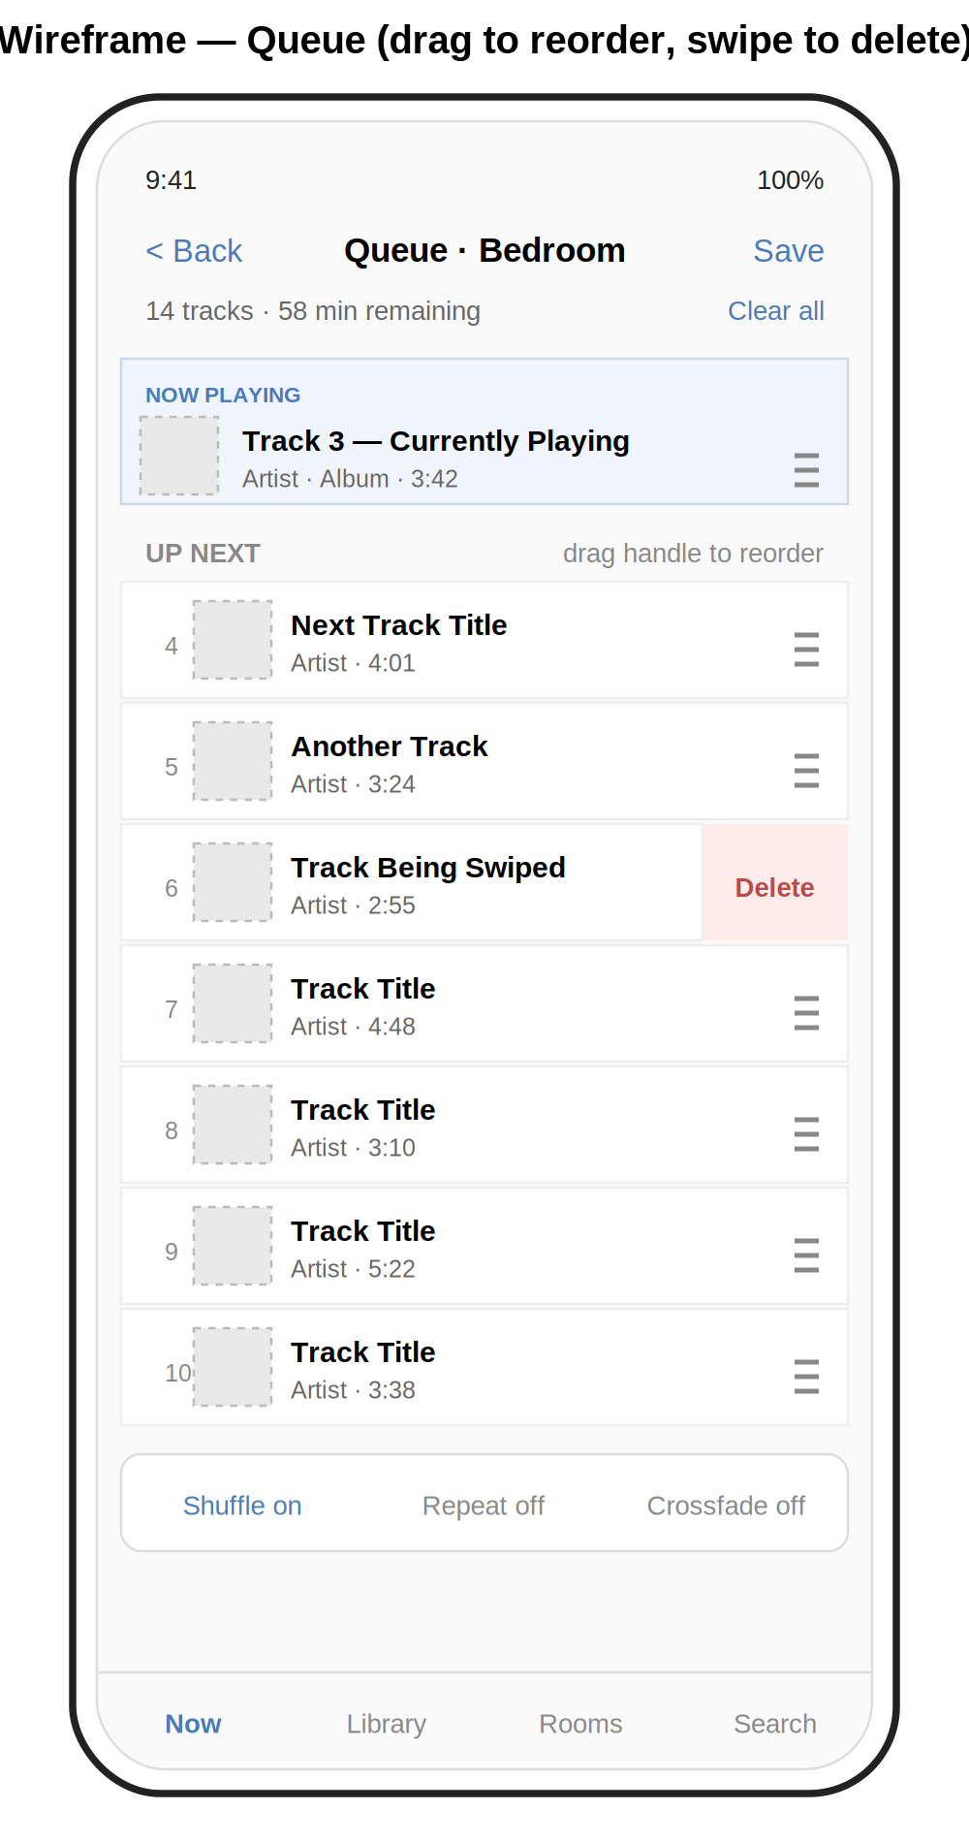
Figure 6 — Queue wireframe with drag-to-reorder and swipe-to-delete.

9. Backend API Specification
All endpoints are prefixed with /api and require a bearer token in the Authorization header. JSON request and response bodies. The frontend speaks only this API; it never talks directly to Sonos.

9.1 Discovery and rooms
Method + Path | Purpose | Body / Returns
GET /api/rooms | List all rooms with current state (track, volume, group, playing/paused). | 200 → Room[]
GET /api/rooms/{id} | Get full state for one room. | 200 → Room
GET /api/groups | List all current groups and members. | 200 → Group[]
POST /api/groups/{id}/join | Add a room to a group. | { room_id } → 204
POST /api/groups/{id}/leave | Remove a room from its group. | { room_id } → 204
POST /api/groups/party | Group all rooms. | → 204

9.2 Playback control
Method + Path | Purpose | Body / Returns
POST /api/rooms/{id}/play | Start playback or play a specific URI. | { uri?, mode? } → 204
POST /api/rooms/{id}/pause | Pause the room (or its group). | → 204
POST /api/rooms/{id}/next | Skip to next track. | → 204
POST /api/rooms/{id}/previous | Skip to previous track. | → 204
PUT /api/rooms/{id}/seek | Seek to position. | { seconds } → 204
PUT /api/rooms/{id}/volume | Set room volume. | { value: 0–100 } → 204
PUT /api/rooms/{id}/mute | Set mute state. | { muted: bool } → 204
PUT /api/rooms/{id}/play_mode | Set shuffle/repeat/crossfade. | { shuffle, repeat, crossfade } → 204

9.3 Library and search
Method + Path | Purpose | Body / Returns
GET /api/library/artists | Paged artist list. | ?offset&limit → Artist[]
GET /api/library/albums | Paged album list. | ?offset&limit&artist_id → Album[]
GET /api/library/albums/{id}/tracks | Tracks of an album. | → Track[]
GET /api/library/tracks | Paged track list. | ?offset&limit&album_id → Track[]
GET /api/library/genres | Genre list. | → Genre[]
GET /api/library/folders | Folder browse view. | ?path → Item[]
GET /api/search | Aggregated search. | ?q → { artists, albums, tracks }
POST /api/library/reindex | Trigger library re-index. | → 202 + job_id
GET /api/library/reindex/{job_id} | Re-index progress. | → { status, progress }

9.4 Queue and playlists
Method + Path | Purpose | Body / Returns
GET /api/rooms/{id}/queue | Current queue. | → Track[]
POST /api/rooms/{id}/queue | Add an item. | { uri, position?, mode } → 204
DELETE /api/rooms/{id}/queue/{index} | Remove queue item by index. | → 204
PUT /api/rooms/{id}/queue/{index} | Move queue item. | { new_index } → 204
DELETE /api/rooms/{id}/queue | Clear queue. | → 204
GET /api/playlists | Sonos playlists. | → Playlist[]
POST /api/playlists | Create a playlist. | { name } → Playlist
GET /api/favourites | Sonos favourites. | → Favourite[]

9.5 Events
Method + Path | Purpose | Body / Returns
GET /api/events | Server-Sent Events stream of state changes. | text/event-stream
GET /api/healthz | Liveness probe. | → { status: 'ok' }

10. Data Model
The library cache is a SQLite database with the following essential tables. Foreign keys enforce referential integrity. Indexes are added on every column the UI filters or sorts by.

artists
- id (integer, primary key)
- name (text, indexed)
- sort_name (text, indexed) — name with leading articles stripped

albums
- id (integer, primary key)
- title (text, indexed)
- sort_title (text, indexed)
- album_artist_id (integer, foreign key → artists.id)
- year (integer)
- track_count (integer)
- art_uri (text)

tracks
- id (integer, primary key)
- title (text, indexed)
- album_id (integer, foreign key → albums.id)
- artist_id (integer, foreign key → artists.id)
- track_number (integer)
- duration_seconds (integer)
- file_uri (text) — the x-file-cifs:// URI Sonos uses
- genre (text, indexed)
- added_at (timestamp)

Other tables
- genres — denormalised view of distinct genres.
- playlist_imports — imported M3U playlists from the library.
- settings — single-row table for user preferences.

11. Phased Build Plan
The build is structured in five phases, each producing a usable increment. After each phase, the app should be deployable and demoable. This mirrors the pattern used successfully in earlier projects: ship a small thing, see it working, expand.

Phase 1 — Backend foundation
Goal: a FastAPI service that discovers Sonos speakers, reports their state, and accepts basic playback commands.
- Set up Python project structure with pyproject.toml, virtual environment, and pre-commit hooks.
- Install SoCo and FastAPI. Confirm soco.discover() returns the existing speakers from the development machine.
- Implement endpoints F-DM-01 through F-DM-04 and F-PC-01 through F-PC-04.
- Add bearer-token middleware (F-OP-03) and the /healthz endpoint.
- Write unit tests for the SoCo wrapper layer using a recorded fixture.
- Containerise the backend with a small Dockerfile so it can run on the eventual host.
Exit criterion: curl can play, pause, and skip on a real speaker through the API.

Phase 2 — Library cache and search
Goal: full music library is browseable and searchable through the API.
- Design the SQLite schema as in section 10 above.
- Write the indexer that walks the Sonos music-library API via SoCo and populates SQLite.
- Implement the library and search endpoints (F-LB-* and F-SR-*).
- Add background scheduling for periodic re-index (F-LB-09).
- Benchmark search performance against a representative library size and tune indexes.
Exit criterion: GET /api/search?q=beatles returns aggregated results in under 500ms.

Phase 3 — Frontend skeleton
Goal: a minimal but installable PWA that shows real data.
- Choose a framework (recommendation: vanilla JS with a tiny router, or Vue 3 if a framework is preferred — React is overkill here).
- Build the four primary screens as static layouts: Now Playing, Library, Rooms, Search.
- Wire up the API client with the bearer token from a settings screen.
- Implement the SSE listener and render basic state updates.
- Add the PWA manifest, app icons, and a service worker that caches the shell.
- Test 'Add to Home Screen' on iPhone Safari end to end.
Exit criterion: app installs to home screen, opens full-screen, and shows live room states.

Phase 4 — Core interactions
Goal: every must-have interaction works.
- Volume sliders with throttled requests, optimistic UI, and SSE confirmation.
- Library browse with alphabet jump-bar and segmented control.
- Touch-to-play album behaviour with long-press action sheet.
- Queue view with drag-to-reorder and swipe-to-delete.
- Rooms view with grouping interactions.
- Aggregated search results UI.
Exit criterion: every Must-priority requirement in section 5 is functional.

Phase 5 — Polish and deploy
Goal: the app is reliable, pleasant, and lives on the controller host.
- Light and dark theme.
- Loading states, empty states, and error states for every screen.
- Settings screen for default tap action, theme, and library refresh.
- Logging, log rotation, and a systemd service unit (or container restart policy) on the controller host.
- Documentation: README, install guide, configuration reference.
- Run the app for a week as the only Sonos controller; fix what hurts.
Exit criterion: app has been used daily for seven consecutive days without bugs blocking a common task.

12. Open Questions and Risks

12.1 Open questions
- Q1. Where does the controller host run? Options: a Raspberry Pi 4, a Docker container on the QNAP NAS, or a small VM on the existing Ubuntu workstation. Each has trade-offs on always-on availability and noise. Decision needed before Phase 1.
- Q2. How should album art be served? Sonos exposes art via per-speaker URIs that aren't directly reachable from the PWA. Two options: backend proxies and caches art, or backend rewrites art URIs to a stable cache path. Proxy with caching is simpler.
- Q3. Should the library cache be authoritative or only a hint? If authoritative, the backend trusts SQLite and never re-queries Sonos for browse data. If hint, browse falls through to Sonos when SQLite misses. Authoritative is faster; hint is more correct after manual library changes.
- Q4. Frontend framework choice: vanilla JS, Vue 3, or React? Vanilla keeps the bundle tiny and aligns with existing skill set. Vue is a comfortable middle ground. React adds tooling complexity for limited gain on a project this size.
- Q5. Does the household need separate user accounts, or is a single shared bearer token sufficient? A single token is simpler and probably right; revisit if multiple people start using the app heavily.

12.2 Risks
- R1. SoCo or Sonos API drift. Sonos has historically deprecated UPnP control surfaces with little warning. Mitigation: keep the SoCo dependency current and write integration tests against a real speaker.
- R2. iOS Safari PWA limitations. Safari is the most restrictive PWA host. Background tabs may be aggressively suspended; lock-screen integration is impossible. Mitigation: design assuming the app is only useful when foregrounded, and accept the trade-off.
- R3. Large library performance. Libraries with hundreds of thousands of tracks may stress the SQLite cache or the indexer. Mitigation: paginate everything, benchmark with realistic data, and add FTS5 to SQLite if substring search becomes slow.
- R4. Network changes. Speakers reboot, IPs change, the network gets reconfigured. Mitigation: SoCo handles most of this, but the backend must re-discover gracefully and the SSE stream must reconnect on the frontend.
- R5. Scope creep. The temptation to add streaming services, alarms, or Apple Watch support is real. Mitigation: section 2.3 is sacred until v1 has shipped.

13. Glossary
- Coordinator. The Sonos speaker designated as the leader of a group. Only the coordinator accepts transport commands; followers mirror its output.
- Group. Two or more Sonos speakers playing the same audio in sync.
- PWA. Progressive Web App. A web application enhanced with a manifest and service worker so it can be installed to a device home screen and behave like a native app.
- SMB. Server Message Block, the file-sharing protocol used between the Sonos speakers and the QNAP NAS.
- SoCo. An open-source Python library for controlling Sonos speakers via UPnP. The backend is built on SoCo.
- SSE. Server-Sent Events. An HTTP-based mechanism for the server to push events to the browser over a single long-lived connection.
- UPnP. Universal Plug and Play. The discovery and control protocol Sonos speakers expose on the local network. SoCo speaks UPnP.

