Sonos Local Library Controller
Product Requirements Document
A Progressive Web App for controlling Sonos speakers
with a NAS-resident MP3 library, built on a fork of TinySonos
Version 0.4 — Draft
Author: Ray

Revision History
Version | Date | Changes
0.1 | Apr 2026 | Initial draft. Open question on host (Pi vs QNAP container vs Ubuntu workstation).
0.2 | Apr 2026 | Host decision committed: dedicated Raspberry Pi 4. Updated section 4 architecture, section 6 reliability NFRs, section 11 build plan now includes deployment phase, section 12 Q1 closed. Architecture diagram redrawn. New section 11.6 Deployment added.
0.3 | Apr 2026 | Build strategy committed: fork jasonacox/TinySonos as backend foundation. Section 1 updated. New section 4.2 covers fork strategy. Section 5 reframed with TinySonos vs new attribution. Section 11 build plan revised: phases 1-2 replaced with 'fork, learn, harden'. Section 12 risks updated. License compatibility added.
0.4 | Apr 2026 | Added new section 5: Development Environment & Toolchain. Documents Claude Code (native installer), GSD v1 (per-project), Pi SSH access, Docker buildx, deployment workflow. Subsequent sections renumbered (was 5..13, now 6..14). New diagram (Figure 2) shows the dev workflow. Build plan Phase 0 added: "Set up the development environment" before Phase 1.

1. Executive Summary
This document specifies a Progressive Web App (PWA) that controls Sonos speakers on a home LAN, with a primary focus on browsing and playing audio files (.mp3 and similar) hosted on a network-attached storage (NAS) device. The app is installed to the iPhone home screen via Safari and behaves like a native app. It is built on top of a self-hosted Python backend running on a dedicated Raspberry Pi.
The product exists because the official Sonos app, particularly after its May 2024 redesign, is widely regarded as poor at the specific job described above. Volume control has noticeable latency, NAS music libraries became second-class citizens, and basic interactions require many taps. A community of frustrated users has migrated to third-party alternatives such as SonoPhone. This project takes inspiration from those alternatives but builds a self-hosted, ad-free, dependency-light tool that any household member can use on Wi-Fi.
Build strategy: this project forks the open-source TinySonos project (jasonacox/TinySonos, MIT licensed) as its backend foundation. TinySonos already provides Python + SoCo + FastAPI-style web service + REST + Server-Sent Events + Docker host networking, which together cover the bulk of the backend specification. The work is therefore concentrated on hardening that backend, adding what TinySonos does not provide (alphabet jump-bar support, optimistic-UI volume semantics, bearer-token authentication), and building a high-quality iPhone-first PWA frontend on top of the API. Section 4.2 details what is reused and what is changed.
Development workflow: Claude Code (Anthropic's terminal-based coding agent) on an Ubuntu workstation drives the build, structured by GSD v1 ("Get Shit Done") as a per-project context-engineering and spec-driven development overlay. Claude Code provisions the Pi over SSH and deploys container builds to it, so the developer never logs into the Pi manually after initial bootstrap. Section 5 documents the development environment in full.
Four product principles drive every decision:
- Speed is the feature. Volume changes feel instantaneous. Library searches return in under half a second. Tapping an album plays it.
- NAS-first. The local music library is the headline experience, not an afterthought.
- Minimum taps. Common actions take one tap; nothing common takes more than three.
- Reliability through simplicity. The controller runs on dedicated, single-purpose hardware so that nothing else on the network can disrupt it.

2. Vision and Goals

2.1 Vision
A fast, no-nonsense Sonos controller for people whose music lives on their own NAS. The app should make it effortless to walk into any room, open the app, and have music playing in seconds. It should feel like the controller Sonos would have built if they cared about local-library users.

2.2 Measurable goals
- Volume slider produces audible change on the speaker within 100 milliseconds of touch.
- Library search returns results within 500 milliseconds for a library of up to 50,000 tracks.
- From cold app launch to playing music: under 10 seconds end-to-end.
- Common tasks (play album, group two rooms, change volume, skip track) require no more than two taps.
- App is fully usable on the home LAN with no internet connection.
- Controller service runs continuously for 90 days without manual intervention.
- Mean time to recovery from any controller failure: under 60 seconds, automatically.

2.3 Non-goals (explicitly out of scope)
Calling out non-goals up front prevents scope creep during build. The following are explicitly excluded from version 1 of this product:
- Streaming services (Spotify, Apple Music, Tidal, Amazon Music, etc.).
- Internet radio and TuneIn integration.
- Apple Watch support — impossible from a PWA.
- Lock-screen and Control Center transport controls — also a PWA limitation.
- CarPlay support.
- Speaker setup, firmware updates, and stereo-pair configuration — handled by official Sonos app.
- Alarms and sleep timers — deferred to v2.
- Voice control or Siri integration.
- Public internet access. The app is LAN-only by design. Remote access can be layered on via the existing UDM Pro WireGuard VPN if needed.

3. Personas and User Stories

3.1 Personas
Primary persona — Ray, the owner.
Owns the NAS, the Sonos system, and built the app. Comfortable with technology. Wants the controller to be reliable, fast, and to surface the deep functionality of the Sonos system without burying it. Often interacts from bed or the kitchen counter.
Secondary persona — household member.
Less technical. Wants to walk in, hit play, change rooms, and adjust volume. Will not tolerate complexity or latency. Should never need to think about IP addresses, group coordinators, or library shares. If the app fails twice, they go back to the official Sonos app and the project is dead — so the dedicated Pi exists as much for them as for Ray.

3.2 User stories
User stories are written as: "As a [persona], I want to [action] so that [outcome]."
- US-01: As Ray, I want to open the app and immediately see what's playing in every room, so that I can take action without navigating menus.
- US-02: As a household member, I want to tap an album cover and have it play in my current room, so that I don't have to pick from a menu of options.
- US-03: As Ray, I want to drag a volume slider and hear the change instantly, so that the experience feels like a physical knob.
- US-04: As a household member lying in bed, I want to pause music in another room without unlocking my phone any further than necessary.
- US-05: As Ray, I want to search across all artists, albums, and tracks at once and see results grouped by category, so that I don't have to switch tabs to find what I want.
- US-06: As Ray, I want to navigate a long alphabetical list using a side-rail jump bar, so that I don't have to scroll through hundreds of items.
- US-07: As a household member, I want to group two rooms together for a party, so that the music plays in both at the same time and stays in sync.
- US-08: As Ray, I want to add an entire album to the existing queue without interrupting the current track, so that I can build a listening session over time.
- US-09: As Ray, I want the app to remember which room I last controlled, so that I land on a useful screen on every launch.
- US-10: As Ray, I want the queue view to show the currently playing track at the top with up-next visible below, so that I never lose my place.
- US-11: As a household member, I want the app to keep working even if the controller machine reboots, with full state recovery within seconds.
- US-12: As Ray, I want to swipe a track out of the queue to remove it, so that pruning a queue is fast and tactile.

4. System Architecture
The system has three parts: an iPhone running the PWA in Safari, a dedicated Raspberry Pi 4 on the LAN running the backend in a Docker container, and the existing Sonos speakers and QNAP NAS. The Pi is the only new piece of hardware being added. The diagram below shows how they fit together.
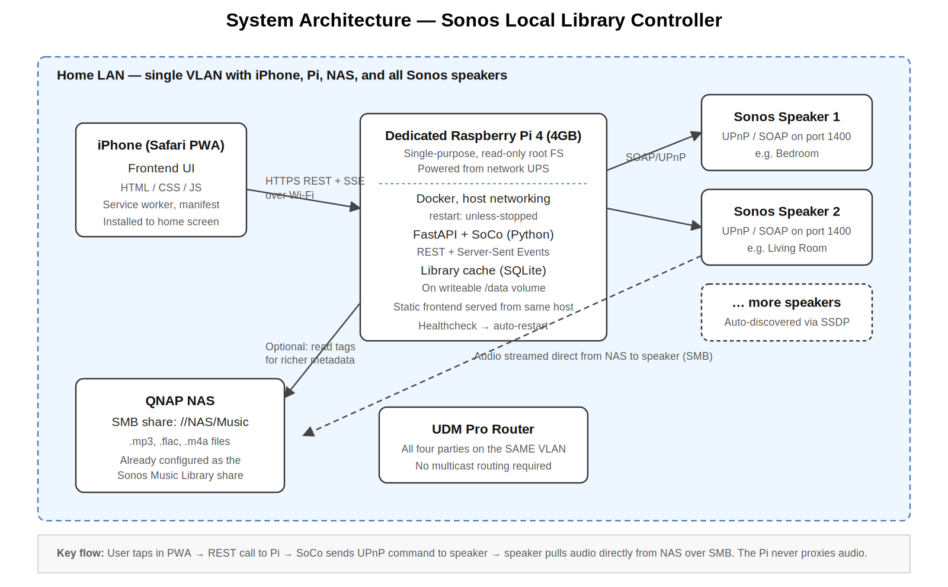
Figure 1 — System architecture. Audio data never flows through the Pi.

4.1 Architectural decisions

4.1.1 Why a PWA, not a native iOS app
Native iOS development requires a Mac running Xcode, an Apple Developer subscription, and Swift expertise. None of those align with the existing development environment (Ubuntu, PHP, Python, JavaScript). A PWA delivers the bulk of the native experience — installable to the home screen, full-screen, app-like behaviour — using only web technologies. The trade-offs are real but acceptable: no lock-screen controls, no Apple Watch, limited background behaviour. Since Sonos is itself a LAN-bound system, those limitations rarely matter in practice.

4.1.2 Why fork TinySonos rather than build from scratch
An open-source project, TinySonos by jasonacox (https://github.com/jasonacox/TinySonos, MIT licensed), already implements the bulk of the backend specified in this PRD: Python + SoCo control, a FastAPI-style web service, RESTful endpoints for playback and library browsing, Server-Sent Events for real-time UI updates, M3U playlist support, multi-room grouping, individual and group volume management, Docker packaging with host networking, and aggressive command-queue auto-play logic for reliable continuous playback.
Building this same surface area from scratch would consume the first two phases of the build plan (perhaps 60–80 hours of work) without delivering anything the user can see. Forking TinySonos converts that time into time spent on the parts of the product that actually differentiate it from existing options: the iPhone PWA shell, the alphabet jump-bar, the zero-latency volume model, and the SonoPhone-grade UX patterns identified in the research phase.
TinySonos is licensed MIT, which permits forking, modification, redistribution, and use in proprietary products without copyleft obligation. The project's chosen approach — Python web service with SoCo, REST + SSE, host-networked Docker — is identical to the architecture this PRD specified independently in v0.1, which is a strong signal that the choices are sound. Forking captures that work directly. Section 4.2 details what is reused versus changed.

4.1.3 Why FastAPI + SoCo on the backend
SoCo is the de facto Python library for controlling Sonos via UPnP. It auto-discovers speakers, exposes a music-library API, manages queues, handles grouping, and gracefully tolerates speakers coming and going on the network. A FastAPI-style web service wraps it in a clean async REST interface. The combination is well-supported, has small dependencies, and produces a backend that is straightforward to read and maintain. TinySonos uses essentially this stack, so the choice is preserved unchanged.

4.1.4 Why a dedicated Raspberry Pi as the controller host
The controller's reliability is the single biggest factor in whether the app gets used or abandoned. Co-tenant hosting (running the controller alongside other services on the QNAP NAS or on a developer workstation) introduces failure modes that have nothing to do with the controller itself: NAS firmware updates, unrelated container resource contention, workstation reboots and sleep cycles. A dedicated Raspberry Pi 4 (4GB) eliminates these failure modes by doing exactly one thing.
The Pi runs Raspberry Pi OS Lite with a read-only root filesystem; only a small writeable /data partition holds the SQLite library cache and configuration file. SD-card corruption, the traditional Pi weakness, is essentially eliminated by this configuration.

4.1.5 Why a separate library cache
The Sonos players index the NAS music library themselves, but querying that index through SoCo for every browse operation is slow on large libraries and contributes to UI latency. The Pi keeps a SQLite mirror of artists, albums, tracks, genres, and folder structure, refreshed on demand. All browse and search operations hit SQLite directly. This is the single biggest win for perceived speed. (TinySonos has rudimentary album browsing; an enhanced cache layer is one of the deliberate additions in the fork — see section 4.2.)

4.1.6 Audio path
The Pi never touches audio data. When the user picks a track, the Pi tells the Sonos coordinator (via SoCo / UPnP) to play a URI of the form x-file-cifs://NAS/Music/path/track.mp3. The speaker then opens its own SMB connection directly to the NAS and streams from there. This keeps the Pi's CPU and network footprint trivial. Note: TinySonos by default streams files via an HTTP file server it runs on the host; the fork will switch to direct x-file-cifs URIs because the existing Sonos Music Library share is already configured on the speakers and pulling from NAS over SMB is faster and more reliable than going through the Pi.

4.1.7 State synchronisation
The frontend subscribes to a Server-Sent Events (SSE) endpoint at /api/events, an architecture inherited from TinySonos. The Pi pushes state changes (now playing, volume, queue updates, group topology changes) as they happen. The frontend reconnects automatically if the SSE stream is interrupted, e.g. during a Pi reboot.

4.1.8 Network requirements
The Pi, the NAS, all Sonos speakers, and the iPhone must all be on the same VLAN. Sonos uses UPnP/SSDP multicast for discovery and peer-to-peer UDP for grouping. While multicast routing across VLANs is technically possible on the UDM Pro, it is the most common cause of subtle, hard-to-diagnose failures in DIY Sonos setups. Keeping everything on one VLAN is a deliberate simplicity choice that pays for itself many times over in operational reliability.

4.2 Fork strategy: reuse vs change
This section is the explicit boundary between what the project takes unchanged from TinySonos and what it modifies, replaces, or adds. It is the single most important reference for build planning and for evaluating whether a given piece of work belongs in the upstream project or in the fork.

4.2.1 Reused unchanged from TinySonos
- SoCo wrapper layer. The PlaybackController class and its single-threaded command queue. The reliability work in TinySonos v0.1.0 is excellent and exactly the kind of code that would have been painful to develop from scratch.
- Speaker discovery and topology tracking. Discovery via SoCo, group/coordinator handling, dynamic re-discovery on network changes.
- Transport endpoints. Play, pause, stop, next, previous, seek, shuffle, repeat — already present and well-tested.
- Volume endpoints. Per-speaker and group volume; mute. Endpoint shapes will be aligned with section 10 of this PRD but the underlying SoCo calls are unchanged.
- Server-Sent Events stream. The /api/events publish/subscribe machinery.
- Multi-room grouping. Join and unjoin endpoints, party mode, coordinator selection.
- Queue management primitives. Add, clear, view queue. Drag-to-reorder and swipe-to-delete are surface-level frontend behaviours that build on these.
- Docker packaging. The Dockerfile, host-network mode, restart policy. The fork retains this and extends it for arm64 cross-compilation.
- M3U playlist parsing. For imported playlists from the music library.

4.2.2 Modified from TinySonos
- Audio playback URIs. TinySonos streams via its own HTTP file server on port 54000. The fork switches to x-file-cifs:// URIs that point directly at the existing NAS share, removing the Pi from the audio path entirely. This change improves both reliability and audio quality (no transcoding, no re-streaming, native Sonos handling).
- Library indexing. TinySonos's album browser is functional but limited. The fork builds a comprehensive SQLite cache layered on top, with the schema described in section 11 — artists, albums, album-artists, genres, composers, folder hierarchy, indexed for substring search.
- Authentication. TinySonos has no authentication on its endpoints. The fork adds bearer-token middleware on every /api endpoint, with the token generated at first install and stored on the writeable /data partition.
- Endpoint shapes. TinySonos's URLs are pragmatic but inconsistent (e.g. /play, /albums/all, /speaker_join/{ip}). The fork normalises everything to RESTful /api/rooms, /api/groups, /api/library/* paths as specified in section 10, while keeping legacy paths as aliases during the transition for any local automation that depended on them.
- Healthcheck endpoint. /api/healthz returns structured JSON including discovery state, library cache freshness, and SSE subscriber count — for the watchdog and monitoring.
- Logging. Structured logs to stdout in JSON format, consumable by `docker logs`, with file rotation on the /data volume.

4.2.3 Added beyond TinySonos
- iPhone-first PWA frontend. TinySonos has a desktop-oriented HTML/CSS web UI. The fork replaces it entirely with a new PWA frontend designed for iPhone Safari, including manifest, service worker, app icons, and the wireframes in section 9. The original UI is removed from the build.
- Alphabet jump-bar. A signature feature for navigating long lists, called out in user research as missing from every existing controller. Not present in TinySonos and built fresh.
- Aggregated search UI. SonoPhone-style single search box returning grouped Artists / Albums / Tracks results in one view. Backed by an /api/search endpoint added on top of the new SQLite cache.
- Optimistic-UI volume model. Frontend updates the slider position immediately and debounces requests; backend confirmation arrives via SSE. Throttling at 20 requests/second per slider. This is a frontend pattern; the backend already accepts the calls.
- Touch-to-Play action defaulting. Tap = play immediately, long-press = full action sheet. Configurable in settings. Frontend interaction pattern, not a backend change.
- Watchdog for stuck-discovery state. If discovery returns zero rooms for more than 60 seconds when it had rooms previously, the FastAPI process exits and the container restarts cleanly.
- Read-only root filesystem support. The Dockerfile and runtime config are adjusted so the container runs cleanly when the host's root FS is read-only and only /data is writeable.
- Multi-architecture image build. linux/arm64 for the Pi production target, linux/amd64 for the Ubuntu development target, from a single buildx pipeline.

4.2.4 Removed from TinySonos
- Built-in HTTP file server (port 54000). Made unnecessary by the switch to x-file-cifs:// URIs.
- Plex export tools (the tools/ directory). Outside the scope of this product; not included in the deployed image. May remain in the source tree as developer reference.
- Original web UI in web/. Replaced by the new PWA frontend.

4.2.5 Upstream contribution policy
Where bug fixes or improvements made in the fork are general-purpose and not specific to this project's product direction (e.g. fixes to the SoCo wrapper, Docker improvements, performance fixes), they should be opened as pull requests against the upstream TinySonos project as a courtesy. Project-specific changes (the new frontend, the SQLite cache, bearer-token auth, x-file-cifs URI rewriting) stay in the fork. The fork's README will credit TinySonos prominently and link to the upstream project.
The fork is permitted to diverge significantly. There is no commitment to track upstream's main branch — upstream changes will be cherry-picked when relevant rather than merged automatically.

5. Development Environment and Toolchain
This section documents everything needed to build the project: the development workstation, the tooling installed on it, the production target hardware, and the workflow that connects them. Phase 0 of the build plan (section 12) implements this environment before any feature work begins.
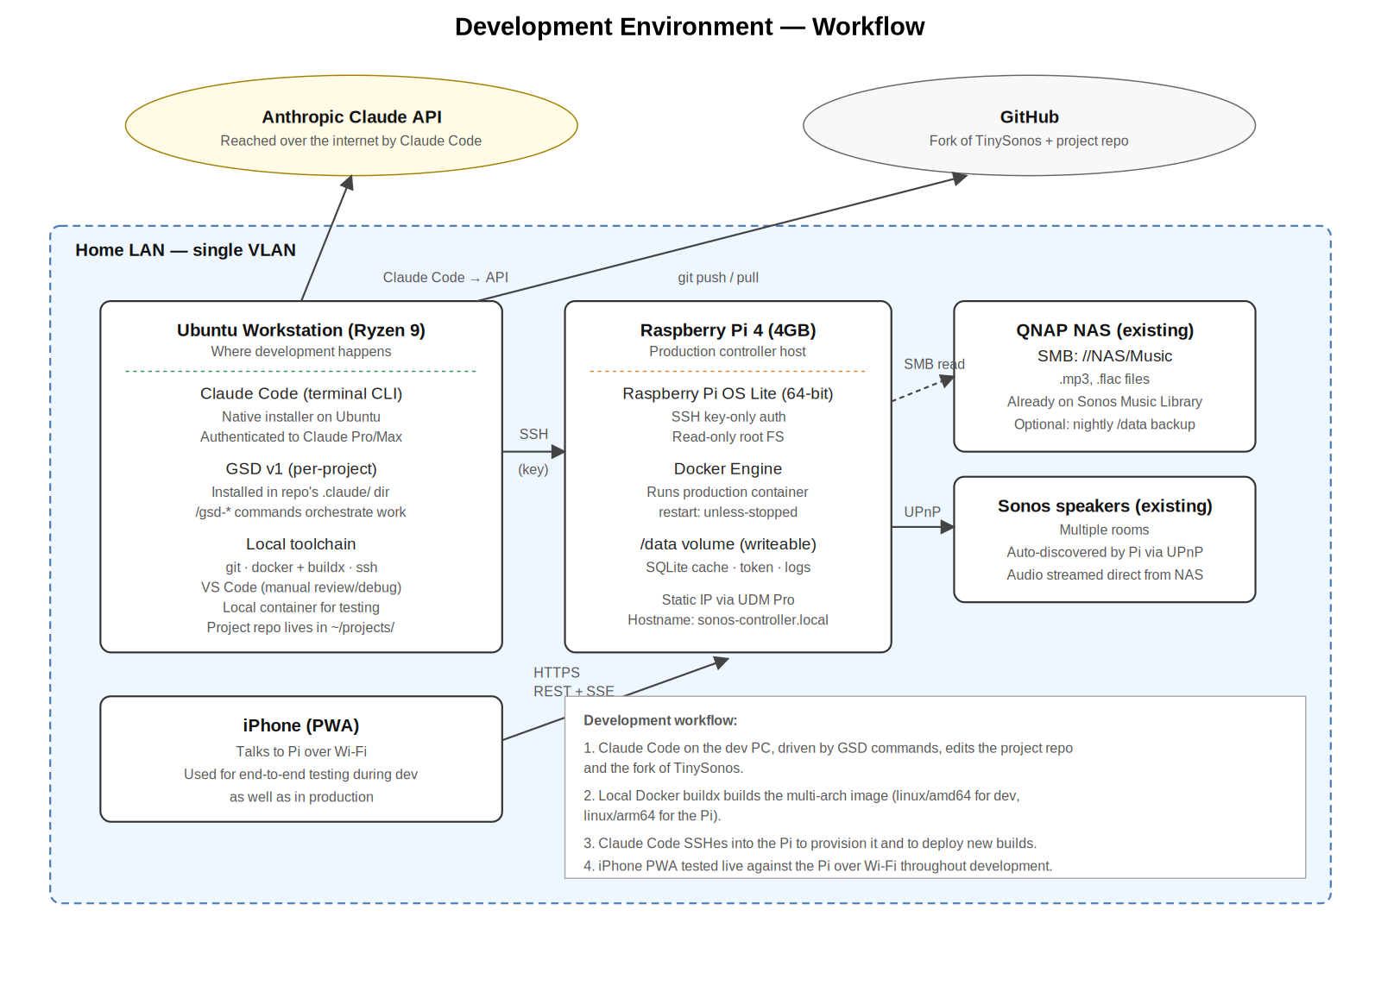
Figure 2 — Development environment workflow.

5.1 Development workstation
All code is written and tested on Ray's existing Ubuntu workstation.
Item | Detail
CPU / RAM | AMD Ryzen 9 3950X, 32GB+ DDR4-3600 (existing)
OS | Ubuntu 24.04 LTS or later
Disk | At least 20GB free for project repo, container images, and Docker buildx caches
Network | Wired connection to the home LAN, same VLAN as the Pi, NAS, and Sonos speakers
Editor | VS Code (existing) for manual review and debugging
Containerisation | Docker Engine + buildx for multi-arch image builds
Version control | Git (existing); GitHub account for hosting the fork
The workstation is the only machine that holds the full project source. The Pi only ever holds compiled container images and the writeable /data volume.

5.2 AI coding agent: Claude Code
Claude Code is Anthropic's terminal-based AI coding agent. It runs as a CLI on the workstation, reads and edits files in the project repo, executes shell commands (including git, docker, ssh), and drives the bulk of the implementation work for this project.
Item | Detail
Installation method | Native installer on Ubuntu (no Node.js dependency)
Install command | curl -fsSL https://claude.ai/install.sh | bash
Documentation | https://docs.claude.com/en/docs/claude-code/overview
Account | Existing Claude Pro or Max subscription is sufficient; alternatively an Anthropic Console API account
Authentication | Browser-based OAuth on first run; session token cached locally
Auto-update | Yes (native installer); kept current with no manual intervention
First-run check | claude doctor diagnoses any PATH or auth issues

5.2.1 Claude Code permissions for this project
This project uses Claude Code in a high-autonomy mode. The recommended posture is to start sessions with the --dangerously-skip-permissions flag (see section 5.3) so GSD can do its work without constant confirmation prompts. As a defence-in-depth measure, the project's .claude/settings.json explicitly denies reads of files that should never be opened by the agent:
{
"permissions": {
"deny": [
"Read(.env)",
"Read(.env.*)",
"Read(**/secrets/*)",
"Read(**/*credential*)",
"Read(**/*.pem)",
"Read(**/*.key)",
"Read(/data/token)"
]
}
}

5.3 Workflow harness: GSD v1
Claude Code is a powerful agent but a long single session degrades in quality as its context window fills — a phenomenon GSD's authors call "context rot." GSD v1 ("Get Shit Done," by TÂCHES) is a meta-prompting and spec-driven development system that solves this by externalising state into files, splitting work into small plans, executing each plan in a fresh subagent context, and committing atomically per task so any failure is easy to bisect. It is open-source under MIT licence and installs as Claude Code skills.
GSD is chosen for this project because its workflow shape — discuss → plan → execute → verify → ship, repeated per phase — maps almost exactly onto the phased build plan in section 12. GSD's brownfield support (the /gsd-map-codebase command) is purpose-built for the situation here: forking a moderately-sized existing project (TinySonos) and extending it. Phase 1's "read the codebase end to end" exercise becomes literally one GSD command.

5.3.1 GSD installation and configuration
Item | Detail
Project | https://github.com/gsd-build/get-shit-done
Version | v1.x (the prompt/skills-based overlay; not the v2 standalone CLI)
Install method | npx get-shit-done-cc --claude --local (per-project, not global)
Install location | ./.claude/skills/gsd-* in the project repo
Updates | npx get-shit-done-cc@latest re-run periodically
Licence | MIT
The per-project install is intentional. It places GSD's configuration inside the repo so the workflow travels with the codebase: anyone who clones the project (now or later) gets the same setup. It also keeps Ray's global Claude Code configuration untouched for any other projects.
Recommended Claude Code launch command for this project, captured in the project's README and run-script:
cd ~/projects/sonos-controller
claude --dangerously-skip-permissions
The flag avoids the friction of approving every git commit, every docker build, every ssh call. Defence-in-depth lives in the deny-list (5.2.1) and the SSH key boundary (5.5) rather than in interactive prompts.

5.3.2 GSD workflow used in this project
Each phase in section 12's build plan is one GSD cycle. The commands flow as follows:
Command | What it does in this project
/gsd-new-project | Run once at the start of Phase 0. Initialises .planning/ structure, asks discovery questions, generates PROJECT.md, REQUIREMENTS.md, ROADMAP.md, STATE.md from the contents of this PRD.
/gsd-map-codebase | Run early in Phase 1 against the cloned TinySonos fork. Spawns parallel agents to map the upstream codebase architecture, conventions, and concerns. Output feeds every subsequent /gsd-plan-phase.
/gsd-discuss-phase N | Run before each numbered phase. Captures implementation preferences specific to that phase (e.g. "the alphabet jump-bar should use intersection observers, not scroll-position math") so the planner doesn't have to guess.
/gsd-plan-phase N | Generates 2–3 atomic task plans for the phase, each small enough for a fresh 200K-token context. Plans are verified against PRD requirements before execution begins.
/gsd-execute-phase N | Runs the plans in parallel waves where possible, sequential where dependencies require. Each task gets its own atomic commit. Walk away, return to completed work.
/gsd-verify-work N | User acceptance testing pass — Ray walks through the testable deliverables, marks pass/fail, and any failures generate fix plans automatically.
/gsd-ship N | Creates a clean PR branch with phase output, suitable for review and merge to main.
/gsd-quick | For ad-hoc work outside the phase structure (e.g. a one-off bug fix during Phase 5 polish). Same agents and atomic commits, but no full plan ceremony.

5.3.3 Model profile
GSD lets the agent assign different Claude models to different stages (planning, execution, verification). For this project the default "balanced" profile is appropriate: Opus for planning (where reasoning quality matters most), Sonnet for execution (the bulk of the work), Sonnet for verification. The profile can be tuned later with /gsd-set-profile if budget or quality results suggest a change.

5.4 Local toolchain on the workstation
In addition to Claude Code and GSD, the workstation needs a small set of standard tools. Most are already installed on the existing Ubuntu environment; this list is the explicit dependency manifest.
Tool | Purpose
git ≥ 2.40 | Version control. Project repo cloned from GitHub fork.
docker engine ≥ 24 | Local container builds and tests. Same image goes to production.
docker buildx | Multi-architecture image builds (linux/amd64 and linux/arm64) from a single source.
docker compose plugin | Local dev stack via docker-compose.dev.yml; mirrors production compose file.
ssh client (openssh) | Provisioning and deploying to the Pi. A dedicated SSH key is generated for this purpose (see 5.5).
python ≥ 3.12 with venv | For running the backend natively during early development without Docker. Mirrors the version inside the production image.
node.js ≥ 20 (LTS) | For frontend tooling (whichever framework section 13 Q4 selects), and for the npx-based GSD install command.
curl, jq | API smoke testing during development (e.g. curl -H 'Authorization: Bearer $TOKEN' http://sonos-controller.local:8080/api/rooms | jq)
sqlite3 CLI | Manual inspection of the library cache during development.
VS Code | Manual editor for review, diff inspection, and debugging Python or frontend code interactively.

5.5 Production target: Raspberry Pi access
The Pi is the production deployment target (section 12.6 covers the full deployment workflow). For development purposes, the relevant fact is that Claude Code on the workstation accesses the Pi over SSH using a dedicated key, and uses that access to provision the Pi, deploy container images, and inspect logs — without Ray ever needing to log in manually after initial bootstrap.

5.5.1 SSH key setup
During Phase 0, Ray generates a dedicated SSH key on the workstation specifically for this project. The key is not shared with any other host or use, which means a key compromise can be remediated by replacing one key without disturbing other systems.
# On the workstation
ssh-keygen -t ed25519 -f ~/.ssh/sonos_controller_key -C "sonos-controller@workstation"
# After flashing Raspberry Pi OS Lite with the public key authorised:
ssh -i ~/.ssh/sonos_controller_key pi@sonos-controller.local
# Add to ~/.ssh/config so plain `ssh sonos-controller` works:
Host sonos-controller
HostName sonos-controller.local
User pi
IdentityFile ~/.ssh/sonos_controller_key
IdentitiesOnly yes

5.5.2 Pi network identity
The Pi must be reachable at a stable address from the workstation. This is achieved with two complementary mechanisms:
- DHCP reservation on the UDM Pro pinning the Pi's MAC address to a fixed IP within the LAN VLAN.
- mDNS hostname (sonos-controller.local) for human-friendly access. Avahi runs on the Pi by default in Raspberry Pi OS.
Either mechanism is sufficient on its own. Using both means that even if mDNS resolution fails on a particular client, the IP-based fallback works.

5.5.3 What Claude Code does over SSH
During Phase 0 (initial Pi setup), Claude Code uses SSH to:
- Verify connectivity and key-based authentication.
- Apply OS package updates (sudo apt update && sudo apt upgrade -y).
- Install Docker via the official convenience script and add the pi user to the docker group.
- Configure the read-only root filesystem (overlayroot) and create the writeable /data partition.
- Configure log rotation, fail2ban, automatic security updates, and a daily healthcheck cron entry.
- Verify the configuration with a reboot and a successful curl against /api/healthz once the container is deployed.
During later phases, Claude Code uses SSH only to deploy new container builds:
# From the workstation, after building a new image:
docker save sonos-controller:vX.Y | ssh sonos-controller "docker load"
ssh sonos-controller "cd ~/sonos-controller && docker compose pull && docker compose up -d"
ssh sonos-controller "docker compose logs --tail=50 -f" # to verify

5.6 Source control and repository layout
The project lives in two places on GitHub:
- The fork of jasonacox/TinySonos, which becomes the backend. This is a true GitHub fork so its history connects to upstream and PRs can flow back when appropriate (see section 4.2.5).
- Optionally, a separate top-level project repo for the PRD itself, the iPhone PWA frontend, the deployment compose files, and any operational documentation. Some teams prefer a monorepo with the fork pulled in as a subtree or submodule. For this single-developer project, two clean repos with the fork as the backend and a separate frontend repo is simpler and is the recommended layout.
Local layout on the workstation:
~/projects/
├── sonos-controller/ # Fork of TinySonos (the backend)
│ ├── .claude/ # GSD per-project install lives here
│ ├── .planning/ # GSD's working state — committed to git
│ ├── server.py, src/, ... # TinySonos source (renamed/restructured over time)
│ ├── Dockerfile
│ ├── docker-compose.yml # Production compose for the Pi
│ ├── docker-compose.dev.yml # Local dev compose with volume mounts and hot reload
│ └── README.md # Credits TinySonos prominently (see 4.2.5)
│
└── sonos-controller-pwa/ # iPhone PWA frontend
├── .claude/ # Independent GSD install for the frontend project
├── .planning/
├── src/, public/, ...
└── manifest.webmanifest, sw.js, icons/

5.7 Continuous integration (deferred)
CI is deliberately not part of v1. The smoke-test suite in Phase 1 runs locally on the workstation; the seven-day pre-cutover trial in Phase 6 acts as integration testing. If the project later acquires more contributors or the test suite grows enough that running it manually becomes a chore, GitHub Actions is the obvious choice — Claude Code can scaffold workflows when that point is reached. Until then, the simplicity is intentional.

5.8 Onboarding from zero
If Ray ever needs to rebuild the development environment from scratch (new workstation, fresh OS install), the steps in order are:
- Install the Ubuntu base toolchain: git, docker, docker buildx, ssh, python3.12, node.js 20, sqlite3.
- Install Claude Code: curl -fsSL https://claude.ai/install.sh | bash, then claude doctor to verify.
- Authenticate Claude Code by running `claude` and following the OAuth flow with the existing Pro/Max account.
- Generate a fresh SSH key for the Pi (see 5.5.1) and add the public key to ~pi/.ssh/authorized_keys on the Pi (or to the Pi's flash configuration if rebuilding the Pi too).
- Clone both repos: git clone the fork and the PWA repo into ~/projects/.
- Install GSD into each repo: npx get-shit-done-cc --claude --local.
- Open Claude Code in the relevant project directory: cd ~/projects/sonos-controller && claude --dangerously-skip-permissions.
- Run /gsd-progress to see where the project stands and resume work.
End-to-end this should take well under an hour. Documenting the steps in the project README — and keeping the README updated as tooling evolves — is the recovery plan for any environment loss.

6. Functional Requirements
Each requirement carries a priority. Must-haves are necessary for v1 release. Should-haves are strongly desired for v1 if time permits. Nice-to-haves are deferred. Out items are explicitly excluded from v1.
Priority colour key: Must (red) · Should (yellow) · Nice (green) · Out (grey).
The Source column indicates the origin of each requirement. "TinySonos" means the requirement is already substantially met by the upstream project and only minor adaptation is expected. "TinySonos+" means TinySonos provides a baseline but meaningful work is required to meet the requirement at the quality level demanded. "New" means this is added by the fork. This column directly maps to where the build effort goes.

6.1 Speaker discovery and management
ID | Requirement | Priority | Source
F-DM-01 | Auto-discover all Sonos speakers on the LAN at backend start. | Must | TinySonos
F-DM-02 | Maintain an up-to-date list of speakers, group topology, and coordinator assignments. | Must | TinySonos
F-DM-03 | Re-discover speakers when topology changes (speaker added, removed, regrouped). | Must | TinySonos
F-DM-04 | Display each speaker's current playback state on the Rooms screen. | Must | TinySonos+ (frontend new)
F-DM-05 | Show speaker model and firmware version in a details view. | Nice | New

6.2 Playback control
ID | Requirement | Priority | Source
F-PC-01 | Play, pause, and stop the currently selected room. | Must | TinySonos
F-PC-02 | Skip to next track and to previous track. | Must | TinySonos
F-PC-03 | Seek within the current track via a draggable progress bar. | Must | TinySonos+ (frontend new)
F-PC-04 | Toggle shuffle and repeat (off / one / all). | Must | TinySonos
F-PC-05 | Toggle crossfade for the current group. | Should | New
F-PC-06 | Replay the previously played track in the queue. | Should | New
F-PC-07 | Route all transport commands to the group coordinator, raising a clear error if attempted on a follower. | Must | TinySonos

6.3 Volume
ID | Requirement | Priority | Source
F-VL-01 | Per-speaker volume sliders visible on the Rooms screen with no mode change required. | Must | TinySonos+ (frontend new)
F-VL-02 | Group volume slider that scales all member volumes proportionally. | Must | TinySonos
F-VL-03 | Mute toggle per speaker and per group. | Must | TinySonos
F-VL-04 | Volume changes appear in the UI optimistically before backend confirmation. | Must | New (frontend pattern)
F-VL-05 | Volume changes during a drag are throttled to no more than 20 requests per second per slider. | Must | New (frontend pattern)
F-VL-06 | Numeric volume value popup appears while dragging. | Should | New (frontend pattern)
F-VL-07 | Bass, treble, and loudness EQ controls available in a per-room settings sheet. | Nice | New

6.4 Music library browsing
ID | Requirement | Priority | Source
F-LB-01 | Browse the library by Artist, Album, Album-Artist, Genre, Track, and Folder. | Must | TinySonos+ (cache new)
F-LB-02 | Display album art thumbnails in list views and large album art on detail views. | Must | TinySonos+
F-LB-03 | Alphabet jump-bar on the right edge of long alphabetised lists. | Must | New
F-LB-04 | Tapping an album cover plays it immediately, replacing the queue ("Touch to Play" default). | Must | New (frontend pattern)
F-LB-05 | Long-press on any list item reveals a full action sheet (play now, play next, add to end, replace queue, add to playlist). | Must | New (frontend pattern)
F-LB-06 | User-configurable default tap action (play now vs add to end). | Should | New
F-LB-07 | Recently added and recently played sections on the Library home screen. | Should | TinySonos+ (recent already partial)
F-LB-08 | Manual library re-index trigger with progress indicator. | Must | New
F-LB-09 | Background re-index every 6 hours (configurable). | Should | New

6.5 Search
ID | Requirement | Priority | Source
F-SR-01 | Single search field that queries artists, albums, and tracks simultaneously. | Must | New
F-SR-02 | Results presented as one screen, grouped into Artists / Albums / Tracks sections, with counts visible. | Must | New
F-SR-03 | Results return within 500ms for libraries up to 50,000 tracks. | Must | New (cache-driven)
F-SR-04 | Search is case-insensitive and matches substrings within metadata fields. | Must | New
F-SR-05 | Clear search button and recent searches list. | Should | New

6.6 Queue management
ID | Requirement | Priority | Source
F-QM-01 | View current queue with the now-playing track always visible at the top. | Must | Common feedback gap
F-QM-02 | Reorder tracks via drag-and-drop with a clear drag handle. | Must | New
F-QM-03 | Remove individual tracks via swipe-to-delete. | Must | New (frontend pattern)
F-QM-04 | Clear the entire queue with a confirmation prompt. | Must | TinySonos
F-QM-05 | Save the current queue as a Sonos playlist. | Should | New
F-QM-06 | "Add to queue", "Play next", and "Replace queue" available from any track or album action sheet. | Must | TinySonos+
F-QM-07 | Queue automatically follows playback progress. | Must | TinySonos

6.7 Multi-room and grouping
ID | Requirement | Priority | Source
F-GR-01 | View all groups and standalone rooms on a single Rooms screen. | Must | TinySonos+ (UI new)
F-GR-02 | Add a room to an existing group via tap or drag. | Must | TinySonos+
F-GR-03 | Remove a room from its group with a single tap. | Must | TinySonos
F-GR-04 | "Party Mode" button groups all rooms under a single coordinator. | Should | TinySonos
F-GR-05 | Group composition changes propagate to all clients within 1 second. | Must | TinySonos
F-GR-06 | UI clearly identifies the coordinator within each group. | Should | New

6.8 Playlists and favourites
ID | Requirement | Priority | Source
F-PL-01 | Browse Sonos playlists and Sonos favourites. | Must | New (TinySonos M3U-only today)
F-PL-02 | Create, rename, and delete Sonos playlists. | Should | New
F-PL-03 | Add tracks, albums, and artists to an existing playlist. | Should | New
F-PL-04 | Browse imported playlists from the music library (M3U, etc.). | Should | TinySonos

6.9 Now Playing
ID | Requirement | Priority | Source
F-NP-01 | Full-screen Now Playing view with large album art, track metadata, progress bar, and transport controls. | Must | New
F-NP-02 | Volume slider for the active room or group accessible without leaving the Now Playing view. | Must | New
F-NP-03 | Quick access to the queue from the Now Playing view. | Must | New
F-NP-04 | Quick access to the room/group switcher from the Now Playing view. | Must | New
F-NP-05 | Album art occupies a large portion of the screen with no peripheral clutter. | Must | New

6.10 Settings and operations
ID | Requirement | Priority | Source
F-OP-01 | Settings screen exposes default tap action, theme (light/dark/auto), and library refresh trigger. | Must | New
F-OP-02 | Backend exposes a /healthz endpoint returning JSON with discovery state and library cache freshness. | Must | New
F-OP-03 | Bearer token authentication on all backend endpoints, configurable in a single config file. | Must | New
F-OP-04 | Logs are written to a file on the writeable volume with rotation, accessible via SSH on the Pi. | Must | New
F-OP-05 | Backend recovers automatically if Sonos network changes (DHCP renewal, speaker reboot). | Must | TinySonos
F-OP-06 | Container restarts automatically on failure with no manual intervention. | Must | TinySonos+

7. Non-Functional Requirements

7.1 Performance
- Volume slider drag: target latency from touch to audible change is under 100 ms over a quiet LAN.
- Library list initial render: under 500 ms for any browse view.
- Search response: under 500 ms for libraries up to 50,000 tracks.
- App cold start to interactive: under 2 seconds when the service worker has cached the shell.
- Backend memory footprint: under 250 MB resident on the Pi.
- Backend CPU footprint: under 5% of one Pi 4 core at idle, under 30% during indexing.

7.2 Reliability
- Container uptime: 90 days continuous operation expected. Restart policy is `unless-stopped`.
- Mean time to recovery from any controller failure: under 60 seconds, automatically. No manual steps required.
- Speaker disappearance from the network is handled gracefully — the affected room is shown as offline rather than crashing the app.
- Library cache rebuild is incremental where possible and fully self-healing if the cache file is deleted.
- Pi root filesystem is mounted read-only; only the /data partition is writeable. SD-card corruption from constant writes is therefore not a failure mode.
- Pi boots back to a working controller within 60 seconds of power restoration after a power outage.
- Watchdog: the FastAPI process kills itself if discovery returns zero rooms for more than 60 seconds when it had rooms previously, allowing the container to restart cleanly.

7.3 Security
- Backend listens only on the LAN interface; bound to the Pi's LAN IP.
- All endpoints require a bearer token. The token is generated on first install and stored in the Pi's /data/config.toml and the PWA's localStorage during onboarding.
- No user data is sent off the LAN. No telemetry, no analytics, no cloud.
- If the user enables WireGuard remote access via the UDM Pro, the same token authentication continues to apply.
- Pi is hardened: SSH key-only authentication, fail2ban, automatic security updates from the Raspberry Pi OS package repository.
- Dedicated SSH key (separate from any other key Ray uses) authorises only the workstation to administer the Pi.

7.4 Compatibility
- Frontend supports iOS Safari 16 and later. Tested on iPhone 12 and newer hardware.
- Backend supports Sonos S1 and S2 firmware via SoCo's UPnP control.
- Backend Docker image targets linux/arm64 (Pi 4) and linux/amd64 (Ubuntu workstation for development). Single multi-arch image.

7.5 Accessibility
- All interactive elements have a tap target of at least 44×44 points.
- Text uses iOS dynamic type sizing where supported.
- Colour contrast ratios meet WCAG AA at minimum.
- Critical state changes (now playing, room switch) are announced via aria-live regions.

7.6 Licence and attribution
- The fork inherits the MIT license from TinySonos and remains MIT licensed itself.
- The fork's README prominently credits TinySonos and links to the upstream repository.
- The original LICENSE file from TinySonos is preserved in the source tree.
- Where significant code is reused unchanged, file headers retain attribution to the original author.
- GSD v1 (MIT licensed) is acknowledged in the project README as the development workflow tooling.

8. User Flows
The most common journey through the app is the "play an album in my room" sequence. The diagram below traces what happens when a user goes from a cold app launch to dragging the volume slider on a playing track.
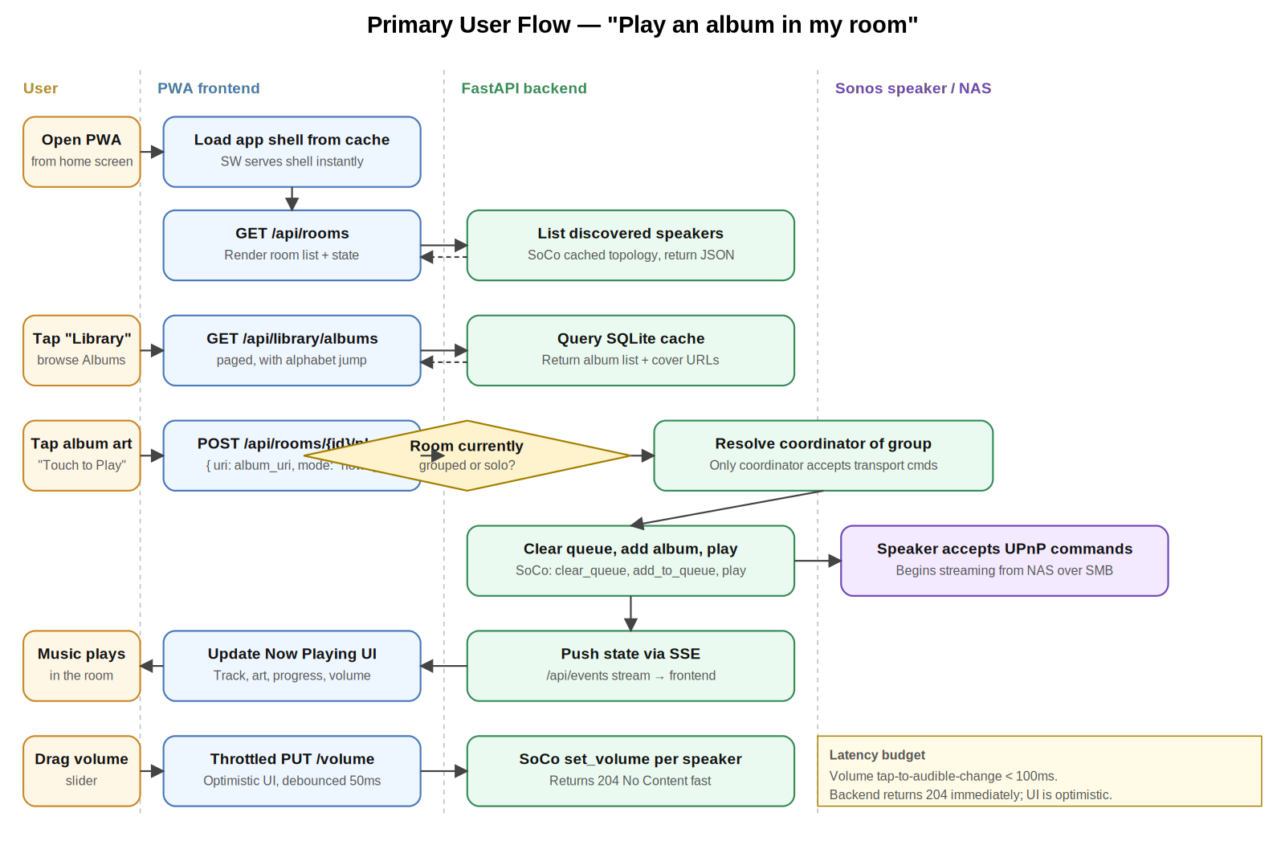
Figure 3 — Primary user flow, swimlane view.

8.1 Other key flows
In addition to the primary flow, the app supports these journeys:
- Group two rooms. User opens Rooms tab → taps 'Add to group' on a solo room → picks the target group → backend calls SoCo join() and confirms via SSE.
- Aggregated search. User opens Search tab → types a query → backend queries SQLite cache → returns Artists / Albums / Tracks groups → user taps any result to play or queue.
- Add album to existing queue. User long-presses album in Library → action sheet → picks 'Add to end of queue' → backend calls SoCo add_to_queue() without clearing → user continues listening.
- Switch the controlled room. User taps the room indicator in any header → room picker sheet appears → user picks new room → entire UI rebinds to that room's state.
- Recover from a Pi reboot. Container restarts automatically → backend rediscovers speakers and rebuilds in-memory state from Sonos itself → SSE stream reconnects from the frontend → UI re-syncs within seconds. No user action required.

9. Wireframes
These are low-fidelity wireframes. They establish information architecture, hierarchy, and interaction patterns. Visual styling (typography, exact colours, spacing) is left to the implementation phase. Wireframes assume an iPhone-sized portrait viewport (around 390 points wide). All four screens are part of the new PWA frontend; none of them inherit from TinySonos's existing UI.

9.1 Now Playing
The Now Playing screen is the default landing view. It shows the active room (top-left, tap to switch), large album art, track metadata, a draggable progress bar, transport controls, and a volume slider. Secondary actions (add to queue, shuffle, repeat, queue access) are along the bottom. The room picker is accessed by tapping the room name in the header.
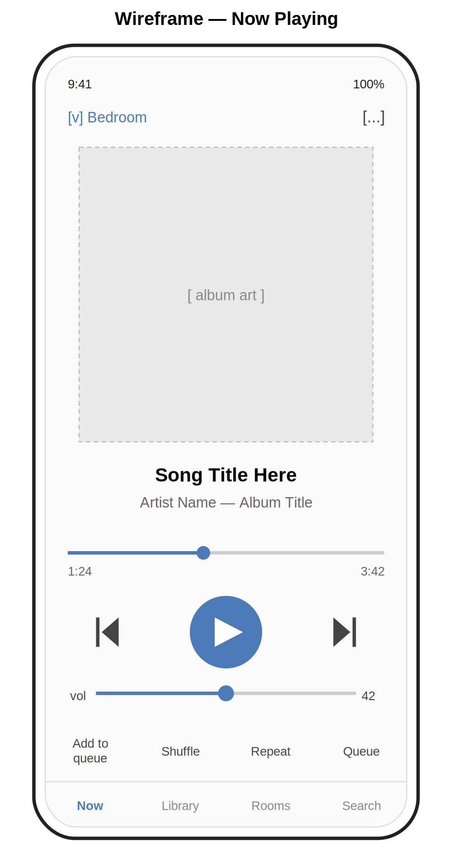
Figure 4 — Now Playing wireframe.

9.2 Library Browse
The Library tab opens to Albums by default with a segmented control to switch between Albums, Artists, Tracks, and Folders. A search field sits above the list. Sections are headed by their starting letter, and an alphabet jump-bar runs down the right edge for fast navigation. Each row shows album art, title, and one line of supporting metadata. A persistent mini Now Playing strip sits above the tab bar.
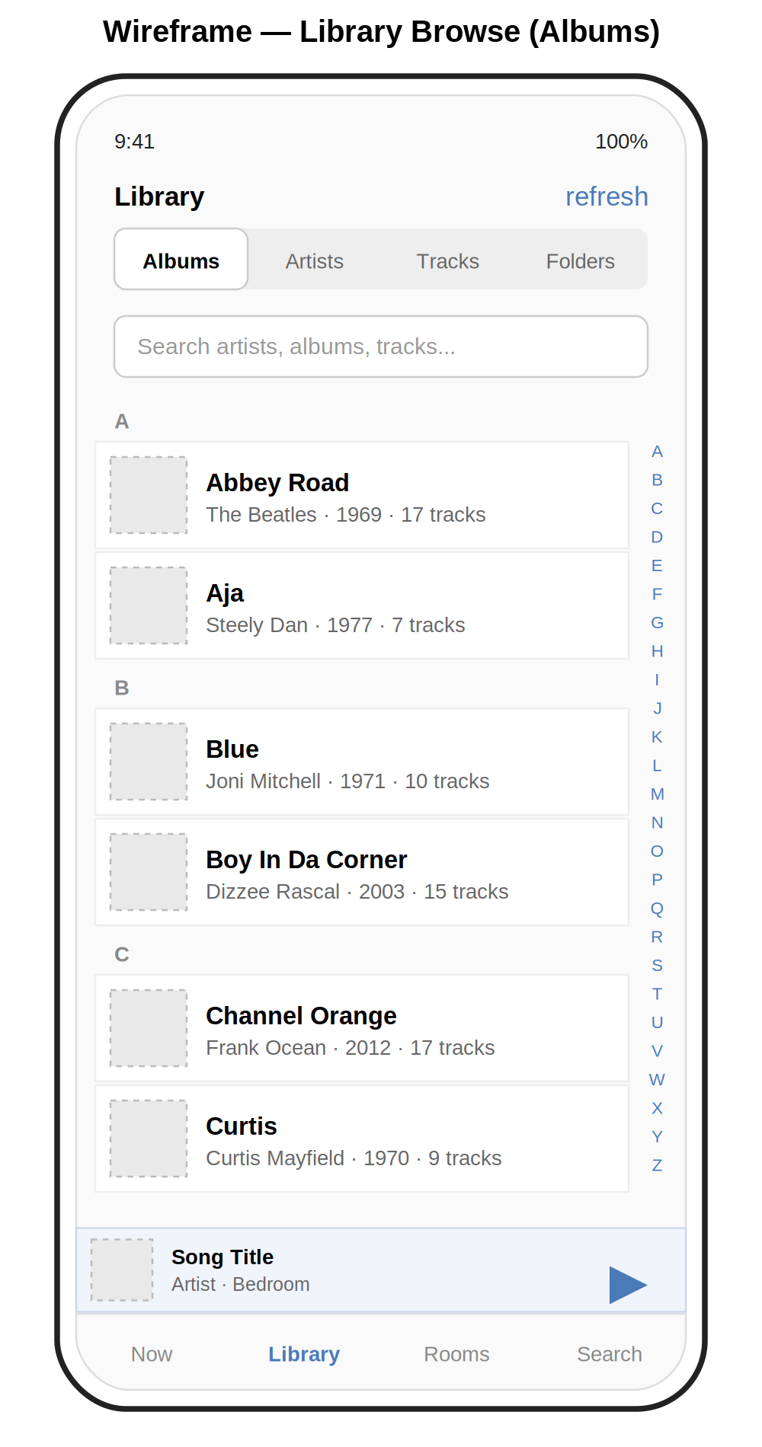
Figure 5 — Library Browse wireframe with alphabet jump-bar.

9.3 Rooms
The Rooms screen shows all rooms and groups on one scrollable view. Groups are visually distinct from solo rooms (subtle blue background) and contain a group volume slider above per-member sliders. Solo rooms show their own slider, current state, and an action to add them to a group. A 'Party Mode' button at the bottom groups all rooms in one tap.
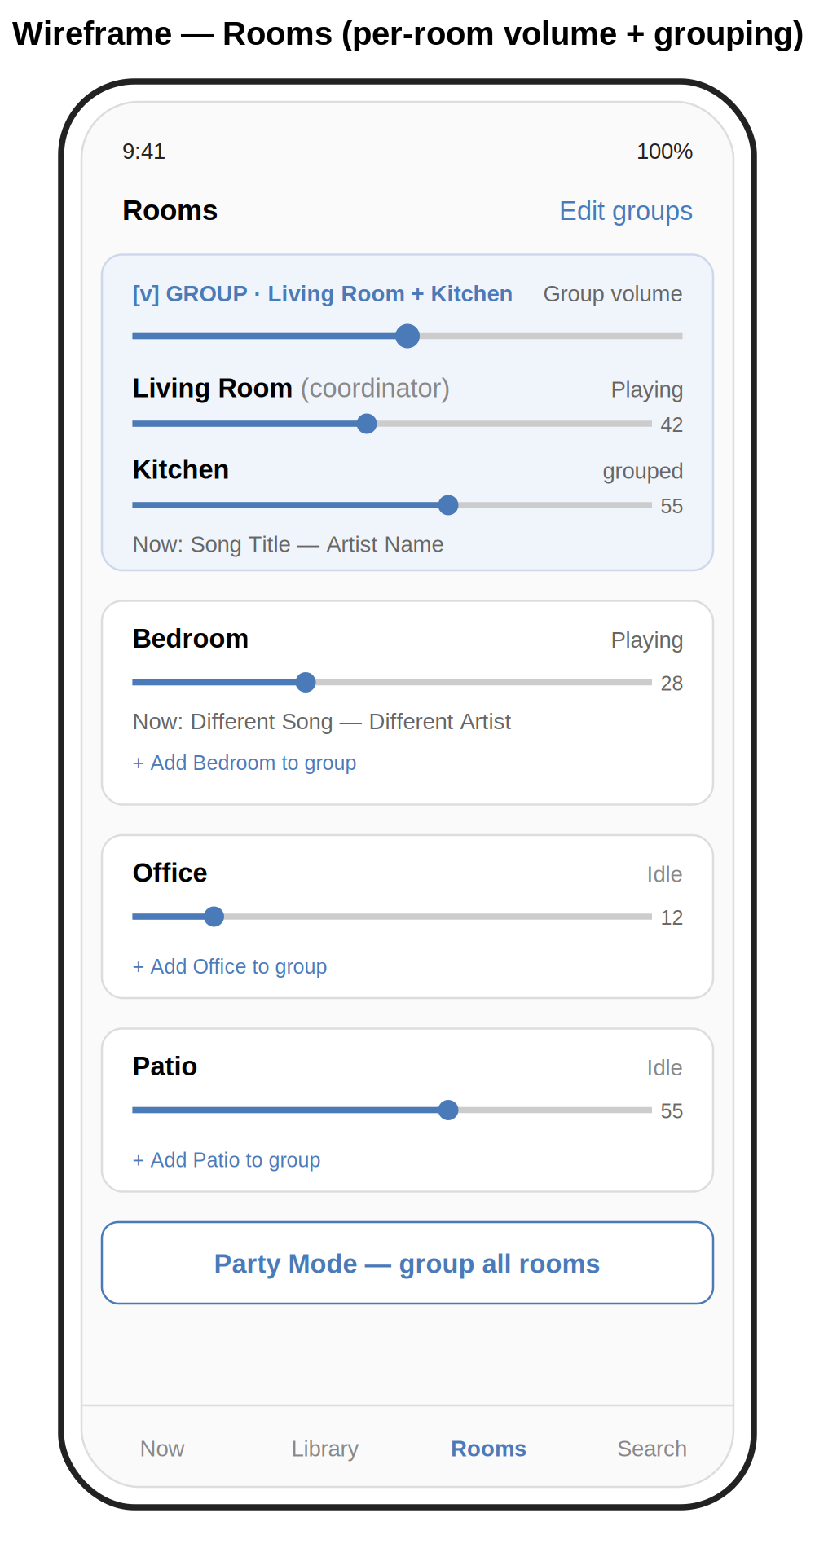
Figure 6 — Rooms wireframe with grouped and standalone speakers.

9.4 Queue
The Queue view always shows the currently playing track at the top in a highlighted row. Up Next tracks follow with their queue position numbered. Each row has a drag handle on the right for reordering. Swiping a row left reveals a Delete action. Mode toggles for shuffle, repeat, and crossfade sit above the tab bar.
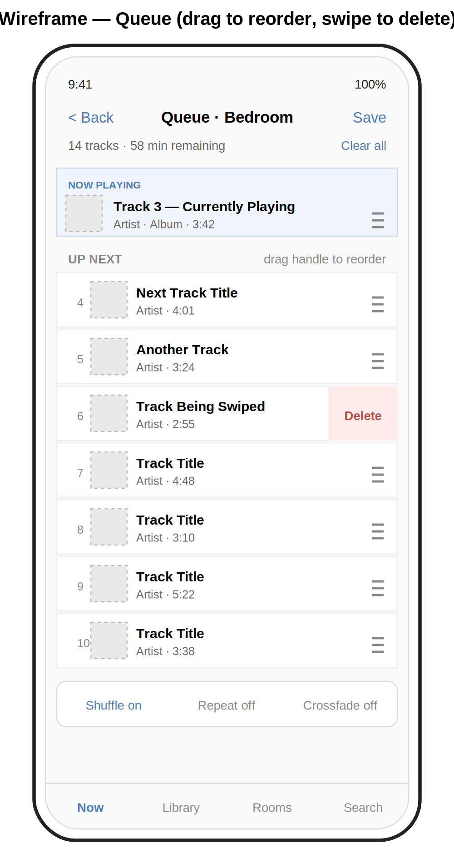
Figure 7 — Queue wireframe with drag-to-reorder and swipe-to-delete.

10. Backend API Specification
All endpoints are prefixed with /api and require a bearer token in the Authorization header. JSON request and response bodies. The frontend speaks only this API; it never talks directly to Sonos.
These endpoint shapes are the target after the fork's URL normalisation work. TinySonos's pragmatic-but-inconsistent paths (e.g. /play, /albums/all) will be aliased to the canonical /api/* paths during the transition and removed after the frontend is fully ported.

10.1 Discovery and rooms
Method + Path | Purpose | Body / Returns
GET /api/rooms | List all rooms with current state. | 200 → Room[]
GET /api/rooms/{id} | Get full state for one room. | 200 → Room
GET /api/groups | List all current groups and members. | 200 → Group[]
POST /api/groups/{id}/join | Add a room to a group. | { room_id } → 204
POST /api/groups/{id}/leave | Remove a room from its group. | { room_id } → 204
POST /api/groups/party | Group all rooms. | → 204

10.2 Playback control
Method + Path | Purpose | Body / Returns
POST /api/rooms/{id}/play | Start playback or play a specific URI. | { uri?, mode? } → 204
POST /api/rooms/{id}/pause | Pause the room (or its group). | → 204
POST /api/rooms/{id}/next | Skip to next track. | → 204
POST /api/rooms/{id}/previous | Skip to previous track. | → 204
PUT /api/rooms/{id}/seek | Seek to position. | { seconds } → 204
PUT /api/rooms/{id}/volume | Set room volume. | { value: 0–100 } → 204
PUT /api/rooms/{id}/mute | Set mute state. | { muted: bool } → 204
PUT /api/rooms/{id}/play_mode | Set shuffle/repeat/crossfade. | { shuffle, repeat, crossfade } → 204

10.3 Library and search
Method + Path | Purpose | Body / Returns
GET /api/library/artists | Paged artist list. | ?offset&limit → Artist[]
GET /api/library/albums | Paged album list. | ?offset&limit&artist_id → Album[]
GET /api/library/albums/{id}/tracks | Tracks of an album. | → Track[]
GET /api/library/tracks | Paged track list. | ?offset&limit&album_id → Track[]
GET /api/library/genres | Genre list. | → Genre[]
GET /api/library/folders | Folder browse view. | ?path → Item[]
GET /api/search | Aggregated search. | ?q → { artists, albums, tracks }
POST /api/library/reindex | Trigger library re-index. | → 202 + job_id
GET /api/library/reindex/{job_id} | Re-index progress. | → { status, progress }

10.4 Queue and playlists
Method + Path | Purpose | Body / Returns
GET /api/rooms/{id}/queue | Current queue. | → Track[]
POST /api/rooms/{id}/queue | Add an item. | { uri, position?, mode } → 204
DELETE /api/rooms/{id}/queue/{index} | Remove queue item by index. | → 204
PUT /api/rooms/{id}/queue/{index} | Move queue item. | { new_index } → 204
DELETE /api/rooms/{id}/queue | Clear queue. | → 204
GET /api/playlists | Sonos playlists. | → Playlist[]
POST /api/playlists | Create a playlist. | { name } → Playlist
GET /api/favourites | Sonos favourites. | → Favourite[]

10.5 Events and health
Method + Path | Purpose | Body / Returns
GET /api/events | Server-Sent Events stream of state changes. | text/event-stream
GET /api/healthz | Liveness + readiness probe. | → { status, rooms_discovered, library_count, library_age_seconds }

11. Data Model
The library cache is a SQLite database stored on the Pi's writeable /data volume. This schema is part of the new code added by the fork; TinySonos's existing in-memory album cache is replaced by this persistent, queryable store. Foreign keys enforce referential integrity. Indexes are added on every column the UI filters or sorts by.

artists
- id (integer, primary key)
- name (text, indexed)
- sort_name (text, indexed) — name with leading articles stripped

albums
- id (integer, primary key)
- title (text, indexed)
- sort_title (text, indexed)
- album_artist_id (integer, foreign key → artists.id)
- year (integer)
- track_count (integer)
- art_uri (text)

tracks
- id (integer, primary key)
- title (text, indexed)
- album_id (integer, foreign key → albums.id)
- artist_id (integer, foreign key → artists.id)
- track_number (integer)
- duration_seconds (integer)
- file_uri (text) — the x-file-cifs:// URI Sonos uses
- genre (text, indexed)
- added_at (timestamp)

Other tables
- genres — denormalised view of distinct genres.
- playlist_imports — imported M3U playlists from the library.
- settings — single-row table for user preferences.

12. Phased Build Plan
The build is structured in seven phases (Phase 0 plus Phases 1–6). Each phase produces a usable increment. Phases 1 and 2 differ from a from-scratch build because the fork strategy converts "build the backend" into "understand and harden the backend." Phase 0 is new in v0.4 and exists because the development environment now needs explicit setup (see section 5).
Each phase corresponds to one GSD discuss → plan → execute → verify → ship cycle.

Phase 0 — Set up the development environment
Goal: a fully configured development environment, a provisioned Raspberry Pi reachable from the workstation, and the GSD workflow primed to drive the rest of the build.
- Install or verify the local toolchain on the workstation (section 5.4).
- Install Claude Code via the native installer; authenticate against the existing Pro/Max account; run claude doctor to verify.
- Create the project directories under ~/projects/ as in section 5.6.
- Create the GitHub fork of jasonacox/TinySonos under Ray's account; clone it locally.
- Create the (optional) separate frontend repo under Ray's GitHub account; clone it locally.
- Install GSD v1 into each project's .claude/ directory: npx get-shit-done-cc --claude --local.
- Generate the dedicated SSH key (section 5.5.1) and add it to ~/.ssh/config.
- Acquire the Pi 4 hardware (PSU, ethernet cable, A2-rated SD card, optional small UPS).
- Flash Raspberry Pi OS Lite (64-bit) using Raspberry Pi Imager. Pre-configure hostname, SSH key, locale, ethernet preference.
- First boot from ethernet on the same VLAN as the Sonos speakers and NAS. Pin the IP in the UDM Pro.
- From the workstation, run /gsd-new-project in the backend repo to initialise GSD's planning structure (using the contents of this PRD as input).
Exit criterion: from the workstation, `ssh sonos-controller` works without a password prompt; `claude` opens with GSD commands available; /gsd-progress shows the project initialised at Phase 1.

Phase 1 — Fork and learn
Goal: a working fork of TinySonos running locally with all upstream functionality intact, and a documented understanding of how it works.
- Run /gsd-map-codebase against the cloned TinySonos fork. The output feeds every later GSD plan command.
- Run `docker compose up` against real speakers from the workstation; verify discovery, playback, and queue management work end to end.
- Read the codebase end to end (Claude Code, with the codebase map open). Produce a one-page architectural map: where discovery happens, how SSE is published, how the playback controller's command queue works, where the M3U parsing lives, how the original UI talks to the backend.
- Identify any obvious bugs or smells; capture them as fork-local issues. Send obviously general-purpose fixes upstream as PRs (section 4.2.5).
- Write a small smoke-test suite that exercises core endpoints against a real speaker. This catches regressions during the rest of the build.
Exit criterion: the upstream-equivalent web UI works against your real speakers from the fork on your Ubuntu workstation, and you can answer in one minute where any given feature lives in the codebase.

Phase 2 — Harden the backend
Goal: a backend that meets the must-have requirements TinySonos does not yet meet, with the API normalised to section 10 shapes.
- Add bearer-token authentication middleware to all endpoints; generate token at first run; expose configuration via /data/config.toml.
- Replace the built-in HTTP file server flow with x-file-cifs:// URIs. Test with the existing Sonos Music Library share.
- Build the SQLite library cache schema (section 11). Write the indexer that walks the Sonos music-library API via SoCo.
- Implement the new /api/library/* and /api/search endpoints backed by the SQLite cache.
- Normalise URL paths to /api/rooms, /api/groups, /api/library, /api/playlists. Keep TinySonos's legacy paths as aliases for one phase.
- Upgrade /api/healthz to return structured JSON for monitoring.
- Add the watchdog for stuck-discovery state (NFR 7.2).
- Refactor logging to structured JSON on stdout; add log rotation on /data.
- Build the multi-arch Docker image (linux/amd64 + linux/arm64) via buildx.
Exit criterion: GET /api/search?q=beatles returns aggregated results in under 500ms, all endpoints require valid tokens, and the container runs cleanly with a read-only host root filesystem.

Phase 3 — Frontend skeleton
Goal: a minimal but installable PWA that shows real data.
- Choose a framework (recommendation: vanilla JS with a tiny router, or Vue 3 if a framework is preferred — React is overkill here).
- Build the four primary screens as static layouts: Now Playing, Library, Rooms, Search.
- Wire up the API client with the bearer token from a settings screen.
- Implement the SSE listener and render basic state updates.
- Add the PWA manifest, app icons, and a service worker that caches the shell.
- Test 'Add to Home Screen' on iPhone Safari end to end.
Exit criterion: app installs to home screen, opens full-screen, and shows live room states.

Phase 4 — Core interactions
Goal: every must-have interaction works.
- Volume sliders with throttled requests, optimistic UI, and SSE confirmation.
- Library browse with alphabet jump-bar and segmented control.
- Touch-to-play album behaviour with long-press action sheet.
- Queue view with drag-to-reorder and swipe-to-delete.
- Rooms view with grouping interactions.
- Aggregated search results UI.
Exit criterion: every Must-priority requirement in section 6 is functional.

Phase 5 — Polish
Goal: the app is reliable, pleasant, and ready to leave the development workstation.
- Light and dark theme.
- Loading states, empty states, and error states for every screen.
- Settings screen for default tap action, theme, and library refresh.
- Container healthcheck wired to /healthz; restart policy `unless-stopped` verified.
- Remove TinySonos's legacy URL aliases after confirming the new frontend uses only canonical paths.
- Remove TinySonos's original web UI from the build.
Exit criterion: container survives a forced kill and returns to full functionality within 60 seconds, and has run for 7 days continuously on the workstation without intervention.

Phase 6 — Deployment to the Pi
Goal: the application lives on its dedicated hardware and is the household's primary Sonos controller.
Note: Phase 0 already provisioned the Pi base OS, SSH access, and Docker installation. This phase finishes the production configuration and cuts over from workstation testing to live Pi operation. Claude Code drives the full sequence over SSH; Ray does not need to log in to the Pi manually.

12.6.1 Read-only root filesystem
Reliability requires that the OS root filesystem be mounted read-only, so that the SD card cannot be corrupted by writes during a power outage. Only the controller's /data directory needs to be writeable.
- Use the `raspi-config` overlay-fs feature, or follow a documented `overlayroot` setup, to make / read-only.
- Create a dedicated writeable partition or bind-mounted directory at /data, owned by the docker user and large enough for the SQLite cache plus logs (1 GB is generous).
- Verify with `mount | grep ' / '` that the root mount is read-only after reboot.
- Plan: any time you need to update OS packages, temporarily disable the read-only overlay, apply updates, re-enable, reboot. This is intentional friction — it stops casual writes.

12.6.2 Container deployment
The same multi-arch image built during Phase 2 is used. Production-side configuration is captured in a single docker-compose.yml file kept in git on the Ubuntu workstation.
docker-compose.yml (production):
services:
sonos-controller:
image: sonos-controller:latest
container_name: sonos-controller
network_mode: host # required for UPnP discovery
restart: unless-stopped
volumes:
- /data/sonos-controller:/data
environment:
- AUTH_TOKEN_FILE=/data/token
- LOG_LEVEL=info
- LIBRARY_REFRESH_HOURS=6
healthcheck:
test: ["CMD", "curl", "-f", "http://localhost:8080/api/healthz"]
interval: 30s
timeout: 5s
retries: 3
- Image transfer to the Pi: `docker save sonos-controller:latest | ssh sonos-controller "docker load"` — no registry needed for one-person deployments.
- Start the container: `ssh sonos-controller "cd ~/sonos-controller && docker compose up -d"`.
- Confirm rooms appear via `curl -H "Authorization: Bearer $TOKEN" http://sonos-controller.local:8080/api/rooms`.
- Reboot the Pi to confirm the container comes back automatically and re-discovers all speakers.

12.6.3 Operational checks
- Configure log rotation on /data/sonos-controller/logs (logrotate, weekly, keep 4).
- Add a daily cron entry on the Pi that pings /api/healthz and writes the result to a syslog tag — easy to grep later if something goes wrong.
- Document the recovery runbook in the project README: how to rebuild from scratch in under 30 minutes if the SD card dies.

12.6.4 Cutover
- Run the Pi in production for one week with the official Sonos app still installed as a backup.
- After the trial week with no critical incidents, the project is live. Remove the official app from the home screen of any household member who wants the cleaner experience.
Exit criterion: app has been used daily for seven consecutive days on the Pi without bugs blocking a common task, the container has been restarted at least once and recovered within 60 seconds, and the household member has used the app unprompted at least three times.

13. Open Questions and Risks

13.1 Resolved questions
- Q1 (RESOLVED in v0.2). Where does the controller host run? Decision: a dedicated Raspberry Pi 4 (4GB), running Raspberry Pi OS Lite with a read-only root filesystem and Docker. The Pi runs only this service. Rationale is captured in section 4.1.4.
- Q7 (RESOLVED in v0.3). Build from scratch or fork an existing project? Decision: fork jasonacox/TinySonos. The architecture it implements matches what this PRD specified independently, the licence is permissive, and the time saved redirects to the iPhone PWA work where it most matters. Rationale and reuse/change boundaries are captured in section 4.2.
- Q9 (RESOLVED in v0.4). What is the development environment and AI agent workflow? Decision: Claude Code (native installer on Ubuntu) driven by GSD v1 (per-project install). Pi accessed over SSH with a dedicated key. Section 5 documents this in full.

13.2 Open questions
- Q2. How should album art be served? Sonos exposes art via per-speaker URIs that aren't directly reachable from the PWA. Two options: backend proxies and caches art, or backend rewrites art URIs to a stable cache path. Proxy with caching is simpler. TinySonos has some art-resolution logic worth examining before deciding.
- Q3. Should the library cache be authoritative or only a hint? If authoritative, the backend trusts SQLite and never re-queries Sonos for browse data. If hint, browse falls through to Sonos when SQLite misses. Authoritative is faster; hint is more correct after manual library changes.
- Q4. Frontend framework choice: vanilla JS, Vue 3, or React? Vanilla keeps the bundle tiny and aligns with existing skill set. Vue is a comfortable middle ground. React adds tooling complexity for limited gain on a project this size.
- Q5. Does the household need separate user accounts, or is a single shared bearer token sufficient? A single token is simpler and probably right; revisit if multiple people start using the app heavily.
- Q6. How is the Pi backed up? The /data volume contains the SQLite cache (regenerable) and the auth token (small). A nightly tarball pushed to the QNAP via rsync would be enough; the entire system is otherwise reproducible from source.
- Q8. How aggressive should the fork be in keeping in sync with upstream TinySonos? Current default is "cherry-pick fixes when relevant; don't auto-merge." Revisit if upstream becomes substantially more active or if a useful new feature lands.

13.3 Risks
- R1. SoCo or Sonos API drift. Sonos has historically deprecated UPnP control surfaces with little warning. Mitigation: keep the SoCo dependency current and write integration tests against a real speaker. TinySonos is also exposed to this risk; upstream activity is a useful early warning indicator.
- R2. iOS Safari PWA limitations. Safari is the most restrictive PWA host. Background tabs may be aggressively suspended; lock-screen integration is impossible. Mitigation: design assuming the app is only useful when foregrounded, and accept the trade-off.
- R3. Large library performance. Libraries with hundreds of thousands of tracks may stress the SQLite cache or the indexer on Pi-class hardware. Mitigation: paginate everything, benchmark with realistic data, and add FTS5 to SQLite if substring search becomes slow.
- R4. Pi hardware failure. SD cards die, PSUs fail. Mitigation: read-only root filesystem prevents most SD-card corruption; nightly /data backups to the QNAP enable rebuild in 30 minutes; the Pi is a $60 commodity item easily replaced.
- R5. Network changes. Speakers reboot, IPs change, the network gets reconfigured. Mitigation: SoCo handles most of this, but the backend must re-discover gracefully and the SSE stream must reconnect on the frontend. The watchdog in 7.2 catches the rest.
- R6. Scope creep. The temptation to add streaming services, alarms, or Apple Watch support is real. Mitigation: section 2.3 is sacred until v1 has shipped.
- R7. Inheriting upstream bugs or architectural quirks. Forking trades unknown-unknowns of from-scratch work for known-unknowns of upstream code. Mitigation: Phase 1 explicitly includes "read end-to-end" before adding anything; smoke-test suite catches regressions; the fork is permitted to diverge and rewrite any piece of TinySonos that proves problematic.
- R8. Upstream becomes abandoned or hostile. TinySonos is a one-person project with one star at the time of the fork. If upstream is abandoned, the fork carries on under MIT terms with no obligation. If upstream takes a direction incompatible with this product, the fork simply diverges further. Mitigation is structural: the licence permits any of these outcomes.
- R9. Tooling drift. Claude Code, GSD, and SoCo all move quickly. A breaking change in any of them mid-project could cost a day to recover from. Mitigation: pin a known-good version of GSD in the repo; rely on Claude Code's auto-update for the AI agent itself but be ready to roll back via the native installer if a release misbehaves; pin SoCo in pyproject.toml.

14. Glossary
- Claude Code. Anthropic's terminal-based AI coding agent. Reads and edits files, runs shell commands, and drives most of the implementation work for this project. https://docs.claude.com/en/docs/claude-code/overview
- Coordinator. The Sonos speaker designated as the leader of a group. Only the coordinator accepts transport commands; followers mirror its output.
- Fork. A copy of an open-source project's source code, typically hosted as an independent repository, that is modified separately from the original. This project forks TinySonos as its starting point.
- GSD (Get Shit Done). An open-source meta-prompting and spec-driven development system for Claude Code by TÂCHES. Solves "context rot" by structuring work as small, atomic plans run in fresh subagent contexts. https://github.com/gsd-build/get-shit-done
- Group. Two or more Sonos speakers playing the same audio in sync.
- Host networking. A Docker network mode where the container shares the host's network stack. Required for UPnP/SSDP discovery to work.
- MIT License. A permissive open-source licence that allows free use, modification, and redistribution including in proprietary derivatives, with no copyleft obligation. The licence under which TinySonos and GSD are published, and which this project's fork inherits.
- PWA. Progressive Web App. A web application enhanced with a manifest and service worker so it can be installed to a device home screen and behave like a native app.
- Read-only root. A Linux configuration where the / filesystem is mounted read-only and only specific directories are writeable. Eliminates SD-card corruption from constant writes on Raspberry Pi.
- SMB. Server Message Block, the file-sharing protocol used between the Sonos speakers and the QNAP NAS.
- SoCo. An open-source Python library for controlling Sonos speakers via UPnP. The backend is built on SoCo.
- SSE. Server-Sent Events. An HTTP-based mechanism for the server to push events to the browser over a single long-lived connection.
- TinySonos. An open-source Sonos web service by jasonacox (https://github.com/jasonacox/TinySonos), MIT licensed. The upstream project that this PRD's backend forks.
- UPnP. Universal Plug and Play. The discovery and control protocol Sonos speakers expose on the local network. SoCo speaks UPnP.
- Upstream. In a fork relationship, the original repository being forked from. TinySonos is upstream; this project is the fork.
- Watchdog. A self-monitoring process that detects when a service is in a stuck state (e.g. discovery returning zero rooms when there should be many) and forces a restart.
- x-file-cifs URI. A URI scheme Sonos uses to play files directly from an SMB/CIFS share, in the form x-file-cifs://server/share/path/track.mp3. Used by the fork to keep the Pi out of the audio path.

