American MahJong Practice 2023 Installation

Download and Install

Download and install the latest build from the App Store at. You will see the GET button or a cloud icon if you have an older version installed.

https://apps.apple.com/us/app/american-mahjong-practice-2019/id1458051621

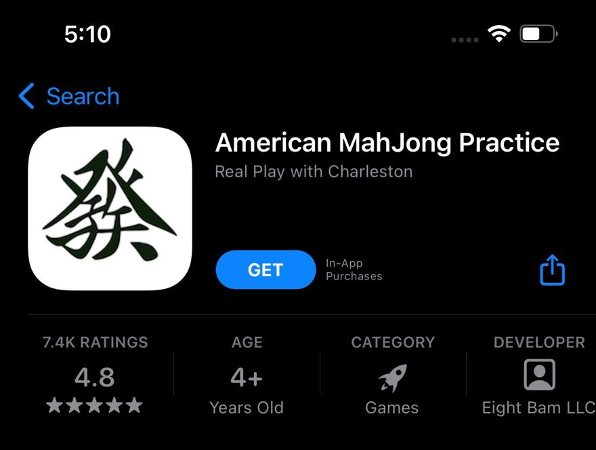

2. Purchase

Purchase 2023. Both options include all features.

Use the Restore Purchases option to install on a second device, like your iPad without having to purchase a second time.

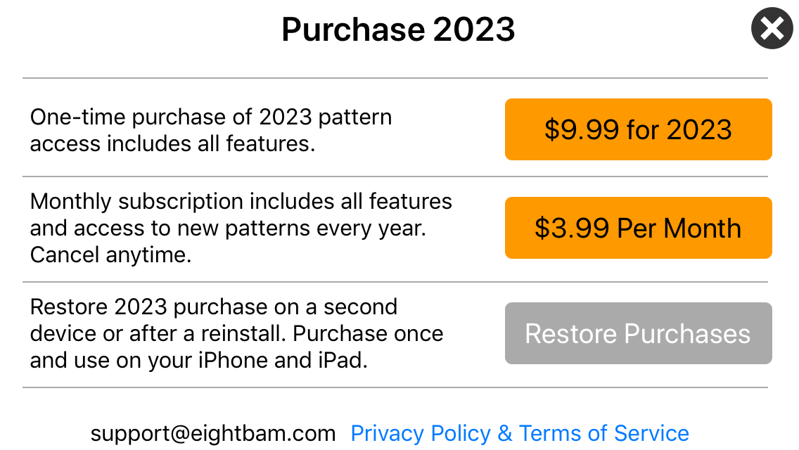

Change Years

Look in the bottom right corner for the year. Mahjong Practice supports multiple years of cards. If you don’t see 2023 go to settings and change the year. Use the Gear icon in the lower right corner to open Settings.
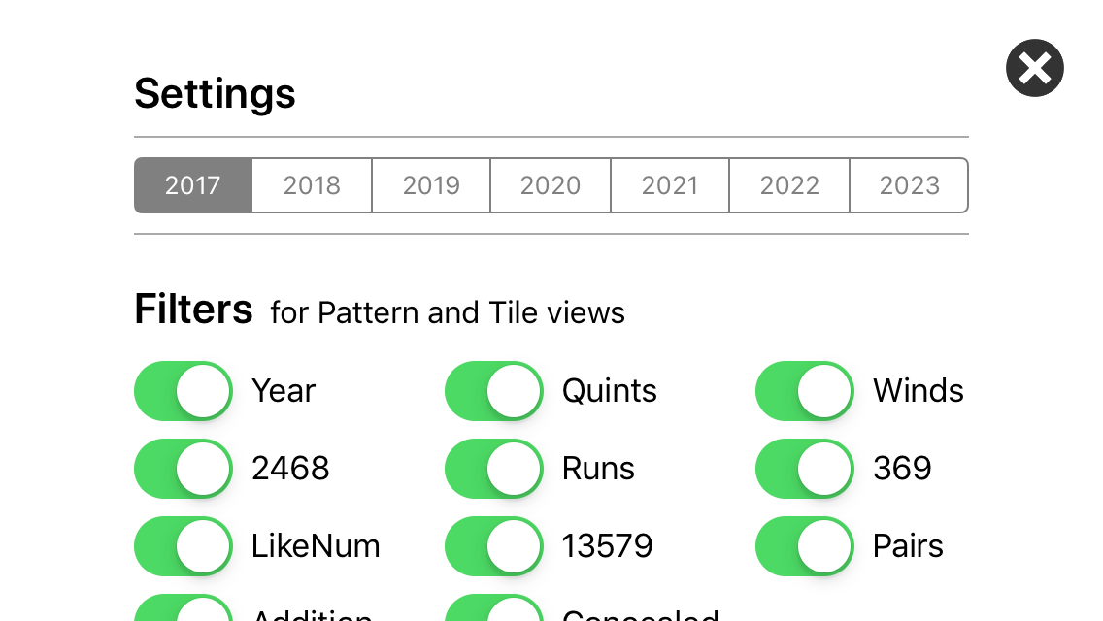

Fixing problems

Enable In App Purchases

If you are getting an error when trying to purchase, check in-app purchases are enabled in your phones settings.

https://support.apple.com/en-us/HT204396

Remove, Reboot and Reinstall

When all else fails you can uninstall, reboot and reinstall the app. This will sometimes fix the problem.

Hold down on the Mahjong Icon until a Remove Menu comes up

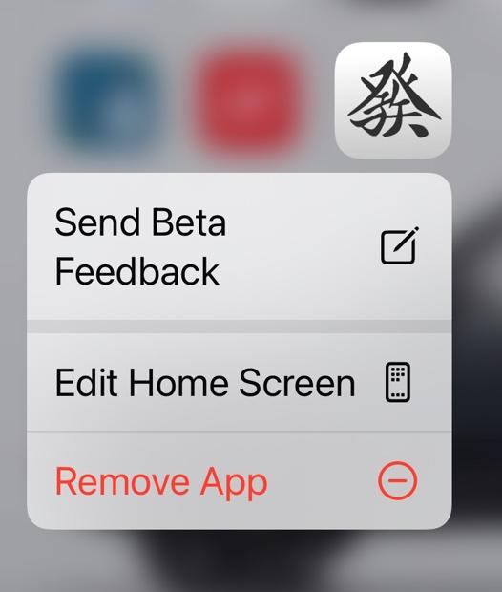

After removing, reboot your device. This will clear the apple cache of network packets.

Then follow the steps in section 1 of this document to download and install again.

If the purchase already worked use the Restore Purchase option on the purchase menu. See the next section to check your purchases.

Viewing and Managing Purchases

On your iPhone, iPad, or iPod touch

- Open the Settings app.
- Tap your name, then tap Media & Purchases.
- Tap View Account. You might be asked to sign in.
- Tap Purchase History. (or Subscriptions)
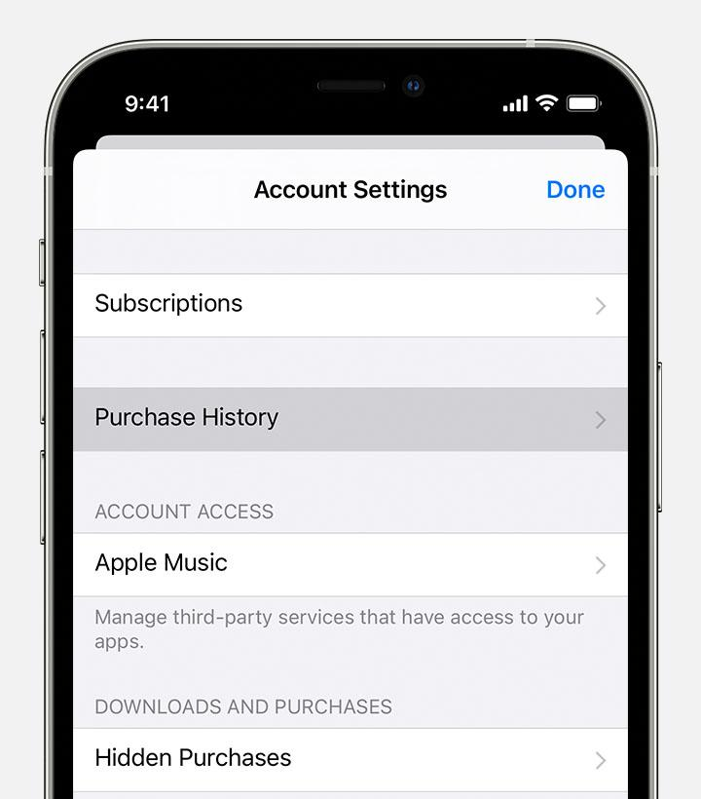

- Your purchase history appears. If needed Tap Last 90 Days, then select a different date range.
Learn what to do if you can't find the item that you’re looking for or if you find unexpected charges

