American Mahjong Practice 2023 Installation

Table of Contents
Installation 2
1.1 Download and Install 2
1.2 Purchase 3
1.3 Restore Purchase 3
1.4 Change Years 4
Checking what you have 4
2.1 Mahjong Practice Version 4
2.2 Viewing and Managing Purchases 5
Fixing problems 6
3.1 “In-app purchases are not active” 6
3.2 “In-app purchases are not allowed” 6
3.3 Remove, Reboot and Reinstall 7

Installation

Download and Install

Download and install the latest build from the App Store on each of your devices.

https://apps.apple.com/us/app/american-mahjong-practice-2019/id1458051621

You will use the OPEN button if you already have the latest version.

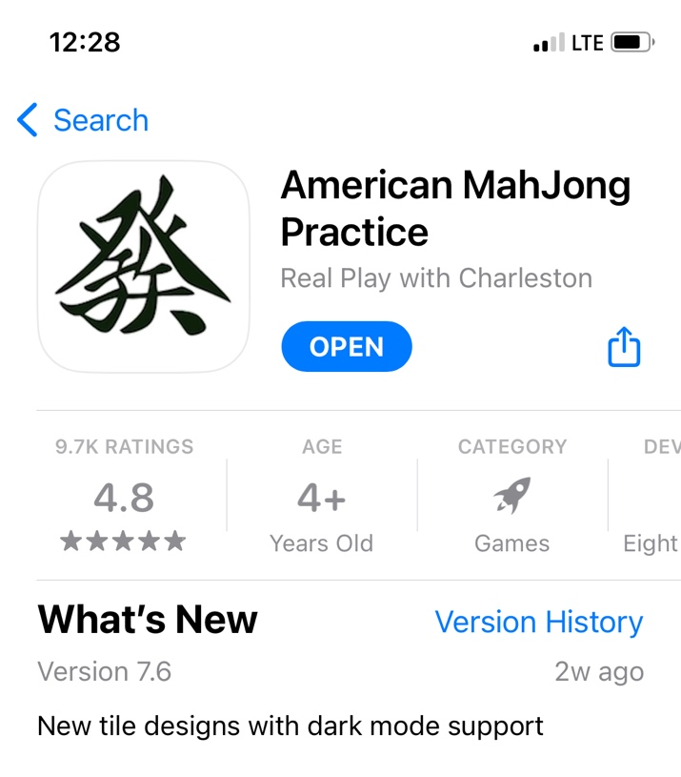

OR you a Cloud Download icon if you have an older version.

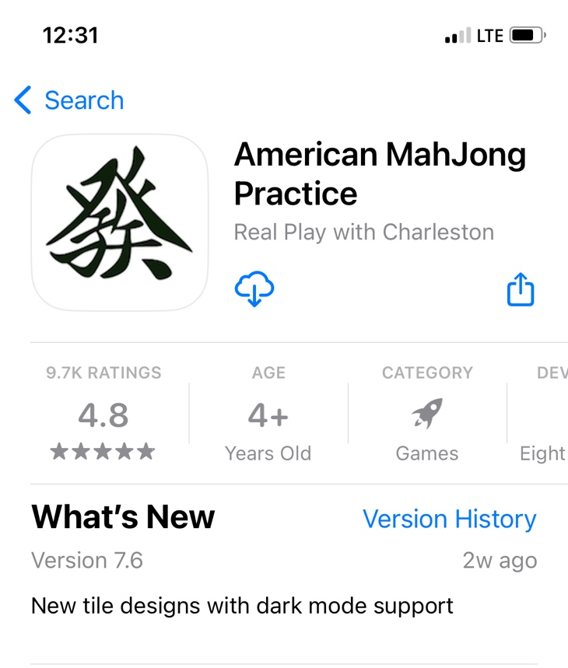

OR a GET button if this is your first download with the current Apple ID.

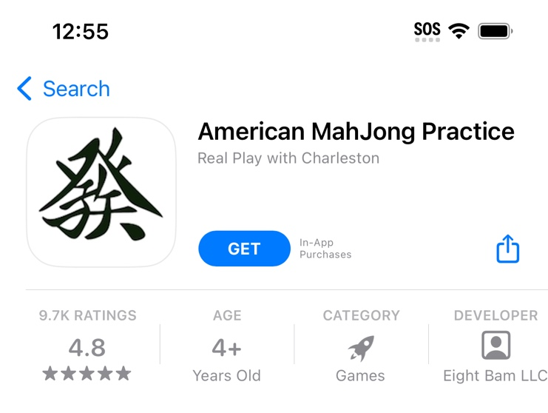

Purchase

Purchase 2023. Both options include all features.

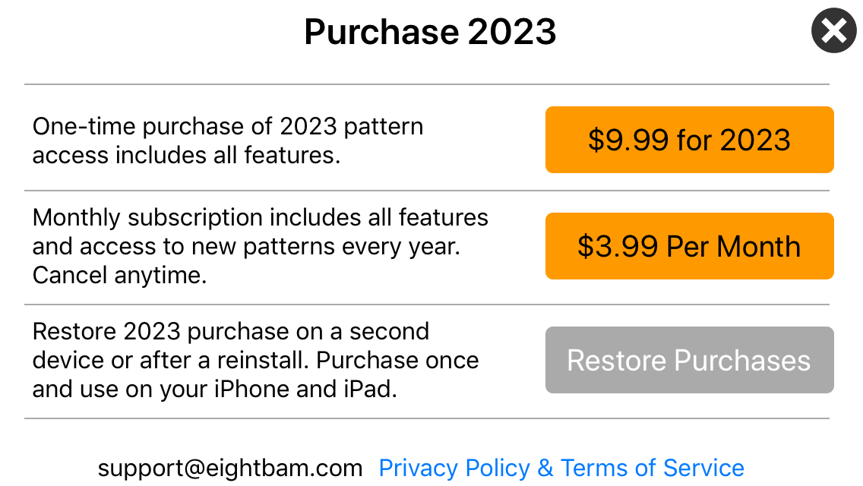

Restore Purchase

Use the Restore Purchases option to install on a second device, like your iPad without having to purchase a second time. The Restore Purchases button is the third button on the purchase menu. It is a gray button, it is not disabled.

You must be logged in with the same Apple ID to use Restore Purchase. If you are logged in with a different Apple ID, Apple will not find your receipt.

If you are buying one time purchases you need to do it every year. They do not auto renew. You cannot restore 2023 with a 2022 purchase. But you can install the latest build and restore 2023 on multiple devices.

Subscriptions will renew automatically and can be installed on all your devices with the Restore Purchase button. Download the latest build to get the latest years patterns and features and bug fixes.

Change Years

Look in the bottom right corner for the year. Mahjong Practice supports multiple years of cards. If you don’t see 2023 go to settings and change the year. Use the Gear icon in the lower right corner to open Settings.

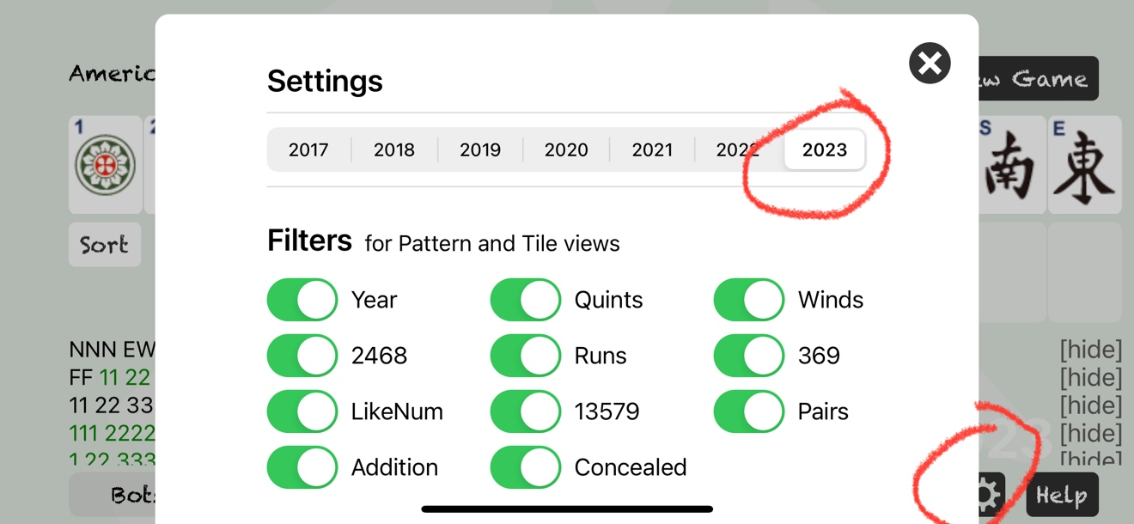

Checking what you have

2.1 Mahjong Practice Version

Check the version number at the bottom of the screen. If you downloaded the latest successfully you will have version 7.6 or newer.

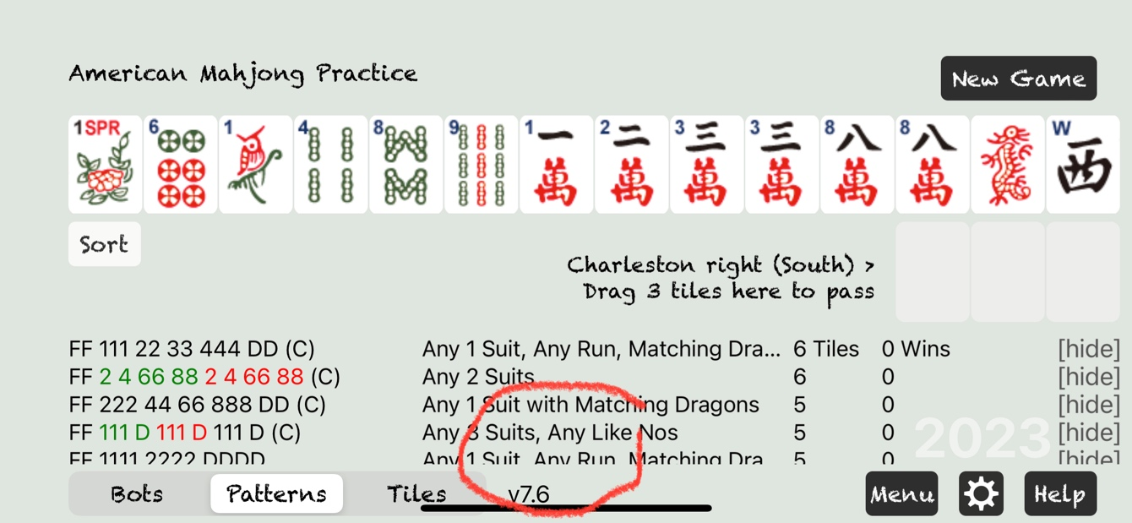

2.2 Checking your Apple ID

Your Apple is used for purchasing in-app purchases. If you are on multiple devices you Apple ID must match on every device.

https://support.apple.com/en-us/HT201354

2.2 Viewing and Managing Purchases

https://support.apple.com/en-us/HT204088

On your iPhone, iPad, or iPod touch

- Open the Settings app.
- Tap your name, then tap Media & Purchases.
- Tap View Account. You might be asked to sign in.
- Tap Purchase History. (or Subscriptions)

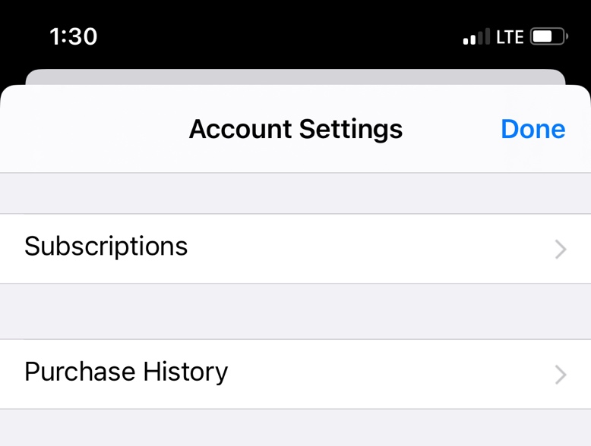

- Your purchase history appears. If needed Tap Last 90 Days, then select a different date range.

Fixing problems

“In-app purchases are not active”
If you get this error message Apple cannot find a receipt for Mahjong Practice for the Apple ID that you are currently logged in with. Most frequently this happens when your iPad and iPhone are setup with different Apple IDs. But also this could happen if your original purchase never completed.

See the Section 2 above to make sure that your purchase completed in history and also check the Apple ID on your iPhone and on your iPad to make sure that they match.

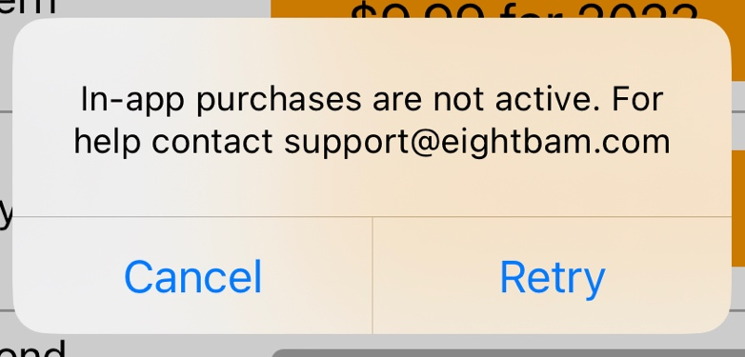

“In-app purchases are not allowed”

If you are getting this error when trying to purchase, check your devices privacy settings. Open the apple Settings app and go to Screen Time > Content & Privacy Restrictions > iTunes & App Store Purchases > In-app Purchases. A lot of iPads have this setting enabled to block accidental purchases.

https://support.apple.com/en-us/HT204396

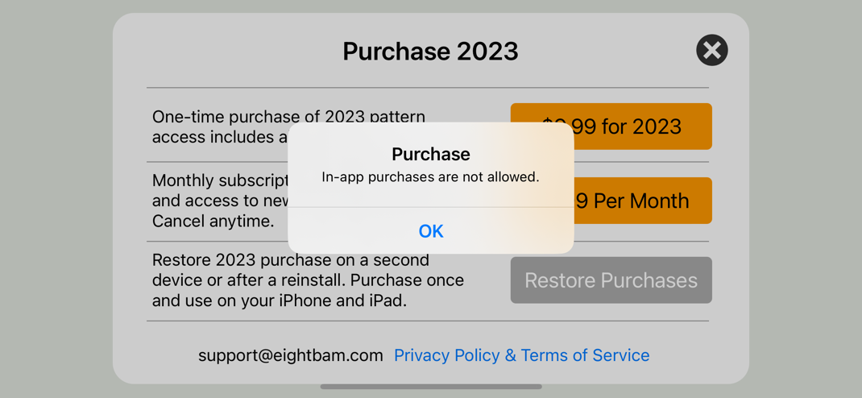

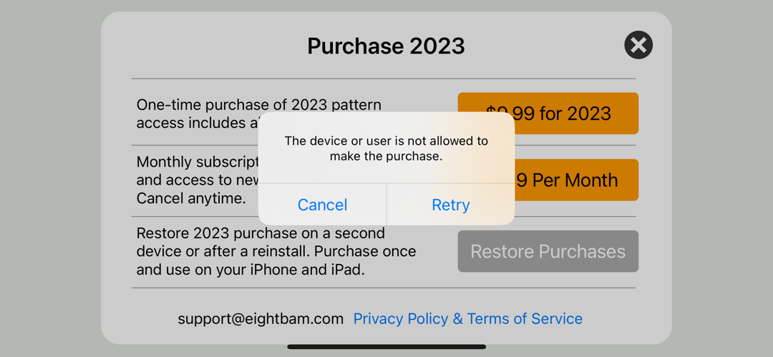

Remove, Reboot and Reinstall

When all else fails you can uninstall, reboot and reinstall the app. This will sometimes fix the problem.

Hold down on the Mahjong Icon until a Remove Menu comes up

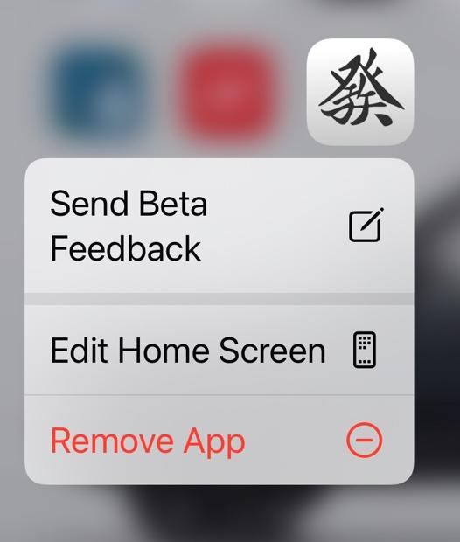

After removing, reboot your device. This will clear the apple cache of network packets.

Then follow the steps in Section 1 of this document to download and install again.

If the purchase already worked use the Restore Purchase option on the purchase menu.

Contact support@eightbam.com

We are always happy to help. Screen shots are great for quickly finding a problem, but we can work without them also.

