|  |  |
| --- | --- |
|  | Write Right!  AI powered Mail writing assistant. |

# Set Up Plugin

1. Compose mail

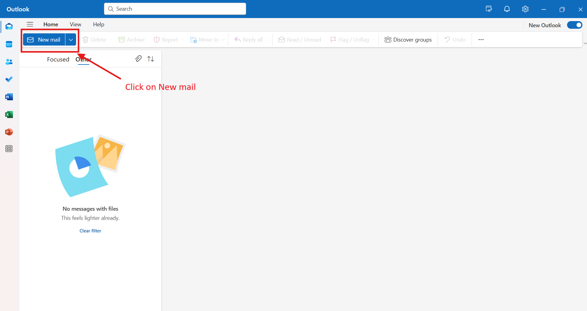

1. Click on Add-ins icon

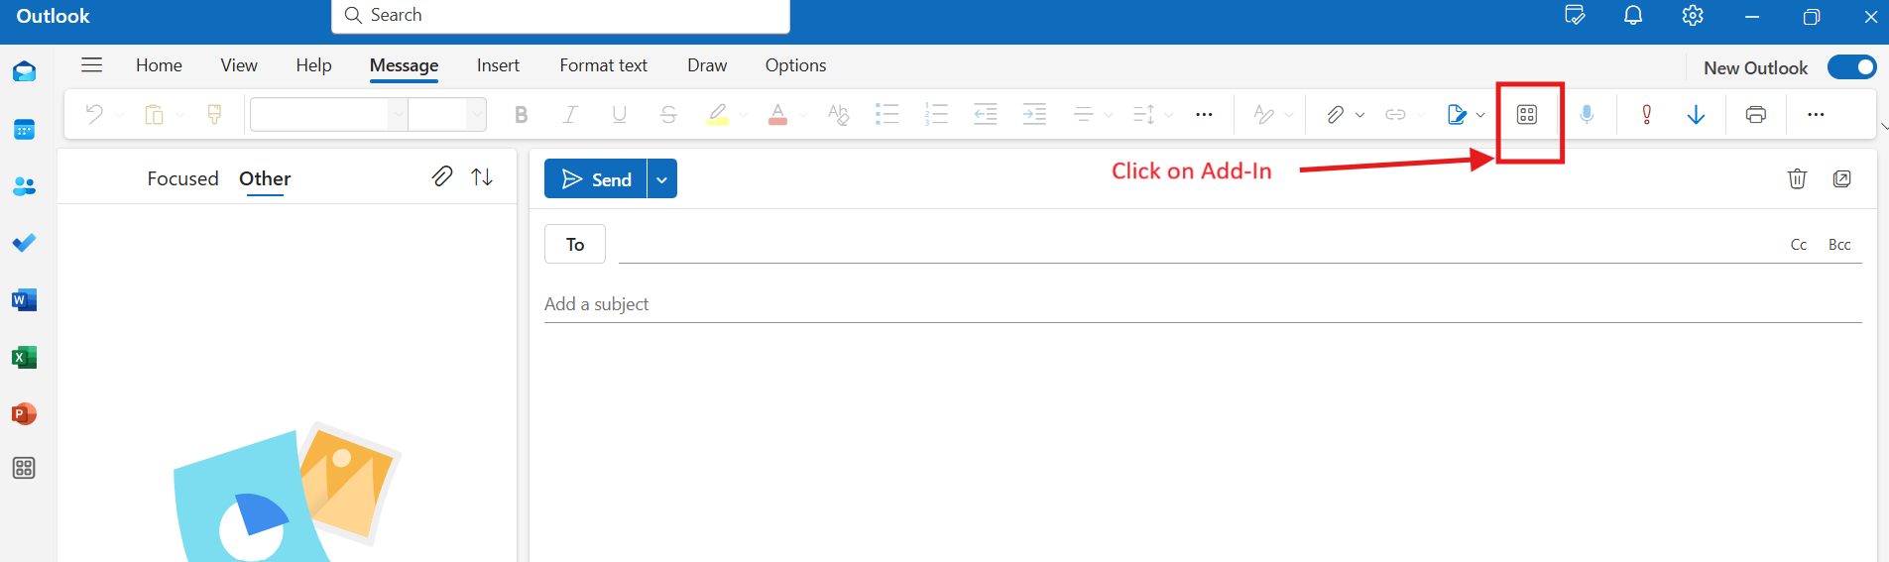

1. Get add-ins

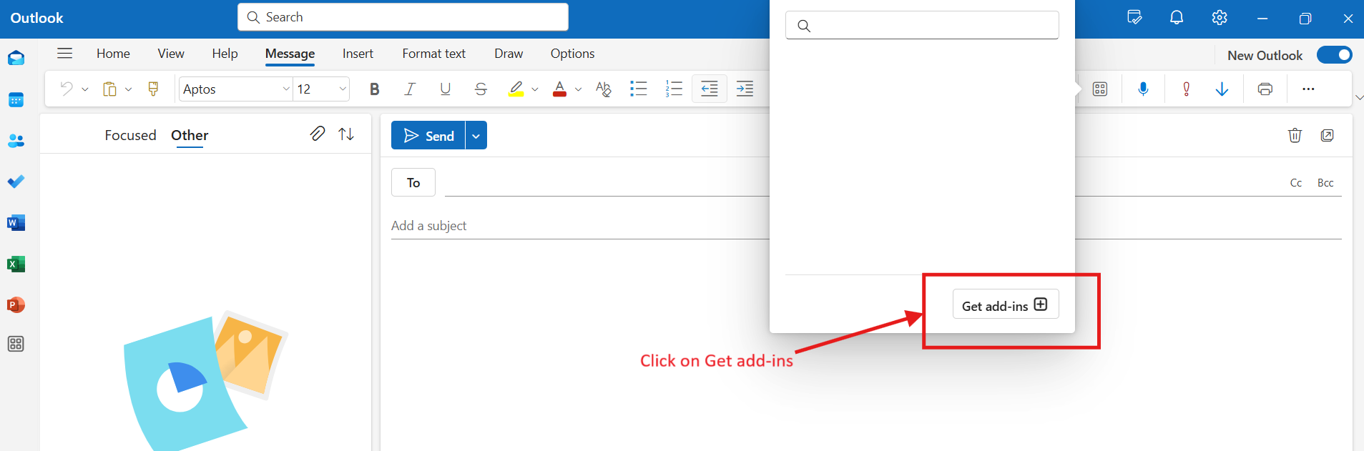

1. Navigate to My add-ins and add custom add in

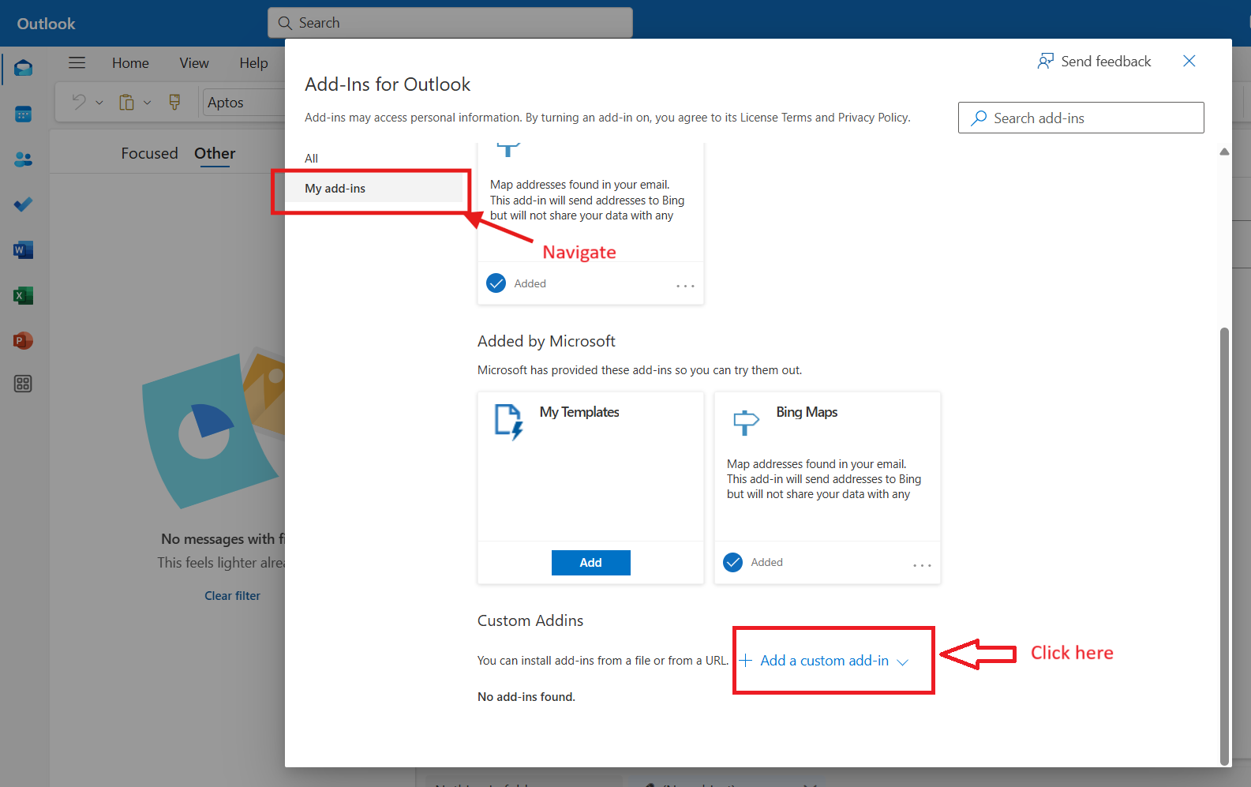

1. Select manifest.xml

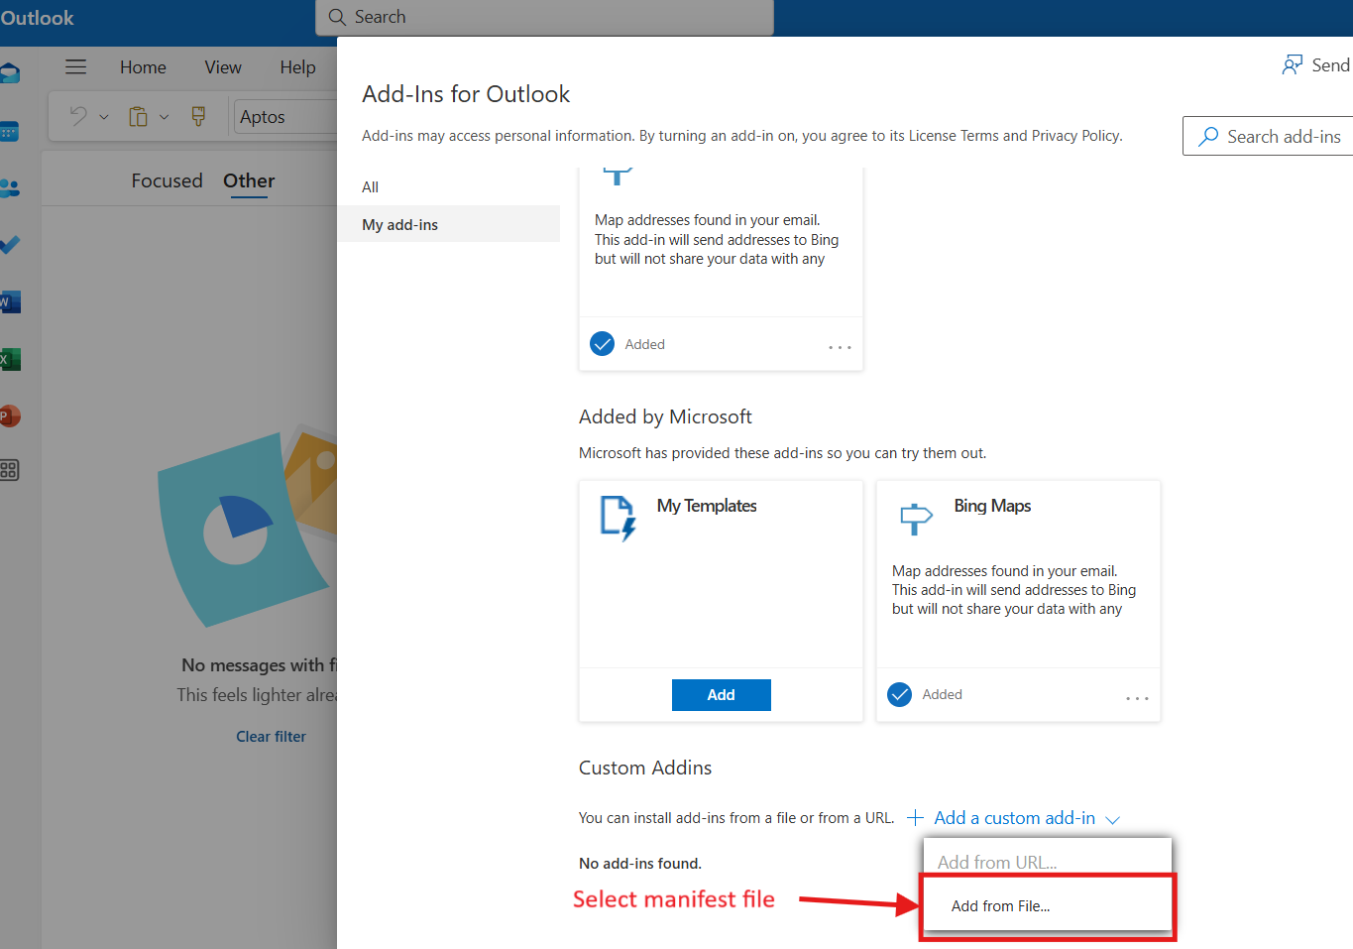

1. Click on install and wait for schema validation

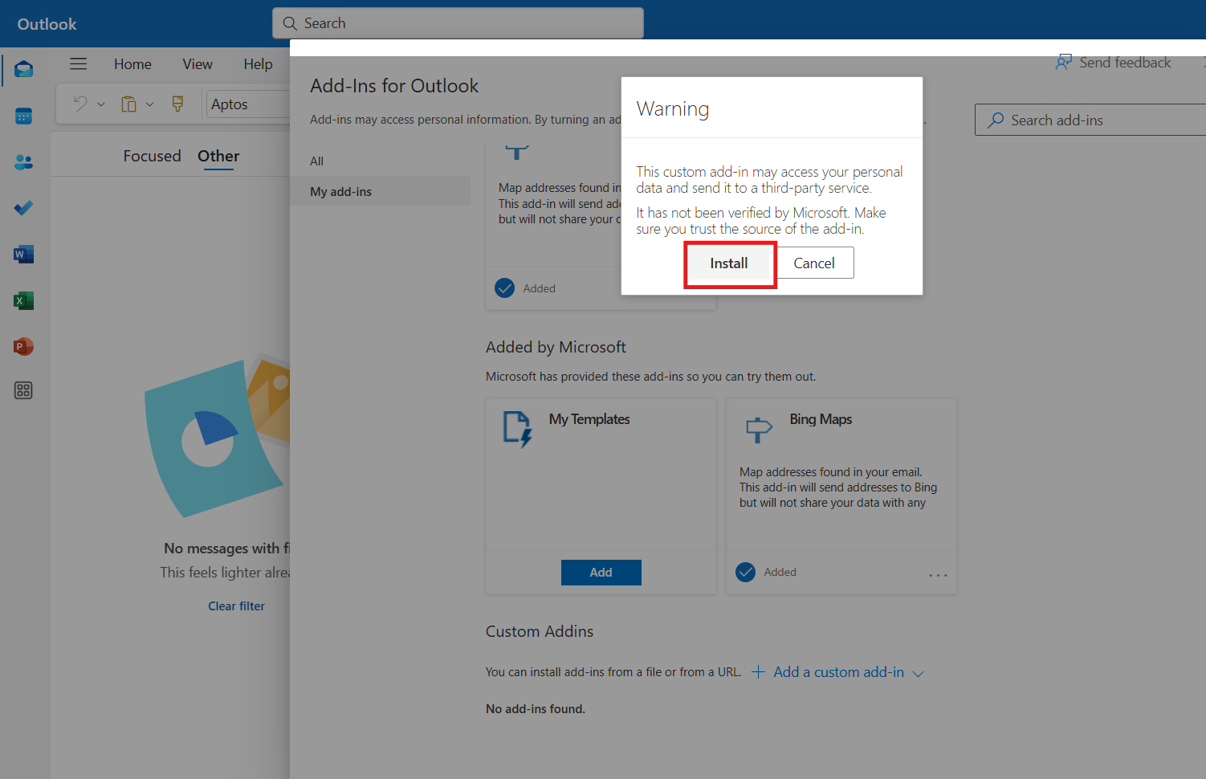

7) After successful installation, Activate plugin from Add-ins

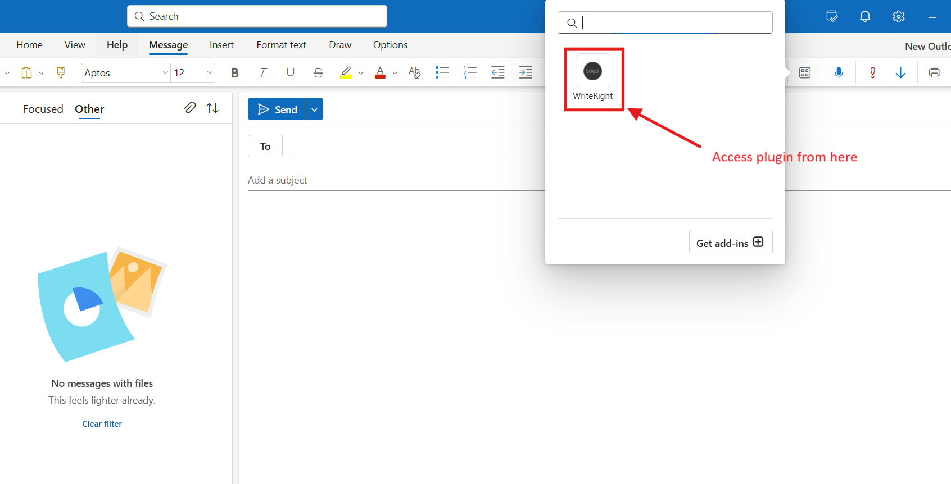

# How to use Plugin

Plugin can be used in two ways

1. Write a draft in outlook body and same will be picked for text refinement in text field of plugin.

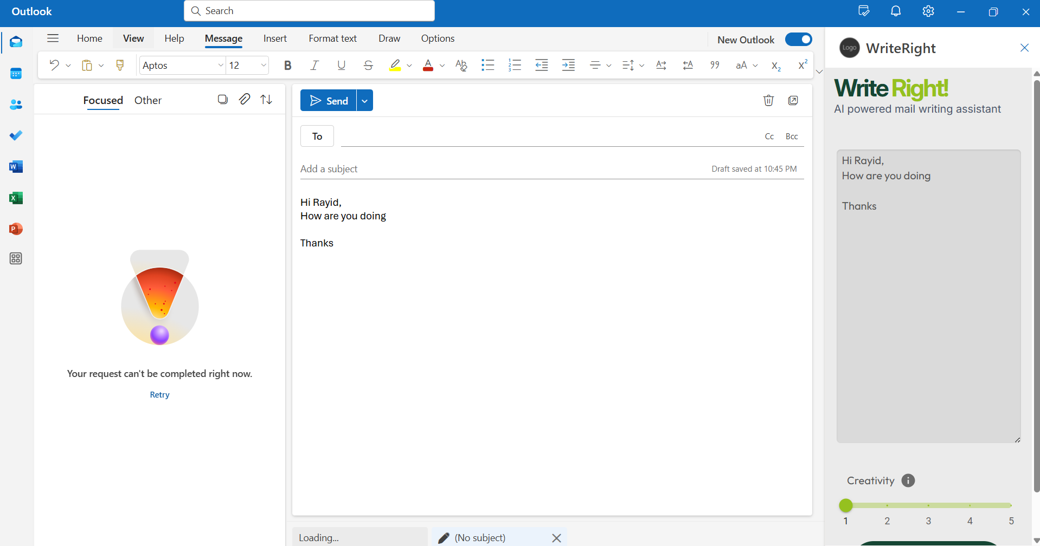

1. Enter your requirement prompt directly into the plugin text field( ex: write a mail on xyz )

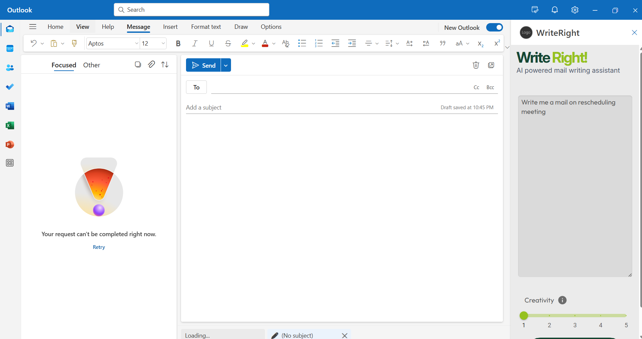

Features:

Creativity: This slider lets you adjust the creativity levels where 1 being with lowest creativity and 5 being highly creative.

Levels are divided as follows:

**Level 1 – Proof Reader:** which just checks for grammatical mistakes and fix them.

**Level 2 – Clarity Refiner :** maintains the same context of given draft but brings in more clarity by rearranging sentences.

**Level 3 – Tone Enhancer :** Modifies the input draft to enhance the tone in mail.

**Level 4 – Message Polisher:** Keeps the same context with higher freedom for creativity.

**Level 5- Rewrite :** Entire mail is rewritten professionally by AI while keeping the same context.

Transfer Button: This button helps to directly export the output from AI to the mail body without any need to copy paste.

Error Handling: The errors are handled via toast for user feedback.