Created by,

*X00179223 -* Raymond McCarthy

*X00167646 -* Taiwo Obadare

*X00162597 -* Vishvajit Sundarrajan

Supervised by,

- Patricia Magee

Project Year 2

Online bookshop with Stock Control

Contents

Introduction 1

Project Design 1

Overall Goals: 1

Requirements 2

High priority: 2

Medium priority: 3

Low priority: 3

Goals 3

Iteration 1 (Prototype) – Delivery date: **5/3/21 – 10pm** 3

Iteration 2 (Prototype) – Delivery date: **26/3/21 – 10pm** 3

Iteration 3 (Final Iteration) – Delivery date: **26/4/21 – 10pm** 4

Assessing Feasibility 4

Use Case Diagram 5

Use Case Descriptions 5

Class Diagram 5

# Introduction

For the second-year project our team consisting of Raymond McCarthy, Taiwo Obadare, and Vishvajit Sundarrajan, will create an electronic commerce website with the primary goal of selling goods for profit.

The type of e-commerce store we have chosen to create is a bookstore with stock control capabilities using Python, HTML, CSS, and the Django Framework. We will be using Microsoft Azure DevOps for project management and source control.

# Project Design

## Overall Goals:

Our end goal is to have a fully functional, easy to navigate user friendly website with all the functionality and features necessary to operate as an e-commerce store.

We will design database models to store information about our customers, products, and orders. Products will be uniquely identifiable with the use of uuid modelling. We will develop administration account types that are authorized to view, add, and update database information.

The website will have the ability for our customers to sign up, sign in and sign out. Our website will have a clear and organized visual user interface with the use of images to present our products, a navigation bar to traverse the website and drop-down menu links to access account features.

We will include pages for customer reviews as well as a contact us page with relevant information, these pages will use Django forms to allow customers to submit information.

Books will be easily located with a search feature and separated into relevant categories. Products can be viewed by category, product detail, and all products.

We will make use of the Django session framework to store cart information for our users. For credit card processing we will implement a Stripe payment facility. After making payment our customers will be redirected to a thank you page and can view their order details.

We will make use of the slug field to make sure our products are easily found by search engines. And implement a voucher feature for sales and offers.

Our website will be well tested using software quality and assurance testing techniques for error handling and bug detection.

And finally, when requirements have been met, we will launch the website on a domain server.

## Requirements:

### High priority:

* Web site structure.
* Web page design.
* Sign up/log in/log out.
* Database models.
  + Customers
  + Products
  + Orders
  + UUID
* Shopping cart functionality
  + Add items to cart.
  + Remove items from cart.
  + Empty cart.
  + Finalize order.
* Website deployment.
* Make payment.
* Django admin for performing add/update.
* Django session framework to manage shopping cart.
* Stripe API functionality.

### Medium priority:

* Graphics and images.
* Review page.
* Paginator.
* Search.
* Navbar links.
* Contact us page.

### Low priority:

* Slug.
* Vouchers.

## Goals

## Iteration 1 (Prototype) – Delivery date: **5/3/21 – 10pm**

* We will meet for our scrum session on Microsoft teams to discuss the iteration and determine our approach for completing tasks on **16/2/21 at 9am**.
* Tasks set out:
* Develop a working system with core functionality.
  + Initialize and fork repository.
  + Create models.
    - Users
    - Products
    - Admin
  + Develop views, templates, and URLs.
  + Develop add, update, and delete functionality by Admin.
  + Design templates.
    - Base.html
    - Navbar.html
    - Products pages
    - Sign up/in/out.
    - Styling
* Paginator & Search functionality.
* Cart application.
* Design a series of tests to verify that the system is working correctly.
* Document any issues or problems encountered.
* Write a 700-word iteration reporting work completed.

## Iteration 2 (Prototype) – Delivery date: **26/3/21 – 10pm**

* By the time we have reached iteration two we plan to have a well-built foundation with basic functionality to build upon.
* We will meet on Microsoft teams for our scrum session to discuss the approach for our next iteration on **9/3/21 at 9am**.
* Tasks set out:
  + We will now implement additional functionality such as:
    - Strip payment API.
    - Orders app.
    - Thank you, page.
    - Contact us page.
    - Sign up, sign in & sign out.
    - Vouchers functionality.
    - Many to many mapping
      * This will allow us to add the same product to multiple categories, e.g. ‘Crime’ & ‘Thriller’.
    - Incorporating the Django ‘Slug’ field.
  + More testing for our newly implemented code.
  + Removal of any residual bugs from previous tests.
  + Submit a 700-word report on work completed.

## Iteration 3 (Final Iteration) – Delivery date: 26/4/21 – 10pm

* We will meet on Microsoft teams on **13/4/21 at 9am** for our scrum session to discuss our approach for the final iteration**.**
* At this stage of the project, we will have completed all coding and testing of the functionality of our website and be focusing on testing and making minor adjustments to improve overall functionality and appearance where necessary.
* We will prepare our final iteration documentation and our final prototype for review before **10pm** on the **26th of April 2021.**
* The documentation will include:
  + A table of contents, numbered headings, page numbers and references
  + An outline of each member’s responsibility and participation within the project
  + An introduction to the project, including project plan and requirements document.
  + Reports for each iteration (Iteration 1, Iteration 2 & Iteration 3).
  + Concluding paragraph highlighting the achievements of the project, any shortcomings and what could be improved by future enhancements.
  + The document should be bound with a cover page indicating:
    - Title of project
    - Names & Student IDs of students
    - Name of Supervisor

# Assessing Feasibility

[insert text]

# Use Case Diagram

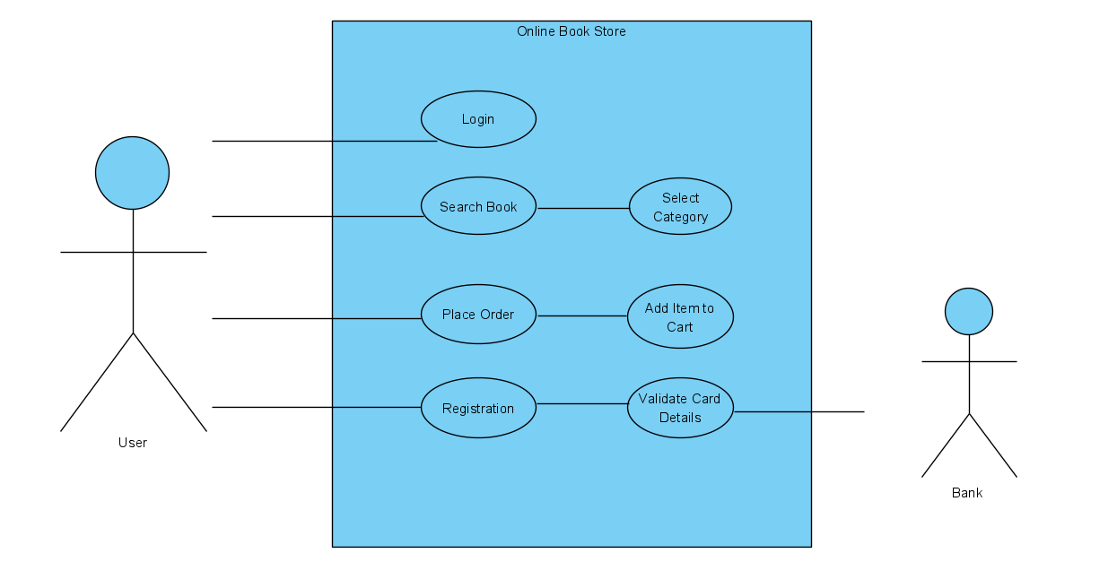

# Use Case Descriptions

[insert text]

# Class Diagram

[insert diagram]